**A Comprehensive Assessment of Water Quality Status of Kerala State**

**(Surface Water Quality)**

## Purpose Driven Study

## Hydrology Project (Phase II)

By

*Kerala State Irrigation Department*

Government of Kerala

Thiruvananthapuram

*Kerala State Ground Water Department*

Government of Kerala

Thiruvananthapuram

&

***Hard Rock Regional Centre***

***National Institute of Hydrology***

Belgaum, Karnataka

March 2014

Contents

Chapter 1

* 1. Introduction

Chapter 2

2.1 Literature Review

Chapter 3

3.1 Water Quality Status Of Kerala

Chapter 4

4.1 Surface Water Quality Analysis

Chapter 5

5.1 Methodology

Chapter 6

* 1. Chandragiripuzha
  2. Valapattanam
  3. Bharathapuzha
  4. Chalakkudy
  5. Kabini
  6. Chaliyar
  7. Periyar
  8. Muvattupuzha
  9. Meenachil
  10. Manimala
  11. Pamba
  12. Achankovil
  13. Kallada
  14. Karamana
  15. Vamanapuram

Chapter 7

7.1 Regression Analysis of the Water Quality Data of Post-monsoon 2011

7.2 Regression Analysis of the Water Quality Data of Pre-monsoon 201

7.3 Regression equation for different surface water quality variables

(Postmonsoon 2011)

7.4 Regression equation for different surface water quality variables

(Premonsoon 2012)

Chapter 8

8.1 Dissolved Oxygen Modeling

8.2 Qual-2K Modelling For Do

8.3 Concepts in Formulation of Model

8.4 Discretization of River Reach

8.5 Deoxygenation Coefficient

8.6 Reaeration Rate Coefficient

8.7 Water Quality Analysis of Selected Rivers of Kerala

8.8 Results of Biological, Bacteriological and Pesticide Analysis of Surface

8.9 Surface water quality Processes

List of figures

|  |  |  |
| --- | --- | --- |
| **Sl. no** | **Figure number** | **Title** |
| 1 | 6.1a | Seasonal variation of water quality parameters in Chandragiri river |
| 2 | 6.1b | Spatial variation of major cations along the river Chandragiri (Upstream to downstream) during Premonsoon 2008 |
| 3 | 6.1c | Spatial variation of major anions along the river Chandragiri (Upstream to downstream) during Premonsoon 2008 |
| 4 | 6.1d | Spatial variation of bacteriological parameters along the river Chandragiri (Upstream to downstream) during Premonsoon 2008 |
| 5 | 6.1e | Spatial variation of major cations along the river Chandragiri (Upstream to downstream) during Postmonsoon 2008 |
| 6 | 6.1f | Spatial variation of major anions along the river Chandragiri (Upstream to downstream) during Postmonsoon 2008 |
| 7 | 6.1g | Spatial variation of bacteriological parameters along the river Chandragiri (Upstream to downstream) during Postmonsoon 2008 |
| 8 | 6.1h | Spatial variation of major cations along the river Chandragiri (Upstream to downstream) during Premonsoon 2009 |
| 9 | 6.1i | Spatial variation of major anions along the river Chandragiri (Upstream to downstream) during Premonsoon 2009 |
| 10 | 6.1j | Spatial variation of bacteriological parameters along the river Chandragiri (Upstream to downstream) during Premonsoon 2009 |
| 11 | 6.1k | Piper’s Classification of water (Post-monsoon, 2011) |
| 12 | 6.1l | Piper ‘s Classification of Water (Pre-monsoon, 2012) |
| 13 | 6.1m | Irrigation Classification of water (Post-monsoon 2011) |
| 14 | 6.1n | Irrigation Classification of water (Pre-monsoon 2012) |
| 15 | 6.2a | Seasonal variation of water quality parameters in Valapattanam river |
| 16 | 6.2b | Spatial variation of major cations along the river Valapattanam (Upstream to downstream) during Premonsoon 2008 |
| 17 | 6.2c | Spatial variation of major anions along the river Valapattanam (Upstream to downstream) during Premonsoon 2008 |
| 18 | 6.2d | Spatial variation of bacteriological parameters along the river Valapattanam (Upstream to downstream) during Premonsoon 2008 |
| 19 | 6.2e | Spatial variation of major cations along the river Valapattanam (Upstream to downstream) during Postmonsoon 2008 |
| 20 | 6.2f | Spatial variation of major anions along the river Valapattanam (Upstream to downstream) during Postmonsoon 2008 |
| 21 | 6.2g | Spatial variation of major cations along the river Valapattanam (Upstream to downstream) during Postmonsoon 2008 |
| 22 | 6.2h | Spatial variation of major cations along the river Valapattanam (Upstream to downstream) during Premonsoon 2009 |
| 23 | 6.2i | Spatial variation of major anions along the river Valapattanam (Upstream to downstream) during Premonsoon 2009 |
| 24 | 6.2j | Spatial variation of bacteriological parameteras along the river Valapattanam (Upstream to downstream) during Premonsoon 2009 |
| 25 | 6.2k | Piper’s Classification of Valapattanam river water Postmonsoon 2011 |
| 26 | 6.2l | Piper’s Classification of Valapattanam river water premonsoon 2012 |
| 27 | 6.2m | USSL Classification of Valapattanam river water (post-monsoon, 2011) |
| 28 | 6.2n | USSL Classification of Valapattanam river water (pre-monsoon, 2012) |
| 29 | 6.3a | Seasonal variation of water quality parameters in Bharathapuzha river |
|  |  |  |
| 30 | 6.3b | Spatial variation of major cations along the river Bharathapuzha (Upstream to downstream) during Premonsoon 2008 |
| 31 | 6.3c | Spatial variation of major anions along the river Bharathapuzha (Upstream to downstream) during Premonsoon 2008 |
| 32 | 6.3d | Spatial variation of bacteriological parameters along the river Bharathapuzha (Upstream to downstream) during Premonsoon 2008 |
| 33 | 6.3e | Spatial variation of major cations along the river Bharathapuzha (Upstream to downstream) during Postmonsoon 2008 |
| 34 | 6.3f | Spatial variation of major anions along the river Bharathapuzha (Upstream to downstream) during Postmonsoon 2008 |
| 35 | 6.3g | Spatial variation of bacteriological parameters along the river Bharathapuzha (Upstream to downstream) during Postmonsoon 2008 |
| 36 | 6.3h | Spatial variation of major cations along the river Bharathapuzha (Upstream to downstream) during Premonsoon 2009 |
| 37 | 6.3i | Spatial variation of major anions along the river Bharathapuzha (Upstream to downstream) during Premonsoon 2009 |
| 38 | 6.3j | Spatial variation of bacteriological parameters along the river Bharathapuzha (Upstream to downstream) during Pre-monsoon 2009 |
| 39 | 6.3k | Piper’s Classification of Bharathapuzha river (post-monsoon 2011) |
| 40 | 6.3l | Piper’s Classification of Bharathapuzha river (pre-monsoon 2012) |
| 41 | 6.3m | USSL Classification of Bharathapuzha (post-monsoon, 2011) |
| 42 | 6.3n | USSL Classification of Bharathapuzha (pre-monsoon, 2012) |
| 43 | 6.4a | Seasonal variation of water quality parameters in Chalakudy river |
| 44 | 6.4b | Spatial variation of major cations along the river Chalakudy (Upstream to downstream) during Premonsoon 2008 |
| 45 | 6.4c | Spatial variation of major anions along the river Chalakudy (Upstream to downstream) during Premonsoon 2008 |
| 46 | 6.4d | Spatial variation of bacteriological parameters along the river Chalakudy (Upstream to downstream) during Premonsoon 2008 |
| 47 | 6.4e | Spatial variation of major cations along the river Chalakudy (Upstream to downstream) during Postmonsoon 2008 |
| 48 | 6.4f | Spatial variation of major anions along the river Chalakudy (Upstream to downstream) during Postmonsoon 2008 |
| 49 | 6.4g | Spatial variation of bateriological parameters along the river Chalakudy (Upstream to downstream) during Postmonsoon 2008. |
| 50 | 6.4h | Spatial variation of major cations along the river Chalakudy (Upstream to downstream) during Premonsoon 2009 |
| 51 | 6.4i | Spatial variation of major anions along the river Chalakudy (Upstream to downstream) during Premonsoon 2009 |
| 52 | 6.4j | Spatial variation of bacteriological parameters along the river Chalakudy (Upstream to downstream) during Premonsoon 2009 |
| 53 | 6.4k | Piper’s Classification of Chalakudy river water (post-monsoon, 2011) |
| 54 | 6.4l | Piper’s Classification of Chalakudy river water (pre-monsoon, 2012) |
| 55 | 6.4m | USSL Classification of Chalakudy river (post-monsoon, 2011) |
| 56 | 6.4n | USSL Classification of Chalakudy river (pre-monsoon, 2012) |
| 57 | 6.5a | Seasonal variation of water quality parameters in Kabini river |
| 58 | 6.5b | Spatial variation of major cations along the river Kabini (Upstream to downstream) during Premonsoon 2008 |
| 59 | 6.5c | Spatial variation of major anions along the river Kabini (Upstream to downstream) during Premonsoon 2008 |
| 60 | 6.5d | Spatial variation of bacteriological parameters along the river Kabini (Upstream to downstream) during Premonsoon 2008 |
| 61 | 6.5e | Spatial variation of cations along the river Kabini (Upstream to downstream) during Postmonsoon 2008 |
| 62 | 6.5f | Spatial variation of anions along the river Kabini (Upstream to downstream) during Postmonsoon 2008 |
| 63 | 6.5g | Spatial variation of bacteriological parameters along the river Kabini (Upstream to downstream) during Postmonsoon 2008 |
| 64 | 6.5h | Spatial variation of major cations along the river Kabini (Upstream to downstream) during Premonsoon 2009 |
| 65 | 6.5i | Spatial variation of major anions along the river Kabini (Upstream to downstream) during Premonsoon 2009 |
| 66 | 6.5j | Spatial variation of bacteriological parameters along the river Kabini (Upstream to downstream) during Premonsoon 2009 |
| 67 | 6.5k | Piper’s Classification of water (Post-monsoon, 2011) |
| 68 | 6.5l | Piper’s Classification of water (Pre-monsoon, 2012) |
| 69 | 6.5m | USSL Classification of Kabini river (post-monsoon, 2011) |
| 70 | 6.5n | USSL Classification of Kabini river (pre-monsoon, 2012) |
| 71 | 6.6a | Seasonal variation of water quality parameters in Chaliyar river |
| 72 | 6.6b | Spatial variation of major cations along the river Chaliyar (Upstream to downstream) during Premonsoon 2008 |
| 73 | 6.6c | Spatial variation of major anions along the river Chaliyar (Upstream to downstream) during Premonsoon 2008 |
| 74 | 6.6d | Spatial variation of bacteriological parameters along the river Chaliyar (Upstream to downstream) during Premonsoon 2008 |
| 75 | 6.6e | Spatial variation of cations along the river Chaliyar (Upstream to downstream) during Postmonsoon 2008 |
| 76 | 6.6f | Spatial variation of anions along the river Chaliyar (Upstream to downstream) during Postmonsoon 2008 |
| 77 | 6.6g | Spatial variation of bacteriological parameters along the river Chaliyar (Upstream to downstream) during Postmonsoon 2008 |
| 78 | 6.6h | Spatial variation of cations along the river Chaliyar (Upstream to downstream) during Premonsoon 2009 |
| 79 | 6.6i | Spatial variation of anions along the river Chaliyar (Upstream to downstream) during Premonsoon 2009 |
| 80 | 6.6j | Spatial variation of bacteriological parameters along the river Chaliyar (Upstream to downstream) during Premonsoon 2009 |
| 81 | 6.6k | Piper’s Classification of Chaliyar water (post-monsoon, 2011) |
| 82 | 6.6l | Piper’s Classification of Chaliyar water (pre-monsoon, 2012) |
| 83 | 6.6m | USSL Classification of Chaliyar (post-monsoon, 2011) |
| 84 | 6.6n | USSL Classification of Chaliyar (pre-monsoon, 2012) |
| 85 | 6.7a | Seasonal variation of water quality parameters in Periyar river |
| 86 | 6.7b | Spatial variation of major cations along the river Periyar (Upstream to downstream) during Premonsoon 2008 |
| 87 | 6.7c | Spatial variation of major anions along the river Periyar (Upstream to downstream) during Premonsoon 2008 |
| 88 | 6.7d | Spatial variation of bacteriological parameters along the river Periyar (Upstream to downstream) during Premonsoon 2008 |
| 89 | 6.7e | Spatial variation of major cations along the river Periyar (Upstream to downstream) during Postmonsoon 2008 |
| 90 | 6.7f | Spatial variation of major anions along the river Periyar (Upstream to downstream) during Postmonsoon 2008 |
| 91 | 6.7g | Spatial variation of bacteriological parameters along the river Periyar (Upstream to downstream) during Postmonsoon 2008 |
| 92 | 6.7h | Spatial variation of major cations along the river Periyar (Upstream to downstream) during Premonsoon 2009 |
| 93 | 6.7i | Spatial variation of major anions along the river Periyar (Upstream to downstream) during Premonsoon 2009 |
| 94 | 6.7j | Spatial variation of bacteriological parameters along the river Periyar (Upstream to downstream) during Premonsoon 2009 |
| 95 | 6.7k | Piper’s Classification of Periyar water (post-monsoon, 2011) |
| 96 | 6.7l | Piper’s Classification of Periyar water (pre-monsoon, 2012) |
| 97 | 6.7m | USSL Classification of Periyar (post-monsoon, 2011) |
| 98 | 6.7n | USSL Classification of Periyar (pre-monsoon, 2012) |
| 99 | 6.8a | Seasonal variation of water quality parameters in Muvattupuzha river |
| 100 | 6.8b | Spatial variation of major cations along the river Muvattupuzha (Upstream to downstream) during Premonsoon 2008 |
| 101 | 6.8c | Spatial variation of major anions along the river Muvattupuzha (Upstream to downstream) during Premonsoon 2008 |
| 102 | 6.8d | Spatial variation of bacteriological parameters along the river Muvattupuzha (Upstream to downstream) during Premonsoon 2008 |
| 103 | 6.8e | Spatial variation of major cations along the river Muvattupuzha (Upstream to downstream) during Postmonsoon 2008 |
| 104 | 6.8f | : Spatial variation of major anions along the river Muvattupuzha (Upstream to downstream) during Postmonsoon 2008 |
| 105 | 6.8g | Spatial variation of bacteriological parameters along the river Muvattupuzha (Upstream to downstream) during Postmonsoon 2008 |
| 106 | 6.8h | Spatial variation of major cations along the river Muvattupuzha (Upstream to downstream) during Premonsoon 2009 |
| 107 | 6.8i | Spatial variation of major cations along the river Muvattupuzha (Upstream to downstream) during Premonsoon 2009 |
| 108 | 6.8j | Spatial variation of bacteriological parameters along the river Muvattupuzha (Upstream to downstream) during Premonsoon 2009 |
| 109 | 6.8k | Piper’s Classification of Muvattupuzha water (post-monsoon, 2011) |
| 110 | 6.8l | Piper’s Classification of Muvattupuzha water (pre-monsoon, 2012) |
| 111 | 6.8m | USSL Classification of Periyar (post-monsoon, 2011) |
| 112 | 6.8n | USSL Classification of Periyar (pre-monsoon, 2012) |
| 113 | 6.9a | Seasonal variation of water quality parameters in Meenachil river |
| 114 | 6.9b | Spatial variation of major cations along the river Meenachil (Upstream to downstream) during Premonsoon 2008 |
| 115 | 6.9c | Spatial variation of major anions along the river Meenachil (Upstream to downstream) during Premonsoon 2008 |
| 116 | 6.9d | Spatial variation of bacteriological parameters along the river Meenachil (Upstream to downstream) during Premonsoon 2008 |
| 117 | 6.9e | Spatial variation of major cations along the river Meenachil (Upstream to downstream) during Postmonsoon 2008 |
| 118 | 6.9f | Spatial variation of major anions along the river Meenachil (Upstream to downstream) during Postmonsoon 2008 |
| 119 | 6.9g | Spatial variation of bacteriological parameters along the river Meenachil (Upstream to downstream) during Postmonsoon 2008 |
| 120 | 6.9h | Spatial variation of major cations along the river Meenachil (Upstream to downstream) during Premonsoon 2009 |
| 121 | 6.9i | Spatial variation of major anions along the river Meenachil (Upstream to downstream) during Premonsoon 2009 |
| 122 | 6.9j | Spatial variation of bacteriological parameters along the river Meenachil (Upstream to downstream) during Pre-monsoon 2009. |
| 123 | 6.9k | Piper’s Classification of Meenachil water (post-monsoon, 2011) |
| 124 | 6.9l | Piper’s Classification of Meenachil water (pre-monsoon, 2012) |
| 125 | 6.9m | USSL Classification of Meenachil (post-monsoon, 2011) |
| 126 | 6.9n | USSL Classification of Meenachil (pre-monsoon, 2012) |
| 127 | 6.10a | Seasonal variation of water quality parameters in Manimala river |
| 128 | 6.10b | Spatial variation of major cations along the river Manimala (Upstream to downstream) during Premonsoon 2008 |
| 129 | 6.10c | Spatial variation of major anions along the river Manimala (Upstream to downstream) during Premonsoon 2008 |
| 130 | 6.10d | Spatial variation of bacteriological parameters along the river Manimala (Upstream to downstream) during Premonsoon 2008 |
| 131 | 6.10e | Spatial variation of major cations along the river Manimala (Upstream to downstream) during Postmonsoon 2008 |
| 132 | 6.10f | Spatial variation of major anions along the river Manimala (Upstream to downstream) during Postmonsoon 2008 |
| 133 | 6.10g | Spatial variation of bacteriological parameters along the river Manimala (Upstream to downstream) during Postmonsoon 2008 |
| 134 | 6.10h | Spatial variation of major cations along the river Manimala (Upstream to downstream) during Premonsoon 2009 |
| 135 | 6.10i | Spatial variation of major anions along the river Manimala (Upstream to downstream) during Premonsoon 2009 |
| 136 | 6.10j | Spatial variation of bacteriological parameters along the river Manimala (Upstream to downstream) during Premonsoon 2009 |
| 137 | 6.10k | Piper‘s Classification of Water (Post-monsoon, 2011) |
| 138 | 6.10l | Piper‘s Classification of Water (Pre-monsoon, 2012) |
| 139 | 6.10m | USSL Classification of Manimala (post-monsoon, 2011) |
| 140 | 6.10n | USSL Classification of Manimala (pre-monsoon, 2012) |
| 141 | 6.11a | Seasonal variation of water quality parameters in Pamba river |
| 142 | 6.11b | Spatial variation of major cations along the river Pamba (Upstream to downstream) during Premonsoon 2008 |
| 143 | 6.11c | Spatial variation of major anions along the river Pamba (Upstream to downstream) during Premonsoon 2008 |
| 144 | 6.11d | Spatial variation of bacteriological parameters along the river Pamba (Upstream to downstream) during Premonsoon 2008 |
| 145 | 6.11e | Spatial variation of major cations along the river Pamba (Upstream to downstream) during Postmonsoon 2008 |
| 146 | 6.11f | Spatial variation of major anions along the river Pamba (Upstream to downstream) during Postmonsoon 2008 |
| 147 | 6.11g | Spatial variation of bacteriological parameters along the river Pamba (Upstream to downstream) during Postmonsoon 2008 |
| 148 | 6.11h | Spatial variation of major cations along the river Pamba (Upstream to downstream) during Premonsoon 2009 |
| 149 | 6.11i | Spatial variation of major anions along the river Pamba (Upstream to downstream) during Premonsoon 2009 |
| 150 | 6.11j | Spatial variation of bacteriological parameters along the river Pamba (Upstream to downstream) during Premonsoon 2009 |
| 151 | 6.11k | Piper ‘s Classification of Water (Post-monsoon, 2011) |
| 152 | 6.11l | Piper ‘s Classification of Water (Pre-monsoon, 2012) |
| 153 | 6.11m | USSL Classification of Periyar (post-monsoon, 2011) |
| 154 | 6.11n | USSL Classification of Periyar (pre-monsoon, 2012) |
| 155 | 6.12a | Seasonal variation of water quality parameters in Achankovil river |
| 156 | 6.12b | Spatial variation of major cations along the river Achenkovil (Upstream to downstream) during Premonsoon 2008 |
| 157 | 6.12c | Spatial variation of major anions along the river Achenkovil  (Upstream to downstream) during Premonsoon 2008 |
| 158 | 6.12d | Spatial variation of bacteriological parameters along the river Achenkovil(Upstream to downstream) during Premonsoon 2008 |
| 159 | 6.12e | Spatial variation of major cations along the river Achenkovil  (Upstream to downstream) during Postmonsoon 2008 |
| 160 | 6.12f | Spatial variation of major anions along the river Achenkovil  (Upstream to downstream) during Postmonsoon 2008 |
| 161 | 6.12g | Spatial variation of bacteriological parameters along the river Achenkovil (Upstream to downstream) during Postmonsoon 2008 |
| 162 | 6.12h | Spatial variation of major cations along the river Achenkovil  (Upstream to downstream) during Premonsoon 2009 |
| 163 | 6.12i | Spatial variation of major anions along the river Achenkovil  (Upstream to downstream) during Premonsoon 2009 |
| 164 | 6.12j | Spatial variation of bacteriological parameters along the river Achenkovil  (Upstream to downstream) during Premonsoon 2009 |
| 165 | 6.12k | Piper ‘s Classification of Water (Post-monsoon, 2011) |
| 166 | 6.12l | Piper ‘s Classification of Water (Pre-monsoon, 2012) |
| 167 | 6.12m | USSL Classification of Achenkovil (post-monsoon, 2011) |
| 168 | 6.12n | USSL Classification of Achenkovil (pre-monsoon, 2012) |
| 169 | 6.13a | Seasonal variation of water quality parameters in Kallada river |
| 170 | 6.13b | Spatial variation of major cations along the river Kallada  (Upstream to downstream) during Premonsoon 2008 |
| 171 | 6.13c | Spatial variation of major anions along the river Kallada  (Upstream to downstream) during Premonsoon 2008 |
| 172 | 6.13d | Spatial variation of bacteriological parameters along the river Kallada  (Upstream to downstream) during Premonsoon 2008 |
| 173 | 6.13e | Spatial variation of major cations along the river Kallada  (Upstream to downstream) during Postmonsoon 2008 |
| 174 | 6.13f | Spatial variation of major anions along the river kallada  (Upstream to downstream) Postmonsoon 2008 |
| 175 | 6.13g | Spatial variation of bacteriological parameters along the river Kallada  (Upstream to downstream) during Postmonsoon 2008 |
| 176 | 6.13h | Spatial variation of major cations along the river Kallada  (Upstream to downstream) during Premonsoon 2009 |
| 177 | 6.13i | Spatial variation of major anions along the river Kallada  (Upstream to downstream) during Premonsoon 2009 |
| 178 | 6.13j | Spatial variation of bacteriological parameters along the river Kallada  (Upstream to downstream) during Premonsoon 2009 |
| 179 | 6.13k | Piper ‘s Classification of Water (Post-monsoon, 2011) |
| 180 | 6.l3l | Piper ‘s Classification of Water (Pre-monsoon, 2012) |
| 181 | 6.13m | USSL Classification of Kallada (post-monsoon, 2011) |
| 182 | 6.13n | USSL Classification of Kallada (pre-monsoon, 2012) |
| 183 | 6.14a | Seasonal variation of water quality parameters in Karamana river  (Except EC (microsiemen/cm) all are in mg/l) |
| 184 | 6.14b | Spatial variation of major cations along the river Karamana  (Upstream to downstream) during Premonsoon 2008 |
| 185 | 6.14c | Spatial variation of major anions along the river Karamana  (Upstream to downstream) during Premonsoon 2008 |
| 186 | 6.14d | Spatial variation of DO along the river Karamana  (Upstream to downstream) during Premonsoon 2008 |
| 187 | 6.14e | Spatial variation of major cations along the river Karamana(Upstream to downstream) during Postmonsoon 2008 |
| 188 | 6.14f | Spatial variation of major anions along the river Karamana  (Upstream to downstream) during Postmonsoon 2008 |
| 189 | 6.14g | Spatial variation of DO along the river Karamana (Upstream to downstream) during Postmonsoon 2008 |
| 190 | 6.14h | Spatial variation of major cations along the river Karamana  (Upstream to downstream) during Premonsoon 2009 |
| 191 | 6.14i | Spatial variation of major anions along the river Karamana  (Upstream to downstream) during Premonsoon 2009 |
| 192 | 6.14j | Spatial variation of DO along the river Karamana  (Upstream to downstream) during Premonsoon 2009 |
| 193 | 6.14k | Piper ‘s Classification of Water (Pre-monsoon, 2011) |
| 194 | 6.14l | Piper ‘s Classification of Water (Pre-monsoon, 2012) |
| 195 | 6.14m | USSL Classification of Karamana (post-monsoon, 2011) |
| 196 | 6.14n | USSL Classification of Karamana (pre-monsoon, 2012) |
| 197 | 6.15a | Piper‘s Classification of Water (Post-monsoon, 2011) |
| 198 | 6.15b | Piper‘s Classification of Water (Pre-monsoon, 2012) |
| 199 | 6.15c | USSL Classification of Vamanapuram (post-monsoon, 2011) |
| 200 | 6.15d | USSL Classification of Vamanapuram (pre-monsoon, 2012) |
| 201 | 7.1  (1-20) | Regression Analysis of the Water Quality Data of Post-monsoon 2011 |
| 202 | 7.2  (1-20) | Regression Analysis of the Water Quality Data of Pre-monsoon 2012 |
| 203 | 8.3a | Reaeration rate (/d) versus depth and velocity (Covar 1976). |
| 204 | 8.4a | Schematic representation of Pamba river discretization |
| 205 | 8.6a | QUAL2K Model Calibration by using Pamba River DO-BOD data |

List of tables

|  |  |  |
| --- | --- | --- |
| **Sl .no** | **Table number** | **Title** |
| 1 | 5a | Analytical Methods and Equipments used in the study |
| 2 | 5b | Phenolphthalein and Methyl Orange Alkalinity |
| 3 | 6.1a | Variation of Water Quality parameters in Chandragiripuzha during Post-monsoon 2011 |
| 4 | 6.1b | Variation of Water Quality parameters in Chandragiripuzha during Pre-monsoon 2012 |
| 5 | 6.1c | Factor Analysis results of Chandragiripuzha (Post-monsoon 2011) |
| 6 | 6.1d | Factor Analysis results of Chandragiripuzha (Pre-monsoon 2012) |
| 7 | 6.1e | Estimated values of Water Quality Indices by Bascaron and CCME methods for Chandragiri basin (2008-2012) |
| 8 | 6.1f | CCME Score of Chandragiripuzha (Pre-monsoon) |
| 9 | 6.1g | CCME Score of Chandragiripuzha (Post-monsoon) |
| 10 | 6.2a | Variation of Water Quality parameters in Valapattanam river during Post-monsoon 2011 |
| 11 | 6.2b | Variation of Water quality parameters in Valapattanam during Pre-monsoon 2012 |
| 12 | 6.2c | Factor Analysis of Water Quality parameters of Valapattanam river during Post-monsoon 2011 |
| 13 | 6.2d | Factor Analysis of Water Quality parameters of Valapattanam river during Pre-monsoon 2012 |
| 14 | 6.2e | Overall CWQI and WQI Estimated values of Valapattanam basin for the selected station (2008-2012) |
| 15 | 6.2f | CCME Score/rating of Valapattanam river during pre-monsoon (2008-2012) |
| 16 | 6.2g | CCME Score/rating of Valapattanam river during post-monsoon (2008-2012) |
| 17 | 6.3a | Variation of Water Quality parameters in Bharathapuzha river during Post-monsoon 2011 |
| 18 | 6.3b | Variation of Water Quality parameters in Bharathapuzha river during Pre-monsoon 2012 |
| 19 | 6.3c | Factor Analysis results of Bharathapuzha river during post- monsoon 2011 |
| 20 | 6.3d | Factor Analysis results of Bharathapuzha during pre-monsoon (2012) |
| 21 | 6.3e | Overall CWQI and WQI Estimated values of Bharathapuzha basin for the selected station (2008-2012) |
| 22 | 6.3f | CCME Score of Bharathapuzha (pre-monsoon, 2008-2012) |
| 23 | 6.3g | CCME scores of Bharathapuzha (post-monsoon, 2008,2011) |
| 24 | 6.4a | Variation of Water Quality parameters in Chalakudy river during post-monsoon 2011 |
| 25 | 6.4b | Variation of Water Quality parameters in Chalakudy river during pre- monsoon 2012 |
| 26 | 6.4c | Factor Analysis results of Chalakudy river during post-monsoon (2011) |
| 27 | 6.4d | Factor Analysis results of Chalakudy river during pre-monsoon (2012) |
| 28 | 6.4e | Overall CWQI and WQI Estimated values of Chalakkudy basin for the selected station (2008-2012) |
| 29 | 6.4f | CCME Score of Chalakudy river (pre-monsoon, 2008-2012) |
| 30 | 6.4g | CCME Score of Chalakudy river during post-monsoon (2008,2011) |
| 31 | 6.5a | Variation of Water Quality parameters in Kabini river during post-monsoon 2011 |
| 32 | 6.5b | Variation of Water Quality parameters in Kabini river during  pre-monsoon 2012 |
| 33 | 6.5c | Factor Analysis results of Kabini river during post-monsoon (2011) |
| 34 | 6.5d | Factor Analysis results of Kabini river during pre-monsoon (2012) |
| 35 | 6.5e | Overall CWQI and WQI Estimated values of Kabini basin for the selected Station (2008-2012) |
| 36 | 6.5f | CCME Score of Chalakudy river (pre-monsoon, 2008-2012) |
| 37 | 6.5g | CCME Score of Chalakudy river (post-monsoon, 2008,2011) |
| 38 | 6.6a | Variation of Water Quality parameters in Chaliyar during post-monsoon 2011 |
| 39 | 6.6b | Variation of Water Quality parameters in Chaliyar during pre-monsoon 2012 |
| 40 | 6.6c | Factor Analysis results of Chaliyar during post-monsoon (2011) |
| 41 | 6.6d | Factor Analysis results of Chaliyar during pre-monsoon (2012) |
| 42 | 6.6e | Overall CWQI and WQI Estimated values of Chaliyar basin for the selected station (2008-2012) |
| 43 | 6.6f | CCME Score of Chaliyar (pre-monsoon, 2008-2012) |
| 44 | 6.6g | CCME Score of Chaliyar (post-monsoon, 2008,2011) |
| 45 | 6.7a | Variation of Water Quality parameters in Periyar during post-monsoon 2011 |
| 46 | 6.7b | Variation of Water Quality parameters in Periyar during pre-monsoon 2011 |
| 47 | 6.7c | Factor Analysis results of Chaliyar during post-monsoon (2011) |
| 48 | 6.7d | Factor Analysis results of Chaliyar during pre-monsoon (2012) |
| 49 | 6.7e | Overall CWQI and WQI Estimated values of Periyar basin for the selected station (2008-2012) |
| 50 | 6.7f | CCME Score of Periyar (pre-monsoon, 2008-2012) |
| 51 | 6.7g | CCME Score of Periyar (post-monsoon, 2008,2011) |
| 52 | 6.8a | Variation of Water Quality parameters in Muvattupuzha during post- monsoon 2011 |
| 53 | 6.8b | Variation of Water Quality parameters in Muvattupuzha during pre-monsoon 2012 |
| 54 | 6.8c | Factor Analysis results of Muvattupuzha during post-monsoon (2011) |
| 55 | 6.8d | Factor Analysis results of Muvattupuzha during pre-monsoon (2012) |
| 56 | 6.8e | Overall CWQI and WQI Estimated values of Muvattupuzha basin for the selected station (2008-2012) |
| 57 | 6.8f | CCME Score of Muvattupuzha (pre-monsoon, 2008-2012) |
| 58 | 6.8g | CCME Score of Muvattupuzha (post-monsoon, 2008,2011) |
| 59 | 6.9a | Variation of Water Quality parameters in Meenachil during post-  monsoon 2011 |
| 60 | 6.9b | Variation of Water Quality parameters in Meenachil during pre- monsoon 2012 |
| 61 | 6.9c | Factor Analysis results of Meenachil during post-monsoon (2011) |
| 62 | 6.9d | Factor Analysis results of Meenachil during pre-monsoon (2012) |
| 63 | 6.9e | Overall CWQI and WQI Estimated values of Meenachil basin for the selected station (2008-2012) |
| 64 | 6.9f | CCME Score of Meenachil (post-monsoon, 2008,2011) |
| 65 | 6.9g | CCME Score of Meenachil (pre-monsoon, 2008-2012) |
| 66 | 6.10a | Variation of Water Quality parameters in Manimala during post- monsoon 2011 |
| 67 | 6.10b | Variation of Water Quality parameters in Manimala during pre-monsoon 2012 |
| 68 | 6.10c | Factor Analysis results of Manimala during post-monsoon (2011) |
| 69 | 6.10d | Factor Analysis results of Manimala during pre-monsoon (2012) |
| 70 | 6.10e | Overall CWQI and WQI Estimated values of Manimala basin for the selected station (2008-2012) |
| 71 | 6.10f | CCME Score of Manimala river (pre-monsoon, 2008-2012) |
| 72 | 6.10g | CCME Score of Manimala river (post-monsoon, 2008,2011) |
| 73 | 6.11a | Variation of Water Quality parameters in Pamba during post- monsoon 2011 |
| 74 | 6.11b | Variation of Water Quality parameters in Pamba during post-  monsoon 2011 |
| 75 | 6.11c | Factor Analysis results of Pamba during post-monsoon (2011) |
| 76 | 6.11d | Factor Analysis results of Pamba during pre-monsoon (2012) |
| 77 | 6.11e | Overall CWQI and WQI Estimated values of Periyar basin for the selected station (2008-2012) |
| 78 | 6.11f | CCME Score of Pamba (pre-monsoon, 2008-2012) |
| 79 | 6.11g | CCME Score of Pamba (post-monsoon, 2008,2011) |
| 80 | 6.12a | Variation of Water Quality parameters in Achenkovil during post-monsoon 2011 |
| 81 | 6.12b | Variation of Water Quality parameters in Achenkovil during pre-  monsoon 2012 |
| 82 | 6.12c | Factor Analysis results of Achenkovil during post-monsoon (2011) |
| 83 | 6.12d | Factor Analysis results of Achenkovil during pre-monsoon (2012) |
| 84 | 6.12e | Overall CWQI and WQI Estimated values of Achenkovil basin for the selected station (2008-2012) |
| 85 | 6.12f | CCME Score of Achenkovil (pre-monsoon, 2008-2012) |
| 86 | 6.12g | CCME Score of Achenkovil (pre-monsoon, 2008,2011) |
| 87 | 6.13a | Variation of Water Quality parameters in Kallada during post-monsoon 2011 |
| 88 | 6.13b | Variation of Water Quality parameters in Kallada during pre- monsoon 2011 |
| 89 | 6.13c | Factor Analysis results of Kallada during post-monsoon (2011) |
| 90 | 6.13d | Factor Analysis results of Kallada during pre-monsoon (2012) |
| 91 | 6.13e | Overall CWQI and WQI Estimated values of Kallada basin for the selected station (2008-2012) |
| 92 | 6.13f | CCME Score of Kallada (pre-monsoon, 2008-2012) |
| 93 | 6.13g | CCME Score of Kallada (post-monsoon, 2008-2011) |
| 94 | 6.14a | Variation of Water Quality parameters in Karamana during post-monsoon 2011 |
| 95 | 6.14b | Table 6.14b: Variation of Water Quality parameters in Karamana during pre- monsoon 2012 |
| 96 | 6.14c | Factor Analysis results of Karamana during post-monsoon (2011) |
| 97 | 6.14d | Factor Analysis results of Karamana during pre-monsoon (2012) |
| 98 | 6.14e | Overall CWQI and WQI Estimated values of Karamana basin for the selected station (2008-2012) |
| 99 | 6.14f | CCME Score of Karamana (pre-monsoon, 2008-2012) |
| 100 | 6.14g | CCME Score of Karamana (post-monsoon, 2008,2011) |
| 101 | 6.15a | Variation of Water Quality parameters in Vamanapuram during post- monsoon 2011 |
| 102 | 6.15b | Variation of Water Quality parameters in Vamanapuram during pre- monsoon 2012 |
| 103 | 6.15c | Factor Analysis results of Vamanapuram during post-monsoon (2011) |
| 104 | 6.15d | Factor Analysis results of Vamanapuram during pre-monsoon (2012) |
| 105 | 6.15e | Overall CWQI and WQI Estimated values of Periyar basin for the selected station (2008-2012 |
| 106 | 6.15f | CCME Score of Vamanapuram (pre-monsoon, 2008-2012) |
| 107 | 6.15g | CCME Score of Vamanapuram (post-monsoon, 2008,2011) |
| 108 | 7.3 | Regression equation for different surface water quality variables (Postmonsoon 2011) |
| 109 | 7.4 | Regression equation for different surface water quality variables (Postmonsoon 2011) |
| 110 | 8.8  (1-19) | Results of Biological, Bacteriological and Pesticide Analysis of Surface water (Sampling Locations in each distrct along with river basin name are mentioned) |

Chapter 1

1.1 INTRODUCTION

General

The land, water, and air together are called as a abiotic components (environments) and the organisms are called as the biotic members (like producers, consumers, and Decomposers). The system consisting of whole biotic community in a abiotic environment is called as Ecosystem. The functions of the abiotic components and biotic members are well established and in existence since origin of the earth. A well balanced system exists in the nature between the organisms and the nature. However, in recent days due to the explosive growth of population, industry and agriculture activities created an imbalance between the two and therefore lot of environmental related problems cropped up. In order to keep the environment and organisms following factors need to be understood in detail.

1] Organisms and Environments are mutually reactive and interdependent.

2] Environment is much dynamic and varying from time and space.

3] Species tries to maintain uniformity in structure, function, reproduction

growth, developments

4] The organisms tries to modify the Environment

5] The structural and functional unit of the nature is ecosystem.

6] The ecosystem is consisting of whole biotic community in a

given area ( biosphere ) and abiotic environment.

7] Energy is a driving force in ecosystem.

8] The chemical components of the ecosystem always move in

biogeochemical ( atmospheric ) cycles.

9] The growth of the organisms is influenced by the environment.

Water is an essential natural resource for sustaining life and environment, which we have always thought to be available in abundance and free gift of nature. However, chemical composition of surface or subsurface water is one of the prime factors on which suitability of the water for domestic, industrial or agricultural purpose demands. The water in rivers, streams, ocean, and soil contain a variety of dissolved substance from soils which will move to ground water. In recent years continuous growth in population, rapid urbanization, and industrialization has endangered the very existence of human race.

With the rapid growth of population and industrialization in the country, pollution of natural water by municipal and industrial wastes has increased tremendously. The pollution is objectionable and damaging for varied reasons of primary importance and are possible hazards to the public health. Of a lesser consequence, but still very real, is the aesthetic damage to the attributes of streams and destruction of the economic values of clean natural water. The pollution of rivers and domestic sewage has increased tremendously and producing the most unsanitary conditions in the environment.

Both surface and ground water are liable to pollution. More often than not, the pollutants that reach groundwater have their origin in polluted surface water. At present, emphasis is mainly directed towards detection, prevention and amelioration of surface water and atmospheric pollution due to the ease with which pollution can be detected. On the other hand ground water pollution may remain undetected due to removal by filtration, of many of the preliminary indicators of pollution, viz. color, odour, taste, temperature, turbidity, or presence of foreign matter , during movement through soil, subsoil and aquifer materials. Nevertheless, the hazard of pollution may persist undetected. According to Hem (1970), although some polluted surface waterscan be restored to reasonable quality levels fairly rapidly, pollution of ground water may also be so slow in recovering from the polluted condition that it becomes necessary to think of the pollution of aquifers as almost irreversible once it has occurred. For this reason, great care is needed to protect our water resources.

In order to understand the water quality problems, it is essential to know the various surface and groundwater quality process which are ultimately responsible for changes in water quality scenario.

**Pre-independence Scenario of Environment**

Historical events of Environmental issues starts with the Mauryan empire who have ruled the India between 300 BC to 232 BC. The Koutalya , a scholar in the Mauryan empire has written the world famous “ Arthashatra” which informs about the administrative set up of the empire. He introduced the concept of Municipal Council for the first time. He narrated the development and maintenance of the agriculture, industry, mining, and forest. It was during this period only that the avenue plantation along roadside, recharge basins, MI tanks etc were constructed. The environmental status was well maintained during this period.

**Post-Independence Scenarioof Environment**

The problem of rivers and streams has assumed considerable importance and urgency after independence of our country as a result of growth of industry and rapid urbanization. The industrial effluents and domestic waste was of great concern and challenge to the society. There was a tendency to dispose off the waste directly into water bodies without treatment. The drinking water source was polluted and fishing activity was reduced considerably. The pollution of rivers and streams has caused a major setback for country’s economy.

Under the above circumstances, a committee was set up in 1962 to draw a draft for prevention of water pollution. The committee submitted its report which was circulated to all the States. The existing rules and prevailing local provisions in the Country was neither adequate nor satisfactory. The Central Council of Local Self Government considered the report of the Committee and recommended to resolve a single law to deal with the water pollution. Accordingly, a draft bill was prepared and put for considerations at a joint session of Central Council of Local Self Government and the 5 th conference of State Ministers of Town and Country planning held in 1965. As per the decision of the of Joint session, draft bill was considered by the Committee of Ministers of Local Self Government from the States of Bihar, Madras, Maharastra, Rajastan, Haryana, and West Bangal. The committee felt necessity of introducing a comprehensive legislation to control the water pollution. It includes following salient features—

1. Establishing of the Central as well as State water pollution Prevention boards with required technical and administrative staff with delegated powers.
2. Penalty Provision for contravention of this Act.
3. Establishing Center and State water testing laboratories.

The legislatures of the States of Gujarat, Jammu & Kashmir, Kerala, Haryana, and Karnataka have passed a resolution empowering the Parliament to pass necessary legislation on this subject. Thus, the water (Prevention and Control of Pollution ) Act 1974 ( water act ) was enacted in pursuance of clause (1) of Article 252 of the Constitution. The Central Board for the Prevention and control of water pollution was formed. According to this act, the Central Government and State Government have to provide funds to the Boards for implementation of this act. The same was not done due to paucity of funds. In view of this, the Water (Prevention and Control of Pollution) Cess Act 1977 was passed by act no 36 of 1977 to enable the Board to collect cess from the local authority and specified industries.

In the process of implementation of this Act, various difficulties were encountered. The time period to set up the State Board was 6 months which was inadequate. The States were finding difficulty to appoint full time Chairman for this board. The water act was amended by Act No 44 of 1978 to remove such difficulties. This act can be treated as first environmental act after independence.

Due to the rapid and concentrated industrialization at one place, the problem of Air pollution was felt in the country. The National Environmental Engineering Research Institutes of Nagpur has confirmed the impact of air pollution in the cities like Calcutta, Bombay, Delhi etc. the polluted air has a detrimental effect on the health of people, animals, vegetation, and property.

Meanwhile, the United Nations Conference on the Human Environment was held in Stockholm on June 1972 wherein the India has participated. It was unanimously decided to preserve the natural resources of the earth, which include preservation of quality of air and control of air pollution. The Government decided to implement the decision of the said conference, which are related to the air pollution. It was proposed to entrust the work of prevention and control of Air pollution to the Central Board for the Prevention and control of water pollution. In view of this, the water act was again amended. It was decided that the Central Board for the Prevention and control of water pollution, constituted under the water (Prevention and Control of pollution) act, 1974 will also perform the function of the Central Board for the Prevention and control of Air pollution and of a State Board for the Prevention and control of Air pollution in union territories. Under this circumstance, the Air (Prevention and control of pollution) Act 1981 was enacted to implement the decision of Stockholm conference. Further to this, the Parliament in the thirty-seventh year of the Republic of India has passed the Environment (Protection) Act 1986 (enacted by Central Act 29 of 1986). This includes the protection of water, land and air; and interrelation between human beings with water, land and air.

The Air (Prevention and control of pollution) Act 1981 act was again amended by act no 47 of 1987. As per this act, the person establishing the industry has to obtain permission from the board. The punishment clause was introduced in this act. The power of closure, stoppage of the services such as water and electricity was given to the board. The empowered board for discharging this duty was the “Board for the Prevention and Control of Water pollution”.

The water Act implemented by the Central and State have again faced certain administrative and practical difficulties. The water Act was again amended by Act No 53 of 1988 making the following amendments.

1. The “Board for the Prevention and Control of Water pollution” was

renamed as “ Central State Pollution Control Board” to deal with both

Water and air pollution.

1. The board was empowered to recover any cost as a land revenue

under provision of the act.

1. The consent of board was compulsory for establishing and expanding

Any Industry.

1. The penal provision was made for violations of act and at par with Air

Act 1981, amended by act 47 of 1987.

1. The public was at liberty to approach court regarding violation after giving a notice of 60 days to the board.
2. The board was empowered to direct for closure of default Industry and stoppage of the services such as water and electricity’s.

ENVIRONMENT PROTECTION ACT

The existing laws dealing with several environmental matters were focusing on a particular pollution of specific categories. The list of the pollutants and hazards material was increasing in number and beyond the scope of the existing laws. Some of the environmental hazardous matters were not covered under any of the laws. There was a uncovered gap in the area of environmental hazards. There are inadequate linkages in handling matters of industrial & environmental safety. The transportation of new chemical hazardous substances, its handling, disposal of the waste has landed into great complexity. There was need for an authority, which will lead a role of studying, planning, and implementing long term requirements of environmental safety, and to give direction, to co-ordinate speedy and adequate response to threatening environmental situation.

In view of the above, the Parliament in the thirty-seventh year of the Republic of India, has passed the Environment (Protection) Act 1986(enacted by Central Act 29 of 1986.) This includes the protection of water, land and air; and interrelation between human beings with water, land and air.

Environmental Issues of the Present Century

With the rapid growth of population and industrialization in the country, pollution of natural water by municipal and industrial wastes has increased tremendously. The pollution is objectionable and damaging for varied reasons of primary importance and are possible hazards to the public health. Of a lesser consequence, but still very real, is the aesthetic damage to the attributes of streams and destruction of the economic values of clean natural waters. The pollution of rivers and streams by industrial wastes and domestic sewage has increased tremendously and producing the most unsanitary conditions in the environment. The fast growing population and industrialization resulted in use of vast quantity of water for variety of purposes ranging from mere cooling to raw material transport medium, cleansing agent, and as a source of steam for heating and power production. Industry often uses its own supply system, including pre-treatment as necessary, or takes advantage of the public water supply. The years intervening between early times and present day times saw the setting up of industrial development of residential colonies, around the industrial townships and the use of land as dumping places for human wastes. The systematic construction of present day sewer is the result of attention paid to disease outbreak, traced to consumption of water from wells polluted due to seepage from the waste dumping places. For certain purposes waste water can be treated and reused or desalinated sea water may be an option. Technology and economics determine the choice in any particular case. In principle, almost any water source can be brought up to the quality standards. However, in most of the cases we are not getting the expected results due to unawareness among the people and mismanagement of the system by authorities or public. In such cases, the adoption sewer systems of the present day, the problem has only moved in its location, as the waste of the entire city is presumably collected and discharged at a few concentrated outlets - `sewage farms’ , outside the city limits.

Poor management of these sewage farms will lead to problems of odor, insect breeding and diseases. There may be complaints about operational practices to use the land in other ways. Growth and concentration of population may demand more load as urban population encroaches too with astonishing rapidity is making the water pollution problems more complex. It might not be possible for us, at this stage to comprehend and assess some of the effects of the waste stemming from production and large scale use of the new chemical products.

Waste waters are generally classified as industrial waste water or municipal wastewater. Characteristics compatible with municipal wastewater is often discharged to the municipal sewers. Many industrial wastewaters require pretreatment to remove non-compatible substances prior to discharge into the municipal system. Water collected in municipal wastewater systems, having been put to a wide variety of uses, containing a wide variety of contaminants. Quantitatively, constituents of waste water vary significantly, depending upon the percentage and type of industrial waste present and amount of dilution from infiltration/inflow into the collection systems.

The composition of wastewater from a collection system may change slightly on a seasonal basis reflecting different water uses. Additionally daily fluctuations in quality are also observable and correlate well with flow conditions. Generally, smaller systems with more homogeneous uses produce greater fluctuations in wastewater compositions. Any natural water – rainwater, surface water, or ground water contains dissolved chemicals. Some of the substances that find the way naturally into water are unhealthy to us or to other life-forms as, unfortunately are some of the materials produced by modern industry, agriculture, and just people themselves.

Sewage water when used for agriculture land, there exists a possibility of contamination in a long run. Large quantities of water-soluble chemicals are currently used in agriculture. Some of these chemicals remain in the root zone, whereas some are transported downward with water, particularly where more water infiltrates into the soil than is used by the crop. To understand the impact of some of these chemicals, it is important to investigate the processes that control their movement from the soil surface through the root zone down to the ground water table. The rate of movement of a given solute moves in the soil system depends on the average flow pattern, on the rate of molecular diffusion, and on the ability of the porous material to spread the solute as a result of local variations in the average flow.

**Chapter 2**

**LITERATURE REVIEW**

Water is very important constituent of the ecosystem on the earth. The importance of water quality preservation and improvement is constantly increasing. There are various kinds of organic, inorganic and biological water pollutants, in both surface and ground water systems. In evaluating surface water pollution impacts associated with the construction and operation of a potential project, two main sources of water pollutants should be considered: non-point and point. Non point sources are also referred to as `area’ or `diffuse’ sources. Non-point pollutants refer to those substances which can be introduced into receiving waters as a result of urban area, industrial area or rural runoff.- for example, sediment, pesticides or nitrates entering a surface water because of runoff from agricultural farms. Point source are related to specific discharges from municipalities or industrial complexes – for example, organics or metals entering a surface water as result of waste water discharge from manufacturing plant. In a given body of surface water, non-point source pollution can be significant contributor to the total pollutants loading, particularly with regard to pesticides and nutrients, (Canter, 1996).

The pesticides are very dangerous and harmful because of their tissue degradation and carcinogenic in nature (IARC Monograph, 1987). The pesticides are bioaccumulative and relatively stable and, therefore, require close monitoring. The herbicides and nematicides are frequently water pollutants due to their direct application to the plants. According to Indian standards all the pesticides should be absent in drinking water (ISI, 1991). However, the EEC Directive 80/778 (EEC, 1988) concerning the quality of water for human consumption, established the maximum concentration of each pesticide at 0.1 μg/L and the total pesticides concentration at 0.5 μg/L (Vettorazzi, 1979). The WHO has classified the pesticides into five groups on the basis of their (LD50 values) hazardous nature. The EPA has (Cova et al., 1990) also elaborated the lists of the pesticides properties which indicate their groundwater contamination potential.

The major sources of the pesticide pollution are agricultural, forestry, industries and domestic activities. However, the pesticides pollution through air has also been reported. The dust particles in air adsorbed the pesticides (due to pesticides spray in agriculture, forestry and domestic use) and then contaminate natural water resources, sediments and soil through rain water (Jain and Ali, 1997). The pesticides from domestic, industrial and agricultural effluents enter into the food chain through ground/surfacewater. The pesticides from the contaminated water are taken up by plants and animals and enter into the food chain. The study of such pollutants in different water resources started in 1950 in USA with multiple detection of various pesticides. The same issue has been addressed in other countries. It has been reported that the increasing amount of the pesticide residue may be present in the soil and these can ultimately be leached to aquifer levels and contaminate the groundwater or they may be carried away by runoff waters and soil erosion (Raju, et al., 1993, Miliadis, 1994 snd Sherma, 1995) in natural water resources including rivers. In India, some reports have been published on the presence of organochlorine pesticides in some urban water resources near Kolkata (Thakker and pande, 1986 and Thakker and Vaidya , 1992) and Indian Coastal water and sediments (Sarkar and Gupta, 1989) and Srakar et al., 1997). The pesticides pollution of some of the Indian rivers of north and and north east regions has been reported by Pathak, et al., 1992).

In and around Belgaum, surface water quality investigations have been reported by Jayashree (2000) where she reported the water quality contamination in Bellary nala which also feeds some of the adjoining groundwater systems. Purandara et al, (2004) studied the water quality of Malaprabha river and reported the impact sewage effluennt through Mass balance approach. Madhurima (2000) and Hiremath (2001) conducted detailed investigations in Ghataprabha river.

**Chapter 3**

**3.1 WATER QUALITY STATUS OF KERALA**

Kerala is endowedwith 41 west flowing and 3 east flowing rivers. Kerala enjoys a monsoonal climate, and hence the rivers of Kerala are seasonal. In other words, the bankful stages are punctuated by periods of base flow twice annually. The South west and the North east monsoons are the cause of such distinct seasonality of river discharge.

The Kerala region can be divided into four distinct geomorphic zones, which are represented in the river basins examined in this research. The highland zone ranges in altitude from nearly 600 m to 2500 m, the midland from 300 m to 600 m and the lowland from 30 to 300 m. The coastal land is characterized by lagoons and ancient or modern dunes. The Kerala Public Works Department in one of their reports have identified three physiographic zones viz., the lowland falling below 25 ft. (7.6 m), the midlandlying between 25 ft. and 250 ft. (7.6 to 76 m) and the highland rising above 250 ft. or 76 m.

The lowland region covers most of the state and about 62% of the total area of the state falls within 0 to 300 m. altitude range. Another important aspect of the topographic grain of the region is the ridges and alternating valleys (lineaments) that strike roughly in a NW-SE direction. The river courses are in fact initially controlled by the regional strike of foliation of the crystalline rocks. The Achankovil lineament and the Achankovil shear zone are typical examples.

The area covered by these basins is geologically more or less monotonous. The highland zone western ghat zone-is formed by the oldest rocks of Pre-Cambrian age, belonging to the granulite facies of metamorphism. Charnockite, gneisses, basic dikes, quartz and pegmatite veins are typical of the Pre-cambrian rocks. Most of these rocks are very rich in elements like O, Si, Al, Fe, Ca, Na, K, Mg in the order of abundance.

These rocks have undergone weathering and have transformed themselves into laterite. Laterite in Kerala coastal belt has also formed out of the transformation of sedimentary rocks of Tertiary age, and occurs as cappings. Further weathering of laterite has given rise to lateritic soil. Laterite is very rich in either oxides of iron or aluminium, and in the latter case sometimes qualifies as an ore of Aluminium. In the lowland zone large and extensive outcrops of laterite derived from the Precambrian rocks as well as laterite derived form the sedimentary rocks of Tertiary age have been noticed.

The coastal land zone on the other had is the result of the late tertiary and quaternary processes of sedimentation, and dispersal of sediments. Effects of Neo-tectonics are also noticed in this tract. The coastal land zone is characterised by the presence of lagoons which link the river channels with the Laccadive sea.

**Relevance of the study**

Many previous studies reveal that the rivers of Kerala are increasingly being polluted from the industrial and domestic waste and from the pesticides and fertilizer used in agriculture. Another major water quality problem associated with rivers of Kerala is bacteriological pollution due to dumping of solid waste, bathing and discharge of effluents. Such studies indicate high degree of industrial pollution for Periyar, Chaliyar, Chithrapuzha, etc., bacteriological pollution in Pamba and Meenachil, salinity (conductivity) in Periyar, Chaliyar, Kuppam and Neeleswaram. In recent times, pollution levels in the water bodies and drinking water sources of Kerala have gone up at an alarming rate. Factors led to the steady deterioration of water quality:

* unscientific waste disposal
* inability to protect the rivers and other water bodies
* unplanned construction of toilets in populated areas

However, necessary data on water quality status are not available for proper planning and management of the water resources. Vulnerability of water resources to pollution needs to be addressed in a regional scale. By considering the above facts, the State Government of Kerala has proposed the present project with the coordination of the National Institute of Hydrology under the ongoing Hydrology Project (Phase II):

* to identify the regional water quality problems
* to develop quality indices
* to evolve strategies to protect the existing water bodies by conducting public awareness programmes
* to adopt appropriate preventive and remedial measures

On the serious issue of water quality, more investigations are required to assess the real situation in order to device remedial measures and management options. Vulnerability of precious sources of water to pollution needs to be addressed in a regional scale. Any investigations without addressing quality issues in the right perspective may not yield sustainable results. Keeping in view of the above facts, the objectives of the proposed 3-year Purpose Driven Study are listed as below:

* To ascertain the existing pollution level of rivers, lakes, ponds, streams, wells, water taps and other water bodies in Kerala.
* To evolve water quality index for the surface water bodies and quality modeling for the selected river reaches.
* To develop vulnerability index for groundwater resources and to carry out quality modeling for selected blocks.
* To create awareness among the people about the locations & causes of pollution and thereby to initiate proper pollution control practices.

**Chapter 4**

**4.1 SURFACE WATER QUALITY ANALYSIS**

Kerala is one among the most thickly populated region in the world and the population is increasing at a rate of 14% per decade. As a result of the measures to satisfy the needs of the huge population,the rivers of kerala have been increasingly polluted from the industrial and domestic waste and from the use of pesticides and fertilizer in agriculture.Industries discharge hazardous pollutants like phosphates, sulphides, ammonia, fluorides, heavy metals and insecticides into the downstream reaches of the river. The river periyar and chaliyar are very good examples for the pollution due to industrial effluents. It is estimated that nearly 260million litres of trade effluents reach the Periyar estuary daily from the Kochi industrial belt.

The major water quality problems associated with rivers of kerala is bacteriological pollution.The assessment of river such as Pamba, Manimala, Chalakudy, Periyar, Muvattupuzha, Meenachil and Achenkovil indicate that the major quality problem is due to bacteriological pollution and falls under B or C category of CPCB classification. There are other local level quality problems faced by all rivers, especially due to dumping of solid waste, bathing and discharge of effluents.

Kerala State Irrigation Department has selected 477 monitoring stations to understand the major water quality problems and to identify critical areas, covering all regions of the State. The stations were selected under each of the Irrigation sub-divisions and sections, and corresponding major river basins. The monitoring locations include rivers, ponds, lakes and tap water. The water samples were collected and the analyses were conducted for 3 seasons; pre-monsoon 2008, post-monsoon 2008 and pre-monsoon 2009. The initial analyses of the data yielded following inferences regarding the general water quality status of the surface water resources of Kerala.

Number of monitoring points selected by the Kerala State Irrigation Department (river basin-

wise):Thiruvananthapuram Division 74 stations

Chengannur Division 76 stations

Kottayam Division 98 stations

Thrissur Division 229 stations

Parameters monitored by the State Irrigation Dept. are:

1) Turbidity 2 ) PH

3) Electrical Conductivity 4) Temperature

5) Acidity 6) Alkalinity

7) Sulphate (as SO4) 8) Total dissolved solids

9) Total hardness (as CaCO3) 10) Calcium (Ca)

11) Magnesium (Mg) 12) Chloride (Cl)

13) Fluoride (Fl) 14) Iron (as Fe)

15) Nitrate 16) Dissolved Oxygen

17) NH3 –N 18) Coliforms

19) E- Coli 20) Residual Chlorine

The samples collected at Trivandrum, Chengannoor and Kottayam sub divisions (from 250 locations) were tested in Kerala Water Authority Laboratories. The samples collected at Thalassery and Kozhikode sub division (175 locations) were analysed at CWRDM laboratory at Kozhikode. Samples collected at Thrissur sub division were tested at Kerala Water Authority Laboratory.

**Chapter 5**

**METHODOLOGY**

**Sampling Techniques and Preservation**

Sampling is one of the most important and foremost step in collection of representative water samples for surface water quality studies. Moreover, the integrity of the sample must be maintained from the time of collection to the time of analysis. Factors involved in the proper selection of sampling sites depends on the objectives of the study, accessibility, chemical source locations, manpower, and facilities available to conduct the study. Furthermore, the hydrologist must be aware of the locations of point and non point sources of chemical and physical constituents, such as industrial complexes, sewage out falls, agricultural wastes etc. The use of a few strategic locations and enough samples to define the results in terms of statistical significance is usually much more reliable than using many stations with only a few samples from each.

The quantity of samples to be collected varies with the extent of laboratory analysis to be performed. A sample volume between two and three litres is normally sufficient for a fairly complete analysis. The total number of samples will depend upon the objectives of the monitoring programme. One container of 500 ml sample was acidified with nitric acid for analysis of metal ions. Some parameters like pH and temperature were measured in the field at the time of sample collection using portable kits and the other chemical parameters were analyzed in the laboratory.

Strategy for Sampling during 2010-2011

After the preliminary data analysis and field investigations, it is felt that, to understand the actual level of water quality deterioration and cause, a monitoring strategy has to be adopted. Such strategy will also help in modeling and to develop management strategy.

Accordingly, a strategy has been planned for further monitoring during the year 2010. The monitoring strategy is given below

Land use/Land cover changes may be given priority. This should include

Forest cover. Stations located within forest area or on forest plantations (provided forest/plantations are covered in significant areas of the river basin.

Agriculture Land: Samples must be collected from different river reaches flowing through the agriculture land. It is very important to know the type of crops and the fertizers and pesticides used in these areas.

Geology and soil are varying within a different stretches of the river, therefore, sampling must represent areas of varying geology and soils.

It is important to select areas to represent urban and rural populations. Areas dominated by flats and residential and non residential colonies within the city limits and also from outskirts of the city are also necessary.

In areas following an influence of estuary, sampling must be done close to the estuarine boundary and also away from the boundary.

In coastal districts, it is necessary to select areas close to sea coast and also from areas perpendicular to the well close to the sea coast. Distance must be fixed as 250 m, 500 m 1000 m from the coast. However, it depends upon the availability of wells.

Apart from the above, industrial areas, petrol pumps and bulk storage of petroleum products, municipal solid waste disposal (land –fill) areas/background areas may also be taken into consideration while taking samples.

**Methods of Analysis:**

The quality of water depends on a large number of individual hydrological, physical, chemical and biological factors. Some parameters are of special importance and deserve frequent attention and observation, whereas other gives a rough picture of water body and its quality status.

During the present study, the chemical properties and the constituents of water analyzed are pH, Specific conductance (EC), Temperature, Total Dissolved Solids, Alkalinity (carbonates and bicarbonates), Hardness and major cations and anions.

Chemical parameters of the samples were analyzed in the laboratory by standard methods recommended in the manuals. Some of the parameters like pH and temperature were measured in the field by using portable kits, at the time of sample collection. The list of equipments used and methods of analysis are presented in Table 1.

**pH**

The pH value of water is a measure of hydrogen ion concentration. The pH value may be determined potentiometrically by a wide variety of pH meters which are battery operated or run by standard-line power. They are equipped with glass and reference electrodes which require standardizing with standard buffer solutions before each measurement.

**Temperature**

The temperature of the water is measured at the time of sample collection by using mercury thermometers calibrated to 0.1 to 0.5°C division. Water temperature is also measured by electrical instruments equipped with thermistor-type sensors.

**Electrical Conductivity**

The electrical conductivity is the measure of capacity of water to carry an electrical current and is directly related to the concentrations of ionized substances in the water. The cell constant of the instrument is determined with the standard KCl solution. The instrument is set at the cell constant, immerse the electrode in the water sample and record the reading.

**Table 4.5a: Analytical Methods and Equipments used in the study**

|  |  |  |  |
| --- | --- | --- | --- |
| **Sl.No.** | **Parameters** | **Methods** | **Equipments** |
| 1. | PH | Electrometric | pH Meter (AQUA LYTIC) |
| 2. | Total Dissolved Solids | Electrometric |  |
| 3. | Conductivity | Electrometric |  |
| 4. | Temperature | Thermometric | T 100 N LCD - Thermometer |
| 5. | Calcium | Titration by EDTA | Volumetric glassware |
| 6. | Magnesium | Titration by EDTA | Volumetric glassware |
| 7. | Sodium | Flame emission | Flame Photometer |
| 8. | Potassium | Flame emission | Flame Photometer |
| 9. | Carbonate | Titration | Volumetric glassware |
| 10. | Bicarbonate | Titration | Volumetric glassware |
| 11. | Chloride | Titration by Silver nitrate | Volumetric glassware |
| 12. | Sulphate | Turbidimetric |  |
| 13. | Hardness | Titration by EDTA | Volumetric glassware |

**Total Dissolved Solids**

In water sources, the dissolved solids, which usually predominate, consist mainly of inorganic salts and small amount of organic matter. Take 100 ml of water sample in a borosil beaker and evaporate the whole water to dryness. The residue left in the beaker is then weighed and expressed in mg/l as TDS.

**Alkalinity**

Total alkalinity is the measure of capacity of water to neutralize a strong acid. The alkalinity in the water is generally imparted by the salts of carbonates, bicarbonates, borates, nitrates and silicates. Take 50 ml of water sample in a conical flask; add 2-3 drops of phenolphthalein indicator. Titrate it against 0.02N H2SO4 till the pink color just disappears. Then to same solution, add 2-3 drops of methyl orange indicator, continue the titration with 0.02N H2SO4 till the pink color reappears. Calculate phenolphthalein (P) alkalinity and methyl orange (M) alkalinity. Then calculate OH, CO3 and HCO3 with the help of table 2.

**Table4.5b:Phenolphthalein and Methyl Orange Alkalinity**

|  |  |  |  |
| --- | --- | --- | --- |
| **ALKALINITY** | **OH** | **CO3** | **HCO3** |
| P = 0 | 0 | 0 | M |
| P = M/2 | 0 | 2P | 0 |
| P < M/2 | 0 | 2P | M - 2P |
| P > M/2 | 2P – M | 2(M - P) | 0 |
| P = M | M | 0 | 0 |

**Sulphate**

Sulphate appears in natural water in a wide range of concentrations. Sulphate ions are precipitated in acetic acid solution with barium chloride so as to form a uniform suspension of barium sulphate crystals. The absorbance of the suspension is measured by a Photoelectric Colorimeter and the sulphate concentration is determined by comparison of the reading with a standard curve.

**Chloride**

The chloride ions are always present in water in one or more forms like CaCl2, MgCl2 and NaCl etc. It is determined volumetrically by Mohr’s method, titrating against standard silver nitrate solution in the presence of potassium chromate indicator. Take 100 ml of water sample in aconical flask, add a pinch of potassium chromate indicator. Titrate against standard silver nitrate solution till the color of the solution changes from yellow to brick red.

**Total Hardness**

Total hardness can be estimated volumetrically by titrating against EDTA solution. Take 50 ml of water sample in a conical flask, and add 2 to 3 drops of Eriochrome Black T indicator and 2-3 ml of ammonia buffer solution. Titrate with standard EDTA till color changes from wine red to blue.

**Calcium**

Hardness of water is caused by the presence of bivalent metallic ions with cations and anions of Ca++. It can be determined volumetrically by titration with EDTA. Take 50 ml of water sample in a conical flask. Add 1 ml of 2N NaOH solution and a pinch of murexide indicator, so that the color will be pink. Titrate it with EDTA till color changes from pink to purple.

**Magnesium**

Hardness of water is caused by the presence of bivalent metallic ions with cations and anions of Mg++. Magnesium is determined by subtracting the value of calcium from the total hardness value.

**Sodium & Potassium**

Trace amounts of sodium and potassium can be determined by flame emission photometry at a wavelength of 589 and 766.5 nm respectively. The sample is sprayed into a gas flame and excitation is carried out under carefully controlled and reproducible conditions. The desired spectral line is isolated by the use of interference filters or by a suitable slit arrangement in light-dispersing devices such as prisms or gratings. The intensity of light is measured by a photo tube potentiometer or other appropriate circuit. The standard calibration curve is prepared and concentration of sample is determined from the calibration curve.

**Chapter 6**

**Chandragiripuzha**

**Chandragiri Puzha** is the main river in Kasaragod district of Kerala state. This river is also known as Payaswini. Chandragiri Puzha is located at around 3 km from Kasaragod Town and it’s the main river in Kasaragod district. The river has a length of 105 km and a basin area of 1406 sq km.The famous Chandragiri fort , built by Sivappa Nayak of Bednore , in the 17th century is located in the banks of Chandragiri river . The river is considered as the traditional boundary between Kerala and the Tuluva Kingdom. The river originates in a village called Koinadu of Kodagu (Coorg) district in Karnataka state. The river flows in a north-westerly direction through Sullia taluk of Dakshina Kannada district in Karnataka State. In Sullia, this river is known as Payaswini river and it’s the main water source for domestic and agricultural purposes.

Figure 6.1a: Seasonal variation of water quality parameters in Chandragiri river

Figure 1a shows the variations of water quality parameters during the pre-monsoon and post-monsoon season 2008. The water quality variations as shown in Figure 1aindicates that there is a gradual increase of all observed chemical parameters from pre-monsoon 2008 to pre-monsoon 2009. This increase is an indication that the river is still prone to erosional processes and brings large quantity of sediment leading to higher EC and TDS values. Apart from this there is a significant change in the land use pattern and anthropogenic activities all along the stretch of Chandragiri river.

Nileshwar river also exhibited a similar character as that of Chandragiri river. However, the concentrations of various parameters are much lower than that of Chandragiri river. This shows that the influence of sea water is quite less in this region(south of Chandragiri).

Figure 6.1b: Spatial variation of major cations along the river Chandragiri (Upstream to downstream) during Premonsoon 2008

Figure 6.1c: Spatial variation of major anions along the river Chandragiri (Upstream to downstream) during Premonsoon 2008

From figure 1c, it is evident that the river water is dominated by alkalinity rather than chlorinity. The higher concentration of carbonate could be due to the rock exposure rather human interference.

Figure 6.1d: Spatial variation of bacteriological parameters along the river Chandragiri (Upstream to downstream) during Premonsoon 2008

Figure 6.1e: Spatial variation of major cations along the river Chandragiri (Upstream to downstream) during Postmonsoon 2008

Figure 6.1f: Spatial variation of major anions along the river Chandragiri (Upstream to downstream) during Postmonsoon 2008

Figure 6.1g: Spatial variation of bacteriological parameters along the river Chandragiri (Upstream to downstream) during Postmonsoon 2008

Figure 6.1h: Spatial variation of major cations along the river Chandragiri (Upstream to downstream) during Premonsoon 2009

Figure 6.1i: Spatial variation of major anions along the river Chandragiri (Upstream to downstream) during Premonsoon 2009

Figure 6.1j: Spatial variation of bacteriological parameters along the river Chandragiri (Upstream to downstream) during Premonsoon 2009

Apart from the specific observations in the above mentioned rivers, it is also found that the water is moderately saline in some of the locationswhich are close to the coastal belt. The electrical conductivity observed in some of the areaswere very high particularly in Paika (2170 µS/cm), Uppala (1920 µS/cm) and Bambrane (1001 µS/cm). The corresponding TDS values also showed a similar trend. Chloride concentration varied considerably from place to place and the variation was significant in the above mentioned locations (Paika-837 mg/l, Uppala–540 mg/l and Bambrane-260 mg/l). COD is one of the most important parameter which indicates the level of contamination. In Kasaragod area, few locations recorded high COD values, viz. Karuvankayam (23 mg/l), Pallathaduka (20 mg/l), Bambrane (21 mg/l), Paliyathadukka (18 mg/l) and Pallangode (16 mg/l). Total coliform and E.coli were also reported to be very high in some of the locations. In the Payyannur area, the observations showed the presence of highly saline water. In many areas, electrical conductivity exceeded 30000 mg/l, particularly at Perumba and Kariyamkode. This high salinity was also indicated through other parameters such as Chloride (exceeding 13000 mg/l) calcium 300 mg/l, magnesium 600 mg/l and also sulphate which exceeded 1600 mg/l indicating the influence of sea water in these regions.

**Table 6.1a: Variation of Water Quality parameters in Chandragiripuzha during Post-monsoon 2011**

|  |  |  |  |  |  |  |  |
| --- | --- | --- | --- | --- | --- | --- | --- |
| **Parameters** | **UNIT** | **MIN** | | **MAX** | **Mean** | | **Std dev** |
| **Temp** | **°C** | 22.40 | | 26.30 | 24.27 | | 1.37 |
| **PH** |  | 7.63 | | 8.06 | 7.87 | | 0.17 |
| **Turbidity** | **NTU** | 1.00 | | 5.00 | 2.67 | | 1.22 |
| **EC** | **Micro Siemens** | 46.80 | | 66.40 | 53.46 | | 5.90 |
| **TDS** | **Mg/l** | 33.30 | | 44.30 | 37.71 | | 3.54 |
| **Alkalinity** | **Mg/l** | 24.54 | | 41.00 | 32.36 | | 7.09 |
| **TH** | **Mg/l** | 20.00 | | 40.00 | 25.60 | | 7.11 |
| **Calcium** | **Mg/l** | 3.20 | | 4.80 | 3.68 | | 0.77 |
| **Magnesium** | **Mg/l** | 0.97 | | 4.86 | 2.72 | | 1.20 |
| **Bicarbonate** | **Mg/l** | 24.54 | | 41.00 | 32.36 | | 7.09 |
| **Chloride** | **Mg/l** | 6.13 | | 20.45 | 12.87 | | 4.53 |
| **Sodium** | **Mg/l** | 4.90 | | 5.70 | 5.31 | | 0.27 |
| **Potassium** | **Mg/l** | 0.32 | | 1.14 | 0.62 | | 0.22 |
| **Sulphate** | **Mg/l** | 1.60 | | 4.50 | 3.08 | | 0.91 |
| **Phosphate** | **Mg/l** | 0.03 | | 0.03 | 0.03 | | - |
| **Fluoride** | **Mg/l** | 0.10 | | 0.10 | 0.10 | | 0.00 |
| **Nitrate** | **Mg/l** | 0.02 | | 0.36 | 0.18 | | 0.09 |
| **Iron** | **Mg/l** | 0.02 | | 0.02 | 0.02 | | - |
| **DO** | **Mg/l** | 7.73 | | 10.13 | 9.11 | | 0.79 |
| **Bio COD** | **Mg/l** | 1.27 | | 3.40 | 2.33 | | 0.58 |
| **COD** | **Mg/l** | 40.00 | | 96.00 | 61.60 | | 18.40 |
| **Bacteriology** |  |  |  | | |  |  |
| **Total Coliform** | **MPN/100ml** | 200.00 | 2600.00 | | | 1210.00 | 923.10 |

**Table 6.1b: Variation of Water Quality parameters in Chandragiripuzha during**

**Pre -monsoon 2012**

|  |  |  |  |  |  |  |  |
| --- | --- | --- | --- | --- | --- | --- | --- |
| **Parameters** | **UNIT** | **MIN** | | **MAX** | **Mean** | | **Std dev** |
| **Temp** | **°C** | 25.40 | | 30.80 | 26.94 | | 2.06 |
| **Ph** |  | 6.50 | | 6.92 | 6.75 | | 0.14 |
| **Turbidity** | **NTU** | 1.00 | | 2.00 | 1.29 | | 0.49 |
| **EC** | **Micro Seimens** | 70.87 | | 1218.00 | 268.49 | | 397.64 |
| **TDS** | **Mg/l** | 46.55 | | 868.00 | 190.07 | | 283.38 |
| **Alkalinity** | **Mg/l** | 29.86 | | 49.77 | 39.32 | | 7.59 |
| **T H** | **Mg/l** | 12.00 | | 104.00 | 35.60 | | 27.55 |
| **Calcium** | **Mg/l** | 4.80 | | 11.20 | 6.08 | | 1.97 |
| **Magnesium** | **Mg/l** | 2.72 | | 5.64 | 4.22 | | 0.89 |
| **Bicarbonate** | **Mg/l** | 29.86 | | 49.77 | 39.32 | | 7.59 |
| **Chloride** | **Mg/l** | 12.03 | | 152.38 | 34.54 | | 42.84 |
| **Sodium** | **Mg/l** | 2.05 | | 86.54 | 19.59 | | 27.55 |
| **Potassium** | **Mg/l** | 0.52 | | 36.95 | 9.59 | | 11.54 |
| **Sulphate** | **Mg/l** | 2.32 | | 65.28 | 13.61 | | 21.10 |
| **Phosphate** | **Mg/l** | 0.68 | | 0.68 | 0.68 | | #DIV/0! |
| **Nitrate** | **Mg/l** | 0.06 | | 0.37 | 0.17 | | 0.17 |
| **DO** | **Mg/l** | 6.33 | | 8.40 | 7.16 | | 0.68 |
| **Bio COD** | **Mg/l** | 3.63 | | 8.53 | 5.67 | | 1.24 |
| **COD** | **Mg/l** | 40.00 | | 104.00 | 78.40 | | 20.93 |
| **Bacteriology** |  |  |  | | |  |  |
| **Total Coliform** | **MPN/100ml** | 900.00 | 2300.00 | | | 1520.00 | 511.64 |
| **E-Coli** | **MPN/100ml** | 100.00 | 800.00 | | | 366.67 | 280.48 |

**Table 6.1c: Factor Analysis results of Chandragiripuzha (Post-monsoon 2011)**

|  |  |  |  |  |  |  |
| --- | --- | --- | --- | --- | --- | --- |
| Sl.No. | Parameter | Factor 1 | Factor 2 | Factor 3 | Factor 4 | Factor 5 |
| 1 | Alkalinity | 0.779 | 0.012 | 0.250 | 0.186 | 0.162 |
| 2 | Fluoride | 0.839 | -0.013 | 0.004 | -0.506 | 0.133 |
| 3 | Phosphate | -0.288 | -0.921 | 0.171 | -0.070 | 0.156 |
| 4 | Total hardness | -0.272 | 0.139 | 0.812 | 0.092 | 0.086 |
| 5 | Chloride | -0.689 | -0.465 | -0.187 | 0.474 | 0.205 |
| 6 | EC | 0.937 | 0.046 | -0.202 | 0.045 | -0.098 |
| 7 | TDS | 0.936 | 0.071 | -0.222 | 0.121 | -0.122 |
| 8 | Iron | -0.288 | -0.921 | 0.171 | -0.070 | 0.156 |
| 9 | Potassium | -0.249 | 0.290 | -0.794 | -0.163 | 0.189 |
| 10 | Calcium | 0.113 | 0.173 | 0.155 | 0.901 | 0.186 |
| 11 | pH | -0.034 | 0.095 | 0.018 | -0.168 | -0.925 |
| 12 | Nitrate | -0.005 | -0.621 | 0.410 | -0.453 | 0.278 |
| 13 | Magnesium | 0.355 | -0.855 | -0.176 | -0.044 | -0.197 |
| 14 | Sulphate | 0.189 | 0.344 | -0.644 | 0.366 | -0.512 |
| 15 | Sodium | 0.702 | 0.245 | -0.545 | 0.215 | -0.046 |
| Eigen Value | | 5.489 | 3.300 | 2.006 | 1.662 | 1.154 |
| Fraction of variance, % | | 30.059 | 22.370 | 16.469 | 12.021 | 9.816 |
| Cumulative fraction of variance, % | | 30.059 | 52.429 | 68.898 | 80.919 | 90.735 |

Table 6.1d: Factor Analysis results of Chandragiripuzha (Pre-monsoon 2012)

|  |  |  |  |  |
| --- | --- | --- | --- | --- |
| Sl.No. | Parameter | Factor 1 | Factor 2 | Factor 3 |
| 1 | Alkalinity | 0.475 | 0.146 | 0.764 |
| 2 | Phosphate | -0.185 | -0.031 | 0.923 |
| 3 | Total hardness | 0.984 | 0.009 | 0.097 |
| 4 | Chloride | 0.653 | 0.209 | -0.132 |
| 5 | EC | 0.992 | 0.014 | 0.022 |
| 6 | TDS | 0.991 | 0.016 | 0.023 |
| 7 | Potassium | 0.982 | -0.155 | -0.008 |
| 8 | Calcium | 0.850 | 0.192 | 0.264 |
| 9 | pH | -0.790 | 0.213 | -0.348 |
| 10 | Nitrate | 0.102 | 0.883 | -0.116 |
| 11 | Magnesium | -0.123 | 0.876 | 0.186 |
| 12 | Sulphate | 0.993 | -0.015 | -0.007 |
| 13 | Sodium | 0.989 | -0.072 | 0.007 |
| Eigen Value | | 7.998 | 1.783 | 1.568 |
| Fraction of variance, % | | 60.916 | 13.279 | 13.100 |
| Cumulative fraction of variance, % | | 60.916 | 74.195 | 87.295 |

During post-monsoon 2011, first five factors show Eigen values more than 1.Factor 1 shows 30.05% variance. This factor has high positive loadings and strongly associated with alkalinity (0.78), EC and TDS (0.93), sodium (0.70 and fluoride (0.84).Factor 2 shows 22.37% variance. This factor has high negative loadings and strongly associated with phosphateand iron (0.92) and magnesium (0.85) ions. Factor 3 shows 16.46% variance. This factor has high positive loadings and strongly associated with total hardness (0.81). Factor 4 shows 12.02% variance. This has positive loadings on calcium (0.90). Factor 5 shows 9.81% variance and has high negative loadings on pH (0.92).

The first three factors show Eigen values more than 1, thus these three factors are chosen for further analysis. Factor 1 of the pre-monsoon 2012 shows 69.916% variance. This factor has high positive loadings and strongly associated with total hardness (0.98), calcium (0.85), EC and TDS (0.99), sodium (0.98), potassium (0.98) and sulohate (0.99) and moderately associated with chloride (0.65. Factor 2 shows 13.279% variance. This factor has high positive loadings and strongly associated with nitrate (0.88) and magnesium (0.87) ions. Factor 3 shows 13.10% variance. This factor has high positive loadings and strongly associated with alkalinity (0.76).

Table 6.1e : Estimated values of Water Quality Indices by Bascaron and CCME methods for Chandragiri basin (2008-2012)

|  |  |  |  |  |  |  |
| --- | --- | --- | --- | --- | --- | --- |
| **STATION** | **Methods** | **PRE -MONSOON 2008** | **POST -MONSOON 2008** | **PRE - MONSOON 2009** | **POST -MONSOON 2011** | **PRE -MONSOON 2012** |
| Paika | **WQI (Bascaron)** | 66.72 | 69.18 | - | - | - |
| **CCME(WQI)** | 59 | 71 | - | - | - |
| Bavikkara | **WQI** | 79.67 | 74.26 | 72.95 | 71.15 | 55.57 |
| **CCME(WQI)** | 75 | 71 | 82 | 81 | 90 |
| Padiyathadukka | **WQI (Bascaron)** | 80.98 | 74.92 | 68.033 | 72.95 | 58.033 |
| **CCME(WQI)** | 80 | 71 | 91 | 77 | 80 |
| Padiyathukka Near KWA Well | **WQI**  **(Bascaron)** | 79.18 | 78.53 | 74.2623 | - | - |
| **CCME(WQI)** | 82 | 72 | 92 | - | - |
| Thanniyadi | **WQI**  **(Bascaron)** | 82.50 | 76.72 | 59.18 | - | - |
| **CCME(WQI)** | 82 | - | 82 | - | - |
| Ambilady | **WQI**  **(Bascaron)** | 79.34 | 65.08 | 74.26 | 75.90 | 56.07 |
| **CCME(WQI)** | 80 | 70 | 92 | 78 | 86 |
| Karichery | **WQI**  **(Bascaron)** | - | - | - | 77.38 | 49.51 |
| **CCME(WQI)** | - | - | - | 85 | 76 |
| Eranjipuzha | **WQI**  **(Bascaron)** | - | - | - | 71.47 | 64.92 |
| **CCME(WQI)** | - | - | - | 78 | 84 |
| Pallanji | **WQI(Bascaron)** | - | - | - | 63.93 | 70 |
| **CCME(WQI)** | - | - | - | 88 | 86 |
| Athiyadukkam | **WQI** | - | - | - | 71.80 | 67.05 |
| **CCME(WQI)** | - | - | - | 78 | 75 |
| Kottody | **WQI** | - | - | - | 74.43 | 70.16 |
| **CCME(WQI)** | - | - | - | 88 | 78 |
| Pookayam | **WQI** | - | - | - | 86.72 | 72.62 |
| **CCME(WQI)** | - | - | - | 81 | 88 |
| Panathur | **WQI** | - | - | - | 74.43 | 67.70 |
| **CCME(WQI)** | - | - | - | 91 | 88 |
| Aarattukadaru | **WQI** | - | - | - | - | - |
| **CCME(WQI)** | - | 66 | - | - | - |

**Table 6.1f: CCME Score of Chandragiripuzha (Pre-monsoon)**

|  |  |  |  |  |  |  |  |
| --- | --- | --- | --- | --- | --- | --- | --- |
|  | | | | | | | |
| **Data Summary** | **year** | **Overall** | **Drinking** | **Aquatic** | **Recreation** | **Irrigation** | **Livestock** |
| **CWQI** | **2008** | **77** | **81** | **72** | **100** | **70** | **100** |
| **2009** | **82** | **82** | **79** | **100** | **100** | **100** |
| **2012** | **75** | **88** | **58** | **100** | **41** | **100** |
| **F1 (Scope)** | **2008** | 30 | 29 | 33 | 0 | 33 | 0 |
| **2009** | 20 | 14 | 25 | 0 | 0 | 0 |
| **2012** | 38 | 20 | 50 | 0 | 100 | 0 |
| **F2 (Frequency)** | **2008** | 16 | 9 | 33 | 0 | 7 | 0 |
| **2009** | 17 | 15 | 26 | 0 | 0 | 0 |
| **2012** | 20 | 4 | 50 | 0 | 20 | 0 |
| **F3 (Amplitude)** | **2008** | 22 | 15 | 11 | 0 | 40 | 0 |
| **2009** | 16 | 22 | 3 | 0 | 0 | 0 |
| **2012** | 9 | 4 | 14 | 0 | 14 | 0 |

|  |  |  |  |  |  |  |  |
| --- | --- | --- | --- | --- | --- | --- | --- |
| **Table 6.1g: CCME Score of Chandragiripuzha (Post-monsoon)** | | | | | | | |
| **Data Summary** | **year** | **Overall** | **Drinking** | **Aquatic** | **Recreation** | **Irrigation** | **Livestock** |
| **CWQI** | **2008** | **69** | **68** | **55** | **100** | **100** | **100** |
|  | **2011** | **70** | **70** | **53** | **100** | **75** | **100** |
| **F1 (Scope)** | **2008** | 30 | 29 | 67 | 0 | 0 | 0 |
|  | **2011** | 40 | 43 | 67 | 0 | 33 | 0 |
| **F2 (Frequency)** | **2008** | 22 | 17 | 39 | 0 | 0 | 0 |
|  | **2011** | 25 | 21 | 44 | 0 | 6 | 0 |
| **F3 (Amplitude)** | **2008** | 38 | 45 | 8 | 0 | 0 | 0 |
|  | **2011** | 22 | 20 | 11 | 0 | 27 | 0 |

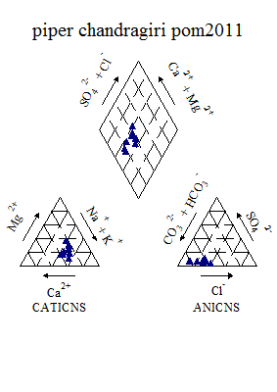

Figure 6.1k : Piper’s Classification of water (Post-monsoon, 2011)

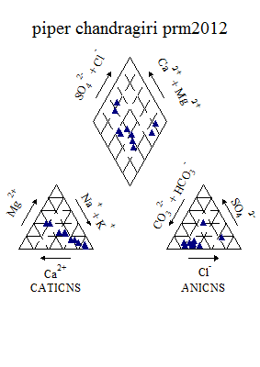

Figure 6.1l : Piper ‘s Classification of Water (Pre-monsoon, 2012)

The Piper-Hill diagram is used to infer hydrogeochemical facies. These plots include two triangles, one for plotting cations and the other for plotting anions. The cation and anion fields are combined to show a single point in a diamond shaped field from which inference is drawn on the basis of hydrogeochemical facies concept. The concept of hydrogeochemical facies was developed in order to understand and identify the water composition in different classes. Geochemical studies often involve synthesis and interpretation of a mass of analytical data. All the graphical methods use a limited number of parameters, usually a subset of the available data, unlike the statistical methods that can utilize all the available parameters. The Piper diagram (Piper, 1944) is the most widely used graphical form for geochemical classification. The diagram displays the relative concentrations of the major cations and anions on two separate trilinear plots, together with a central diamond plot where the points from the two trilinear plots are projected. The central diamond shaped field (quadrilateral field) is used to show overall chemical characters of the water. Back and Hanshaw (1965) defined subdivisions of the diamond field, which represent water type categories that form the basis for one common classification scheme for natural waters. The mixing of water from different sources or evolution path ways can also be illustrated by this diagram (Freeze and Cherry, 1979). Figure shows results of plotting the water samples collected during post-monsoon 2011 and pre-monsoon 2012.Employing the water classification scheme of Back and Hanshaw (1965), the samples are classified into a variety of water types including CaHCO3, NaCl, Mixed CaNaHCO3, Mixed CaMgCl, CaCl and NaHCO3. However, it is found that during the study period, the most dominating class is Mixed CaNaHCO3 followed by NaCl and CaHCO3.

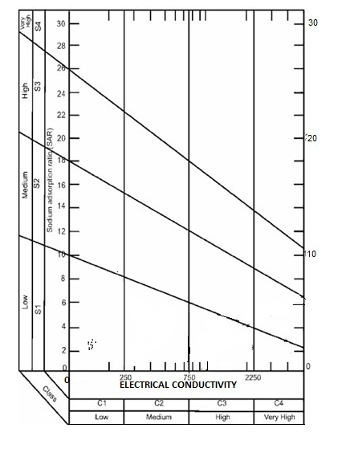

Figure 6.1m:Irrigation Classification of water (Post-monsoon 2011)

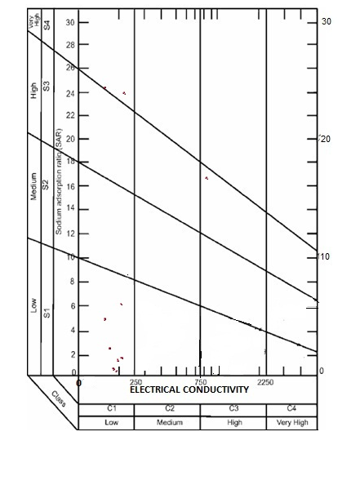

Figure 6.1n: Irrigation Classification of water (Pre-monsoon 2012)

The concentration and composition of dissolved constituents in the water determine its quality for irrigation use. Suitability of water for irrigation is mainly dependent on the effect of total dissolved solids and sodium content which adversely affects the soil quality and plant growth. The sodium hazard is typically expressed as the Sodium Adsorption Ratio (SAR). The SAR quantifies the proportion of sodium to calcium and magnesium ions in a sample. There is a significant relationship between SAR values of irrigation water and the extent to which sodium is absorbed by the soil. When the SAR and Specific conductance of water are known, the classification of the water for irrigation can be determined graphically by plotting these values on the US Salinity diagrams (USSL). The USSL diagram best explains the combined effect of sodium hazard and salinity hazard. Waters have been divided into C1, C2, C3 and C4 types on the basis of salinity hazard and S1, S2, S3, S4 types on the basis of sodium hazard. The significance and interpretations of quality ratings on the USSL diagram can be summarized as follows: (i) Low salinity water (C1) can be used for irrigation with most crops on most soils. (ii) Medium salinity water (C2) can be used if a moderate amount of leaching occurs. Plants with moderate salt tolerance can be grown in most instances without special practices of salinity control. (iii) High salinity water (C3) cannot be used on soils with restricted drainage. Even with adequate drainage, special management for salinity control may be required and plants with good salt tolerance should be selected. (iv)Very high salinity water (C4) is not suitable for irrigation under ordinary conditions, but may be used occasionally, under very special circumstances. The soil must be permeable, drainage must be adequate, irrigation water must be in excess to provide considerable leaching and salt tolerant crops should be selected. From the diagram, it reveals that, 70% of the samples fall under the fields of C1-S1 represents low sodium and low salinity during pre-monsoon and all the samples fall under the fields of C1-S1 during post-monsoon season. According to this the samples of the basin under study, belongs to low salinity and low sodium category.

**6.2. Valapattanam River Basin (Kannur district)**

**Valapattanam River** is the largest river in the [Kannur district](http://en.wikipedia.org/wiki/Kannur_district) of Kerala state. [Valapattam](http://en.wikipedia.org/wiki/Valapattam) town is located on its bank. Valapattanam River originates from the Brahmagiri Reserve Forest in Karnataka at an altitude of 900-1350m above mean sea level and drains into Kannur district. Major tributaries of this river are the Irikkur River,Sreekantapuram River, Bavali River, Veni River, and the Aralam River.

The water quality analysis carried out for Valapattanam river (figure 2a), showed that the quality varies considerably from season to season. One of the most interesting features is that, many of the cations and anions showed an increase from Pre-monsoon 2008 through post-monsoon and pre-monsoon 2009. However, the quality of the water remain within the permissible limits. Similar trend was observed in river Mahe also. This is attributed to the climatic conditions and alsodue to the tourism activities as it is a pilgrimage center of Lord Muthappan. The variation of various anions and cations are shown in figure below.

Figure 6.2a: Seasonal variation of water quality parameters in Valapattanam river

Figure 6.2b: Spatial variation of major cations along the river Valapattanam (Upstream to downstream) during Premonsoon 2008

Figure 6.2c: Spatial variation of major anions along the river Valapattanam (Upstream to downstream) during Premonsoon 2008

Figure 6.2d: Spatial variation of bacteriological parameters along the river Valapattanam (Upstream to downstream) during Premonsoon 2008

Figure 6.2e: Spatial variation of major cations along the river Valapattanam (Upstream to downstream) during Postmonsoon 2008

Figure 6.2f: Spatial variation of major anions along the river Valapattanam (Upstream to downstream) during Postmonsoon 2008

Figure 6.2g: Spatial variation of major cations along the river Valapattanam (Upstream to downstream) during Postmonsoon 2008

Figure 6.2h: Spatial variation of major cations along the river Valapattanam (Upstream to downstream) during Premonsoon 2009

Figure 6.2i: Spatial variation of major anions along the river Valapattanam (Upstream to downstream) during Premonsoon 2009

Figure 6.2j: Spatial variation of bacteriological parameteras along the river Valapattanam (Upstream to downstream) during Premonsoon 2009

Table 6.2a: Variation of Water Quality parameters in Valapattanam river during Post-monsoon 2011

|  |  |  |  |  |  |
| --- | --- | --- | --- | --- | --- |
| **2011** | **UNIT** | **Min** | **Max** | **Mean** | **Std dev** |
| **Temp** | **°C** | 22.40 | 26.30 | 24.31 | 1.16 |
| **Ph** | **-** | 7.30 | 8.05 | 7.73 | 0.24 |
| **Turbidity** | **NTU** | 1.00 | 5.00 | 3.50 | 1.35 |
| **EC** | **Micro Seimens/cm** | 46.40 | 78.40 | 57.25 | 8.44 |
| **TDS** | **Mg/l** | 33.00 | 55.70 | 40.58 | 6.03 |
| **Alkalinity** | **Mg/l** | 18.00 | 39.60 | 28.80 | 5.95 |
| **T H** | **Mg/l** | 8.00 | 40.00 | 22.00 | 8.94 |
| **Calcium** | **Mg/l** | 3.20 | 12.00 | 6.00 | 3.26 |
| **Magnesium** | **Mg/l** | 1.94 | 5.83 | 3.60 | 1.16 |
| **Chloride** | **Mg/l** | 8.18 | 16.36 | 13.97 | 2.73 |
| **Sodium** | **Mg/l** | 4.10 | 6.20 | 4.80 | 0.60 |
| **Potassium** | **Mg/l** | 0.55 | 1.34 | 0.82 | 0.24 |
| **Sulphate** | **Mg/l** | 1.40 | 6.00 | 2.93 | 1.52 |
| **Nitrate** | **Mg/l** | 0.06 | 0.29 | 0.16 | 0.06 |
| **Iron** | **Mg/l** | 0.05 | 0.06 | 0.05 | 0.01 |
| **Manganese** | **Mg/l** | 0.50 | 0.50 | 0.50 | 0.01 |
| **DO** | **Mg/l** | 7.00 | 10.13 | 8.85 | 0.95 |

Table 6.2b: Variation of Water quality parameters in Valapattanam during

Pre-monsoon 2012

|  |  |  |  |  |  |
| --- | --- | --- | --- | --- | --- |
| **2012** | **UNIT** | **Min** | **Max** | **Mean** | **Std dev** |
| **Temp** | **°C** | 26.60 | 31.50 | 27.74 | 1.57 |
| **Ph** | **-** | 5.86 | 656.00 | 60.52 | 187.53 |
| **Turbidity** | **NTU** | 1.00 | 2.00 | 1.50 | 0.53 |
| **EC** | **Micro Seimens/cm** | 74.60 | 167.00 | 97.62 | 24.54 |
| **TDS** | **Mg/l** | 53.00 | 121.00 | 69.61 | 18.06 |
| **Alkalinity** | **Mg/l** | 29.86 | 94.56 | 46.45 | 16.21 |
| **T H** | **Mg/l** | 16.00 | 60.00 | 26.33 | 11.11 |
| **Calcium** | **Mg/l** | 4.80 | 12.80 | 6.40 | 2.26 |
| **Magnesium** | **Mg/l** | 2.72 | 11.47 | 4.88 | 2.24 |
| **Bicarbonate** | **Mg/l** | 29.86 | 94.56 | 46.45 | 16.21 |
| **Chloride** | **Mg/l** | 8.02 | 16.04 | 12.70 | 2.32 |
| **Sodium** | **Mg/l** | 7.57 | 24.80 | 20.68 | 5.89 |
| **Potassium** | **Mg/l** | 4.29 | 10.37 | 9.27 | 2.26 |
| **Sulphate** | **Mg/l** | 2.56 | 6.60 | 4.06 | 1.30 |
| **Phosphate** | **Mg/l** | 0.64 | 0.64 | 0.64 | 1.05 |
| **Fluoride** | **Mg/l** | 0.02 | 0.06 | 0.05 | 0.02 |
| **Nitrate** | **Mg/l** | 0.16 | 0.24 | 0.20 | 0.03 |
| **DO** | **Mg/l** | 5.93 | 8.60 | 7.70 | 0.88 |
| **Bio COD** | **Mg/l** | 4.70 | 8.50 | 6.39 | 0.99 |
| **COD** | **Mg/l** | 48.00 | 96.00 | 66.67 | 14.61 |
| **Bacteriology** |  |  |  |  |  |
| **Total coliform** | **MPN/100ml** | 200.00 | 8400.00 | 2725.00 | 2540 |
| **E-Coli** | **MPN/100ml** | 100.00 | 500.00 | 255.56 | 133 |

Table 6.2c: Factor Analysis of Water Quality parameters of Valapattanam river

during Post-monsoon 2011

|  |  |  |  |  |
| --- | --- | --- | --- | --- |
| Sl.No. | Parameter | Factor 1 | Factor 2 | Factor 3 |
| 1 | Alkalinity | 0.901 | 0.229 | -0.022 |
| 2 | Total hardness | 0.261 | 0.849 | 0.287 |
| 3 | Chloride | 0.108 | 0.112 | -0.609 |
| 4 | EC | 0.919 | -0.085 | 0.223 |
| 5 | TDS | 0.920 | -0.100 | 0.228 |
| 6 | Iron | 0.353 | 0.102 | 0.771 |
| 7 | Potassium | -0.017 | -0.913 | 0.188 |
| 8 | Calcium | 0.770 | 0.295 | -0.268 |
| 9 | pH | -0.237 | 0.107 | 0.853 |
| 10 | Nitrate | 0.847 | 0.024 | -0.099 |
| 11 | Magnesium | 0.157 | 0.857 | 0.219 |
| 12 | Sulphate | -0.689 | 0.050 | 0.339 |
| 13 | Sodium | 0.321 | -0.817 | 0.264 |
| Eigen Value | | 4.769 | 3.662 | 2.224 |
| Fraction of variance, % | | 35.972 | 24.244 | 17.123 |
| Cumulative fraction of variance, % | | 35.972 | 60.216 | 77.339 |

Table 6.2d: Factor Analysis of Water Quality parameters of Valapattanam river

during Pre-monsoon 2012

|  |  |  |  |  |  |  |
| --- | --- | --- | --- | --- | --- | --- |
| Sl.No. | Parameter | Factor 1 | Factor 2 | Factor 3 | Factor 4 | Factor 5 |
| 1 | Alkalinity | 0.890 | 0.107 | 0.052 | -0.061 | 0.260 |
| 2 | Fluoride | 0.695 | 0.212 | -0.641 | -0.141 | 0.106 |
| 3 | Phosphate | -0.044 | 0.085 | 0.082 | 0.924 | 0.059 |
| 4 | Total hardness | 0.990 | 0.043 | 0.041 | 0.002 | 0.052 |
| 5 | Chloride | 0.381 | 0.628 | 0.143 | 0.520 | 0.095 |
| 6 | EC | 0.980 | -0.036 | -0.052 | 0.000 | 0.072 |
| 7 | TDS | 0.981 | -0.039 | -0.044 | 0.000 | 0.079 |
| 8 | Potassium | -0.014 | 0.982 | -0.094 | 0.038 | -0.023 |
| 9 | Calcium | 0.877 | -0.018 | -0.089 | 0.097 | 0.207 |
| 10 | Ph | -0.026 | 0.088 | -0.943 | -0.092 | 0.162 |
| 11 | Nitrate | 0.244 | 0.135 | 0.505 | -0.466 | 0.551 |
| 12 | Magnesium | 0.982 | 0.059 | 0.069 | -0.026 | -0.022 |
| 13 | Sulphate | -0.216 | 0.069 | 0.262 | -0.141 | -0.887 |
| 14 | Sodium | -0.043 | 0.987 | -0.079 | 0.001 | -0.025 |
| Eigen Value | | 6.452 | 2.500 | 1.677 | 1.291 | 1.041 |
| Fraction of variance, % | | 44.058 | 17.390 | 12.058 | 10.033 | 9.046 |
| Cumulative fraction of variance, % | | 44.058 | 61.448 | 73.506 | 83.539 | 92.585 |

During post-monsoon 2011, first three factors show Eigen values more than 1, thus these three factors are chosen for further analysis. Factor 1 of the post-monsoon season shows 35.97% variance. This factor has high positive loadings and strongly associated with EC and TDS (0.92), calcium (0.77),nitrate (0.84) and alkalinity (0.90). Factor 2 shows 24.24% variance. This factor has high positive loadings and strongly associated with total hardness (0.85) and magnesium (0.86) ions. Factor 3 shows 17.12% variance. This factor has high positive loadings and strongly associated with pH (0.85) and iron (0.77).

During pre-monsoon 2012, first five factors show Eigen values more than 1.Factor 1 shows 44.05% variance. This factor has high positive loadings and strongly associated with alkalinity (0.89), EC and TDS (0.98), total hardness (0.99), calcium (0.87), magnesium (0.98) and moderate loading on fluoride (0.69).Factor 2 shows 17.39% variance. This factor has high positive loadings and strongly associated with sodium and potassium (0.98) and moderate loading on chloride (0.62). Factor 3 shows 12.05% variance. This factor has high negative loadings on pH (0.94) and and moderate on nitrate (0.50). Factor 4 shows 10.03% variance. This has positive loadings on phosphate (0.92) and moderate on chloride (0.52). Factor 5 shows 9.046% variance and has high negative loadings on sulphate (0.88) and moderate positive loading on nitrate (0.55).

Table 6.2e: Overall CWQI and WQI Estimated values of Valapattanam basin for the selected station (2008-2012)

|  |  |  |  |  |  |  |
| --- | --- | --- | --- | --- | --- | --- |
| **Station** | **Methods of Analysis** | **Pre -monsoon 2008** | **Post -monsoon 2008** | **Pre - monsoon 2009** | **Post -monsoon 2011** | **Pre -monsoon 2012** |
| Anungode | WQI | 63.44 | 69.50 | 79.67 | 76.39344 | 59.01639 |
| CCME(WQI) | 89 | 90 | 92 | 80 | 77 |
| Aralamkaadavu | WQI | 71.63934 | 72.62295 | 69.18033 | 66.55738 | 60.65574 |
| CCME(WQI) | 91 | 82 | 66 | 68 | 68 |
| Irikkur | WQI | 74.91803 | 80 | 75.2459 | 72.78689 | 59.83607 |
| CCME(WQI) | 78 | 83 | 74 | 74 | 78 |
| Iritty | WQI | 71.47541 | 65.7377 | 71.96721 | 66.88525 | 61.47541 |
| CCME(WQI) | 90 | 72 | 64 | 76 | 77 |
| Keezhur | WQI | 78.85246 | 71.96721 | 77.54098 | - | - |
| CCME(WQI) | 81 | 84 | 82 | - | - |
| Kootupuzha | WQI | 82.29508 | 79.67213 | 78.85246 | 74.42623 | 62.62295 |
| CCME(WQI) | 92 | 78 | 60 | 77 | 80 |
| Kottiyoor | WQI | 71.31148 | 73.11475 | 80.98361 | 69.01639 | 53.27869 |
| CCME(WQI) | 90 | 78 | 83 | 74 | 73 |
| Nuchiyad | WQI | 64.59016 | 75.40984 | 71.80328 | 69.01639 | 66.39344 |
| CCME(WQI) | 90 | 78 | 74 | 72 | 89 |
| Palapuzha | WQI | 79.83607 | 77.37705 | 71.63934 | 70.16393 | 54.09836 |
| CCME(WQI) | 80 | 92 | 83 | 85 | 77 |
| Pattiam | WQI | - | 65.2459 | 67.86885 | - | - |
| CCME(WQI) | - | 69 | 72 | - | - |
| Payyavm | WQI | 76.06557 | 72.95082 | 70 | 71.80328 | 65.2459 |
| CCME(WQI) | 91 | 81 | 69 | 76 | 78 |
| Pazhassy | WQI | 80.32787 | 74.2623 | 73.44262 | - | - |
| CCME(WQI) | 76 | 81 | 80 | 78 | 75 |
| Pazhassy dam | WQI | 77.37705 | 82.95082 | 78.85246 | 64.2623 | 61.14754 |
| CCME(WQI) | 91 | 81 | 81 |  |  |
| Peravoor | WQI | 65.40984 | 77.21311 | 78.36066 | 66.72131 | 52.45902 |
| CCME(WQI) | 79 | 80 | 82 | 90 | 72 |
| Valavupura | WQI | 69.34426 | 77.86885 | 71.14754 | - | - |
|  | CCME(WQI) | 90 | 63 | 65 | - | - |
|  |  |  |  |  |  |  |

|  |  |  |  |  |  |  |  |
| --- | --- | --- | --- | --- | --- | --- | --- |
| Table 6.2f: CCME Score/rating of Valapattanam river during pre-monsoon (2008-2012) | | | | | | | |
| Data Summary | year | Overall | Drinking | Aquatic | Recreation | Irrigation | Livestock |
| CWQI | **2008** | 80 | 83 | 56 | 100 | 100 | 100 |
|  | **2009** | 64 | 60 | 56 | 100 | 81 | 85 |
|  | **2012** | 62 | 60 | 28 | 24 | 100 | 100 |
| **F1 (Scope)** | **2008** | 30 | 29 | 67 | 0 | 0 | 0 |
|  | **2009** | 50 | 57 | 67 | 0 | 33 | 25 |
|  | **2012** | 33 | 33 | 67 | 100 | 0 | 0 |
| **F2 (Frequency)** | **2008** | 15 | 6 | 36 | 0 | 0 | 0 |
|  | **2009** | 22 | 18 | 35 | 0 | 2 | 5 |
|  | **2012** | 27 | 20 | 74 | 8 | 0 | 0 |
| **F3 (Amplitude)** | **2008** | 7 | 7 | 9 | 0 | 0 | 0 |
|  | **2009** | 30 | 36 | 10 | 0 | 1 | 5 |
|  | **2012** | 49 | 58 | 74 | 86 | 0 | 0 |

|  |  |  |  |  |  |  |  |
| --- | --- | --- | --- | --- | --- | --- | --- |
| **Table 6.2g: CCME Score/rating of Valapattanam river during post-monsoon (2008-2012)** | | | | | | | |
| **Data Summary** | **year** | **Overall** | **Drinking** | **Aquatic** | **Recreation** | **Irrigation** | **Livestock** |
| **CWQI** | **2008** | **72** | **71** | **52** | **100** | **100** | **86** |
|  | **2011** | **75** | **72** | **74** | **100** | **80** | **100** |
| **F1 (Scope)** | **2008** | 40 | 43 | 67 | 0 | 0 | 25 |
|  | **2011** | 30 | 29 | 33 | 0 | 33 | 0 |
| **F2 (Frequency)** | **2008** | 22 | 16 | 49 | 0 | 0 | 2 |
|  | **2011** | 18 | 16 | 30 | 0 | 6 | 0 |
| **F3 (Amplitude)** | **2008** | 18 | 22 | 8 | 0 | 0 | 0 |
|  | **2011** | 26 | 35 | 4 | 0 | 9 | 0 |

In general, it is observed that the water quality of Valapattanam river shows the signs of degradation especially along the downstream reaches. It is a fact that the downstream region is mostly affected by saline waters through the estuary. It is also noticed that the 75% of the stations found contaminated with E.Coli. Classification of different stations in Valapattanam river reveals that all the stations fall under the class D due to higher values of BOD. This clearly indicates that the water needs primary treatment to use for drinking purpose. The WQI also indicates a steady decline of water quality in the river which is believed to be due to the man-made disturbances in the catchment and adjoining areas.

Apart from Valapattanam, Thalassery river is one of the seven rivers in [Kannur District](http://www.india9.com/i9show/-Kerala/Kannur-District-14096.htm) of [Kerala](http://www.india9.com/i9show/-Kerala/Kerala-27636.htm). It has its origin on the western cliffs of Kunnoth forest. This river joins the [Arabian Sea](http://www.india9.com/i9show/-Kerala/Arabian-Sea-46127.htm) at Mannayad.A preliminary observations of water quality in the above river showed a drastic change in the characteristic particularly during post-monsoon season. The electrical conductivity, total dissolved solids and chloride concentration has gone above the permissible limits during the post-monsoon. However, during the pre-monsoon all the parameters are much below the permissible limits. It is also noted that the turbidity is quite high in the river during the post-monsoon indicating a higher discharge and sediment load. The contrasting behavior in two seasons is an indication of seasonality of the river flow. In Thalassery, Moolakadavu showed a very high electrical conductivity (5670 µS/cm). The corresponding TDS observed was 3629 mg/l. The hardness of the water was also considerably high (800 mg/l). Apart from this very high concentration of Chloride (1552 mg/l) and sulphate (2900 mg/l) were also recorded in this area. All the higher concentration of the said parameters indicates the presence of salt water in this part of the study area.

Mahe river is one of the important river flowing through the historical town of Mahe. The average concentration of water quality parameters showed a slightly alkaline nature and also there was an increase in EC values from season to season. Chloride concentration also varied considerably. However, all the parameters were found to be within the permissible limits.

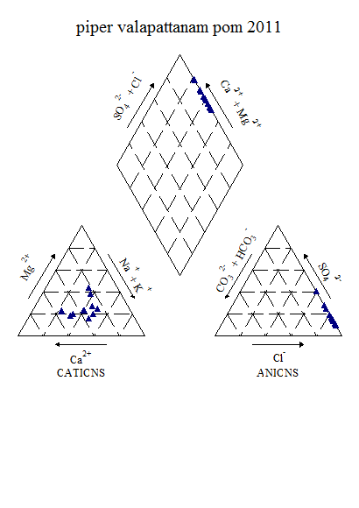

Figure 6.2k: Piper’s Classification of Valapattanam river water

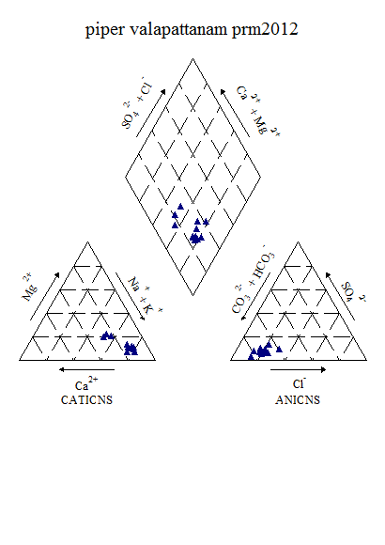

**Figure 6.2l: Piper’s Classification of Valapattanam river water**

Figure 6.2l shows results of plotting the water samples collected during post-monsoon 2011 and pre-monsoon 2012. From the piper trilinear diagram, it is found that during the study period, the most dominating class is CaCl during post-monsoon 2011 and during pre-monsoon 2012, the most dominating type is NaHCO3.

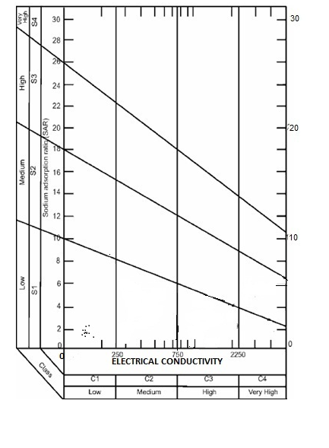

**Figure 6.2m: USSL Classification of Valapattanam river water (post-monsoon, 2011)**

From the diagram, it reveals that, all the samples fall under the fields of C1-S1 represents low sodium and low salinity during post-monsoon 2011 and pre-monsoon 2012 season. According to this the samples of the basin under study, belongs to low salinity and low sodium category.

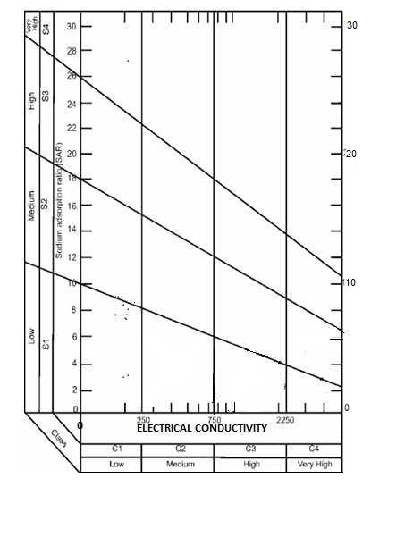

Figure 6.2n: USSL Classification of Valapattanam river water (pre-monsoon, 2012)

**6.3Bharathapuzha River Basin**

Bharathappuzha also known as the River Nila, is the second longest river (209 km) in Kerala, after the [Periyar River](http://en.wikipedia.org/wiki/Periyar_River). The word "Nila" indicates the culture more than just a river. The headwaters of the main tributary of Bharathappuzha originates in the Anaimalai hills in the Westernghats and flows westward with many tributaries joining it, including the Tirur river. For the first 40 km or so, the Bharathapuzha follows an almost northerly course till Pollachi near Coimbatore. At Parli, the Kannadipuzha and Kalpathipuzha merge and flow as Bharathappuzha, following a westerly course until it empties into the Arabian sea at Ponnani. At Thiruvilwamala, Gayathripuzha merges with the river. The Thootha river merges with the Nila at Pallipuram. As the Thootha River is rich in water, after its merger, the Nila becomes thicker in flow.

The surface water quality data pertaining to Bharathapuzha, Keechery and Bhavani River basins showed considerable variations from Pre-monsoon to Post-monsoon seasons. In all locations, the water was colorless except at Thrithala and Pattambi under Bharathapuzha basin. It was found that the major cause of concern is the concentration of sediments for the change in color. The acidity and alkalinity results of the analysis indicated that both the parameters observed were well within the permissible limits. The bacteriological report showed that the total coliform was the major problem in most of the sampling locations. The total coliform count exceeded more than +1100 in many places. Among the major two tributaries, Gayathripuzha indicated high content of total coliform compared to the water from the other tributary, Thuthupuzha.

Based on water quality analysis and the reports from the public, it can be confirmed that sea water ingression reached up to 8 km during the non-monsoon period and such saline water intrusion is negligible during the monsoon period due to the influx of monsoon flood in plenty. During monsoon period the water was fresh. Chemical constituents such as pH, conductivity, DO, bicarbonate, chloride, Hardness, fluoride, Ca, Mg, Na, K and TDS exhibited higher range of concentrations during pre-monsoon periods. All chemical constituents exhibited wide seasonal and regional variations. Major cations and anions showed enrichment in non-monsoon season while nutrients, sulphate, dissolved iron and total suspended solids showed higher concentration in monsoon period. This could be attributed to various reasons such as less dilution of chemical constituents due to the absence of free flow of water which also resulted in greater contact between water and soil in the river, high temperature in summer period, greater use of river water for bathing and laundry purposes during non-monsoon than monsoon season.

The high concentration of nutrients and TSS observed during the monsoon and post-monsoon season originates from geological weathering, agriculture activities together with the heavy flow monsoon water that washed through the agriculture lands of the drainage basin. The various physico-chemical constituents of the river water fall within the prescribed limits of Indian standard (BIS) and WHO standards. It was also observed that iron is one of the important constituent in river waters of Bharathapuzha and Keecheri basins. The concentration of iron varied between 0.6 mg/l and 3.44 mg/l. The presence of Phosphates was also noticed in some of the locations particularly at Puzhakkal and Kanjirapudu. Most significant observation in this region is about the presence of Fluoride in surface water at Pattambi during Post-monsoon season. The concentration was more than 3 mg/l.Figures below shows the variation of water quality during the study period.

Figure 6.3a: Seasonal variation of water quality parameters in Bharathapuzha river

Figure 6.3b: Spatial variation of major cations along the river Bharathapuzha (Upstream to downstream) during Premonsoon 2008

Figure6. 3c: Spatial variation of major anions along the river Bharathapuzha (Upstream to downstream) during Premonsoon 2008

Figure 6.3d: Spatial variation of bacteriological parameters along the river Bharathapuzha (Upstream to downstream) during Premonsoon 2008

Figure 6.3e: Spatial variation of major cations along the river Bharathapuzha (Upstream to downstream) during Postmonsoon 2008

Figure 6.3f: Spatial variation of major anions along the river Bharathapuzha (Upstream to downstream) during Postmonsoon 2008

Figure 6.3g: Spatial variation of bacteriological parameters along the river Bharathapuzha (Upstream to downstream) during Postmonsoon 2008

Figure 6.3h: Spatial variation of major cations along the river Bharathapuzha (Upstream to downstream) during Premonsoon 2009

Figure 6.3i: Spatial variation of major anions along the river Bharathapuzha (Upstream to downstream) during Premonsoon 2009

Figure 6.3j: Spatial variation of bacteriological parameters along the river Bharathapuzha (Upstream to downstream) during Pre-monsoon 2009

Further observations on individual stations in Palakkad region (Bharathapuzha and Bhavani River Basins) showed a drastic change in certain water quality parameters particularly, the electrical conductivity. The maximum electrical conductivity observed was 1110 µS/cm at Kanjikode followed by Chullimada (1050 µS/cm). Similar variation was also found in the case of Total Dissolved Solids. Turbidity values also increased in some of the locations. The maximum turbidity observed was at Plazhy (% NTU). Further, it was observed that, water was acidic in few of the locations (maximum was observed at Chulliyar). Significant quantities of chlorides were also present in some of the places. Highest concentration was observed at Chullmada (310 mg/l).

It is very important to high light the presence of fluorides in surface water. The maximum concentration was observed at 1.95 mg/l at Meenakara. Vitthanassery also showed a higher concentration of fluoride (1.85 mg/l). Phosphates were also appeared in many locations. The maximum was observed at Chulliyar (0.4 mg/l). During the Post-monsoon, though there was a dilution effect on various parameters, the variation from Pre-monsoon to Post-monsoon was marginal. Total coliforms were also considerably high in this region.

In order to verify the results further on the quality of water in the river, observations continued during post-monsoon 2011 and pre-monsoon 2012 for specific locations based on the available results and also based on field information. Basic statistical parameters are shown below (Table 3a & 3b).

**Table 6.3a: Variation of Water Quality parameters in Bharathapuzha river**

**during Post-monsoon 2011**

|  |  |  |  |  |  |  |  |
| --- | --- | --- | --- | --- | --- | --- | --- |
| **Parameters** | **UNIT** | **MIN** | | **MAX** | **Mean** | | **Std dev** |
| **Temp** | **°C** | 25.00 | | 30.00 | 27.03 | | 1.63 |
| **PH** |  | 6.56 | | 7.89 | 7.16 | | 0.40 |
| **Turbidity** | **NTU** | 3.40 | | 27.20 | 10.49 | | 7.90 |
| **EC** | **Micro Seimens** | 63.90 | | 1254.00 | 303.74 | | 292.23 |
| **TDS** | **Mg/l** | 33.56 | | 669.20 | 159.78 | | 155.09 |
| **Alkalinity** | **Mg/l** | 22.00 | | 398.00 | 102.60 | | 95.74 |
| **Acidity** | **Mg/l** | 2.00 | | 10.00 | 3.77 | | 2.37 |
| **TH** | **Mg/l** | 16.00 | | 410.00 | 105.20 | | 103.36 |
| **Calcium** | **Mg/l** | 6.00 | | 44.00 | 20.60 | | 12.24 |
| **Magnesium** | **Mg/l** | 2.43 | | 91.37 | 20.56 | | 22.80 |
| **Bicarbonate** | **Mg/l** | 22.00 | | 398.00 | 102.60 | | 95.74 |
| **Chloride** | **Mg/l** | 12.50 | | 162.50 | 38.74 | | 35.78 |
| **Sodium** | **Mg/l** | 4.36 | | 126.00 | 25.24 | | 30.52 |
| **Potassium** | **Mg/l** | 1.10 | | 9.79 | 2.92 | | 1.84 |
| **Sulphate** | **Mg/l** | 0.30 | | 32.80 | 6.92 | | 10.92 |
| **Phosphate** | **Mg/l** | 0.04 | | 0.55 | 0.08 | | 0.11 |
| **Fluoride** | **Mg/l** | 0.18 | | 1.95 | 0.54 | | 0.31 |
| **Nitrate** | **Mg/l** | 0.16 | | 0.72 | 0.47 | | 0.18 |
| **Iron** | **Mg/l** | 0.07 | | 1.60 | 0.73 | | 0.42 |
| **DO** | **Mg/l** | 6.80 | | 9.00 | 7.68 | | 0.66 |
| **Bio COD** | **Mg/l** | 0.20 | | 3.50 | 1.48 | | 0.85 |
| **COD** | **Mg/l** | 2.00 | | 14.00 | 6.13 | | 3.96 |
| **Bacteriology** |  |  |  | | |  |  |
| **Total Coliform** | **MPN/100ml** | 1200.00 | 4600.00 | | | 2770.00 | 1209.22 |
| **E-Coli** | **MPN/100ml** | 70.00 | 930.00 | | | 293.50 | 218.40 |

**Table 6.3b: Variation of Water Quality parameters in Bharathapuzha river**

**during Pre-monsoon 2012**

|  |  |  |  |  |  |  |  |
| --- | --- | --- | --- | --- | --- | --- | --- |
| **Parameters** | **UNIT** | **MIN** | | **MAX** | **Mean** | | **Std dev** |
| **Temp** | **°C** | 29.00 | | 37.00 | 32.20 | | 2.63 |
| **Ph** |  | 6.44 | | 8.32 | 7.20 | | 0.52 |
| **Turbidity** | **NTU** | 1.00 | | 20.90 | 5.72 | | 5.51 |
| **EC** | **Micro Seimens** | 65.32 | | 920.00 | 267.67 | | 235.90 |
| **TDS** | **Mg/l** | 36.07 | | 497.80 | 147.31 | | 128.09 |
| **Alkalinity** | **Mg/l** | 20.00 | | 196.00 | 76.10 | | 56.60 |
| **Acidity** | **Mg/l** | 2.00 | | 15.00 | 6.60 | | 3.38 |
| **T H** | **Mg/l** | 20.00 | | 244.00 | 80.10 | | 63.94 |
| **Calcium** | **Mg/l** | 4.01 | | 60.12 | 17.59 | | 12.56 |
| **Magnesium** | **Mg/l** | 2.91 | | 44.10 | 15.16 | | 12.65 |
| **carbonate** | **Mg/l** | 45.00 | | 45.00 | 45.00 | | #DIV/0! |
| **Bicarbonate** | **Mg/l** | 20.00 | | 196.00 | 73.85 | | 53.30 |
| **Chloride** | **Mg/l** | 5.00 | | 130.00 | 32.65 | | 33.19 |
| **Sodium** | **Mg/l** | 2.76 | | 66.50 | 13.72 | | 14.53 |
| **Potassium** | **Mg/l** | 1.18 | | 14.36 | 3.77 | | 3.42 |
| **Sulphate** | **Mg/l** | 1.61 | | 35.29 | 10.29 | | 9.04 |
| **Phosphate** | **Mg/l** | 0.02 | | 0.61 | 0.06 | | 0.13 |
| **Fluoride** | **Mg/l** | 0.02 | | 0.80 | 0.43 | | 0.25 |
| **Nitrate** | **Mg/l** | 0.15 | | 3.03 | 0.60 | | 0.66 |
| **Iron** | **Mg/l** | 0.02 | | 0.77 | 0.19 | | 0.20 |
| **DO** | **Mg/l** | 4.50 | | 8.60 | 6.99 | | 1.28 |
| **Bio COD** | **Mg/l** | 1.00 | | 52.50 | 5.88 | | 11.12 |
| **COD** | **Mg/l** | 8.00 | | 820.00 | 67.80 | | 179.28 |
| **Bacteriology** |  |  |  | | |  |  |
| **E-Coli** | **MPN/100ml** | 3.00 | 240.00 | | | 62.47 | 56.72 |

Table 6.3c: Factor Analysis results of Bharathapuzha river during post-monsoon 2011

|  |  |  |  |  |
| --- | --- | --- | --- | --- |
| Sl.No. | Parameter | Factor 1 | Factor 2 | Factor 3 |
| 1 | Alkalinity | 0.992 | 0.020 | 0.022 |
| 2 | Fluoride | 0.895 | -0.129 | -0.355 |
| 3 | Phosphate | 0.058 | 0.923 | 0.069 |
| 4 | Total hardness | 0.991 | 0.003 | -0.012 |
| 5 | Chloride | 0.972 | -0.029 | 0.131 |
| 6 | EC | 0.996 | 0.033 | 0.032 |
| 7 | TDS | 0.996 | 0.031 | 0.037 |
| 8 | Iron | -0.480 | 0.719 | -0.248 |
| 9 | Potassium | 0.892 | 0.139 | 0.211 |
| 10 | Calcium | 0.793 | 0.090 | -0.424 |
| 11 | pH | 0.700 | 0.168 | -0.030 |
| 12 | Nitrate | 0.393 | -0.065 | -0.803 |
| 13 | Magnesium | 0.988 | -0.008 | 0.044 |
| 14 | Sulphate | 0.852 | 0.090 | 0.363 |
| 15 | Sodium | 0.977 | -0.007 | 0.121 |
| Eigen Value | | 10.654 | 1.458 | 1.231 |
| Fraction of variance, % | | 63.387 | 10.326 | 15.233 |
| Cumulative fraction of variance, % | | 63.387 | 73.713 | 88.946 |

Table 6.3d: Factor Analysis results of Bharathapuzha during pre-monsoon (2012)

|  |  |  |  |  |
| --- | --- | --- | --- | --- |
| Sl.No. | Parameter | Factor 1 | Factor 2 | Factor 3 |
| 1 | Alkalinity | 0.427 | 0.418 | 0.760 |
| 2 | Fluoride | 0.584 | 0.552 | 0.168 |
| 3 | Phosphate | 0.756 | -0.501 | -0.022 |
| 4 | Total hardness | 0.920 | 0.095 | 0.325 |
| 5 | Chloride | 0.914 | 0.124 | 0.070 |
| 6 | EC | 0.951 | 0.154 | 0.253 |
| 7 | TDS | 0.953 | 0.151 | 0.246 |
| 8 | Iron | 0.216 | -0.717 | 0.304 |
| 9 | Potassium | 0.954 | -0.174 | 0.099 |
| 10 | Calcium | 0.882 | -0.164 | 0.303 |
| 11 | pH | 0.204 | 0.800 | 0.155 |
| 12 | Nitrate | 0.139 | -0.171 | 0.904 |
| 13 | Magnesium | 0.908 | 0.152 | 0.327 |
| 14 | Sulphate | 0.845 | 0.057 | 0.118 |
| 15 | Sodium | 0.858 | 0.367 | 0.179 |
| Eigen Value | | 9.526 | 2.112 | 1.255 |
| Fraction of variance, % | | 57.492 | 14.690 | 13.521 |
| Cumulative fraction of variance, % | | 57.492 | 72.182 | 85.703 |

During post-monsoon 2011, first three factors show Eigen values more than 1, thus these three factors are chosen for further analysis. Factor 1 shows 63.38% variance. This factor has high positive loadings and strongly associated with pH (0.70), EC and TDS (0.99), calcium (0.79), magnesium (0.98), sodium (0.97), potassium (0.89), total hardness (0.99), sulphate (0.85), chloride (0.97) and fluoride (0.89). Factor 2 shows 10.32% variance. This factor has high positive loadings and strongly associated with phosphate (0.92) and iron (0.71). Factor 3 shows 15.23% variance. This factor has negative loadings with nitrate (0.80).

During pre-monsoon 2012, first three factors show Eigen values more than 1.Factor 1 shows 57.49% variance. This factor has high positive loadings and strongly associated with EC and TDS (0.95), calcium (0.88), magnesium (0.90), sodium (0.86), potassium (0.95), total hardness (0.92), sulphate (0.84), phosphate (0.76), chloride (0.91) and moderately on fluoride (0.58). Factor 2 shows 14.69% variance. This factor has high positive loadings and strongly associated with pH(0.80) and moderately on fluoride (0.55). Factor 3 shows 13.52% variance. This factor has high positive loadings and strongly associated with nitrate (0.90) and alkalinity (0.76).

Table 6.3e. Overall CWQI and WQI Estimated values of Bharathapuzha basin for the

selected station (2008-2012)

|  |  |  |  |  |  |  |
| --- | --- | --- | --- | --- | --- | --- |
| **Station** | **Methods** | **Pre -monsoon 2008** | **Post -monsoon 2008** | **Pre - monsoon 2009** | **Post -monsoon 2011** | **Pre -monsoon 2012** |
| Alathur | WQI | 65.90164 | 82.45902 | 76.72131 | 73.27869 | 71.47541 |
| CCME(WQI) | 58 | 69 | 52 | 56 | 72 |
| Cheerakuzhy | WQI | 73.60656 | 78.03279 | 74.7541 | 76.39344 | 71.96721 |
| CCME(WQI) | 67 | 46 | 68 | 63 | 72 |
| Cheruthuruthy | WQI | 76.39344 | 79.01639 | 73.27869 | 80.65574 | 78.68852 |
| CCME(WQI) | 72 | 50 | 71 | 71 | 67 |
| Chittady | WQI | 82.95082 | 80.65574 | 76.06557 | 78.03279 | 73.60656 |
| CCME(WQI) | 80 | 41 | 61 | 53 | 51 |
| Chittoor | WQI | 67.37705 | 77.54098 | 78.85246 | 66.55738 | 78.52459 |
| CCME(WQI) | 77 | 40 | 90 | 58 | 68 |
| Chuliyar | WQI | 58.68852 | 72.78689 | 74.2623 | - | - |
| CCME(WQI) | 46 | 55 | 77 | - | - |
| Chullimada | WQI | 68.85246 | 70.16393 | - | 74.2623 | 59.01639 |
| CCME(WQI) | 50 | 68 | - | 66 | 52 |
| Kalpathy | WQI | 70.65574 | 68.03279 | 70.16393 | 72.95082 | 81.80328 |
| CCME(WQI) | 63 | 69 | 76 | 62 | 80 |
| Kanjikode | WQI | 56.55738 | 65.57377 | 74.2623 | 66.39344 | 66.55738 |
| CCME(WQI) | 44 | 68 | 69 | 52 | 76 |
| Kanjirapuzha | WQI | - | - | 81.63934 | - | - |
| CCME(WQI) | - | - | 82 | - | - |
| Karalmanna | WQI | - | - | - | 77.37705 | 89.83607 |
| CCME(WQI) | - | - | - | 63 | 83 |
| Karimpuzha | WQI | - | - | - | 78.68852 | 75.08197 |
| CCME(WQI) | - | - | - | 66 | 91 |
| Koodallur | WQI | - | - | - | 76.55738 | 86.39344 |
| CCME(WQI) | - | - | - | 65 | 83 |
| Kuttippuram | WQI | 63.93443 | 75.57377 | 71.47541 | - | - |
| CCME(WQI) | 73 | 33 | - | - | - |
| Malampuzha Dam | WQI | 61.47541 | 75.08197 | 76.55738 | - | - |
| CCME(WQI) | 61 | 70 | 77 | - | - |
| Mangalam Dam | WQI | 76.72131 | 81.63934 | 73.44262 | 73.77049 | 76.55738 |
| CCME(WQI) | 55 | 71 | 67 | 48 | 76 |
| Mangalam Wadakkanchery | WQI | 80.16393 | 81.14754 | 76.22951 | - | - |
| CCME(WQI) | 65 | 61 | 77 | - | - |
| Meenkara | WQI | 67.70492 | 82.78689 | 66.39344 | - | - |
| CCME(WQI) | 52 | 72 | 55 | - | - |
| Ottappalam | WQI | 76.55738 | 64.42623 | 78.85246 | 79.34426 | 74.42623 |
| CCME(WQI) | 72 | 65 | 78 | 69 | 82 |
| Pampady | WQI | 77.04918 | 78.03279 | 75.57377 | 71.14754 | 80.4918 |
| CCME(WQI) | 69 | 54 | 89 | 57 | 76 |
| Parali | WQI | 70.81967 | 69.67213 | 77.86885 | 69.83607 | 79.34426 |
| CCME(WQI) | 62 | 68 | 78 | 51 | 80 |
| Pattambi | WQI | 67.40492 | 77.86885 | 68.85246 | 76.55738 | 83.77049 |
| CCME(WQI) | 60 | 72 | 40 | 70 | 81 |
| Plazhy | WQI | 69.67213 | 76.55738 | 65.90164 | - | - |
| CCME(WQI) | 44 | 80 | 40 | - | - |
| Pothundy | WQI | 79.5082 | 75.57377 | 85.08197 | - | - |
| CCME(WQI) | 64 | 70 | 78 | - | - |
| Pulamanthole | WQI | 73.44262 | 82.29508 | 87.86885 | 77.37705 | 82.95082 |
| CCME(WQI) | 82 | 68 | 73 | 67 | 82 |
| Thathamangalam | WQI | 89.5082 | 79.67213 | 77.21311 | - | - |
| CCME(WQI) | 74 | 40 | 89 | - | 77 |
| Thiruvegapura | WQI | 65.90164 | 78.03279 | 83.93443 | 68.19672 | 83.93443 |
| CCME(WQI) | 79 | 70 | 89 | 63 |  |
| Thrippalur | WQI | 72.45902 | 81.14754 | 69.01639 | - | - |
| CCME(WQI) | 61 | 71 | 55 | - | - |
| Thrithala | WQI | 75.2459 | 71.63934 | 78.68852 | - | - |
| CCME(WQI) | 70 | 71 | 89 | - | - |
| Vandazhy | WQI | 73.44262 | 69.83607 | 74.42623 | 74.2623 | 70.98361 |
| CCME(WQI) | 57 | 33 | 57 | 48 | 65 |
| Vithnassery | WQI | 71.96721 | 63.93443 | 75.40984 | 76.72131 | 72.45902 |
| CCME(WQI) | 59 | 59 | 81 | 76 | 65 |
| Walayar Dam | WQI | 70.32787 | 78.52459 | 76.88525 | - | - |
| CCME(WQI) | 48 | 71 | 70 | - | - |

|  |  |  |  |  |  |  |  |
| --- | --- | --- | --- | --- | --- | --- | --- |
| **Table 6.3f: CCME Score of Bharathapuzha (pre-monsoon, 2008-2012)** | | | | | | | |
| **Data Summary** | **year** | **Overall** | **Drinking** | **Aquatic** | **Recreation** | **Irrigation** | **Livestock** |
| **CWQI** | **2008** | 46 | 39 | 32 | 100 | 70 | 88 |
|  | **2009** | 56 | 53 | 46 | 100 | 75 | 76 |
|  | **2012** | 62 | 64 | 52 | 100 | 81 | 100 |
| **F1 (Scope)** | **2008** | 64 | 75 | 100 | **0** | 50 | 20 |
|  | **2009** | 50 | 57 | 75 | **0** | 25 | 25 |
|  | **2012** | 50 | 43 | 75 | **0** | 33 | 0 |
| **F2 (Frequency)** | **2008** | 31 | 30 | 51 | **0** | 10 | 5 |
|  | **2009** | 23 | 18 | 35 | **0** | 3 | 3 |
|  | **2012** | 23 | 18 | 32 | **0** | 4 | 0 |
| **F3 (Amplitude)** | **2008** | 61 | 67 | 36 | **0** | 8 | 3 |
|  | **2009** | 52 | 56 | 44 | **0** | 36 | 34 |
|  | **2012** | 36 | 43 | 13 | **0** | 0 | 0 |

|  |  |  |  |  |  |  |  |
| --- | --- | --- | --- | --- | --- | --- | --- |
| **Table 6.3g. CCME scores of Bharathapuzha (post-monsoon, 2008,2011)** | | | | | | | |
| **Data Summary** | **year** | **Overall** | **Drinking** | **Aquatic** | **Recreation** | **Irrigation** | **Livestock** |
| **CWQI** | **2008** | **41** | **37** | **19** | **100** | **50** | **49** |
|  | **2011** | **53** | **56** | **57** | **100** | **61** | **85** |
| **F1 (Scope)** | **2008** | 55 | 62 | 100 | 0 | 25 | 40 |
|  | **2011** | 50 | 29 | 50 | **0** | 67 | 25 |
| **F2 (Frequency)** | **2008** | 33 | 32 | 56 | **0** | 2 | 6 |
|  | **2011** | 32 | 29 | 47 | **0** | 5 | 3 |
| **F3 (Amplitude)** | **2008** | 80 | 82 | 82 | **0** | 83 | 78 |
|  | **2011** | 55 | 63 | 31 | **0** | 1 | 0 |

The river went through a series of challenges which saw its degradation that has reached a point of no return. People started making the river dirty and left it in the mouth of death. Bharathapuzha is now dirty because of the actions of we human beings. The river gets lifeless due to we human beings. The river water got dirty and it is not now potable. Until a few decades back the river used to flow effortlessly during even intense summer. However, due to the sand mining in the last 30 years, the thick sand bed has been completely vanished and has been replaced with grasses and bushes which has become an environmental catastrophe. At the peak of the sand mining period of mid 1990s at least 40-50 lorries carrying tons of pristine sand was a common sight at each 'kadavu' (entrance to the river) of the river every day. Considering the hundreds of the 'kadavu' throughout its length, the amount of sand mined in these years is unimaginable. Today, with almost no sand in many parts of the river, people have started mining sand from underwater which has become a profitable business for many.

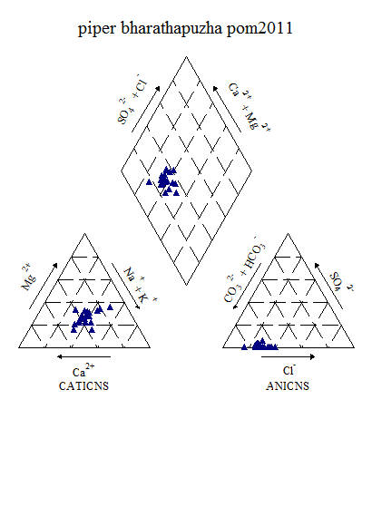

Figure6.3k : Piper’s Classification of Bharathapuzha river (post-monsoon 2011)

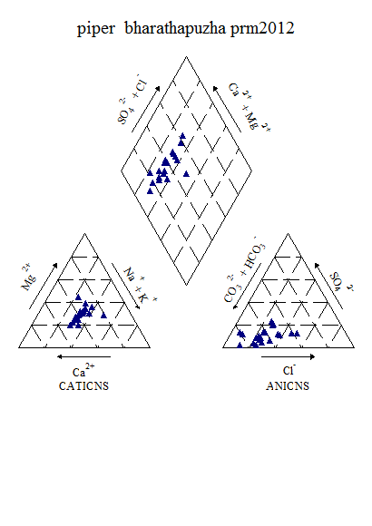

Figure6.3l : Piper’s Classification of Bharathapuzha river (pre-monsoon 2012)

From the piper diagram, it shows during post-monsoon 2011 the most dominating water type is CaHCO3 and during pre-monsoon 2012 is CaHCO3 followed by mixed CaMgCl type.

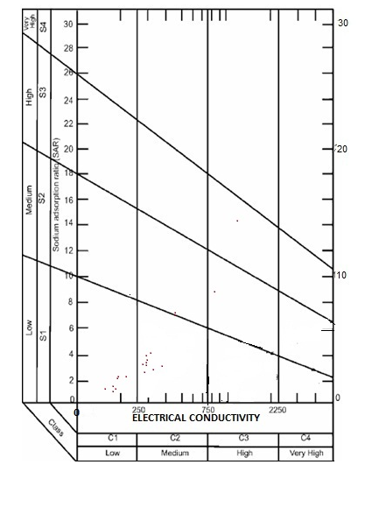

Figure 6.3m:USSL Classification of Bharathapuzha (post-monsoon, 2011)

From the USSL classification, during post-monsoon 2011, water fall under C1S1, C2S2 and C3S3 and belongs to low to high sodium and low salinity to high salinity category. Also, The same trend is noticed during pre-monsoon 2012.

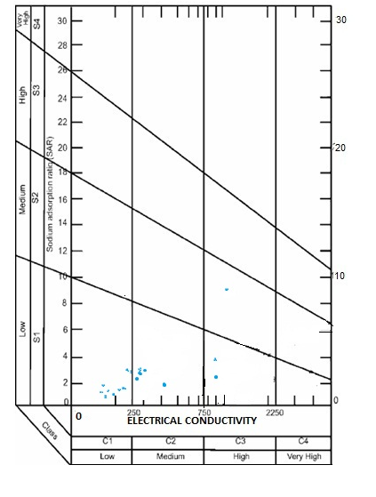

Figure 6.3n:USSL Classification of Bharathapuzha (pre-monsoon, 2012)

**6.4. Chalakkudy River Basin**

The Chalakudy river basin with an area of 1525km2 isa tributary of the Periyar, the largest river in Kerala. There aresix reservoirs impounded in this basin. The present studyis limited to the stretch from the Poringalkuttu reservoir tothe confluence of the Chalakudy river with the Periyar(Figure 1). The length of this stretch is 80 km, with acatchment area of 583 km2. Relief varies from 20 m at theriver mouth to 1000 m in the northeastern part of the catchment.Dominant rock types are charnockite and biotite gneiss,with recent sediments in the western part and along theriver. Geomorphologically, this stretch is characterized byfloodplain, transitional plain, low rolling terrain, moderatelyundulating terrain, highly undulating terrain and hilly area.Average annual rainfall in this area is around 3300 mm,varying from a little over 3000 mm in Chalakudy town to3700 mm in Poringalkuttu. Seasonal variation of temperatureis within 5°C. Total average annual drainage discharge(1980–2000) is 1421.81 million m3 near Chalakudy town,as reported by the Irrigation Department, Government ofKerala.

The chemical analysis data of Chalakudy River basin indicated that the entire area of the basin is dominated by acidic type of rocks. The acidic rock might have contributed to the lower pH in the waters of the region. In all stations it is found that the pH is less than 7. Further, it is interesting to note that during the post-monsoon season, in-spite of heavy rainfall and dilution, there was no significant change in pH value. It was observed that there was an increase in the calcium and magnesium concentration from season to season. It was also observed that, coliforms are also of concern as the count showed more than +1100 in many of the locations.

Figure 6.4a: Seasonal variation of water quality parameters in Chalakudy river

Figure 6.4b: Spatial variation of major cations along the river Chalakudy (Upstream to downstream) during Premonsoon 2008

Figure 6.4c: Spatial variation of major anions along the river Chalakudy (Upstream to downstream) during Premonsoon 2008

Figure 6.4d: Spatial variation of bacteriological parameters along the river Chalakudy (Upstream to downstream) during Premonsoon 2008

Figure 6.4e: Spatial variation of major cations along the river Chalakudy (Upstream to downstream) during Postmonsoon 2008

Figure 6.4f: Spatial variation of major anions along the river Chalakudy (Upstream to downstream) during Postmonsoon 2008

Figure 6.4g: Spatial variation of bateriological parameters along the river Chalakudy(Upstream to downstream) during Postmonsoon 2008.

Figure 6.4h: Spatial variation of major cations along the river Chalakudy(Upstream to downstream) during Premonsoon 2009

Figure 6.4i: Spatial variation of major anions along the river Chalakudy(Upstream to downstream) during Premonsoon 2009

Figure 6.4j: Spatial variation of bacteriological parameters along the river Chalakudy(Upstream to downstream) during Premonsoon 2009

Further, in Thrissur region, results of the water quality analysis of Puzhakkal river showed that there is an increase in electrical conductivity, TDS and chloride concentration during the post-monsoon in comparison to the pre-monsoon period. However, the decline found in the pre-monsoon season 2009 is comparatively lower than the previous year. This could be attributed to the rainfall and overland flow occurred during the period. In the case of Keecheri river these variations are found to be gradual in the case of electrical conductivity, TDS and chloride concentrations. Total hardness showed a reverse trend indicating the gradual increase from season to season.

It is also very important to note that in Karuvannur and Puzhakkal river basin, in some of the locations, all major anions and cations were far above the permissible limits. The cause for such a drastic variation could be due to the presence of artificial canal. The electrical conductivity was enormously high and the maximum was 56910µS/cm at Enamakkal and 48450µS/cm at Thriprayar. The corresponding TDS observed in the said stations were 24930 mg/l and 21270 mg/l respectively. Hardness of the water was also found to be very high. 5765 mg/l was observed at Enamakkal and 4573 mg/l at Thriprayar. Similarly, those stations were marked by very high concentration of Chloride (17594 mg/l and 14595 mg/l) and also certain anions such as sulphate and phosphates. Apart from this, Iron is one of the important elements which were widely distributed in the surface waters of this region. The maximum concentration of Iron observed was 4.4 mg/l. The bacteriological analysis also showed considerable variations. The DO level has showed a drop up to 2.4 mg/l which was observed at Pillathode.

Table 6.4a: Variation of Water Quality parameters in Chalakudy river duringpost-monsoon 2011

|  |  |  |  |  |  |  |  |
| --- | --- | --- | --- | --- | --- | --- | --- |
| **Parameters** | **UNIT** | **MIN** | | **MAX** | **Mean** | | **Std dev** |
| **Temp** | **°C** | 25.00 | | 29.00 | 27.56 | | 1.59 |
| **PH** |  | 5.29 | | 6.49 | 5.95 | | 0.41 |
| **Turbidity** | **NTU** | 2.10 | | 5.30 | 4.16 | | 1.09 |
| **EC** | **Micro Seimens** | 39.82 | | 137.70 | 61.37 | | 32.06 |
| **TDS** | **Mg/l** | 20.53 | | 71.88 | 31.75 | | 16.91 |
| **Alkalinity** | **Mg/l** | 12.00 | | 25.00 | 16.89 | | 4.86 |
| **Acidity** | **Mg/l** | 2.50 | | 2.50 | 2.50 | | 0.00 |
| **TH** | **Mg/l** | 14.00 | | 50.00 | 24.00 | | 11.22 |
| **Calcium** | **Mg/l** | 4.00 | | 18.00 | 8.00 | | 4.36 |
| **Magnesium** | **Mg/l** | 1.94 | | 4.86 | 3.35 | | 0.95 |
| **Bicarbonate** | **Mg/l** | 12.00 | | 25.00 | 16.89 | | 4.86 |
| **Chloride** | **Mg/l** | 7.50 | | 20.00 | 11.11 | | 3.77 |
| **Sodium** | **Mg/l** | 2.02 | | 3.74 | 2.79 | | 0.58 |
| **Potassium** | **Mg/l** | 1.04 | | 1.22 | 1.13 | | 0.07 |
| **Sulphate** | **Mg/l** | 2.05 | | 2.05 | 2.05 | |  |
| **Phosphate** | **Mg/l** | 0.03 | | 0.04 | 0.04 | | 0.00 |
| **Fluoride** | **Mg/l** | 0.00 | | 0.22 | 0.06 | | 0.07 |
| **Nitrate** | **Mg/l** | 0.25 | | 0.91 | 0.39 | | 0.20 |
| **Iron** | **Mg/l** | 0.12 | | 0.59 | 0.31 | | 0.17 |
| **DO** | **Mg/l** | 6.10 | | 8.10 | 7.29 | | 0.62 |
| **Bio COD** | **Mg/l** | 0.40 | | 1.70 | 0.90 | | 0.50 |
| **COD** | **Mg/l** | 2.00 | | 10.00 | 5.60 | | 2.97 |
| **Bacteriology** |  |  |  | | |  |  |
| **Total Coliform** | **MPN/100ml** | 1600.00 | 4600.00 | | | 3066.67 | 1198.96 |
| **E-Coli** | **MPN/100ml** | 60.00 | 640.00 | | | 167.78 | 179.57 |

Table 6.4b: Variation of Water Quality parameters in Chalakudy river during pre-

monsoon 2012

|  |  |  |  |  |  |  |  |
| --- | --- | --- | --- | --- | --- | --- | --- |
| **Parameters** | **UNIT** | **MIN** | | **MAX** | **Mean** | | **Std dev** |
| **Temp** | **°C** | 28.00 | | 32.00 | 30.78 | | 1.30 |
| **Ph** |  | 4.91 | | 6.30 | 5.80 | | 0.41 |
| **Turbidity** | **NTU** | 1.30 | | 7.60 | 3.11 | | 2.23 |
| **EC** | **Micro Seimens** | 37.28 | | 352.60 | 124.18 | | 127.72 |
| **TDS** | **Mg/l** | 19.54 | | 198.90 | 68.65 | | 72.35 |
| **Alkalinity** | **Mg/l** | 12.00 | | 22.00 | 15.33 | | 3.00 |
| **Acidity** | **Mg/l** | 5.00 | | 10.00 | 6.67 | | 2.17 |
| **T H** | **Mg/l** | 12.00 | | 126.00 | 39.56 | | 41.71 |
| **Calcium** | **Mg/l** | 4.01 | | 40.08 | 12.47 | | 12.86 |
| **Magnesium** | **Mg/l** | 1.46 | | 20.88 | 6.58 | | 7.08 |
| **Bicarbonate** | **Mg/l** | 12.00 | | 22.00 | 15.33 | | 3.00 |
| **Chloride** | **Mg/l** | 8.00 | | 94.00 | 31.33 | | 35.31 |
| **Sodium** | **Mg/l** | 1.69 | | 16.47 | 4.16 | | 4.73 |
| **Potassium** | **Mg/l** | 1.02 | | 1.96 | 1.27 | | 0.31 |
| **Sulphate** | **Mg/l** | 0.98 | | 1.64 | 1.37 | | 0.35 |
| **Phosphate** | **Mg/l** | 0.02 | | 0.03 | 0.02 | | 0.01 |
| **Fluoride** | **Mg/l** | 0.01 | | 0.04 | 0.02 | | 0.02 |
| **Nitrate** | **Mg/l** | 0.15 | | 0.57 | 0.29 | | 0.14 |
| **Iron** | **Mg/l** | 0.15 | | 0.39 | 0.23 | | 0.07 |
| **DO** | **Mg/l** | 3.80 | | 7.90 | 6.29 | | 1.60 |
| **Bio COD** | **Mg/l** | 0.60 | | 2.00 | 1.16 | | 0.47 |
| **COD** | **Mg/l** | 4.00 | | 36.00 | 16.89 | | 11.23 |
| **Bacteriology** |  |  |  | | |  |  |
| **E-Coli** | **MPN/100ml** | 11.00 | 1100.00 | | | 200.50 | 367.56 |

Statistical analysis of various parameters for the samples collected during post-monsoon 2011 and pre-monsoon 2012 is given in table 4c and 4d.

Table 6.4c: Factor Analysis results of Chalakudy river during post-monsoon (2011)

|  |  |  |  |  |  |
| --- | --- | --- | --- | --- | --- |
| Sl.No. | Parameter | Factor 1 | Factor 2 | Factor 3 | Factor 4 |
| 1 | Alkalinity | 0.569 | 0.683 | -0.013 | 0.216 |
| 2 | Fluoride | -0.290 | -0.166 | -0.165 | -0.738 |
| 3 | Phosphate | 0.182 | 0.101 | 0.059 | -0.762 |
| 4 | Total hardness | 0.935 | 0.173 | 0.272 | -0.007 |
| 5 | EC | 0.969 | 0.133 | 0.197 | 0.014 |
| 6 | TDS | 0.969 | 0.123 | 0.202 | 0.008 |
| 7 | Iron | -0.184 | -0.884 | 0.120 | 0.126 |
| 8 | Potassium | 0.554 | -0.746 | -0.175 | -0.205 |
| 9 | Calcium | 0.955 | 0.058 | 0.235 | 0.066 |
| 10 | pH | -0.204 | -0.810 | -0.474 | 0.034 |
| 11 | Nitrate | 0.985 | -0.040 | -0.122 | -0.018 |
| 12 | Magnesium | -0.011 | 0.257 | 0.909 | -0.117 |
| 13 | Sulphate | 0.957 | 0.100 | -0.231 | 0.014 |
| 14 | Sodium | 0.693 | 0.290 | 0.625 | 0.033 |
| Eigen Value | | 7.481 | 2.917 | 1.920 | 1.258 |
| Fraction of variance, % | | 45.847 | 18.374 | 17.600 | 8.688 |
| Cumulative fraction of variance, % | | 45.847 | 64.221 | 81.821 | 90.509 |

Table 6.4d: Factor Analysis results of Chalakudy river during pre-monsoon (2012)

|  |  |  |  |  |
| --- | --- | --- | --- | --- |
| Sl.No. | Parameter | Factor 1 | Factor 2 | Factor 3 |
| 1 | Alkalinity | 0.935 | 0.021 | -0.231 |
| 2 | Fluoride | -0.139 | 0.908 | -0.211 |
| 3 | Phosphate | -0.251 | -0.702 | -0.441 |
| 4 | Total hardness | 0.807 | 0.176 | 0.548 |
| 5 | Chloride | 0.716 | 0.168 | 0.669 |
| 6 | EC | 0.719 | 0.158 | 0.668 |
| 7 | TDS | 0.722 | 0.161 | 0.663 |
| 8 | Iron | 0.125 | -0.907 | 0.217 |
| 9 | Potassium | 0.438 | 0.128 | 0.879 |
| 10 | Calcium | 0.816 | 0.186 | 0.478 |
| 11 | pH | 0.226 | 0.744 | 0.469 |
| 12 | Nitrate | 0.268 | 0.307 | 0.866 |
| 13 | Magnesium | 0.795 | 0.170 | 0.574 |
| 14 | Sulphate | 0.769 | -0.004 | 0.456 |
| 15 | Sodium | 0.140 | 0.116 | 0.929 |
| Eigen Value | | 9.924 | 2.419 | 1.393 |
| Fraction of variance, % | | 36.000 | 19.940 | 35.631 |
| Cumulative fraction of variance, % | | 36.000 | 55.94 | 91.571 |

During post-monsoon 2011, first four factors show Eigen values more than 1, thus these four factors are chosen for further analysis. Factor 1 shows 45.84% variance. This factor has high positive loadings and strongly associated with EC and TDS (0.96), calcium (0.95),sodium (0.69), total hardness (0.93), sulphate (0.95), nitrate (0.98) and moderately on alkalinity (0.56) and potassium (0.55). Factor 2 shows 18.37% variance. This factor has negative loadings with pH(0.81),iron (0.88) and potassium (0.74) and moderate positive loadings onalkalinity (0.68). Factor 3 shows 17.60% variance. This factor has positive loadings with magnesium (0.90) and moderately on sodium (0.62). Factor 4 shows 8.688% and has negative loadings on fluoride (0.73) and phosphate (0.76).

During pre-monsoon 2012, first three factors show Eigen values more than 1.Factor 1 shows36.00% variance. This factor has high positive loadings and strongly associated with EC and TDS (0.72), calcium (0.81), magnesium (0.79), total hardness (0.80), sulphate (0.76), chloride (0.71) and alkalinity (0.93). Factor 2 shows 19.94% variance. This factor has high positive loadings and strongly associated with pH(0.74), fluoride (0.90) and negative loadings on phosphate (0.70) and iron (0.90). Factor 3 shows 35.63% variance. This factor has high positive loadings and strongly associated with nitrate (0.86), sodium (0.92), potassium (0.87), EC and TDS (0.66), chloride (0.66) and moderately on Total Hardness (0.54) and magnesium (0.57).

Table 6.4e. Overall CWQI and WQI Estimated values of Chalakkudy basin for the

selected station (2008-2012)

|  |  |  |  |  |  |  |
| --- | --- | --- | --- | --- | --- | --- |
| **Station** | **Methods** | **Pre -monsoon 2008** | **Post -monsoon 2008** | **Pre - monsoon 2009** | **Post -monsoon 2011** | **Pre -monsoon 2012** |
| Annamanada-Pulikkakkadayu | WQI | 78.68 | 81.318 | 65.24 | 75.40 | 65.24 |
| CCME(WQI) | 73 | 79 | 88 | 69 | 61 |
| Chalakkudy | WQI | 81.96 | 84.72131 | 72.78 | 61.80 | 80.98 |
| CCME(WQI) | 73 | 79 | 90 | 63 | 75 |
| Kanjirappilly | WQI | 77.37 | 86.72 | 80.16393 | 75.90 | 67.04 |
| CCME(WQI) | 73 | 82 | 90 | 71 | 64 |
| Kannamkuzhy | WQI | - | - | - | 72.131 | 69.50 |
| CCME(WQI) | - | - | - | 58 | 63 |
| Kathikudam | WQI | - | - | - | 75.08197 | 65.24 |
| CCME(WQI) | - | 80 | - | 67 | - |
| Karikkadavu | WQI | - | 78.52 | - | - | - |
| CCME(WQI) | - | - | - | - | - |
| Kundoor | WQI | 69.344 | 73.2786 | 66.55738 | 70.98361 | 60.32787 |
| CCME(WQI) | 66 | 73 | 89 | 69 | 72 |
| Panampillykadavu Kathikudam | WQI | 65.40984 | 86.55 | 75.40984 | - | - |
| CCME(WQI) | - | 74 | 88 | - | 68 |
| Vazhachal Bridge | WQI | - | - | - | 66.55 | 69.18 |
| CCME(WQI) | - | - | - | 55 | 58 |
| Vettilappara | WQI | - | - | - | 73.77049 | 74.59016 |
| CCME(WQI) | - | - | - | 61 | 71 |
| Vynthala | WQI | 74.42 | 83.11475 | 79.01 | 66.88525 | 67.54098 |
| CCME(WQI) | 72 | 72 | 89 | 63 | 68 |

|  |  |  |  |  |  |  |  |
| --- | --- | --- | --- | --- | --- | --- | --- |
| **Table 6.4f: CCME Score of Chalakudy river (pre-monsoon, 2008-2012)** | | | | | | | |
| **Data Summary** | **year** | **Overall** | **Drinking** | **Aquatic** | **Recreation** | **Irrigation** | **Livestock** |
| **CWQI** | **2008** | **68** | **67** | **42** | **100** | **100** | **100** |
|  | **2009** | **90** | **100** | **74** | **100** | **100** | **100** |
|  | **2012** | **66** | **63** | **41** | **42** | **100** | **100** |
| **F1 (Scope)** | **2008** | 40 | 43 | 75 | 0 | **0** | **0** |
|  | **2009** | 10 | 0 | 25 | 0 | **0** | **0** |
|  | **2012** | 40 | 43 | 75 | 100 | **0** | **0** |
| **F2 (Frequency)** | **2008** | 32 | 32 | 58 | 0 | **0** | **0** |
|  | **2009** | 12 | 0 | 32 | 0 | **0** | **0** |
|  | **2012** | 36 | 38 | 66 | 11 | **0** | **0** |
| **F3 (Amplitude)** | **2008** | 20 | 22 | 33 | 0 | **0** | **0** |
|  | **2009** | 9 | 0 | 20 | 0 | **0** | **0** |
|  | **2012** | 25 | 29 | 19 | 0 | **0** | **0** |

|  |  |  |  |  |  |  |  |  |
| --- | --- | --- | --- | --- | --- | --- | --- | --- |
| |  | | --- | | Table 6.4g: CCME Score of Chalakudy river during post-monsoon (2008,2011) | | | | | | | | |
| **Data Summary** | **year** | **Overall** | **Drinking** | **Aquatic** | **Recreation** | **Irrigation** | **Livestock** |
| **CWQI** | **2008** | **75** | **76** | **51** | **100** | **100** | **100** |
|  | **2011** | **63** | **59** | **41** | **100** | **100** | **100** |
| **F1 (Scope)** | **2008** | 27 | 25 | 50 | 0 | 0 | 0 |
|  | **2011** | 40 | 43 | 75 | 0 | 0 | 0 |
| **F2 (Frequency)** | **2008** | 22 | 18 | 52 | 0 | 0 | 0 |
|  | **2011** | 40 | 43 | 68 | 0 | 0 | 0 |
| **F3 (Amplitude)** | **2008** | 24 | 28 | 45 | 0 | 0 | 0 |
|  | **2011** | 30 | 37 | 15 | 0 | 0 | 0 |

From the table it is evident that during the study period none of the parameters exceeded the permissible limits. However, total coliform counts showed a significant increase due to which water cannot be used for drinking purposes. The water quality indices show a marginal decline and increase depending on the season and rainfall pattern.The results presented in this study indicate that variations in water quality were seasonal and can be linked to land use/land cover changes. Urban area showed significant deterioration in water quality. Even monsoon dilution was not always effective. It is also presumed that lack of proper sewage system in the area is a major factor. It is further noticed that the study area is dominatedby intensive agriculture uses with excessive fertilizer applications.

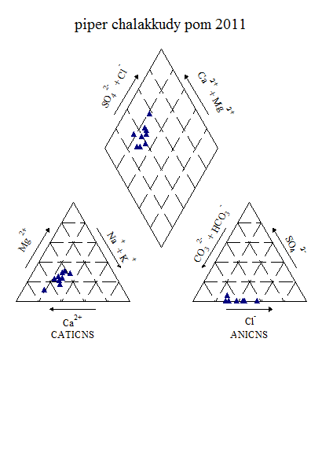

Figure 6.4k : Piper’s Classification of Chalakudy river water (post-monsoon, 2011)

From the piper classification, during post-monsoon 2011, it is clearly shows that water type belongs to CaHCO3 and during pre-monsoon 2012, it shows CaHCO3 type followed by CaCl type.

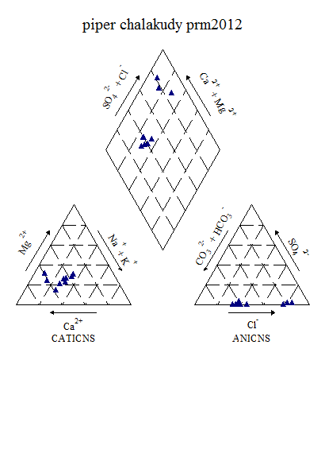

Figure 6.4l : Piper’s Classification of Chalakudy river water (pre-monsoon, 2012)

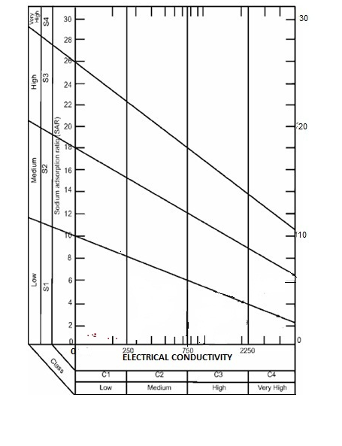

Figure 6.4m:USSL Classification of Chalakudy river (post-monsoon, 2011)

From the USSL diagram, during post-monsoon 2011, water fall under C1S1 and belongs to low sodium and low salinity category. During pre-monsoon 2012, water fall under C1S1, C2S2 and belongs to low sodium and low to medium salinity category.

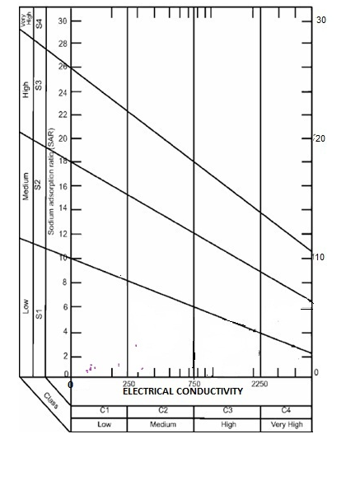

Figure 6.4n: USSL Classification of Chalakudy river (pre-monsoon, 2012)

**6.5.Kabini River Basin**

The **Kabini**, also called *Kabani* and *Kapila*flows through the Wayanad district of Kerala state.The river originates in the Pakramthalam hills at Kuttyadi- Mananthavady road. Makkiyad river and Periya river joins near Korome and Valad respectively. After flowing through Mananthavady town, Panamaram river joins Kabini near Payyampally. One branch of the Panamaram river starts from the Banasura Sagar reservoir near Padinjarethara and the other branch of the river start from Lakkidi] hills. After traversing 2 kilometres from the confluence of Panamaram river Kabini forms an island called Kuruva island, spreading over 520 acres (2.1 km2) with diverse flora and fauna. Within 20 km it reaches the Kabini reservoir bordering Kerala and Karnataka for some distance. Between Kabani reservoir and Kuruva island Kalindi river joins Kabini. The river Kabini has a total course of about 230 km and a catchment area of about 7,040 sq.km. It joins the Cauvery river at Tirumakudal Narasipur.

The water quality analysis of Kabini river water was carried out In Wayanad and adjoining areas. The surface water quality parameters showed wide variations. However, only at very few stations the anions and cations exceeded the permissible limits. It is found that in some of the locations COD showed a significant concentration, particularly, Vellamunda (100 mg/l), Thindumal (66 mg/l), Valad (52 mg/l) and Padinzhavathara (84 mg/l). A notable quantity of phosphate was observed in Sulthan Batheri area (21.8 mg/l). Apart from this (at Sulthanbatheri) bacteriological contamination was noticeably high. Significant numbers of E. coli were observed in places like Kodal kadavu, Mananthavady, Edavaka, Kottikulam, Bavali, Thindummal, Valad and Koodamkunnu.

Figure 6.5a: Seasonal variation of water quality parameters in Kabini river

Figure 6.5b: Spatial variation of major cations along the river Kabini (Upstream to downstream) during Premonsoon 2008

Figure 6.5c: Spatial variation of major anions along the river Kabini (Upstream to downstream) during Premonsoon 2008

Figure 6.5d: Spatial variation of bacteriological parameters along the river Kabini (Upstream to downstream) during Premonsoon 2008

Figure 6.5e: Spatial variation of cations along the river Kabini (Upstream to downstream) during Postmonsoon 2008

Figure6.5f: Spatial variation of anions along the river Kabini (Upstream to downstream) during Postmonsoon 2008

Figure 6.5g: Spatial variation of bacteriological parameters along the river Kabini (Upstream to downstream) during Postmonsoon 2008

Figure 6.5h: Spatial variation of major cations along the river Kabini (Upstream to downstream) during Premonsoon 2009

Figure 6.5i: Spatial variation of major anions along the river Kabini (Upstream to downstream) during Premonsoon 2009

Figure 6.5j: Spatial variation of bacteriological parameters along the river Kabini (Upstream to downstream) during Premonsoon 2009

Water Quality analysis carried out during post-monsoon 2011 and pre-monsoon 2012 are presented in the table 6.5a. It is noticed that all the anions and cations are well within the permissible limits. However, it is observed that the microbial contamination is matter of concern in the study area

Table 6.5a: Variation of Water Quality parameters in Kabini river during post- monsoon 2011

|  |  |  |  |  |  |
| --- | --- | --- | --- | --- | --- |
| **Parameters** | **UNIT** | **MIN** | **MAX** | **Mean** | **Std dev** |
| **Temp** | **°C** | 24.10 | 27.00 | 24.97 | 0.94 |
| **PH** |  | 6.50 | 8.51 | 7.13 | 0.62 |
| **Turbidity** | **NTU** | 1.00 | 5.00 | 3.14 | 1.19 |
| **EC** | **Micro Seimens** | 51.00 | 162.00 | 101.00 | 34.41 |
| **TDS** | **Mg/l** | 34.00 | 106.00 | 66.43 | 22.63 |
| **Alkalinity** | **Mg/l** | 12.70 | 50.80 | 29.48 | 11.78 |
| **TH** | **Mg/l** | 16.00 | 60.00 | 36.86 | 14.31 |
| **Calcium** | **Mg/l** | 3.20 | 11.20 | 7.89 | 2.47 |
| **Magnesium** | **Mg/l** | 0.97 | 8.75 | 4.58 | 2.65 |
| **Chloride** | **Mg/l** | 12.81 | 21.36 | 17.08 | 2.90 |
| **Sodium** | **Mg/l** | 5.30 | 17.30 | 11.04 | 3.59 |
| **Potassium** | **Mg/l** | 1.00 | 4.00 | 2.27 | 0.85 |
| **Sulphate** | **Mg/l** | 0.28 | 2.32 | 0.83 | 0.58 |
| **Phosphate** | **Mg/l** | 0.01 | 0.05 | 0.03 | 0.03 |
| **Fluoride** | **Mg/l** | 0.03 | 0.07 | 0.04 | 0.01 |
| **Nitrate** | **Mg/l** | 0.01 | 0.14 | 0.07 | 0.05 |
| **Iron** | **Mg/l** | 0.03 | 0.03 | 0.03 | #DIV/0! |
| **Manganese** | **Mg/l** | 0.01 | 0.01 | 0.01 | 0.00 |
| **DO** | **Mg/l** | 6.87 | 9.67 | 8.31 | 0.82 |

Table 6.5b: Variation of Water Quality parameters in Kabini river during pre-monsoon 2012

|  |  |  |  |  |  |  |  |
| --- | --- | --- | --- | --- | --- | --- | --- |
| **Parameters** | **UNIT** | **MIN** | | **MAX** | **Mean** | | **Std dev** |
| **Temp** | **°C** | 20.80 | | 26.00 | 23.41 | | 1.32 |
| **Ph** |  | 6.97 | | 7.32 | 7.14 | | 0.10 |
| **Turbidity** | **NTU** | 2.60 | | 49.30 | 15.46 | | 14.60 |
| **EC** | **Micro Seimens** | 52.00 | | 231.00 | 137.21 | | 44.79 |
| **TDS** | **Mg/l** | 37.00 | | 164.00 | 97.21 | | 31.31 |
| **Alkalinity** | **Mg/l** | 18.00 | | 78.00 | 42.93 | | 22.26 |
| **Acidity** | **Mg/l** | 4.00 | | 12.00 | 7.43 | | 2.14 |
| **T H** | **Mg/l** | 16.00 | | 56.00 | 33.43 | | 12.90 |
| **Calcium** | **Mg/l** | 3.20 | | 12.80 | 8.00 | | 2.43 |
| **Magnesium** | **Mg/l** | 0.97 | | 6.80 | 3.81 | | 2.01 |
| **Bicarbonate** | **Mg/l** | 18.00 | | 78.00 | 42.93 | | 22.26 |
| **Chloride** | **Mg/l** | 12.03 | | 28.07 | 21.77 | | 4.64 |
| **Sodium** | **Mg/l** | 1.45 | | 12.11 | 6.11 | | 2.95 |
| **Potassium** | **Mg/l** | 0.52 | | 4.85 | 2.87 | | 1.25 |
| **Sulphate** | **Mg/l** | 1.76 | | 23.76 | 9.41 | | 6.42 |
| **Phosphate** | **Mg/l** | 0.01 | | 0.05 | 0.02 | | 0.01 |
| **Fluoride** | **Mg/l** | 0.04 | | 0.09 | 0.06 | | 0.02 |
| **Nitrate** | **Mg/l** | 0.20 | | 2.10 | 0.51 | | 0.55 |
| **Iron** | **Mg/l** | 0.10 | | 0.57 | 0.28 | | 0.17 |
|  |  | 0.01 | | 0.01 | 0.01 | | #DIV/0! |
| **DO** | **Mg/l** | 4.33 | | 7.00 | 6.13 | | 0.68 |
| **Bio COD** | **Mg/l** | 0.20 | | 2.87 | 1.23 | | 0.73 |
| **COD** | **Mg/l** | 8.00 | | 128.00 | 56.57 | | 36.39 |
| **Bacteriology** |  |  |  | | |  |  |
| **Total Coliform** | **MPN/100ml** | 1500.00 | 3600.00 | | | 2685.71 | 714.53 |
| **E-Coli** | **MPN/100ml** | 100.00 | 2400.00 | | | 1015.38 | 693.84 |

Statistical analysis of various parameters for the samples collected during post-monsoon 2011 and pre-monsoon 2012 is given in table 5c and 5d.

Table 6.5c: Factor Analysis results of Kabini river during post-monsoon (2011)

|  |  |  |  |  |  |
| --- | --- | --- | --- | --- | --- |
| Sl.No. | Parameter | Factor 1 | Factor 2 | Factor 3 | Factor 4 |
| 1 | Alkalinity | 0.599 | 0.140 | 0.718 | 0.146 |
| 2 | Fluoride | -0.128 | -0.257 | -0.096 | -0.779 |
| 3 | Phosphate | -0.324 | 0.746 | -0.278 | -0.011 |
| 4 | Total hardness | 0.919 | 0.018 | 0.299 | 0.162 |
| 5 | Chloride | 0.114 | 0.025 | 0.946 | -0.082 |
| 6 | EC | 0.670 | 0.132 | 0.690 | 0.153 |
| 7 | TDS | 0.670 | 0.137 | 0.691 | 0.150 |
| 8 | Iron | 0.495 | 0.266 | 0.340 | -0.496 |
| 9 | Potassium | 0.444 | -0.034 | 0.543 | 0.569 |
| 10 | Calcium | 0.735 | -0.022 | 0.349 | 0.492 |
| 11 | pH | 0.088 | 0.475 | 0.694 | 0.093 |
| 12 | Nitrate | 0.444 | 0.709 | 0.403 | -0.045 |
| 13 | Magnesium | 0.957 | -0.038 | 0.030 | -0.037 |
| 14 | Sulphate | -0.098 | -0.815 | -0.081 | -0.189 |
| 15 | Sodium | 0.242 | -0.268 | 0.817 | 0.193 |
| Eigen Value | | 7.780 | 2.105 | 1.408 | 1.325 |
| Fraction of variance, % | | 26.369 | 14.782 | 29.274 | 10.695 |
| Cumulative fraction of variance, % | | 26.369 | 41.151 | 70.425 | 81.12 |

Table 6.5d: Factor Analysis results of Kabini river during pre-monsoon (2012)

|  |  |  |  |  |
| --- | --- | --- | --- | --- |
| Sl.No. | Parameter | Factor 1 | Factor 2 | Factor 3 |
| 1 | Alkalinity | 0.874 | -0.363 | 0.207 |
| 2 | Fluoride | 0.857 | -0.136 | 0.200 |
| 3 | Phosphate | 0.269 | 0.458 | 0.352 |
| 4 | Total hardness | 0.950 | -0.169 | -0.015 |
| 5 | Chloride | 0.457 | 0.797 | -0.104 |
| 6 | EC | 0.959 | 0.140 | 0.202 |
| 7 | TDS | 0.962 | 0.143 | 0.189 |
| 8 | Iron | 0.165 | -0.017 | 0.823 |
| 9 | Potassium | -0.220 | 0.862 | -0.242 |
| 10 | Calcium | 0.807 | 0.193 | 0.234 |
| 11 | pH | 0.14 | -0.292 | 0.796 |
| 12 | Nitrate | -0.278 | 0.692 | -0.345 |
| 13 | Magnesium | 0.774 | -0.353 | -0.170 |
| 14 | Sulphate | -0.524 | 0.588 | 0.226 |
| 15 | Sodium | 0.872 | 0.000 | 0.302 |
| Eigen Value | | 7.439 | 2.804 | 1.623 |
| Fraction of variance, % | | 46.525 | 19.189 | 13.393 |
| Cumulative fraction of variance, % | | 46.525 | 65.714 | 79.107 |

During post-monsoon 2011, first four factors show Eigen values more than 1, thus these four factors are chosen for further analysis. Factor 1 shows 26.36% variance. This factor has positive loadings and strongly associated with EC and TDS (0.67), calcium (0.73), magnesium (0.96) total hardness (0.92),and moderately on alkalinity (0.59). Factor 2 shows 14.78% variance. This factor has positive loadings on phosphate (0.75), nitrate (0.71) and negative loadings with sulphate (0.81). Factor 3 shows 29.27% variance. This factor has positive loadings on pH (0.70), alkalinity (0.72), chloride (0.95),EC and TDS (0.70),sodium (0.82)and moderately on potassium (0.54). Factor 4 shows 10.69% and has moderate loadings on potassium (0.57).

During pre-monsoon 2012, first three factors show Eigen values more than 1.Factor 1 shows 46.52% variance. This factor has high positive loadings and strongly associated with alkalinity (0.87), fluoride (0.86), total hardness (0.95), EC and TDS (0.96), calcium (0.81), magnesium (0.77), and sodium (0.87). Factor 2 shows 19.18% variance. This factor has high positive loadings on chloride (0.80), potassium (0.86), and nitrate (0.70) and moderately on sulphate (0.59). Factor 3 shows 13.39% variance. This factor has high positive loadings and strongly associated with iron (0.82) and pH (0.80).

**Table 6.5e: Overall CWQI and WQI Estimated values of Kabini basin for the selected**

**Station (2008-2012)**

|  |  |  |  |  |  |  |
| --- | --- | --- | --- | --- | --- | --- |
| **Station** | **Methods** | **Pre -monsoon 2008** | **Post -monsoon 2008** | **Pre - monsoon 2009** | **Post -monsoon 2011** | **Pre -monsoon 2012** |
| Bavali | WQI | 68.68852 | 79.18033 | 65.90164 | 87.54098 | 69.83607 |
| CCME(WQI) | 74 | 81 | 89 | 79 | 90 |
| Cheriyamkolli | WQI | - | - | - | 89.67213 | 69.18033 |
| CCME(WQI) | - | - | - | 82 | 46 |
| Choottakkadavu | WQI | 73.77049 | 78.52459 | 68.19672 | - | - |
| CCME(WQI) | 73 | 68 | 80 | - | - |
| Kakkavayal | WQI | 72.29508 | 77.54098 | 65.57377 | - | 84.59016 |
| CCME(WQI) | 55 | 78 | 47 | 80 | 79 |
| Kalpetta | WQI | 69.83607 | 80 | 70 |  | 70 |
| CCME(WQI) | 81 | 72 | 76 | 78 | 54 |
| Karapuzha | WQI | 67.21311 | 74.42623 | 69.67213 | - | - |
| CCME(WQI) | 77 | 100 | 70 | - | - |
| Kelothkadavu | WQI | 67.86885 | 75.7377 | 59.67213 | 73.11475 | 77.70492 |
| CCME(WQI) | 62 | 68 | 36 | 72 | 90 |
| Koodalkadavu | WQI | 76.72131 | 70.98361 | 65.7377 | - | - |
| CCME(WQI) | 68 | 71 | 44 | - | - |
| Koodamkunn | WQI | 61.47541 | 64.09836 |  | - | - |
| CCME(WQI) | 88 | 89 | 91 | - | - |
| Mananthavady | WQI | 77.37705 | 73.27869 | 69.34426 | 86.39344 | 75.40984 |
| CCME(WQI) | 78 | 72 | 89 | 76 | 61 |
| Marakadavu | WQI | - | - | - | - | 80.32787 |
| CCME(WQI) | - | - | - | 77 | 76 |
| Muthanga | WQI | 74.91803 | 78.19672 | 66.72131 | - | - |
| CCME(WQI) | 70 | 68 | 75 | - | - |
| Neervaram | WQI | 60.32787 | 71.80328 | 64.91803 | 80 | 73.60656 |
| CCME(WQI) | 41 | 59 | 61 | 77 | 58 |
| Neykuppam | WQI | - | - | - | 85.08197 | 72.29508 |
| CCME(WQI) | - | - | - | 80 | 67 |
| Orap | WQI | - | - | - | 72.13115 | 81.63934 |
| CCME(WQI) | - | - | - | 74 | 62 |
| Padinharathara | WQI | 70.98361 | 74.59016 | 76.88525 | - | - |
| CCME(WQI) | 76 | 48 | 78 | - | - |
| Panamaram | WQI | 77.37705 | 76.06557 | 68.52459 | 82.95082 | 70 |
| CCME(WQI) | 67 | 78 | 75 | 81 | 68 |
| Pulppally | WQI | 78.36066 | - | 76.06557 | - | - |
| CCME(WQI) | 73 | - | 91 | - | - |
| Puthusserikkadavu | WQI | 69.34426 | 69.83607 | 69.01639 | 86.55738 | 65.7377 |
| CCME(WQI) | 63 | 90 | 67 | 80 | 51 |
| Thindummel | WQI | 64.91803 | 64.09836 | 68.19672 | 83.93443 | 81.14754 |
| CCME(WQI) | 90 | 88 | 78 | 91 | 81 |
| Valad | WQI | 69.34426 | 71.96721 | 68.85246 | - | - |
| CCME(WQI) | 81 | 91 | 78 | - | - |
| Vythiri | WQI | 66.39344 | 57.86885 | 54.09836 | - | 82.62295 |
| CCME(WQI) | 72 | 80 | 66 | 85 | 69 |

From the above table it is evident that the water quality is getting deteriorated due to various reasons, such as urbanization followed by land use/land cover changes. Most of the catchment area of Kabini was earlier undisturbed, but in recent days lot human interference is noticed which resulted in the decline of water quality.

|  |  |  |  |  |  |  |  |
| --- | --- | --- | --- | --- | --- | --- | --- |
| **Table 6.5f: CCME Score of Chalakudy river (pre-monsoon, 2008-2012)** | | | | | | | |
| **Data Summary** | **year** | **Overall** | **Drinking** | **Aquatic** | **Recreation** | **Irrigation** | **Livestock** |
| **CWQI** | **2008** | **42** | **36** | **37** | **100** | **100** | **79** |
|  | **2009** | **57** | **52** | **36** | **100** | **100** | **83** |
|  | **2012** | **61** | **59** | **64** | **100** | **100** | **100** |
| **F1 (Scope)** | **2008** | 60 | 71 | 100 | 0 | 0 | 25 |
|  | **2009** | 50 | 57 | 100 | 0 | 0 | 25 |
|  | **2012** | 27 | 25 | 50 | 0 | 0 | 0 |
| **F2 (Frequency)** | **2008** | 29 | 27 | 37 | 0 | 0 | 18 |
|  | **2009** | 22 | 17 | 43 | 0 | 0 | 6 |
|  | **2012** | 22 | 18 | 34 | 0 | 0 | 0 |
| **F3 (Amplitude)** | **2008** | 74 | 80 | 19 | 0 | 0 | 18 |
|  | **2009** | 50 | 58 | 21 | 0 | 0 | 15 |
|  | **2012** | 57 | 65 | 16 | 0 | 0 | 0 |

|  |  |  |  |  |  |  |
| --- | --- | --- | --- | --- | --- | --- |
| **Table6.5g: CCME Score of Chalakudy river (post-monsoon, 2008,2011)** | | | | | | |
| **Data Summary** | **year** | **Overall** | **Drinking** | **Aquatic** | **Recreation** | **Irrigation** |
| **CWQI** | **2008** | **62** | **56** | **37** | **100** | **100** |
|  | **2011** | **77** | **77** | **77** | **100** | **100** |
| **F1 (Scope)** | **2008** | 60 | 71 | 100 | 0 | 0 |
|  | **2011** | 27 | 25 | 25 | 0 | 0 |
| **F2 (Frequency)** | **2008** | 23 | 19 | 37 | 0 | 0 |
|  | **2011** | 21 | 16 | 30 | 0 | 0 |
| **F3 (Amplitude)** | **2008** | 16 | 19 | 21 | 0 | 0 |
|  | **2011** | 20 | 25 | 5 | 0 | 0 |

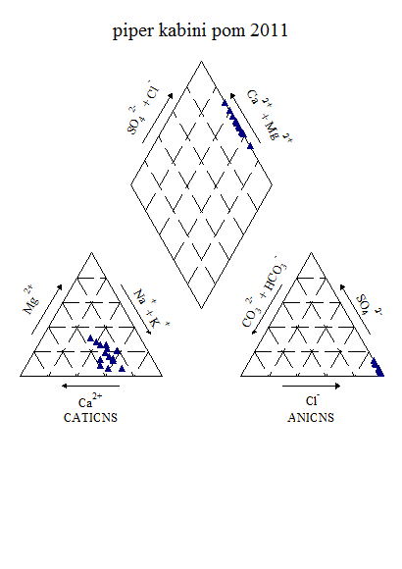

Figure6.5k: Piper’s Classification of water (Post-monsoon, 2011)

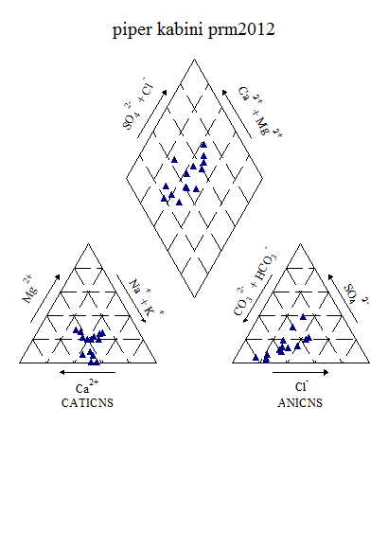

Figure6.5l: Piper’s Classification of water (Pre-monsoon, 2012)

From the piper classification, it indicate that, during post-monsoon 2011, water belongs to CaCl and NaCl type. During pre-monsoon 2012, the water belongs to CaHCO3, mixed CaNaHCO3, and mixed CaMgCl type

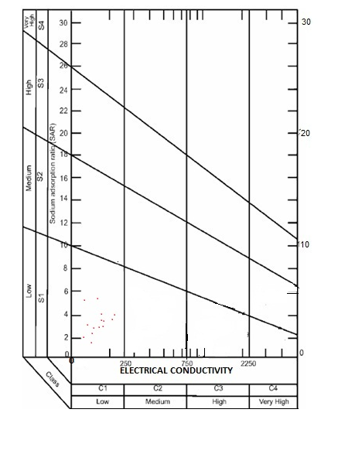

**Figure 6.5m: USSL Classification of Kabini river (post-monsoon, 2011)**

The USSL classification shows the water during post-monsoon 2011 fall under C1S1 and belongs to Low sodium and low salinity type. The same trend is indicated during pre-monsoon 2012 also.

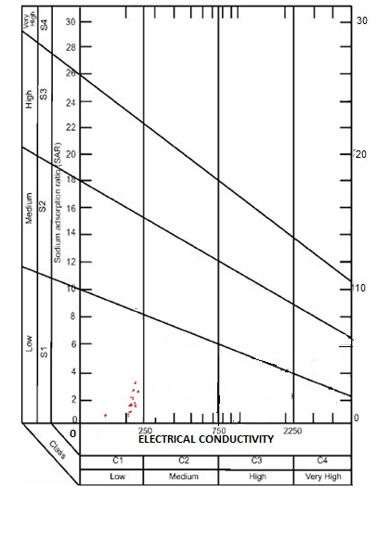

Figure 6.5n: USSL Classification of Kabini river (pre-monsoon, 2012)

**6.6Chaliyar River Basin**

The Chaliyar, known in the lower reaches, as the Beypore is one of the major rivers of Kerala. The main river starts from the Elambalari hills at an altitude of 2,067 m above MSL. It is formed by the confluence of numerous streams and rivers. Its important tributaries are the Cherupuzha, the Iringipuzha, the Kurumbanpuzha, the Kanhirapuzha, the Punnapuzha, the Karimpuzha, the Vadapuram-puzha and the Chaliyarpuzha. The Chaliyar, flowing for a total length of about 169 km finally joins the Arabian Sea at Beypore. The river drains a total area of about 2,933 sq km. of which 388 sq km. lies in Tamil Nadu.

Chaliyar River was in the news a few years ago because of the ecological damage caused by a pulp factory at Mavoor, which releases effluents into the river and affected the marine life. This factory has since closed down.

The present analysis carried out for water quality parameters are all within the permissible limits. However, the total coliform was considerably high and were distributed throughout the study area. In addition, high COD was observed at Areacode (25 mg/l) and Kallukayam (24 mg/l). One of the interesting characteristics of the region is the presence of acidic water in many of the locations and it was significant at Perinthalmanna (5.82) and Makkaramparambu (5.92).

Figure 6.6a: Seasonal variation of water quality parameters in Chaliyar river

Figure 6.6b: Spatial variation of major cations along the river Chaliyar (Upstream to downstream) during Premonsoon 2008

Figure 6.6c: Spatial variation of major anions along the river Chaliyar (Upstream to downstream) during Premonsoon 2008

Figure 6.6d: Spatial variation of bacteriological parameters along the river Chaliyar (Upstream to downstream) during Premonsoon 2008

Figure 6.6e: Spatial variation of cations along the river Chaliyar (Upstream to downstream) during Postmonsoon 2008

Figure 6.6f: Spatial variation of anions along the river Chaliyar (Upstream to downstream) during Postmonsoon 2008

Figure 6.6g: Spatial variation of bacteriological parameters along the river Chaliyar (Upstream to downstream) during Postmonsoon 2008

Figure 6.6h: Spatial variation of cations along the river Chaliyar (Upstream to downstream) during Premonsoon 2009

Figure 6.6i: Spatial variation of anions along the river Chaliyar (Upstream to downstream) during Premonsoon 2009

Figure 6.6j: Spatial variation of bacteriological parameters along the river Chaliyar (Upstream to downstream) during Premonsoon 2009

Water quality analysis of post-monsoon 2011 and pre-monsoon 2012 shows that the river water is potable and all anions and cations lie within the permissible limit. Table shows range of various chemical constituents present in the Chaliyar river

Table 6.6a: Variation of Water Quality parameters in Chaliyar during post-monsoon 2011

|  |  |  |  |  |  |  |  |
| --- | --- | --- | --- | --- | --- | --- | --- |
| **Parameters** | **UNIT** | **MIN** | | **MAX** | **Mean** | | **Std dev** |
| ***Temp*** | **°C** | 26.80 | | 30.20 | 28.56 | | 1.01 |
| **PH** |  | 6.34 | | 8.21 | 7.26 | | 0.71 |
| **Turbidity** | **NTU** | 1.00 | | 5.00 | 3.82 | | 1.25 |
| **EC** | **Micro Seimens** | 58.00 | | 161.00 | 89.64 | | 28.02 |
| **TDS** | **Mg/l** | 41.00 | | 115.00 | 62.64 | | 20.84 |
| **Alkalinity** | **Mg/l** | 12.70 | | 57.40 | 29.42 | | 13.99 |
| **Acidity** | **Mg/l** | 2.00 | | 3.00 | 2.11 | | 0.33 |
| **TH** | **Mg/l** | 20.00 | | 56.00 | 39.27 | | 10.71 |
| **Calcium** | **Mg/l** | 3.20 | | 16.00 | 8.29 | | 3.34 |
| **Magnesium** | **Mg/l** | 2.92 | | 13.61 | 6.45 | | 2.93 |
| **Bicarbonate** | **Mg/l** | 12.70 | | 57.40 | 29.42 | | 13.99 |
| **Chloride** | **Mg/l** | 11.76 | | 34.17 | 19.05 | | 7.17 |
| **Sodium** | **Mg/l** | 5.40 | | 24.60 | 9.91 | | 5.25 |
| **Potassium** | **Mg/l** | 0.61 | | 7.80 | 2.62 | | 2.75 |
| **Sulphate** | **Mg/l** | 0.72 | | 3.68 | 1.74 | | 1.36 |
| **Fluoride** | **Mg/l** | 0.02 | | 0.04 | 0.03 | | 0.01 |
| **Nitrate** | **Mg/l** | 0.05 | | 0.15 | 0.10 | | 0.03 |
| **Iron** | **Mg/l** | 0.02 | | 0.02 | 0.02 | | #DIV/0! |
| **DO** | **Mg/l** | 7.33 | | 9.20 | 8.27 | | 0.56 |
| **Bio COD** | **Mg/l** | 0.87 | | 2.60 | 1.75 | | 0.65 |
| **COD** | **Mg/l** | 32.00 | | 96.00 | 67.64 | | 23.01 |
| **Bacteriology** |  |  |  | | |  |  |
| **Total Coliform** | **MPN/100ml** | 200.00 | 2700.00 | | | 1109.09 | 697.79 |
| **E-Coli** | **MPN/100ml** | 100.00 | 300.00 | | | 200.00 | 106.90 |

**Table 6.6b: Variation of Water Quality parameters in Chaliyar during pre-monsoon 2012**

|  |  |  |  |  |  |  |  |
| --- | --- | --- | --- | --- | --- | --- | --- |
| **2012** | **UNIT** | **MIN** | | **MAX** | **Mean** | | **Std dev** |
| **Temp** | **°C** | 26.20 | | 29.50 | 28.17 | | 0.96 |
| **Ph** |  | 7.06 | | 7.68 | 7.25 | | 0.17 |
| **Turbidity** | **NTU** | 1.20 | | 4.00 | 2.70 | | 0.82 |
| **EC** | **Micro Seimens** | 63.00 | | 225.00 | 98.09 | | 45.10 |
| **TDS** | **Mg/l** | 44.90 | | 158.00 | 69.37 | | 31.66 |
| **Alkalinity** | **Mg/l** | 23.00 | | 51.00 | 33.51 | | 9.07 |
| **Acidity** | **Mg/l** | 4.00 | | 8.00 | 4.36 | | 1.21 |
| **T H** | **Mg/l** | 16.00 | | 40.00 | 23.27 | | 7.76 |
| **Calcium** | **Mg/l** | 3.20 | | 9.60 | 5.67 | | 1.66 |
| **Magnesium** | **Mg/l** | 0.97 | | 3.89 | 2.21 | | 1.16 |
| **Bicarbonate** | **Mg/l** | 23.00 | | 51.00 | 33.51 | | 9.07 |
| **Chloride** | **Mg/l** | 12.03 | | 36.09 | 19.32 | | 6.42 |
| **Sodium** | **Mg/l** | 5.11 | | 14.02 | 7.76 | | 2.40 |
| **Potassium** | **Mg/l** | 0.75 | | 1.75 | 1.35 | | 0.32 |
| **Sulphate** | **Mg/l** | 3.64 | | 9.28 | 5.27 | | 1.55 |
| **Phosphate** | **Mg/l** | 0.01 | | 0.04 | 0.02 | | 0.01 |
| **Fluoride** | **Mg/l** | 0.02 | | 0.15 | 0.06 | | 0.03 |
| **Nitrate** | **Mg/l** | 0.20 | | 0.21 | 0.20 | | 0.00 |
| **Iron** | **Mg/l** | 0.04 | | 0.10 | 0.07 | | 0.02 |
| **DO** | **Mg/l** | 6.73 | | 8.00 | 7.39 | | 0.43 |
| **Bio COD** | **Mg/l** | 0.20 | | 1.67 | 0.84 | | 0.52 |
| **COD** | **Mg/l** | 8.00 | | 72.00 | 37.82 | | 24.29 |
| **Bacteriology** |  |  |  | | |  |  |
| **Total Coliform** | **MPN/100ml** | 470.00 | 7100.00 | | | 3560.91 | 2013.71 |
| **E-Coli** | **MPN/100ml** | 100.00 | 2100.00 | | | 680.00 | 573.10 |

Table 6.6c: Factor Analysis results of Chaliyar during post-monsoon (2011)

|  |  |  |  |  |  |
| --- | --- | --- | --- | --- | --- |
| Sl.No. | Parameter | Factor 1 | Factor 2 | Factor 3 | Factor 4 |
| 1 | Alkalinity | -0.166 | -0.398 | -0.100 | 0.634 |
| 2 | Fluoride | -0.280 | -0.623 | -0.330 | 0.494 |
| 3 | Total hardness | 0.593 | 0.700 | 0.288 | 0.034 |
| 4 | Chloride | 0.050 | 0.918 | 0.292 | -0.048 |
| 5 | EC | 0.952 | 0.074 | 0.212 | -0.071 |
| 6 | TDS | 0.937 | 0.120 | 0.227 | -0.074 |
| 7 | Iron | -0.020 | -0.196 | -0.280 | -0.615 |
| 8 | Potassium | 0.033 | 0.978 | -0.035 | 0.099 |
| 9 | Calcium | 0.264 | 0.143 | 0.923 | -0.005 |
| 10 | pH | -0.348 | -0.383 | 0.212 | -0.727 |
| 11 | Nitrate | 0.539 | -0.647 | -0.258 | -0.240 |
| 12 | Magnesium | 0.172 | 0.164 | 0.936 | 0.008 |
| 13 | Sulphate | 0.533 | 0.787 | -0.029 | 0.164 |
| 14 | Sodium | 0.938 | 0.184 | 0.119 | 0.177 |
| Eigen Value | | 6.956 | 2.689 | 1.913 | 1.460 |
| Fraction of variance, % | | 28.487 | 31.002 | 16.005 | 11.281 |
| Cumulative fraction of variance, % | | 28.487 | 59.489 | 75.494 | 86.775 |

Table 6.6d: Factor Analysis results of Chaliyar during pre-monsoon (2012)

|  |  |  |  |  |  |
| --- | --- | --- | --- | --- | --- |
| Sl.No. | Parameter | Factor 1 | Factor 2 | Factor 3 | Factor 4 |
| 1 | Alkalinity | 0.899 | 0.236 | 0.020 | -0.046 |
| 2 | Fluoride | -0.135 | -0.977 | 0.004 | 0.101 |
| 3 | Phosphate | -0.102 | 0.417 | -0.215 | -0.560 |
| 4 | Total hardness | 0.958 | 0.150 | 0.067 | 0.139 |
| 5 | Chloride | 0.774 | 0.032 | 0.059 | 0.511 |
| 6 | EC | 0.917 | -0.019 | -0.098 | 0.377 |
| 7 | TDS | 0.921 | -0.011 | -0.092 | 0.366 |
| 8 | Iron | 0.138 | -0.219 | 0.065 | 0.913 |
| 9 | Potassium | 0.241 | 0.399 | -0.663 | -0.255 |
| 10 | Calcium | 0.805 | -0.064 | 0.093 | 0.504 |
| 11 | pH | 0.350 | 0.466 | 0.735 | -0.105 |
| 12 | Nitrate | -0.135 | -0.977 | 0.004 | 0.101 |
| 13 | Magnesium | 0.861 | 0.300 | 0.028 | -0.212 |
| 14 | Sulphate | 0.499 | 0.082 | -0.249 | 0.780 |
| 15 | Sodium | 0.718 | 0.169 | -0.478 | 0.401 |
| Eigen Value | | 7.550 | 3.437 | 1.340 | 1.030 |
| Fraction of variance, % | | 42.756 | 18.117 | 9.045 | 19.129 |
| Cumulative fraction of variance, % | | 42.756 | 60.873 | 69.918 | 89.047 |

The water quality indices estimated by using CCME and Bascaron methods are presented below (Table 6e)

During post-monsoon 2011, first four factors show Eigen values more than 1, thus these four factors are chosen for further analysis. Factor 1 shows 28.48% variance. This factor has positive loadings and strongly associated with EC (0.95), TDS (0.93), and moderately on total hardness (0.59) and nitrate (0.54). Factor 2 shows 31.00% variance. This factor has positive loadings on total hardness (0.70), chloride (0.92),potassium (0.98) and sulphate (0.78). Factor 3 shows 16.00% variance. This factor has positive loadings on calcium (0.92) and magnesium (0.93). Factor 4 shows 11.28% and has moderate loadings on alkalinity (0.63).

During pre-monsoon 2012, first four factors show Eigen values more than 1.Factor 1 shows 42.75% variance. This factor has high positive loadings and strongly associated with alkalinity (0.90), total hardness (0.96), chloride (0.77), EC and TDS (0.92), calcium (0.80), magnesium (0.86), and sodium (0.72). Factor 2 shows 18.11% variance. This factor has high negative loadings on fluorideand nitrate (0.98). Factor 3 shows 9.04% variance. This factor has positive loadings and strongly associated with pH (0.73). Factor 4 shows 19.12% and has positive loadings on iron (0.91) and sulphate (0.78) and moderate loadings on chloride (0.51) and calcium (0.50).

Table 6.6e. Overall CWQI and WQI Estimated values of Chaliyar basin for the selected station (2008-2012)

|  |  |  |  |  |  |  |
| --- | --- | --- | --- | --- | --- | --- |
| **Station** | **Methods** | **Pre -monsoon 2008** | **Post -monsoon 2008** | **Pre - monsoon 2009** | **Post -monsoon 2011** | **Pre -monsoon 2012** |
| Edavanna | WQI | 76.72131 | 75.9016 | 68.19672 | 71.14754 | 76.88525 |
| CCME(WQI) | 79 | 90 | 68 | 77 | 82 |
| Kanjirapuzha | WQI | 70.78689 | 70.1639 | 72.95082 | 73.93443 | 75.40984 |
| CCME(WQI) | 92 | 77 | 70 | 76 | 81 |
| Karimpuzha bridge (Near Teak museum) | WQI | 82.45902 | 81.8032 | 70.4918 | 74.7541 | 75.7377 |
| CCME(WQI) | 90 | 91 | 80 | 91 | 82 |
| Koodathai | WQI | - | - | - | 73.11475 | 78.52459 |
| CCME(WQI) | - | - | - | - | - |
| Koolimad (Behind KWA P.H.) | WQI | 81.96721 | 76.7213 | 78.03279 | 69.83607 | 70.16393 |
| CCME(WQI) | 80 | 92 | 70 | 82 | 79 |
| KWA water sump Cherani(Manjeri) | WQI | 73.60656 | 64.5901 | 84.59016 | - | - |
| CCME(WQI) | 78 | 88 | 71 | 74 | 80 |
| Mampad | WQI | 78.85246 | 72.4590 | 70.32787 | 80 | 71.63934 |
| CCME(WQI) | 79 | 90 | 66 | 79 | 78 |
| Mukkom | WQI | 87.86885 | 70.6557 | 64.7541 | 70.16393 | 71.63934 |
| CCME(WQI) | 80 | 81 | 69 | 79 | 80 |
| Nilambur | WQI | 81.31148 | 74.0983 | 84.59016 | 72.78689 | 77.04918 |
| CCME(WQI) | 83 | 90 | 91 | 69 | 79 |
| Punnapuzha(Near Surya steels, Chunguthara) | WQI | 78.68852 | 74.4262 | 64.59016 | 76.55738 | 77.70492 |
| CCME(WQI) | 91 | 78 | 87 | 74 | 83 |
| Puthalam | WQI | 72.13115 | 67.5409 | 68.19672 | 80.98361 | 76.22951 |
| CCME(WQI) | 92 | 90 | 60 | 81 | 76 |
| Vadapuram | WQI | 81.14754 | 69.1803 | 69.01639 | 67.70492 | 74.59016 |
| CCME(WQI) | 66 | 82 | 68 | 67 | 78 |

|  |  |  |  |  |  |  |  |
| --- | --- | --- | --- | --- | --- | --- | --- |
| **Table 6.6f: CCME Score of Chalakudy river (pre-monsoon, 2008-2012)** | | | | | | | |
| Data Summary | year | Overall | Drinking | Aquatic | Recreation | Irrigation | Livestock |
| CWQI | 2008 | 79 | 79 | 79 | 100 | 100 | 100 |
|  | **2009** | **70** | **69** | **58** | **100** | **100** | **100** |
|  | **2012** | **80** | **83** | **77** | **100** | **100** | **100** |
| **F1 (Scope)** | **2008** | 20 | 14 | 25 | **0** | **0** | **0** |
|  | **2009** | 22 | 17 | 50 | **0** | **0** | **0** |
|  | **2012** | 20 | 14 | 25 | **0** | **0** | **0** |
| **F2 (Frequency)** | **2008** | 20 | 14 | 25 | **0** | **0** | **0** |
|  | **2009** | 24 | 17 | 50 | **0** | **0** | **0** |
|  | **2012** | 21 | 15 | 29 | **0** | **0** | **0** |
| **F3 (Amplitude)** | **2008** | 24 | 30 | 4 | **0** | **0** | **0** |
|  | **2009** | 41 | 48 | 15 | **0** | **0** | **0** |
|  | **2012** | 17 | 21 | 8 | **0** | **0** | **0** |

|  |  |  |  |  |  |  |  |
| --- | --- | --- | --- | --- | --- | --- | --- |
| **Table 6.6g: CCME Score of Chaliyar (post-monsoon, 2008,2011)** | | | | | | | |
| **Data Summary** | **year** | **Overall** | **Drinking** | **Aquatic** | **Recreation** | **Irrigation** | **Livestock** |
| **CWQI** | **2008** | **83** | **88** | **73** | **100** | **100** | **100** |
|  | **2011** | **74** | **73** | **62** | **100** | **100** | **100** |
| **F1 (Scope)** | **2008** | 22 | 17 | 33 | 0 | 0 | 0 |
|  | **2011** | 30 | 29 | 50 | 0 | 0 | 0 |
| **F2 (Frequency)** | **2008** | 17 | 8 | 33 | 0 | 0 | 0 |
|  | **2011** | 24 | 19 | 41 | 0 | 0 | 0 |
| **F3 (Amplitude)** | **2008** | 7 | 8 | 6 | 0 | 0 | 0 |
|  | **2011** | 25 | 32 | 5 | 0 | 0 | 0 |

During the field investigations and held discussions with the locals, it is reported that the downstream stations of the Chaliyar basin registered high bacteriological contamination almost round the year, with the Beypore region emerging the most contaminated. According to the reports it is found that during the pre-monsoon season, 70 per cent of the surface water samples were contaminated with E.coli, 95 per cent during the post-monsoon and 60 per cent during the monsoon season. Salinity intrusion was high in the downstream portions during the pre-monsoon period. In the present investigation also it is noticed that there is a decline in water quality with regard bacterial contamination which needs primary attention from the authorities.

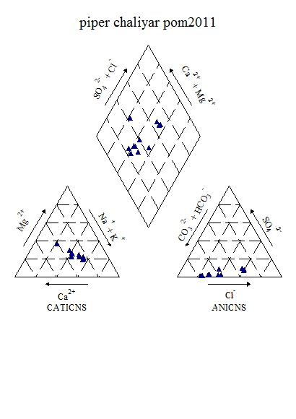

Figure 6.6k : Piper’s Classification of Chaliyar water (post-monsoon, 2011)

From the piper diagram, during post-monsoon 2011shows the water belongs to CaHCO3 followed by mixed CaMgCl types. During pre-monsoon 2012, the water belongs to CaHCO3, NaCl and mixed CaNaHCO3 types.

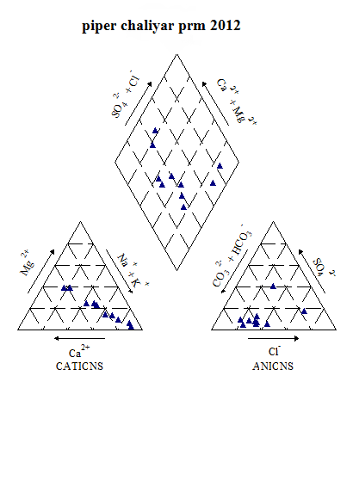

Figure 6.6l: Piper’s Classification of Chaliyar water (pre-monsoon, 2012)

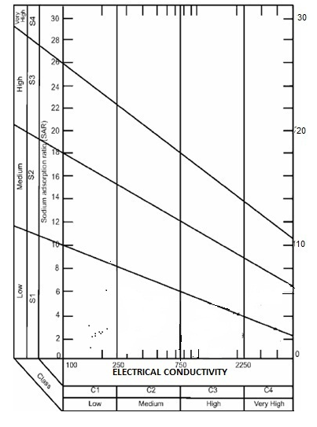

**Figure6.6m : USSL Classification of Chaliyar (post-monsoon, 2011)**

The USSL classification shows the water during post-monsoon 2011 fall under C1S1 and belongs to Low sodium and low salinity type. During pre-monsoon 2012, the water fall under C1S1, C2S2 and C3S3 and belongs to low to medium sodium and low salinity to high salinity category.

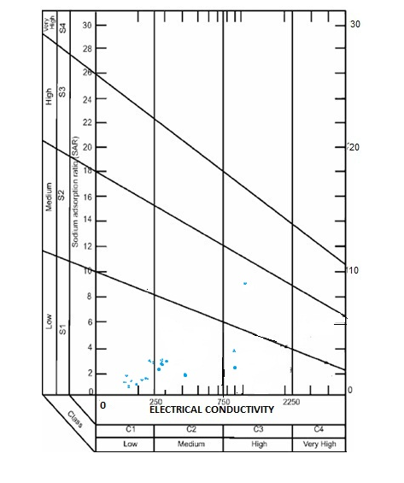

**Figure 6.6n: USSL Classification of Chaliyar (pre-monsoon, 2012)**

**6.7. Periyar River Basin**

The river Periyar, the longest river of the state (PWD,1974; CESS,1984) is considered to be the life line of Central Kerala. It originates from the Sivagiri peaks (1800m MSL) of Sundaramala in Tamil Nadu. The total length is about 300Kms (244Kms in Kerala) with a catchment area of 5396Sq Kms (5284 Sq. Kms in Kerala). The total annual flow is estimated to be 11607cubic meters. During its journey to Arabian Sea at Cochin the river is enriched with water of minor tributaries like Muthayar, Perunthuraiar, Chinnar, Cheruthony, Kattappanayar and Edamalayar at different junctures. Periyar has been performing a pivotal role in shaping the economic prospects of Kerala, as it helps in power generation, domestic water supply, irrigation, tourism, industrial production, collection of various inorganic resources and fisheries. However, as in the case of many other inland water bodies, River Periyar is gradually undergoing eco-degradation throughout its course of flow due to various anthropogenic stresses, which include indiscriminate deforestation, domestic-agricultraindustrial water pollution, excessive exploitation of resources, large scale sand mining, various interferences in the flow of water etc.

About 35% of the area of Periyar basin is forests. But some of these areas have already been cleared for various developmental activities. In the highland region, the major human activities are connected with plantation, hydroelectric projects and newsettlements and building activities in the Idukki district. While the plantation in the very high reaches such as Udumpenchola, Peerumedu and Devikulam are cardamom, tea and pepper, the foothills are cultivated with rubber, coconut and pepper. The midland belt has mainly paddy, coconut and plantains. The irrigation projects of the basin are intended to cater to the requirements of mainly the midland crops. The waste lands cover only 5-8% of the total basin area. These are situated in the highest peaks or the coastal saline belts in the low land. The major industries and settlements are in the lower reaches, especially in the Alwaye, Ernakulam belt.

**A Brief history of Water Quality Problems in Periyar**

A pioneer study on pollution aspects of Periyar river by Paul and Pillai (1976) provides valuable baseline information towards this direction. The study report discusses various important parameters like river discharges at different points, influence of tidal influx in the lower reaches, effluent dilution due to discharge of fresh water from unpolluted area, distribution of radioactivity in sediment-water- biota, concentration of other pollutants like heavy metals, inorganic compounds etc. Jayapalan et al(1976) explored some aspects of physico-chemical and biological variations of Periyar water due to the effluent discharge from FACT. Remani et al(1980) analysed the chemical composition of sediments of Cochin backwaters in relation to the pollution. Further Remani et al(1983) listed the indicator organisms of pollution in the same water body. Fluctuations in the spatial distribution of phytoplankton in the pollution affected zones of Periyar river in relation to certain physico-chemical parameters have been reported by Joseph et al (1984). Joy(1989) made a detailed assessment of the water quality of Periyar river and observed growth response of phytoplankton community so as to predict the probable effect of continued discharge of complex effluents from industries on such organisms. The two major phases of this attempt was 1) Field observation of hydrological factors and its correlation to standing stock of phytoplankton and 2) Algal assays on pure cultures using industrial effluents. Green Peace Reports (1999,2003) describe Eloor industrial area as one of the most vulnerable industrially polluted “hot spots” in the world. Recently they have appointed a full time river keeper to regularly monitor the industrial pollution load of river Periyar.

The results of the analysis of various polluting factors of the river water from three stations revealed that Periyar is being continuously poisoned by factories leading to its death in all aspects. Following is the brief narration of various factors of contamination in the river, consolidated from available literature.

***Radioactivity***

The results of the analysis of radionuclides in sediment, water and biota in the lower reaches of Periyar river is documented in the study report of Paul and Pillai(1976). 228 Ra concentration near the IRE outfall area recorded as high. The levels of 228 Ra of river water were found to be above 0.3(MPC)w on 30% of the random samples analysed. The analysis of sediment has indicated beta activity of 248pCi/gm. Rock phosphate processed in FACT was also registered beta radioactivity of 228pCi /gm. Comparing the gross beta activity levels of monazite(10pCi/gm) and rock phosphate(228pCi/gm), it is found that about 35 tonnes of rock phosphate contributes gross beta activity equivalent to 1tonne of monazite. Hence it may be concluded that a part of the environmental radioactivity is contributed by FACT operations also. Gamma spectra analysis of body parts of three species of edible fishes ie. Aries(Koori), Clupea(Palankanny) and Etroplus(Karimeen) showed significant level of radioactive contamination due to 232 Th . Similar incidence was noted in the case of analysis of certain aquatic weeds like *Eichornia crassipus*. Roots of the plants which are submerged in water exhibited twice the activity as compared with the rest. It was further noticed that the floating community of weeds could transport the radionuclides to distant places throughout the downstream (Paul and Pillai,1976).

Paul and Pillai(1986) probed the transportation of radium in the sediments of Periyar river. Again Paul and Pillai(1990) noted considerable reduction in the radioactivity by a factor of 3 to 5 during the post monsoon, base line, 1980 as compared to pre-monsoon mainly due to the better effluent treatment facility. The study concluded that 226 Ra in the bottom sediments was due to leaching of the nuclides from the phosphogypsum dump sites of the fertilizer factory.

**Trace/ Heavy Metals**

Preliminary reports of the trace/heavy metal concentration in the pollution affected angles of Periyar river is given by Paul and Pillai(1976). Trace elements concentrations in the downstream locations were found to be higher than that of upstream. High Hg content near TCC, elevated concentrations of Copper, Zinc and Cadmium near Binani Zinc and TCC were some of the highlights of the data. Incidentally, slightly increased concentration of Hg was noted in some of the edible fishes, likewise, the levels of Mn, Cd and F were noted to be higher in sediments and water column of the affected areas of the river. Interestingly, an extensive study by NEERI(1992) on water quality of Periyar river from Bhoothathankettu to Eloor ferry ie total 9 stations, recorded comparatively very low level of trace metals in water. Zn, Cd and Hg were reported to be below detectable level. Only the F level was found to be slightly higher. The load of Hg in Periyar river from various sources was estimated as 0.6 kg per day(KSPCB,1981). Comparatively higher concentration of Cu and Zn in bottom sediments was recorded and it was considered as one of the reason for absence of bottom fauna in the polluted zone of Periyar river.

**Nutrients**

Periodical enrichment of water bodies with potential plant nutrients like PO4, NO3, SiO2, SO4 is considered as primary step towards ‘Eutrophication’ of aquatic habitats. The concentration of these nutrients in the different stretches of Periyar river has been discussed elsewhere. Irrespective of the presence of higher quantities of the phosphate and nitrate in the lower reaches of Periyar, this area does not exhibit increase in primary production or profuse growth of algae.

***Nitrate***

Paul and Pillai(1976) observed considerably high concentration of nitrate in water samples from varapuzha to Alwaye ie.Methanam-8.57 ppm, IRE-8.53ppm and TCC-5.5ppm, whereas, a comparatively lesser quantity of nitrate was noted by Joseph et. al. (1984) from Alupuram(1.85 μg/l to 5.48μg/l/L), FACT(4.66μg/l to 6.10μg/l) and Eloor(4.66μg/l to 7.07μg/l). CPCB (1995 and 2000)had given an estimate of nitrate with nitrite river water from three stations ie.Kalady, Sewage disposal zone and Alwaye. NEERI(1992) recorded a highest value of 0.55mg/l(Kodanadu) and lowest value of 1.9mg/l (Kuttikattukara) in river waters. The average value at Eloor Ferry was 1.54mg/l. Joy(1989) observed higher levels of nitrate in Periyar river (maximum of 406μg/l). Many investigators report a gradual rise nitrate concentration in Cochin backwaters (Sankaranarayanan and Qasim,1969; Devassi and Bhattathiri, 1974; Remani et al.,1980; Lakshmanan et al., 1987).

***Phosphate***

Higher phosphate values were recorded in polluted region of Periyar river by Paul and Pillai(1976) ie. 160μg/l(Varapuzha), 640μg/l to 910μg/l (Methanam) and 630μg/l (IRE). In contrast, Jayapalan et al. (1976) observed only negligible amount of inorganic phosphate in the industrial zone of the river. However, later studies showed increasing trend of phosphate enrichment. Joseph et al. (1984) registered a peak value of 955μg/l in polluted zone of the river and NEERI (1992) recorded phosphate level as 0.7ppm near Marthandavarma Bridge and 0.5 in the Eloor ferry region.

The rate of phosphate discharge from various sources has been given as 9500 kg per day(SPCB,1981). Joy(1989) recorded a maximum value of 64.58μg/l of phosphate from pollution affected region of the river.

**Ammonia**

Joseph et al (1984) observed considerably higher concentration of free ammonia in polluted area of Periyar river, especially in pre-monsoon period (288μg/l –FACT; 215μg/l –Eloor). Values showed very significant increase in FACT and Eloor area when cited against an immediate upstream, just above the discharge. Joy(1989) noted increased level of free ammonia in the regions of industrial discharge (Edayar-Eloor area) of the river, ranged between 0.14 to 65.71μg/l. Saraladevi et al (1979) noted the presence of ammonia in the effluents of many factories situated here, which ranged between 0.1 to 3.0ppm. It may be recalled that the unionized form of ammonia is poisonous to organisms.

According to KSPCB (2000) the range of free ammonia at sewage disposal point was 0.005 to 0.023mg/l. This report also gives an estimate of total kjeldahl nitrogen from three stations in river.

**Nitrite**

Joy (1989) noticed the range of nitrite in the Periyar river water as 0.0 to 48μg/l.

***Sulphate***

High level of sulphate in industrial zone of Periyar river water was recorded by Paul and Pillai(1976), ie. Varapuzha-460ppm; Methanam-160ppm and IRE-100ppm. According to KSPCB(1981) the daily sulphate load into the Periyar river was 7500Kg/day.

**Chemical Oxygen Demand (COD)**

Data on Chemical Oxygen Demand is furnished in the report of CPCB(1995 and 2000). Maximum values were 6.4 in 1995 (Kalady, sewage disposal point and Alwaye) and 11 in 2000 (Alwaye).

As discussed above number of water quality problems were reported from various sections of the Periyar. However, in the present study, the average concentration all over the river stretch showed that major anions and cations are well within the desirable ranges. It is highly essential to note that water quality variation are highly time dependent, seasonal and varies according to the flow conditions. Though, the river is pristine for most of the stretch in the upper catchment zones, but it started showing deterioration from Eloor downstream. These are locations where there are number of industries located. Total hardness, calcium and magnesium concentration showed an increasing trend from pre-monsoon 2008, post-monsoon 2009 to pre-monsoon 2009. It also showed that there is a decline in concentration during the post-monsoon due to dilution and higher flow condition.

Dissolved oxygen is one of the prime parameter which needs regular monitoring as it is necessary to sustain aquatic biota and it also provides a self purification capacity of water. Biodegradation of dissolved, suspended and deposited organic materials depends on oxygen, as also on the respiration of aquatic biota. If the river is heavily loaded with organic materials, the amount of oxygen consumed may be more than what can be absorbed through the samples. BOD of the samples remained less than 5 mg/l for most part of the year. The stretch between Angamaly and Kochi is a highly industrialized zone in the Periyar. There are number of industries (more than 200), including Hindustan Insecticide Limited (HIL), Fertilizers and Chemical Travancore Limited (FACT), Indian Rare Earths Ltd., Travancore Cochin Chemicals, Cochin Minerals and Rutile Ltd. These industries take considerable amount of fresh water from the river and also discharge effluents treated or partially treated. Detailed analyses were carried during this study period (Chemical analysis results are awaited).

The river quality data show that Periyar and Chitrapuzha rivers are meeting designated water quality parameters except for DO at Brahmapuram and Manackakadavu. The high coliform count at Kalady and the lowering of DO at Brahmapuram, Manackakadavu and Irumpanam are influenced by non industrial sources. Even though 95 % of household in Kerala have toilet facilities, only 1.1 % are connected to common sewerage system. The rest of the householders and institutions are depending on on-site sanitation, the inadequacies of which also contribute to the pollution. The lowering of DO is attributable to agglomeration of residential buildings and high rise apartment buildings in and around Kakkanad, which houses the District administration Head quarters and many IT industries and also due to the stagnation caused due to silt deposition due to run off from agricultural farms. The area has no sewerage coverage. Provision of sewerage and sewage treatment for the fast developing residential area is an urgent necessity. Chitrapuzha river, a subsidiary of Periyar river is a part of Cochin estuary. It receives effluents from a major fertilizer plant, an oil refinery, and a petrochemical factory. Analysis of physical parameters of Chitrapuzha river revealed the lowest temperature during post monsoon period followed by monsoon period. Temperature

values were high during pre-monsoon period. Similar observations in temperature were made by Pillai et al***.*** (1975)and Balakrishnan and Shynamma (1976).The variation in temperature was mainly due to the atmospheric temperature and due to the influence of effluents. Temporal spatial variations of major anions, cations and bacteriological characteristics are shown below.

Figure 6.7a: Seasonal variation of water quality parameters in Periyar river

Figure 6.7b: Spatial variation of major cations along the river Periyar (Upstream to downstream) during Premonsoon 2008

Figure 6.7c: Spatial variation of major anions along the river Periyar (Upstream to downstream) during Premonsoon 2008

Figure 6.7d: Spatial variation of bacteriological parameters along the river Periyar (Upstream to downstream) during Premonsoon 2008

Figure 6.7e: Spatial variation of major cations along the river Periyar (Upstream to downstream) during Postmonsoon 2008

Figure 6.7f: Spatial variation of major anions along the river Periyar (Upstream to downstream) during Postmonsoon 2008

Figure 6.7g: Spatial variation of bacteriological parameters along the river Periyar (Upstream to downstream) during Postmonsoon 2008

Figure 6.7h: Spatial variation of major cations along the river Periyar (Upstream to downstream) during Premonsoon 2009

Figure 6.7i: Spatial variation of major anions along the river Periyar (Upstream to downstream) during Premonsoon 2009

Figure 6.7j: Spatial variation of bacteriological parameters along the river Periyar (Upstream to downstream) during Premonsoon 2009

Field investigations were carried out along the stretch of the Periyar during post-monsoon 2011 and pre-monsoon 2012, where from most contaminants are reported. The result of the chemical analysis is shown in the table below.

Table 6.7a: Variation of Water Quality parameters in Periyar during post-monsoon 2011

|  |  |  |  |  |  |
| --- | --- | --- | --- | --- | --- |
| **Parameters** | **UNIT** | **Min** | **Max** | **Mean** | **Std dev** |
| **Temp** | **°C** | 22.00 | 31.00 | 27.73 | 2.62 |
| **Ph** | **-** | 5.43 | 6.62 | 6.22 | 0.33 |
| **Turbidity** | **NTU** | 0.60 | 9.50 | 3.91 | 2.85 |
| **EC** | **MicroSeimens/cm** | 37.61 | 6178.00 | 459.71 | 1581.95 |
| **TDS** | **Mg/l** | 19.56 | 3287.00 | 244.12 | 841.80 |
| **Alkalinity** | **Mg/l** | 12.00 | 25.00 | 18.13 | 4.02 |
| **T H** | **Mg/l** | 12.00 | 720.00 | 65.07 | 181.23 |
| **Calcium** | **Mg/l** | 4.00 | 76.00 | 11.07 | 18.06 |
| **Magnesium** | **Mg/l** | 0.97 | 156.49 | 13.12 | 39.68 |
| **Chloride** | **Mg/l** | 7.50 | 1924.40 | 138.63 | 494.02 |
| **Sodium** | **Mg/l** | 2.15 | 1250.00 | 86.37 | 321.91 |
| **Potassium** | **Mg/l** | 0.91 | 36.18 | 3.62 | 9.01 |
| **Sulphate** | **Mg/l** | 0.85 | 93.37 | 13.54 | 30.05 |
| **Fluoride** | **Mg/l** | 0.13 | 0.46 | 0.23 | 0.08 |
| **Nitrate** | **Mg/l** | 0.19 | 0.89 | 0.49 | 0.19 |
| **Iron** | **Mg/l** | 0.01 | 2.11 | 0.35 | 0.53 |
| **DO** | **Mg/l** | 3.40 | 8.90 | 6.83 | 1.74 |

Table 6.7b: Variation of Water Quality parameters in Periyar during pre-monsoon 2011

|  |  |  |  |  |  |
| --- | --- | --- | --- | --- | --- |
| **Parameters** | **UNIT** | **Min** | **Max** | **Mean** | **Std dev** |
| **Ph** | **-** | 5.65 | 6.61 | 6.05 | 0.36 |
| **Turbidity** | **NTU** | 1.20 | 8.80 | 3.55 | 2.02 |
| **EC** | **Micro Seimens/cm** | 32.32 | 2373.00 | 217.15 | 597.04 |
| **TDS** | **Mg/l** | 16.86 | 1235.00 | 113.38 | 310.63 |
| **Alkalinity** | **Mg/l** | 10.00 | 42.00 | 18.13 | 8.83 |
| **Acidity** | **Mg/l** | 2.00 | 6.00 | 2.67 | 1.23 |
| **T H** | **Mg/l** | 10.00 | 315.00 | 36.60 | 77.20 |
| **Calcium** | **Mg/l** | 2.00 | 76.15 | 10.28 | 18.30 |
| **Mg** | **Mg/l** | 0.97 | 58.00 | 6.39 | 14.32 |
| **Bicarbonate** | **Mg/l** | 10.00 | 42.00 | 18.13 | 8.83 |
| **Chloride** | **Mg/l** | 6.00 | 650.00 | 52.33 | 165.36 |
| **Sodium** | **Mg/l** | 1.69 | 278.00 | 22.01 | 70.83 |
| **Potassium** | **Mg/l** | 0.86 | 10.57 | 2.17 | 2.42 |
| **Sulphate** | **Mg/l** | 1.80 | 70.78 | 7.10 | 17.63 |
| **Phosphate** | **Mg/l** | 0.02 | 0.10 | 0.03 | 0.02 |
| **Fluoride** | **Mg/l** | 0.14 | 0.39 | 0.24 | 0.07 |
| **Nitrate** | **Mg/l** | 0.26 | 0.89 | 0.47 | 0.20 |
| **Iron** | **Mg/l** | 0.06 | 0.97 | 0.29 | 0.25 |
| **DO** | **Mg/l** | 4.30 | 10.60 | 7.23 | 1.64 |
| **Bio COD** | **Mg/l** | 0.10 | 4.20 | 1.13 | 0.98 |
| **COD** | **Mg/l** | 2.00 | 92.00 | 16.67 | 24.97 |
| **Bacteriology** |  |  |  |  |  |
| **Total coliform** | **MPN/100ml** | 100.00 | 7100.00 | 1263.64 | 2046.10 |
| **E-Coli** | **MPN/100ml** | 100.00 | 2600.00 | 1350.00 | 1767.77 |

Factor analyses were conducted for both post-monsoon 2011 and pre-monsoon 2012 to understand the loading of various ions. The eigen values,fraction of variance and percentage of cumulative variance are given in table 7c and 7d.

Table 6.7c: Factor Analysis results of Periyar during post-monsoon (2011)

|  |  |  |  |  |
| --- | --- | --- | --- | --- |
| Sl.No. | Parameter | Factor 1 | Factor 2 | Factor 3 |
| 1 | Alkalinity | 0.461 | 0.550 | 0.570 |
| 2 | Fluoride | 0.796 | 0.217 | 0.202 |
| 3 | Total hardness | 0.997 | 0.017 | 0.034 |
| 4 | Chloride | 0.998 | 0.010 | 0.016 |
| 5 | EC | 0.998 | 0.013 | 0.018 |
| 6 | TDS | 0.998 | 0.014 | 0.018 |
| 7 | Iron | -0.060 | -0.065 | 0.879 |
| 8 | Calcium | 0.992 | 0.034 | 0.006 |
| 9 | pH | -0.223 | -0.725 | 0.148 |
| 10 | Nitrate | -0.448 | 0.780 | 0.140 |
| 11 | Magnesium | 0.997 | 0.015 | 0.037 |
| 11 | Sulphate | 0.991 | -0.017 | 0.027 |
| 12 | Sodium | 0.998 | 0.012 | 0.016 |
| Eigen Value | | 9.692 | 1.646 | 1.090 |
| Fraction of variance, % | | 69.003 | 10.783 | 8.983 |
| Cumulative fraction of variance, % | | 69.003 | 79.786 | 88.769 |

Table 6.7d: Factor Analysis results of Periyar during pre-monsoon (2012)

|  |  |  |  |  |
| --- | --- | --- | --- | --- |
| Sl.No. | Parameter | Factor 1 | Factor 2 | Factor 3 |
| 1 | Alkalinity | -0.209 | 0.908 | -0.031 |
| 2 | Fluoride | 0.297 | 0.081 | 0.947 |
| 3 | Phosphate | 0.929 | 0.072 | 0.320 |
| 4 | Total hardness | 0.971 | 0.016 | 0.235 |
| 5 | Chloride | 0.967 | -0.034 | 0.246 |
| 6 | EC | 0.969 | -0.017 | 0.241 |
| 7 | TDS | 0.969 | -0.016 | 0.239 |
| 8 | Iron | 0.297 | 0.081 | 0.947 |
| 9 | Potassium | 0.938 | 0.167 | 0.261 |
| 10 | Calcium | 0.965 | 0.023 | 0.248 |
| 11 | pH | 0.255 | 0.707 | 0.169 |
| 12 | Nitrate | 0.642 | 0.242 | 0.005 |
| 13 | Magnesium | 0.972 | 0.014 | 0.231 |
| 14 | Sulphate | 0.967 | -0.039 | 0.246 |
| 15 | Sodium | 0.968 | -0.032 | 0.244 |
| Eigen Value | | 11.027 | 1.566 | 1.239 |
| Fraction of variance, % | | 66.265 | 9.557 | 16.391 |
| Cumulative fraction of variance, % | | 66.265 | 75.822 | 92.213 |

During post-monsoon 2011, three factors show Eigen values more than 1, thus these three factors are chosen for further analysis. Factor 1 shows 69.00% variance. This factor has positive loadings and strongly associated with EC and TDS (0.99), fluoride (0.80),total hardness (0.99), chloride (0.99), calcium,magnesium, sodium and sulphate (0.99).Factor 2 shows 10.78% variance. This factor has positive loadings on nitrate (0.78) and moderately on alkalinity (0.55). Factor 3 shows 8.98% variance. This factor has positive loadings on iron (0.88) and moderately on alkalinity (0.57).

During pre-monsoon 2012, three factors show Eigen values more than 1.Factor 1 shows 66.26% variance. This factor has high positive loadings and strongly associated with phosphate (0.92), total hardness (0.97), chloride (0.97), EC and TDS (0.97), calcium (0.96), magnesium (0.97), sulphate (0.96), sodium (0.97) and potassium (0.94). Factor 2 shows 9.55% variance. This factor has positive loadings on alkalinity (0.91 and pH (0.71). Factor 3 shows 16.39% variance. This factor has positive loadings and strongly associated with iron and fluoride (0.94).

The water quality indices estimated by using CCME and Bascaron methods are presented below (Table 7e)

Table 6.7e: Overall CWQI and WQI Estimated values of Periyar basin for the selected station (2008-2012)

|  |  |  |  |  |  |  |
| --- | --- | --- | --- | --- | --- | --- |
| **Station** | **Methods** | **Pre -monsoon 2008** | **Post -monsoon 2008** | **Pre - monsoon 2009** | **Post -monsoon 2011** | **Pre -monsoon 2012** |
| Aluva | WQI | 50.98361 | 54.91803 | 74.2623 | 70.32787 | 78.85246 |
| CCME(WQI) | 79 | 79 | 81 | 67 | 74 |
| Aluva Manappuram | WQI | 70.98361 | 68.03279 | 59.5082 | - | - |
| CCME(WQI) | 76 | 63 | 81 | - | - |
| Bhoothathankettu | WQI | 64.59016 | 55.7377 | 75.2459 | 81.96721 | 68.52459 |
| CCME(WQI) | 86 | 45 | 90 | 75 | 73 |
| Chelamattom | WQI | 51.47541 | 61.31148 | 73.60656 | 74.7541 | 68.85246 |
| CCME(WQI) | 84 | 63 | 100 | 70 | 58 |
| Cheruthoni | WQI | - | - | - | 86.22951 | 78.68852 |
| CCME(WQI) | - | - | - | 74 | 79 |
| DO ds | WQI | 57.04918 | 61.31148 | - | - | - |
| CCME(WQI) | 75 | 47 | 89 | - | - |
| Edayar | WQI | 51.31148 | 60.98361 | 55.08197 | 45.40984 | 59.5082 |
| CCME(WQI) | 76 | 62 | 53 | 40 | 55 |
| Kaintinkara kadav | WQI | 53.77049 | 72.29508 | 72.78689 | - | - |
| CCME(WQI) | 76 | 69 | 89 | - | - |
| Kalady | WQI | 62.95082 | 68.36066 | 77.70492 | 73.44262 | 65.57377 |
| CCME(WQI) | 76 | 59 | 90 | 73 | 61 |
| Kalamassery | WQI | 57.04918 | 60.16393 | 68.03279 | 67.70492 | 75.57377 |
| CCME(WQI) | 76 | 70 | 79 | 50 | 61 |
| Karimban | WQI | - | - | - | 94.42623 | 67.86885 |
| CCME(WQI) | - | - | - | 78 | 69 |
| Malayattor | WQI | 52.62295 | 65.40984 | 59.01639 | 86.72131 | 81.80328 |
| CCME(WQI) | 86 | 59 | 90 | 84 | 72 |
| Mangalapuzha | WQI | 68.52459 | 64.7541 | 53.60656 | 71.63934 | 84.59016 |
| CCME(WQI) | 79 | 78 | 59 | 61 | 80 |
| Manjali | WQI | 58.19672 | 60.98361 | 49.18033 | - | - |
| CCME(WQI) | 78 | 89 | 54 | - | - |
| Manjappetty | WQI | 59.5082 | 59.01639 | 76.39344 | 85.90164 | 83.77049 |
| CCME(WQI) | 76 | 61 | 90 | 70 | 75 |
| Manjummel kadav | WQI | 50.4918 | 70.4918 | 36.39344 | - | - |
| CCME(WQI) | 75 | 73 | 54 | - | - |
| Mulankuzhy | WQI | 56.55738 | 75.2459 | 72.45902 | 76.55738 | 75.2459 |
| CCME(WQI) | 68 | 69 | 90 | 74 | 74 |
| Munambam | WQI | 27.86885 | - | - | - | - |
| CCME(WQI) | 38 | - | - | - | - |
| Neriyamanglam | WQI | 50.81967 | 54.91803 | 63.44262 | 83.77049 | 68.36066 |
| CCME(WQI) | 66 | 45 | 88 | 69 | 69 |
| Panamkutty | WQI | - | - | - | 76.55738 | 72.45902 |
| CCME(WQI) | - | - | - | 69 | 65 |
| Pathalam | WQI | 62.13115 | 68.85246 | 57.04918 | - | - |
| CCME(WQI) | 79 | 70 | 78 | - | - |
| Perumbavoor | WQI | 50.4918 | 51.96721 | 73.60656 | - | - |
| CCME(WQI) | 75 | 50 | 90 | - | - |
| Thekkady | WQI | 65.57377 | 66.22951 | 67.86885 | - | - |
| CCME(WQI) |  | 68 | 76 | - | - |
| Undekkadav | WQI | 53.93443 | 69.5082 | 69.34426 | - | - |
| CCME(WQI) | 87 | 64 | 68 | - | - |
| Varappuzha | WQI | 54.09836 | 65.08197 | 56.39344 | - | - |
| CCME(WQI) | 68 | 61 | 66 | - | - |
| Veliyathunadu | WQI | 56.39344 | 63.93443 | 68.85246 | - | - |
| CCME(WQI) | 62 | 87 | 87 | - | - |
| Vendiperiyar | WQI | 55.7377 | 62.95082 | 63.60656 | 76.72131 | 74.91803 |
| CCME(WQI) | 76 | 70 | 79 | 82 | 74 |

|  |  |  |  |  |  |  |  |
| --- | --- | --- | --- | --- | --- | --- | --- |
| Table 6.7f: CCME Score of Periyar (pre-monsoon, 2008-2012) | | | | | | | |
| **Data Summary** | **year** | **Overall** | **Drinking** | **Aquatic** | **Recreation** | **Irrigation** | **Livestock** |
| **CWQI** | **2008** | **58** | **61** | **39** | **100** | **60** | **88** |
| **2009** | **63** | **64** | **49** | **100** | **63** | **100** |
| **2012** | **57** | **51** | **45** | **100** | **80** | **100** |
| **F1 (Scope)** | **2008** | 60 | 57 | 75 | 0 | 67 | 20 |
| **2009** | 50 | 57 | 75 | 0 | 33 | 0 |
| **2012** | 60 | 71 | 75 | 0 | 33 | 0 |
| **F2 (Frequency)** | **2008** | 26 | 20 | 66 | 0 | 9 | 1 |
| **2009** | 19 | 12 | 37 | 0 | 7 | 0 |
| **2012** | 33 | 33 | 56 | 0 | 3 | 0 |
| **F3 (Amplitude)** | **2008** | 30 | 29 | 37 | 0 | 14 | 0 |
| **2009** | 35 | 20 | 29 | 0 | 54 | 0 |
| **2012** | 28 | 32 | 17 | 0 | 11 | 0 |

|  |  |  |  |  |  |  |  |
| --- | --- | --- | --- | --- | --- | --- | --- |
| Table 6.7g: CCME Score of Periyar (post-monsoon, 2008-2012) | | | | | | | |
| **Data Summary** | **year** | **Overall** | **Drinking** | **Aquatic** | **Recreation** | **Irrigation** | **Livestock** |
| **CWQI** | **2008** | **61** | **57** | **47** | **100** | **100** | **100** |
| **2011** | **56** | **50** | **46** | **100** | **75** | **100** |
| **F1 (Scope)** | **2008** | 40 | 43 | 75 | 0 | 0 | 0 |
| **2011** | 60 | 71 | 75 | 0 | 33 | 0 |
| **F2 (Frequency)** | **2008** | 31 | 29 | 49 | 0 | 0 | 0 |
| **2011** | 31 | 31 | 51 | 0 | 2 | 0 |
| **F3 (Amplitude)** | **2008** | 45 | 53 | 19 | 0 | 0 | 0 |
| **2011** | 36 | 40 | 21 | 0 | 27 | 0 |

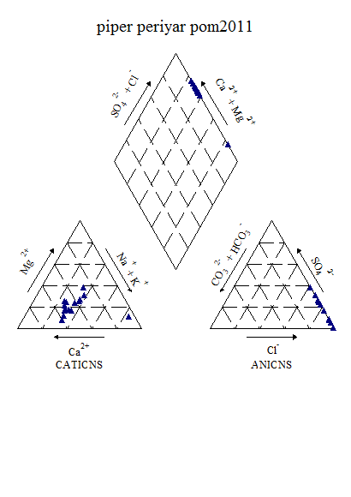

Figure 6.7k : Piper’s Classification of Periyar water (post-monsoon, 2011)

The results drawn from the piper diagram shows that, the water belongs to CaCl type during post-monsoon 2011 and CaHcO3 type during pre-monsoon 2012.

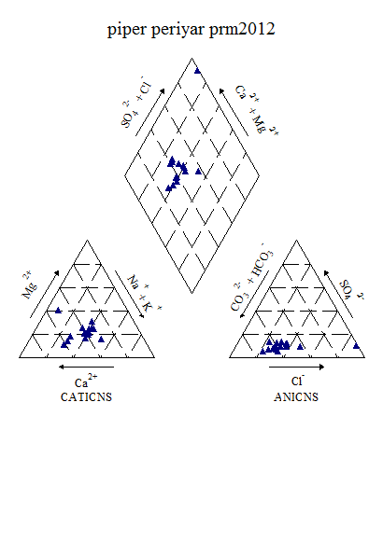

Figure 6.7l: Piper’s Classification of Periyar water (pre-monsoon, 2012)

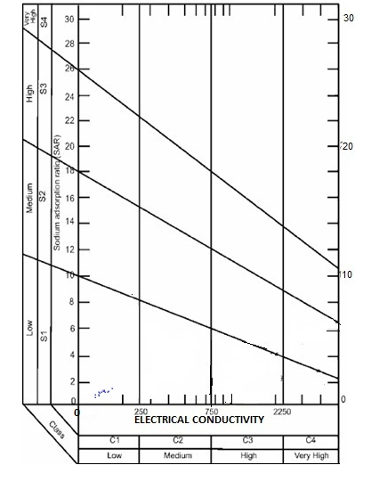

**Figure6.7m: USSL Classification of Periyar (post-monsoon, 2011)**

From the USSL diagram, during post-monsoon 2011, the water fall underC1S1 and belongs to low sodium to low salinity category. The same trend is followed during pre-monsoon 2012 also.

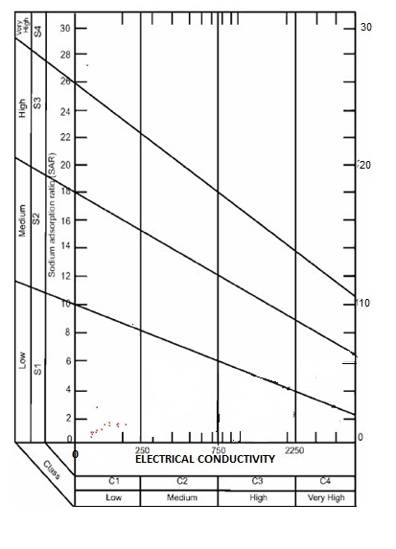

**Figure6.7n: USSL Classification of Periyar (pre-monsoon, 2012)**

**6.8.MuvattupuzhaRiver Basin**

It originates in Idukki district, flows through Ernakulam district to merge into Vembanad Lake and to the Arabian Sea. It is the combination of Thodupuzha River, Kaliyar River and Kothamangalam River. There is a Dam constructed for Irrigation purpose and for small Hydro Electric Project at Malankara near Thodupuzha. The famous Thommankuthu Waterfall is in this river.

Muvattupuzha river is one of the major perennial rivers in Central Kerala.The river empties into Cochin estuary which has a permanent opening, i.e.Cochin bar mouth, through which tides affect the inland water courses. The Pulp & Paper Mill,y, Hindustan Newsprint Limited situated on the bank of the Muvattupuzha river, discharges its effluents into the river. The pulp-paper mill effluents carry heavy load of biodegradable organic substances (Hunter and Faust, 1971) and other pollutants (Klein, 1957; Todd, 1970).The major by-products of this industry consist of the breakdown products of ligninand some amount of cellulosic material (Dugan, 1972). The effluents from the pulp paper factories cause water pollution and affect the riverine biota.

Temperature values were minimum during post-monsoon season and maximum during pre-monsoon period. The temperature fluctuation observed was mainly due to the discharge of effluents and atmospheric variations. In all the four stations, fluctuations in pH were observed. The average values of Total hardness, Alkalinity, calcium, magnesium, chloride and nitrate showed a gradual increase from season to season. However, there is a wide variation in the case of individual stations.Salinity values were high during pre-monsoon period and low during monsoon period. According to Abe et al., (1996) salinity variations in the downstream showed correlation with tides, while upstream showed less correlation with tidal fluctuations in Muvattupuzha river.

Free carbon dioxide produced in the natural unpolluted water can cause acidity. In the present investigation and also based on available literature, the concentration of free CO2reported was low. Comparatively higher values were observed during post-monsoon period. Total solids, both the suspended and dissolved solids were low in the river water as compared to standard values. Total dissolved solids were higher during pre-monsoon period and high values of total suspended solids were observed in post-monsoon period. Dissolved oxygen in all the sampling stations exhibited decreased values and was comparatively higher during monsoon. The effluents discharged into the river had low dissolved oxygen content, which in turn lowered the dissolved oxygen of the river water. The current observations are in accordance with that of Votintsev (1993) who noticed that effluents from pulp paper plants lower the oxygen content of water.

Figure 6.8a: Seasonal variation of water quality parameters in Muvattupuzha river

From the above figure it is found that, the average concentration of physico-chemical characteristics showed a gradual increase from pre-monsoon 2008 to premonsoon 2009. The maximum being observed during pre-monsoon 2009.

Figure6.8b:Spatial variation of major cations along the river Muvattupuzha (Upstream to downstream) during Premonsoon 2008

Figure 6.8c: Spatial variation of major anions along the river Muvattupuzha (Upstream to downstream) during Premonsoon 2008

Figure 6.8d: Spatial variation of bacteriological parameters along the river Muvattupuzha (Upstream to downstream) during Premonsoon 2008

Figure 6.8e: Spatial variation of major cations along the river Muvattupuzha (Upstream to downstream) during Postmonsoon 2008

Figure 6.8f: Spatial variation of major anions along the river Muvattupuzha (Upstream to downstream) during Postmonsoon 2008

Figure 6.8g: Spatial variation of bacteriological parameters along the river Muvattupuzha (Upstream to downstream) during Postmonsoon 2008

Figure 6.8h: Spatial variation of major cations along the river Muvattupuzha (Upstream to downstream) during Premonsoon 2009

Figure 6.8i: Spatial variation of major cations along the river Muvattupuzha (Upstream to downstream) during Premonsoon 2009

Figure 6.8j: Spatial variation of bacteriological parameters along the river Muvattupuzha (Upstream to downstream) during Premonsoon 2009

**Table6. 8a: Variation of Water Quality parameters in Muvattupuzha during post-**

**monsoon 2011**

|  |  |  |  |  |  |
| --- | --- | --- | --- | --- | --- |
| **Parameters** | **UNIT** | **Min** | **Max** | **Mean** | **Std dev** |
| **Temp** | **°C** | 27.00 | 31.00 | 28.86 | 1.13 |
| **Ph** | **-** | 5.81 | 6.81 | 6.27 | 0.23 |
| **Turbidity** | **NTU** | 1.30 | 4.70 | 2.72 | 1.04 |
| **EC** | **Micro Seimens/cm** | 44.10 | 1574.00 | 160.94 | 406.77 |
| **TDS** | **Mg/l** | 23.41 | 846.40 | 86.16 | 218.85 |
| **Alkalinity** | **Mg/l** | 12.00 | 18.00 | 16.00 | 2.22 |
| **T H** | **Mg/l** | 14.00 | 152.00 | 25.57 | 36.42 |
| **Calcium** | **Mg/l** | 4.00 | 18.00 | 6.86 | 3.57 |
| **Magnesium** | **Mg/l** | 1.94 | 32.56 | 4.55 | 8.07 |
| **Chloride** | **Mg/l** | 7.50 | 452.50 | 43.21 | 117.82 |
| **Sodium** | **Mg/l** | 2.61 | 280.30 | 23.18 | 74.01 |
| **Potassium** | **Mg/l** | 1.03 | 10.26 | 2.00 | 2.39 |
| **Sulphate** | **Mg/l** | 6.62 | 32.48 | 19.55 | 18.29 |
| **Phosphate** | **Mg/l** | 0.04 | 0.05 | 0.04 | 0.00 |
| **Fluoride** | **Mg/l** | 0.15 | 0.90 | 0.29 | 0.19 |
| **Nitrate** | **Mg/l** | 0.26 | 0.62 | 0.44 | 0.09 |
| **Iron** | **Mg/l** | 0.02 | 0.64 | 0.27 | 0.18 |
| **DO** | **Mg/l** | 5.60 | 8.90 | 7.21 | 1.06 |

**Table 6.8b: Variation of Water Quality parameters in Muvattupuzha during pre-monsoon 2012**

|  |  |  |  |  |  |
| --- | --- | --- | --- | --- | --- |
| **Parameters** | **UNIT** | **Min** | **Max** | **Mean** | **Std dev** |
| **Ph** | **-** | 5.64 | 6.59 | 6.13 | 0.27 |
| **Turbidity** | **NTU** | 0.80 | 6.50 | 2.84 | 1.52 |
| **EC** | **Micro Seimens/cm** | 52.24 | 304.60 | 86.54 | 76.27 |
| **TDS** | **Mg/l** | 27.77 | 166.60 | 47.19 | 41.78 |
| **Alkalinity** | **Mg/l** | 12.00 | 30.00 | 17.21 | 5.06 |
| **Acidity** | **Mg/l** | 1.00 | 4.00 | 2.00 | 0.68 |
| **T H** | **Mg/l** | 12.00 | 90.00 | 22.21 | 20.25 |
| **Calcium** | **Mg/l** | 4.00 | 30.00 | 6.71 | 6.78 |
| **Mg** | **Mg/l** | 1.94 | 14.57 | 3.77 | 3.41 |
| **Bicarbonate** | **Mg/l** | 12.00 | 30.00 | 17.21 | 5.06 |
| **Chloride** | **Mg/l** | 9.00 | 80.00 | 19.36 | 23.68 |
| **Sodium** | **Mg/l** | 3.00 | 27.12 | 6.24 | 7.11 |
| **Potassium** | **Mg/l** | 1.13 | 4.37 | 1.65 | 0.83 |
| **Sulphate** | **Mg/l** | 1.63 | 53.71 | 6.09 | 13.73 |
| **Phosphate** | **Mg/l** | 0.02 | 0.04 | 0.02 | 0.01 |
| **Fluoride** | **Mg/l** | 0.07 | 0.30 | 0.14 | 0.07 |
| **Nitrate** | **Mg/l** | 0.40 | 0.75 | 0.53 | 0.10 |
| **Iron** | **Mg/l** | 0.01 | 0.31 | 0.14 | 0.10 |
| **DO** | **Mg/l** | 4.90 | 8.50 | 7.23 | 1.05 |
| **Bio COD** | **Mg/l** | 0.10 | 1.70 | 0.90 | 0.55 |
| **COD** | **Mg/l** | 2.00 | 22.00 | 7.25 | 6.92 |
| **Bacteriology** |  |  |  |  |  |
| **Total coliform** | **MPN/100ml** | 100.00 | 1900.00 | 678.57 | 681.83 |
| **E-Coli** | **MPN/100ml** | 100.00 | 100.00 | 100.00 | #DIV/0! |

Factor analyses were conducted for both post-monsoon 2011 and pre-monsoon 2012 to understand the loading of various ions. The eigen values, fraction of variance and percentage of cumulative variance are given in table 7c and 7d.

**Table 6.8c: Factor Analysis results of Muvattupuzha during post-monsoon (2011)**

|  |  |  |  |  |  |
| --- | --- | --- | --- | --- | --- |
| Sl.No. | Parameter | Factor 1 | Factor 2 | Factor 3 | Factor 4 |
| 1 | Alkalinity | 0.202 | 0.889 | 0.212 | 0.220 |
| 2 | Fluoride | 0.894 | 0.297 | 0.116 | -0.211 |
| 3 | Phosphate | -0.029 | 0.063 | -0.813 | 0.394 |
| 4 | Total hardness | 0.993 | 0.066 | 0.086 | 0.034 |
| 5 | Chloride | 0.994 | 0.046 | 0.073 | 0.051 |
| 6 | EC | 0.994 | 0.050 | 0.073 | 0.046 |
| 7 | TDS | 0.994 | 0.051 | 0.074 | 0.046 |
| 8 | Iron | 0.201 | 0.157 | 0.819 | 0.381 |
| 9 | Potassium | 0.992 | 0.093 | 0.056 | -0.000 |
| 10 | Calcium | 0.878 | 0.277 | 0.219 | 0.112 |
| 11 | pH | 0.056 | 0.033 | -0.056 | 0.824 |
| 12 | Nitrate | 0.045 | 0.709 | -0.280 | -0.526 |
| 13 | Magnesium | 0.994 | 0.043 | 0.071 | 0.025 |
| 14 | Sulphate | 0.984 | 0.052 | -0.092 | 0.132 |
| 15 | Sodium | 0.995 | 0.044 | 0.074 | 0.049 |
| Eigen Value | | 9.838 | 1.534 | 1.455 | 1.179 |
| Fraction of variance, % | | 63.572 | 10.099 | 10.433 | 9.264 |
| Cumulative fraction of variance, % | | 63.572 | 73.671 | 84.104 | 93.368 |

**Table 6.8d: Factor Analysis results of Muvattupuzha during pre-monsoon (2012)**

|  |  |  |  |  |
| --- | --- | --- | --- | --- |
| Sl.No. | Parameter | Factor 1 | Factor 2 | Factor 3 |
| 1 | Alkalinity | 0.644 | 0.623 | 0.207 |
| 2 | Fluoride | -0.185 | -0.429 | -0.601 |
| 3 | Phosphate | -0.184 | 0.959 | 0.009 |
| 4 | Total hardness | 0.913 | 0.378 | 0.117 |
| 5 | Chloride | 0.513 | 0.850 | 0.085 |
| 6 | EC | 0.741 | 0.660 | 0.095 |
| 7 | TDS | 0.741 | 0.657 | 0.105 |
| 8 | Iron | 0.578 | -0.061 | -0.056 |
| 9 | Potassium | 0.900 | 0.424 | -0.000 |
| 10 | Calcium | 0.982 | 0.079 | 0.079 |
| 11 | pH | -0.301 | 0.079 | 0.791 |
| 12 | Nitrate | -0.341 | 0.139 | -0.850 |
| 13 | Magnesium | 0.843 | 0.507 | 0.132 |
| 14 | Sulphate | 0.973 | 0.175 | 0.088 |
| 15 | Sodium | 0.359 | 0.923 | 0.060 |
| Eigen Value | | 9.365 | 2.177 | 1.646 |
| Fraction of variance, % | | 45.190 | 30.532 | 12.199 |
| Cumulative fraction of variance, % | | 45.190 | 75.722 | 87.921 |

During post-monsoon 2011, four factors shows Eigen value more than 1. Factor 1 shows 63.57% variance. This factor has positive loadings on fluoride (0.89), total Hardness, chloride, EC, TDS, potassium, magnesium and sodium (0.99), calcium (0.88) and sulphate (0.98). Factor 2 shows 10.099% variance and has positive loadings on alkalinity (0.89) and nitrate (0.71). Factor 3 shows 10.43% variance and has positive loadings on iron (0.82). Factor 4 shows 9.264% variance and has positive loadings on pH (0.82).

During pre-monsoon 2012, three factors shows Eigen value more than1. Factor 1 shows 45.19% variance. This has positive loadings on Total Hardness (0.91), alkalinity (0.64), EC and TDS (0.74), potassium (0.90), calcium (0.98), magnesium (0.84 and sulphate (0.97) and moderately on chloride (0.51) and iron (0.58). Factor 2 shows 30.53% variance. This factor has positive loadings on alkalinity (0.62), phosphate (0.96), chloride (0.85), EC and TDS (0.66) and sodium (0.92). Factor 3 shows 12.19% variance and has positive loadings on pH (0.80).

The water quality indices estimated by using CCME and Bascaron methods are presented below (Table 7e)

**Table 6.8e: Overall CWQI and WQI Estimated values of Muvattupuzha basin for the selected**

**station (2008-2012)**

|  |  |  |  |  |  |  |
| --- | --- | --- | --- | --- | --- | --- |
| **Station** | **Methods** | **Pre -monsoon 2008** | **Post -monsoon 2008** | **Pre - monsoon 2009** | **Post -monsoon 2011** | **Pre -monsoon 2012** |
| Ammelthotty | WQI | 58.19672 | 62.13115 | 62.78689 | - | - |
| CCME(WQI) | 86 | 85 | 90 | - | - |
| Kakkadasserry | WQI | 58.68852 | 62.95082 | 71.96721 | 66.39344 | 62.91803 |
| CCME(WQI) | 79 | 72 | 88 | 69 | 70 |
| Kalampur | WQI | 57.86885 | 70.81967 | 69.34426 | 74.59016 | 67.37705 |
| CCME(WQI) | 79 | 70 | 80 | 69 | 67 |
| Kanjar | WQI | 56.55738 | 60.4918 | 61.14754 | 70.65574 | 71.31148 |
| CCME(WQI) | 83 | 88 | 89 | 61 | 73 |
| Kayanadu | WQI | 68.68852 | 70.16393 | 67.86885 | 73.77049 | 81.31148 |
| CCME(WQI) | 79 | 89 | 76 | 70 | 92 |
| Kothamangalam Egg. college Hostel | WQI | 64.7541 | 68.68852 | 59.83607 | 70.32787 | 76.06557 |
| CCME(WQI) | 75 | 72 | 89 | 71 | 75 |
| Malankara dam DS | WQI | 61.47541 | 64.7541 | 65.90164 | 74.91803 | 76.39344 |
| CCME(WQI) | 81 | 68 | 79 | 72 | 82 |
| Malankara dam | WQI | 68.85246 | 66.22951 | 57.86885 | - | - |
| CCME(WQI) | 84 | 69 | 86 | - | - |
| Muvattupuzha | WQI | 52.95082 | 60.4918 | 60.4918 | 78.52459 | 79.01639 |
| CCME(WQI) | 65 | 79 | 89 | 72 | 73 |
| Nadukkara | WQI | 59.83607 | 64.42623 | 62.13115 | - | - |
| CCME(WQI) | 85 | 73 | 90 | - | - |
| Pareekkanni | WQI | 65.7377 | 64.59016 | 56.55738 | 75.7377 | 74.91803 |
| CCME(WQI) | 79 | 72 | 66 | 62 | 66 |
| Piravom Bridge | WQI | 63.27869 | 73.93443 | 57.04918 | 76.88525 | 69.5082 |
| CCME(WQI) | 76 | 89 | 78 | 72 | 75 |
| Ramamangalam | WQI | 71.47541 | 68.19672 | 69.5082 | 71.96721 | 80.4918 |
| CCME(WQI) | 80 | 89 | 85 | 72 | 76 |
| Thodupuzha RG station | WQI | 59.5082 | 64.59016 | 76.06557 | 74.7541 | 70.81967 |
| CCME(WQI) | 69 | 80 | 89 | 71 | 67 |
| Thodupuzha Town | WQI | 64.7541 | 63.93443 | 60.32787 | 74.91803 | 68.36066 |
| CCME(WQI) | 86 | 68 | 89 | 73 | 70 |
| Thommenkutha | WQI | 68.03279 | 56.22951 | 61.31148 | - | - |
| CCME(WQI) | 87 | 62 | 84 | - | - |
| Vaikon | WQI | 66.72131 | 62.78689 | 44.2623 | 61.47541 | 69.01639 |
| CCME(WQI) | 63 | 70 | 62 | 46 | 70 |
| Vettickattumukku | WQI | 65.57377 | 61.63934 | 66.72131 | 69.5082 | 71.80328 |
| CCME(WQI) | 68 | 66 | 73 | 59 | 71 |

|  |  |  |  |  |  |  |  |  |  |  |  |
| --- | --- | --- | --- | --- | --- | --- | --- | --- | --- | --- | --- |
| **Table 6.8f: CCME Score of Muvattupuzha (pre-monsoon, 2008-2012)** | | | | | | | | | | | |
| **Data Summary** | **year** | **Overall** | **Drinking** | | **Aquatic** | | **Recreation** | | **Irrigation** | | **Livestock** | |
| **CWQI** | **2008** | **70** | **78** | | **56** | | **100** | | **81** | | **86** | |
|  | **2009** | **67** | **66** | | **48** | | **100** | | **76** | | **100** | |
|  | **2012** | **69** | **68** | | **46** | | **100** | | **100** | | **100** | |
| **F1 (Scope)** | **2008** | 44 | 33 | | 50 | | 0 | | 33 | | 25 | |
|  | **2009** | 50 | 57 | | 75 | | 0 | | 33 | | 0 | |
|  | **2012** | 40 | 43 | | 75 | | 0 | | 0 | | 0 | |
| **F2 (Frequency)** | **2008** | 23 | 16 | | 47 | | 0 | | 3 | | 2 | |
|  | **2009** | 16 | 7 | | 36 | | 0 | | 2 | | 0 | |
|  | **2012** | 29 | 27 | | 55 | | 0 | | 0 | | 0 | |
| **F3 (Amplitude)** | **2008** | 16 | 4 | | 32 | | 0 | | 0 | | 0 | |
|  | **2009** | 23 | 13 | | 32 | | 0 | | 24 | | 0 | |
|  | **2012** | 19 | 23 | | 11 | | 0 | | 0 | | 0 | |
| **Table 6.8g: CCME Score of Muvattupuzha (post-monsoon, 2008-2012)** | | | | | | | | | | | | |
| **Data Summary** | **year** | **Overall** | **Drinking** | **Aquatic** | | **Recreation** | | **Irrigation** | | **Livestock** | | |
| **CWQI** | **2008** | **71** | **77** | **57** | | **100** | | **81** | | **100** | | |
|  | **2011** | **57** | **51** | **45** | | **100** | | **80** | | **100** | | |
| **F1 (Scope)** | **2008** | 40 | 29 | 50 | | 0 | | 33 | | 0 | | |
|  | **2011** | 60 | 71 | 75 | | 0 | | 33 | | 0 | | |
| **F2 (Frequency)** | **2008** | 28 | 26 | 53 | | 0 | | 3 | | 0 | | |
|  | **2011** | 38 | 40 | 57 | | 0 | | 2 | | 0 | | |
| **F3 (Amplitude)** | **2008** | 13 | 10 | 16 | | 0 | | 3 | | 0 | | |
|  | **2011** | 22 | 25 | 13 | | 0 | | 7 | | 0 | | |

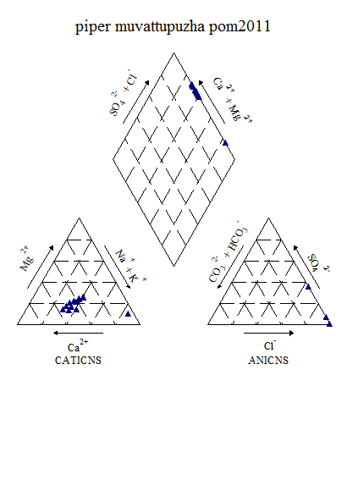

Figure 6.8k : Piper’s Classification of Muvattupuzha water (post-monsoon, 2011)

The piper diagram indicate during post-monsoon 2011that, the water belongs to CaCl type and during pre-monsoon 2012 it belongs to CaHCO3 type.

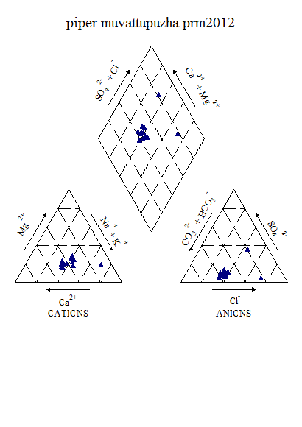

Figure 6.8l: Piper’s Classification of Muvattupuzha water (pre-monsoon, 2012)

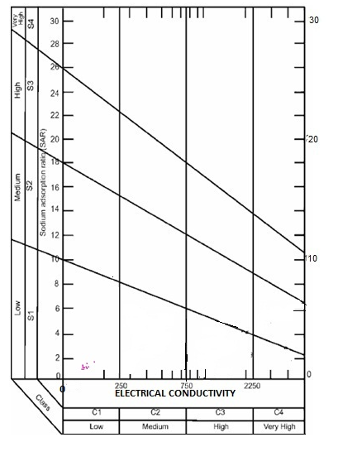

**Figure 6.8m: USSL Classification of Periyar (post-monsoon, 2011)**

The results drawn from USSL classification, during post-monsoon 2011, water fall under

C1S1 and belongs to Low sodium to low salinity type and the same trend is shown during pre-monsoon 2012 also.

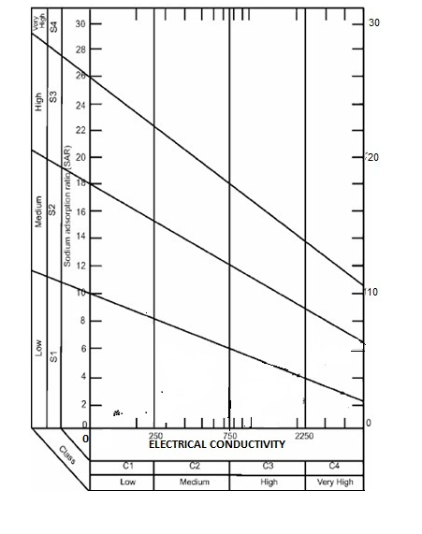

**Figure 6.8n: USSL Classification of Periyar (pre-monsoon, 2012)**

**6.9. Meenachil River Basin**

The Meenachil river flows through the heart of Kottayam district of Kerala state,India. The river is about 78 km long, flows through Poonjar, Teekov, Erattupetta, Palai, Ettumanoor and Kottayam before emptying itself into the Vembanad lake, Kumarkom, the famous tourist place of Kerala.

The Meenachil river is formed by several streams originating from the Western Ghats. The general elevation ranges from 77 m to 1156 m in the high lands and less than 2 m in the lowlands and 8 to 68 m in the midlands. The Meenachil has a watershed area of 1208.11 km². The river has a total annual yield of 2,349 million cubic meter and an annual utilizable yield of 1110 million cubic metre. The river has 38 tributaries including major and minor ones. The river has 47 sub watersheds and 114 micro watersheds. The source of this river areKullathukadavaru, Thrikovillaru, Poonjarapuzha, Chittur and Payyaparathodu. It flows through the city of Kottayam and joins Vembanad Lake.

The water quality analysis carried out during 2008 and 2009 shows that all the parameters were within the permissible limits, except pH and coliform contamination. The river water was found to be acidic (with pH less than 6.5) in many places. At Kumarakom, there was a drastic change in the water quality parameters which were much higher than other locations. This is quite evident by its location which is in the downstream side of the river and a highly disturbed area due to tourism and related activities. Parameters such as Electrical Conductivity (2.64 x 106 µS/cm), Total Dissolved Solids (2.337 x 106), Total Hardness (270 mg/l) and Magnesium (46.70 mg/l) were much higher than the permissible limits. It was also observed that DO is comparatively lower as compared to the other part of the river. The average concentrations plotted for various parameters indicate that there is a variation from season to season. Majority of the parameters showed considerable increase during the pre-monsoon of 2009.

The variation of water quality parameters of Meeanchil river during 2008 and 2009 is shown in figures 6.9a to6.9j.

Figure 6.9a: Seasonal variation of water quality parameters in Meenachil river

In the case of Meenachil ar wide variations are observed all along the stretch of the river from upstream to downstream. The station-wise variations are given in the figures below.

Figure 6.9b: Spatial variation of major cations along the river Meenachil (Upstream to downstream) during Premonsoon 2008

Figure 6.9c: Spatial variation of major anions along the river Meenachil (Upstream to downstream) during Premonsoon 2008

Figure 6.9d: Spatial variation of bacteriological parameters along the river Meenachil (Upstream to downstream) during Premonsoon 2008

Figure 6.9e: Spatial variation of major cations along the river Meenachil (Upstream to downstream) during Postmonsoon 2008

Figure 6.9f: Spatial variation of major anions along the river Meenachil (Upstream to downstream) during Postmonsoon 2008

Figure 6.9g: Spatial variation of bacteriological parameters along the river Meenachil (Upstream to downstream) during Postmonsoon 2008

Figure 6.9h: Spatial variation of major cations along the river Meenachil (Upstream to downstream) during Premonsoon 2009

Figure 6.9i: Spatial variation of major anions along the river Meenachil (Upstream to downstream) during Premonsoon 2009

Figure 6.9j: Spatial variation of bacteriological parameters along the river Meenachil (Upstream to downstream) during Pre-monsoon 2009.

Studies carried out during post-monsoon 2011 and pre-monsoon 2012(Table ) shows that all the chemical parameters within the permissible. However, bacteriological studies indicated that there is a large scale degradation in water quality due to anthropgenic disturbances.

**Table6. 9a: Variation of Water Quality parameters in Meenachil during post-**

**monsoon 2011**

|  |  |  |  |  |  |
| --- | --- | --- | --- | --- | --- |
| **Parameters** | **UNIT** | **Min** | **Max** | **Mean** | **Std dev** |
| **Temp** | **°C** | 24.00 | 29.00 | 26.90 | 1.66 |
| **Ph** | **-** | 5.62 | 6.29 | 5.93 | 0.22 |
| **Turbidity** | **NTU** | 1.30 | 2.90 | 2.07 | 0.54 |
| **EC** | **Micro Seimens/cm** | 37.81 | 54.50 | 44.10 | 4.97 |
| **TDS** | **Mg/l** | 19.17 | 29.34 | 23.09 | 2.95 |
| **Alkalinity** | **Mg/l** | 15.00 | 25.00 | 19.00 | 3.94 |
| **T H** | **Mg/l** | 10.00 | 20.00 | 14.00 | 2.83 |
| **Calcium** | **Mg/l** | 2.00 | 6.00 | 3.60 | 1.26 |
| **Magnesium** | **Mg/l** | 1.46 | 4.37 | 2.53 | 0.85 |
| **Chloride** | **Mg/l** | 7.50 | 15.00 | 10.50 | 2.30 |
| **Sodium** | **Mg/l** | 2.79 | 3.78 | 3.19 | 0.27 |
| **Potassium** | **Mg/l** | 1.01 | 1.34 | 1.16 | 0.09 |
| **Phosphate** | **Mg/l** | 0.04 | 0.06 | 0.05 | 0.01 |
| **Fluoride** | **Mg/l** | 0.11 | 0.37 | 0.20 | 0.09 |
| **Nitrate** | **Mg/l** | 0.20 | 0.61 | 0.43 | 0.13 |
| **Iron** | **Mg/l** | 0.02 | 1.42 | 0.33 | 0.42 |
| **DO** | **Mg/l** | 6.20 | 11.40 | 8.61 | 1.31 |

**Table 6.9b: Variation of Water Quality parameters in Meenachil during pre-**

**monsoon 2012**

|  |  |  |  |  |  |
| --- | --- | --- | --- | --- | --- |
| **Parameters** | **UNIT** | **Min** | **Max** | **Mean** | **Std dev** |
| **Temp** | **°C** | 26.00 | 29.00 | 28.00 | 1.05 |
| **Ph** | **-** | 5.62 | 6.95 | 6.31 | 0.42 |
| **Turbidity** | **NTU** | 1.60 | 29.00 | 9.07 | 10.54 |
| **EC** | **Micro Seimens/cm** | 27.25 | 58.65 | 41.89 | 11.58 |
| **TDS** | **Mg/l** | 14.04 | 30.02 | 21.62 | 5.96 |
| **Alkalinity** | **Mg/l** | 4.00 | 24.00 | 13.20 | 6.55 |
| **Acidity** | **Mg/l** | 2.00 | 6.00 | 4.00 | 0.94 |
| **T H** | **Mg/l** | 8.00 | 28.00 | 15.60 | 7.04 |
| **Calcium** | **Mg/l** | 4.00 | 8.00 | 5.00 | 1.70 |
| **Magnesium** | **Mg/l** | 1.00 | 4.86 | 2.54 | 1.30 |
| **Bicarbonate** | **Mg/l** | 4.00 | 24.00 | 13.20 | 6.55 |
| **Chloride** | **Mg/l** | 7.00 | 10.00 | 8.30 | 1.16 |
| **Sodium** | **Mg/l** | 1.73 | 3.89 | 2.41 | 0.66 |
| **Potassium** | **Mg/l** | 0.65 | 1.36 | 1.00 | 0.20 |
| **Sulphate** | **Mg/l** | 1.95 | 4.19 | 3.05 | 0.79 |
| **Phosphate** | **Mg/l** | 0.02 | 0.19 | 0.04 | 0.05 |
| **Fluoride** | **Mg/l** | 0.39 | 0.72 | 0.56 | 0.23 |
| **Nitrate** | **Mg/l** | 0.44 | 0.74 | 0.60 | 0.12 |
| **Iron** | **Mg/l** | 0.04 | 0.54 | 0.27 | 0.17 |
| **DO** | **Mg/l** | 6.40 | 10.60 | 8.03 | 1.34 |
| **Bio COD** | **Mg/l** | 0.30 | 6.90 | 2.15 | 1.84 |
| **COD** | **Mg/l** | 2.00 | 8.00 | 5.20 | 2.15 |
|  |  |  |  |  |  |
| **Bacteriology** |  |  |  |  |  |
| **Total coliform** | **MPN/100ml** | 1000.00 | 6100.00 | 4280.00 | 1418.76 |
| **E-Coli** | **MPN/100ml** | 100.00 | 1800.00 | 944.44 | 490.18 |

Factor analyses were conducted for both post-monsoon 2011 and pre-monsoon 2012 to understand the loading of various ions. The Eigenvalues, fraction of variance and percentage of cumulative variance are given in table 9c and 9d.

Table 6.9c: Factor Analysis results of Meenachil during post-monsoon (2011)

|  |  |  |  |  |  |
| --- | --- | --- | --- | --- | --- |
| Sl.No. | Parameter | Factor 1 | Factor 2 | Factor 3 | Factor 4 |
| 1 | Alkalinity | -0.373 | -0.146 | 0.492 | 0.634 |
| 2 | Fluoride | -0.097 | 0.238 | -0.754 | -0.527 |
| 3 | Phosphate | 0.144 | 0.217 | -0.309 | 0.873 |
| 4 | Total hardness | 0.272 | -0.907 | 0.125 | -0.171 |
| 5 | Chloride | 0.226 | 0.277 | -0.055 | 0.806 |
| 6 | EC | 0.954 | -0.048 | 0.249 | 0.025 |
| 7 | TDS | 0.970 | -0.025 | 0.196 | 0.029 |
| 8 | Iron | -0.456 | 0.174 | 0.798 | -0.052 |
| 9 | Potassium | 0.965 | -0.155 | 0.031 | 0.093 |
| 10 | Calcium | 0.268 | 0.667 | 0.398 | 0.011 |
| 11 | pH | 0.191 | 0.073 | 0.621 | -0.209 |
| 12 | Nitrate | 0.316 | 0.081 | 0.612 | -0.091 |
| 13 | Magnesium | 0.125 | -0.972 | -0.046 | -0.149 |
| 14 | Sodium | 0.846 | 0.005 | -0.127 | 0.098 |
| Eigen Value | | 4.333 | 2.905 | 2.473 | 1.814 |
| Fraction of variance, % | | 30.16 | 17.743 | 18.566 | 15.846 |
| Cumulative fraction of variance, % | | 30.16 | 47.903 | 66.469 | 82.315 |

Table 6.9d: Factor Analysis results of Meenachil during pre-monsoon (2012)

|  |  |  |  |  |  |
| --- | --- | --- | --- | --- | --- |
| Sl.No. | Parameter | Factor 1 | Factor 2 | Factor 3 | Factor 4 |
| 1 | Alkalinity | 0.695 | 0.436 | 0.512 | -0.017 |
| 2 | Fluoride | 0.588 | -0.064 | -0.184 | 0.730 |
| 3 | Phosphate | -0.160 | 0.123 | -0.796 | -0.226 |
| 4 | Total hardness | 0.952 | 0.212 | 0.113 | 0.058 |
| 5 | Chloride | 0.318 | 0.740 | -0.234 | -0.186 |
| 6 | EC | 0.762 | 0.641 | 0.002 | 0.071 |
| 7 | TDS | 0.780 | 0.611 | 0.023 | 0.051 |
| 8 | Iron | -0.153 | 0.045 | 0.295 | 0.868 |
| 9 | Potassium | -0.050 | 0.852 | -0.080 | 0.220 |
| 10 | Calcium | 0.865 | -0.225 | 0.279 | 0.029 |
| 11 | pH | 0.831 | 0.091 | -0.114 | -0.070 |
| 12 | Nitrate | -0.025 | -0.326 | 0.818 | -0.037 |
| 13 | Magnesium | 0.900 | 0.343 | 0.022 | 0.132 |
| 14 | Sulphate | -0.706 | 0.519 | 0.021 | 0.117 |
| 15 | Sodium | 0.135 | 0.854 | -0.320 | -0.153 |
| Eigen Value | | 6.662 | 3.321 | 1.698 | 1.203 |
| Fraction of variance, % | | 38.951 | 23.959 | 13.025 | 9.951 |
| Cumulative fraction of variance, % | | 38.951 | 62.91 | 75.935 | 85.886 |

During post-monsoon 2011, four factors shows Eigen value more than 1. Factor 1 shows 30.16% variance with positive loadings on EC (0.95), TDS (0.97), potassium (0.96) and sodium (0.85). Factor 2 shows 17.74% variance. This has positive loadings on calcium (0.66) and negative loadings on Total Hardness (0.91) and magnesium (0.97). Factor 3 shows 18.56% variance. This factor has positive loadings on iron (0.79), pH (0.62) and nitrate (0.61). Factor 4 shows 15.846% variance and has positive loadings on alkalinity (0.63), phosphate (0.87) and chloride (0.81).

During pre-monsoon 2012, four factors shows Eigen value more than 1. Factor 1 shows 38.95% variance. This factor has positive loadings with alkalinity (0.69), Total Hardness (0.95), EC (0.76), TDS (0.78), calcium (0.86), pH(0.83), magnesium (0.90) and moderately on fluoride (0.58). Factor 2 shows 23.95% variance. This has positive loadings on chloride (0.74), EC (0.64), TDS (0.61), potassium (0.85) and sodium (0.85) and moderately on sulphate (0.52). Factor 3 shows 13.02% variance. This has positive loadings on nitrate (0.82) and moderately on alkalinity (0.51). Factor 4 shows 9.95% variance. This factor has positive loadings on fluoride (0.73) and iron (0.87).

The water quality indices estimated by using CCME and Bascaron methods are presented below (Table 9e)

**Table 6.9e: Overall CWQI and WQI Estimated values of Meenachil basin for the selected station (2008-2012)**

|  |  |  |  |  |  |  |
| --- | --- | --- | --- | --- | --- | --- |
| **Station** | **Methods** | **Pre -monsoon 2008** | **Post -monsoon 2008** | **Pre - monsoon 2009** | **Post -monsoon 2011** | **Pre -monsoon 2012** |
| Bharananganam- Vattolikadavu | WQI | 64.42623 | 61.63934 | 61.63934 | 66.72131 | 63.44262 |
| CCME(WQI) | 88 | 77 | 80 | 79 | 49 |
| Cheripad | WQI | 68.85246 | 53.27869 | 72.95082 | 73.27869 | 60.98361 |
| CCME(WQI) | 79 | 77 | 75 | 71 | 64 |
| Erattupetta DS | WQI | 65.7377 | 52.78689 |  | 71.47541 | 63.11475 |
| CCME(WQI) | 100 | 77 | 58 | 59 | 67 |
| Erattupetta US of Meenachil | WQI | 59.34426 | 52.62295 | 56.72131 | - | - |
| CCME(WQI) | 79 | 77 | 60 | - | - |
| Erattupetta US of Poonjar | WQI | 57.86885 | 53.44262 | 54.59016 | - | - |
| CCME(WQI) | 86 | 77 | 60 | - | - |
| Kidango | WQI | - | - | - | 66.39344 | 68.52459 |
|  | CCME(WQI) | - | - | - | 72 | 71 |
| Kottayam DS Llickal | WQI | 64.42623 | 56.22951 | 65.08197 | 67.37705 | 64.2623 |
| CCME(WQI) | 89 | 88 | 91 | 63 | 62 |
| Kottayam US Naga mpadam | WQI | 57.21311 | 60.4918 | 66.22951 | - | - |
| CCME(WQI) | 68 | 90 | 82 | - | - |
| Kumarakom | WQI | 65.7377 | 58.52459 | 41.14754 | - | - |
| CCME(WQI) | 68 | 87 | 85 | - | - |
| Mutholykadavu | WQI | - | - | - | 76.06557 | 74.42623 |
| CCME(WQI) | - | - | - | 72 | 67 |
| Pala US Hospital Kadavu | WQI | 55.2459 | 52.78689 | 66.72131 | - | - |
| CCME(WQI) | 87 | 77 | 75 | - | - |
| Pala US PalliKadavu | WQI | 63.60656 | 52.78689 | 57.70492 | 64.09836 | 60.16393 |
| CCME(WQI) | 88 | 77 | 87 | 68 | 43 |
| Patterimadom Arumanno | WQI | - | - | - | 78.68852 | 71.63934 |
| CCME(WQI) | - | - | - | 71 | 83 |
| Peroor Pump House | WQI | 71.96721 | 65.90164 | 65.7377 | 74.09836 | 74.2623 |
| CCME(WQI) | 78 | 89 | 90 | 63 | 71 |
| Poomjar(Kavumkadavu) | WQI | 53.60656 | 63.11475 | 56.88525 | 70.32787 | 67.54098 |
| CCME(WQI) | 88 | 82 | 57 | 72 | 77 |
| Teekoy | WQI | 61.14754 | 52.62295 | 70.16393 | - | - |
| CCME(WQI) | 79 | 77 | 88 | - | - |

|  |  |  |  |  |  |  |  |  |  |
| --- | --- | --- | --- | --- | --- | --- | --- | --- | --- |
| Table 6.9f: CCME Score of Meenachil (post-monsoon, 2008,2011) | | | | | | | | | |
| **Data Summary** | **Year** | **Overall** | **Drinking** | **Aquatic** | **Recreation** | **Irrigation** | **Livestock** |
| **CWQI** | **2008** | **81** | **87** | **50** | **100** | **100** | **100** |
|  | **2011** | **66** | **61** | **45** | **100** | **100** | **100** |
| **F1 (Scope)** | **2008** | 22 | 17 | 50 | 0 | 0 | 0 |
|  | **2011** | 44 | 50 | 75 | 0 | 0 | 0 |
| **F2 (Frequency)** | **2008** | 23 | 16 | 69 | 0 | 0 | 0 |
|  | **2011** | 36 | 39 | 56 | 0 | 0 | 0 |
| **F3 (Amplitude)** | **2008** | 5 | 1 | 13 | 0 | 0 | 0 |
|  | **2011** | 16 | 21 | 14 | 0 | 0 | 0 |

**Table 6.9g: CCME Score of Meenachil(pre-monsoon, 2008-2012)**

|  |  |  |  |  |  |  |  |
| --- | --- | --- | --- | --- | --- | --- | --- |
| **Data Summary** | **year** | **Overall** | **Drinking** | **Aquatic** | **Recreation** | **Irrigation** | **Livestock** |
| **CWQI** | **2008** | **71** | **70** | **48** | **100** | **100** | **100** |
|  | **2009** | **71** | **78** | **66** | **100** | **100** | **87** |
|  | **2012** | **60** | **54** | **44** | **100** | **100** | **100** |
| **F1 (Scope)** | **2008** | 44 | 50 | 75 | 0 | 0 | 0 |
|  | **2009** | 30 | 29 | 25 | 0 | 0 | 20 |
|  | **2012** | 40 | 43 | 75 | 0 | 0 | 0 |
| **F2 (Frequency)** | **2008** | 19 | 12 | 44 | 0 | 0 | 0 |
|  | **2009** | 19 | 12 | 28 | 0 | 0 | 5 |
|  | **2012** | 32 | 34 | 59 | 0 | 0 | 0 |
| **F3 (Amplitude)** | **2008** | 13 | 6 | 23 | 0 | 0 | 0 |
|  | **2009** | 35 | 23 | 45 | 0 | 0 | 8 |
|  | **2012** | 48 | 57 | 13 | 0 | 0 | 0 |

From the present study it is evident that the pH, EC, TDS, Total hardness etc are quite higher in the downstream side of the river particularly at Kumarakom. Earlier studies also highlighted the characteristics of water at Kumarakom. It is also reported by previous researchers that the concentration of Fe, Pb and Cd since these metal ions are extremely toxic and the consumption of this river water may cause serious health problems. The present investigations also shows the presence of certain trace metals which needs detailed investigations to conclude the observations.

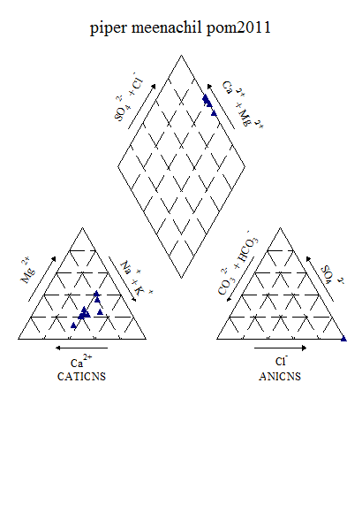

Figure6.9k: Piper’s Classification of Meenachilwater (post-monsoon, 2011)

From the piper diagram results, during post-monsoon 2011, the water belongs to CaCl type and during pre-monsoon 2012, the water belongs to mainly CaHCO3 type.

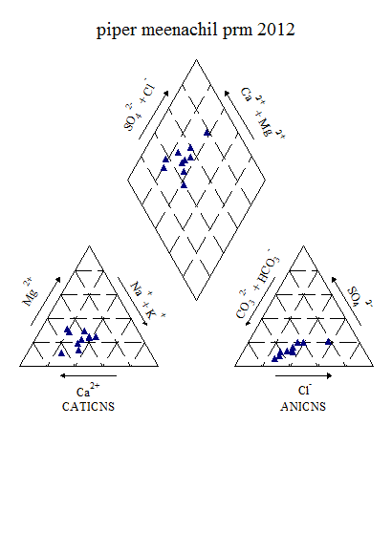

Figure 6.9l: Piper’s Classification of Meenachilwater (pre-monsoon, 2012)

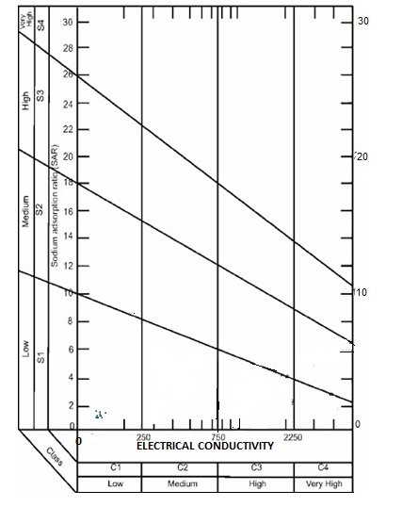

**Figure 6.9m: USSL Classification of Meenachil (post-monsoon, 2011)**

From the USSL classification, during post-monsoon 2011, the water samples fall under C1S1 and Low sodium-Low salinity type. The same trend is followed during pre-monsoon 2012 also.

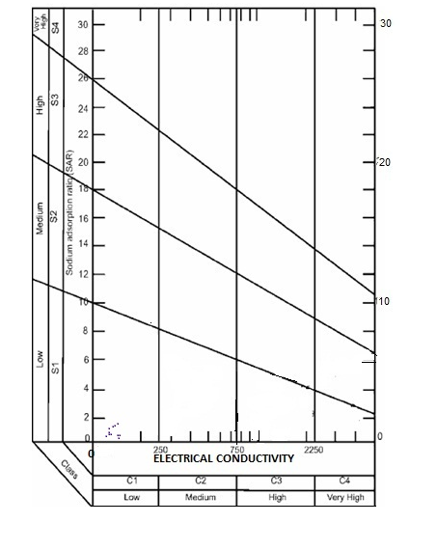

**Figure 6.9n: USSL Classification of Meenachil (pre-monsoon, 2012)**

**6.10 Manimala River Basin**

**Manimala River** has its origin on the Muthavara Hills (2500 feet above main sea level) on the Western Ghats, in [Idukki district](http://en.wikipedia.org/wiki/Idukki_district) of Kerala state. The river passes through the districts of Kottayam, Pathanamthitta and finally joins the Pamba river at Muttar near Tiruvalla in Alappuzha district. Yendayar, Koottikkal, Munadakkayam, Erumeli, Manimala, Kottangal, Kulathurmoozhy, Vaipur, Mallappally, Thuruthicad, Vennikkulam, Kaviyoor, Kallooppara,Niranam, Muttar, Thalavadi, Kozhimukku and Champakkulam lie on the banks of Manimala River. Its running length is estimated at 92 km. It empties itself into the Vembanad lake. Niranam was an ancient sea port at the confluence of Manimala River and Pamba River.

The water quality of Manimala river shows that there is no significant variation during pre-monsoon and post-monsoon season of 2008. However, a steep increase in Electrical conductivity and Total dissolved solids (figure 10a) was observed during 2009. The downstream variation of water quality along the river showed that unlike other rivers, the upstream region is affected by increase of various anions and cations where as in the downstream the quality gets improved as it joins the major river Pamba. The upstream to downstream variation are shown in figures 10b to 10j.

Figure 6.10a: Seasonal variation of water quality parameters in Manimala river

Figure6.10b:Spatial variation of major cations along the river Manimala (Upstream to downstream) during Premonsoon 2008

Figure 6.10c: Spatial variation of major anions along the river Manimala (Upstream to downstream) during Premonsoon 2008

Figure 6.10d: Spatial variation of bacteriological parameters along the river Manimala (Upstream to downstream) during Premonsoon 2008

Figure 6.10e: Spatial variation of major cations along the river Manimala (Upstream to downstream) during Postmonsoon 2008

Figure 6.10f: Spatial variation of major anions along the river Manimala (Upstream to downstream) during Postmonsoon 2008

Figure 6.10g: Spatial variation of bacteriological parameters along the river Manimala (Upstream to downstream) during Postmonsoon 2008

Figure 6.10h: Spatial variation of major cations along the river Manimala (Upstream to downstream) during Premonsoon 2009

Figure 6.10i: Spatial variation of major anions along the river Manimala (Upstream to downstream) during Premonsoon 2009

Figure 6.10j: Spatial variation of bacteriological parameters along the river Manimala (Upstream to downstream) during Premonsoon 2009

Table 6.10a: Variation of Water Quality parameters in Manimala during post-

monsoon 2011

|  |  |  |  |  |  |
| --- | --- | --- | --- | --- | --- |
| **Parameters** | **UNIT** | **Min** | **Max** | **Mean** | **Std dev** |
| **Temp** | **°C** | 24.00 | 30.50 | 26.29 | 2.26 |
| **Ph** | **-** | 3.62 | 7.22 | 5.86 | 0.81 |
| **Turbidity** | **NTU** | 0.40 | 3.10 | 1.56 | 0.79 |
| **EC** | **Micro Seimens/cm** | 27.88 | 66.20 | 49.29 | 11.39 |
| **TDS** | **Mg/l** | 14.39 | 35.27 | 25.90 | 5.99 |
| **Alkalinity** | **Mg/l** | 2.00 | 25.00 | 16.92 | 6.04 |
| **Acidity** | **Mg/l** | 5.00 | 10.00 | 6.67 | 1.63 |
| **T H** | **Mg/l** | 10.00 | 20.00 | 14.50 | 2.97 |
| **Calcium** | **Mg/l** | 2.00 | 8.00 | 4.67 | 1.56 |
| **Magnesium** | **Mg/l** | 1.46 | 2.92 | 2.23 | 0.44 |
| **Chloride** | **Mg/l** | 7.50 | 17.50 | 10.42 | 2.68 |
| **Sodium** | **Mg/l** | 2.22 | 5.97 | 3.61 | 0.94 |
| **Potassium** | **Mg/l** | 1.09 | 4.09 | 1.89 | 0.80 |
| **Phosphate** | **Mg/l** | 0.03 | 0.42 | 0.07 | 0.11 |
| **Fluoride** | **Mg/l** | 0.03 | 0.31 | 0.20 | 0.07 |
| **Nitrate** | **Mg/l** | 0.41 | 1.13 | 0.76 | 0.21 |
| **Iron** | **Mg/l** | 0.01 | 0.77 | 0.21 | 0.23 |
| **DO** | **Mg/l** | 4.70 | 10.40 | 8.04 | 1.43 |

Table 6.10b: Variation of Water Quality parameters in Manimala during pre-

monsoon 2012

|  |  |  |  |  |  |
| --- | --- | --- | --- | --- | --- |
| **Parameters** | **UNIT** | **Min** | **Max** | **Mean** | **Std dev** |
| **Temp** | **°C** | 26.00 | 31.00 | 28.33 | 1.83 |
| **Ph** | **-** | 6.10 | 6.60 | 6.25 | 0.15 |
| **Turbidity** | **NTU** | 0.70 | 3.40 | 1.71 | 0.88 |
| **EC** | **Micro Seimens/cm** | 31.34 | 67.92 | 46.70 | 9.56 |
| **TDS** | **Mg/l** | 16.03 | 34.70 | 24.04 | 4.97 |
| **Alkalinity** | **Mg/l** | 8.00 | 16.00 | 11.17 | 1.99 |
| **Acidity** | **Mg/l** | 2.00 | 6.00 | 3.50 | 1.24 |
| **T H** | **Mg/l** | 8.00 | 16.00 | 12.17 | 2.17 |
| **Calcium** | **Mg/l** | 4.00 | 8.02 | 5.34 | 1.31 |
| **Magnesium** | **Mg/l** | 0.97 | 2.43 | 1.66 | 0.56 |
| **Bicarbonate** | **Mg/l** | 8.00 | 16.00 | 11.17 | 1.99 |
| **Chloride** | **Mg/l** | 7.00 | 12.00 | 9.08 | 1.31 |
| **Sodium** | **Mg/l** | 2.35 | 5.12 | 3.08 | 0.85 |
| **Potassium** | **Mg/l** | 0.69 | 1.59 | 1.23 | 0.27 |
| **Sulphate** | **Mg/l** | 0.93 | 3.81 | 2.65 | 1.00 |
| **Phosphate** | **Mg/l** | 0.02 | 0.03 | 0.02 | 0.00 |
| **Fluoride** | **Mg/l** | 0.07 | 1.12 | 0.33 | 0.33 |
| **Nitrate** | **Mg/l** | 0.37 | 1.10 | 0.79 | 0.23 |
| **Iron** | **Mg/l** | 0.05 | 0.40 | 0.18 | 0.11 |
| **DO** | **Mg/l** | 4.60 | 9.30 | 7.70 | 1.32 |
| **Bio COD** | **Mg/l** | 0.10 | 2.10 | 0.92 | 0.71 |
| **COD** | **Mg/l** | 2.00 | 8.00 | 4.20 | 2.20 |
| **Bacteriology** |  |  |  |  |  |
| **Total coliform** | **MPN/100ml** | 1100.00 | 5800.00 | 2927.27 | 1626.09 |
| **E-Coli** | **MPN/100ml** | 100.00 | 2200.00 | 625.00 | 726.54 |

Factor analyses were conducted for both post-monsoon 2011 and pre-monsoon 2012 to understand the loading of various ions. The eigen values, fraction of variance and percentage of cumulative variance are given in table 10c and 10d.

Table6. 10c: Factor Analysis results of Manimaladuring post-monsoon (2011)

|  |  |  |  |  |  |
| --- | --- | --- | --- | --- | --- |
| Sl.No. | Parameter | Factor 1 | Factor 2 | Factor 3 | Factor 4 |
| 1 | Alkalinity | 0.149 | 0.897 | 0.112 | -0.281 |
| 2 | Fluoride | 0.248 | 0.060 | 0.846 | -0.336 |
| 3 | Phosphate | 0.700 | 0.259 | 0.040 | 0.443 |
| 4 | Total hardness | 0.770 | -0.080 | 0.005 | 0.316 |
| 5 | Chloride | 0.688 | 0.270 | -0.062 | 0.467 |
| 6 | EC | 0.208 | -0.222 | 0.007 | 0.917 |
| 7 | TDS | 0.211 | -0.190 | 0.049 | 0.919 |
| 8 | Iron | 0.697 | -0.096 | 0.146 | 0.045 |
| 9 | Potassium | 0.034 | 0.329 | 0.590 | 0.458 |
| 10 | Calcium | 0.834 | 0.089 | -0.015 | 0.054 |
| 11 | pH | 0.002 | 0.857 | 0.126 | -0.061 |
| 12 | Nitrate | -0.117 | 0.086 | 0.784 | 0.353 |
| 13 | Magnesium | 0.243 | -0.230 | 0.191 | 0.746 |
| 14 | Sodium | 0.558 | 0.248 | 0.062 | 0.768 |
| Eigen Value | | 5.497 | 2.567 | 1.773 | 1.137 |
| Fraction of variance, % | | 23.536 | 14.447 | 12.686 | 27.720 |
| Cumulative fraction of variance, % | | 23.536 | 37.983 | 50.669 | 78.389 |

**Table 6.10d: Factor Analysis results of** Manimala **during pre-monsoon (2012)**

|  |  |  |  |  |  |
| --- | --- | --- | --- | --- | --- |
| Sl.No. | Parameter | Factor 1 | Factor 2 | Factor 3 | Factor 4 |
| 1 | Alkalinity | 0.851 | -0.106 | 0.230 | 0.126 |
| 2 | Fluoride | -0.032 | -0.803 | 0.063 | 0.087 |
| 3 | Phosphate | 0.805 | -0.354 | 0.269 | -0.349 |
| 4 | Total hardness | 0.627 | 0.116 | 0.661 | 0.200 |
| 5 | Chloride | 0.868 | -0.006 | 0.207 | 0.100 |
| 6 | EC | 0.914 | 0.253 | 0.196 | -0.042 |
| 7 | TDS | 0.899 | 0.281 | 0.207 | -0.032 |
| 8 | Iron | 0.074 | 0.711 | 0.253 | 0.339 |
| 9 | Potassium | 0.845 | 0.322 | -0.066 | 0.250 |
| 10 | Calcium | 0.611 | 0.035 | -0.592 | 0.407 |
| 11 | pH | -0.154 | 0.500 | -0.541 | -0.326 |
| 12 | Nitrate | -0.518 | -0.427 | 0.010 | -0.104 |
| 13 | Magnesium | 0.251 | 0.091 | 0.940 | -0.042 |
| 14 | Sulphate | 0.075 | 0.049 | 0.949 | 0.949 |
| 15 | Sodium | 0.875 | -0.212 | -0.034 | 0.091 |
| Eigen Value | | 6.891 | 2.206 | 1.789 | 1.392 |
| Fraction of variance, % | | 42.561 | 13.577 | 15.265 | 10.457 |
| Cumulative fraction of variance, % | | 42.561 | 56.138 | 71.403 | 81.86 |

During post-monsoon 2011, there are four factors has Eigen value more than 1. Factor 1 shows 23.536% variance. This factor has positive loadings on phosphate (0.70), Total Hardness (0.77), chloride and iron (0.69), calcium (0.83) and moderate loadings on sodium (0.56). Factor 2 shows 14.447% variance. This has positive loadings on alkalinity (0.89) and pH (0.86). Factor 3 shows 12.686% variance. This has positive loadings on fluoride (0.85), nitrate (0.78) and moderate loadings on potassium (0.59). Factor 4 shows 27.72% variance. This factor has positive loadings on EC and TDS (0.92), Magnesium (0.75) and sodium (0.77).

During pre-monsoon 2012, four factors have Eigen value more than 1. Factor 1 shows 42.56% variance. This has positive loadings with alkalinity (0.85), phosphate (0.81), Total Hardness (0.63), chloride (0.87), EC (0.91), TDS (0.90), potassium (0.84), calcium (0.61) and sodium (0.87). Factor 2 shows 13.577% variance. This factor has positive loadings iron (0.71) and moderate loading on pH (0.50). Factor 3 shows 15.265% variance. This has positive loadings on Total Hardness (0.66),magnesium (0.94) and sulphate (0.95).Factor 4 shows 10.457% variance and positive loading on sulphate (0.95).

**Table 6.10e: Overall CWQI and WQI Estimated values of Manimala basin for the selected station (2008-2012)**

|  |  |  |  |  |  |  |
| --- | --- | --- | --- | --- | --- | --- |
| **Station** | **Methods** | **Pre -monsoon 2008** | **Post -monsoon 2008** | **Pre - monsoon 2009** | **Post -monsoon 2011** | **Pre -monsoon 2012** |
| Chenappady | WQI | 61.96721 | 59.34426 | 64.59016 | 74.91803 | 78.52459 |
| CCME(WQI) | 90 | 79 | 81 | 73 | 75 |
| Enthayar | WQI | 55.2459 | 64.09836 | 64.7541 | 70.81967 | 75.90164 |
| CCME(WQI) | 88 | 79 | 91 | 82 | 75 |
| Erumely | WQI | 73.44262 | 54.59016 | 62.78689 | 65.90164 | 80.32787 |
| CCME(WQI) | 81 | 68 | 64 | 63 | 75 |
| Kadalimangalam temple(Eruvellipra) | WQI | 67.54098 | 72.29508 | 62.62295 | - | - |
| CCME(WQI) | 52 | 86 | 66 | - | - |
| Kanjirappally DS | WQI | 75.7377 | 54.2623 | 57.21311 | 66.55738 | 74.09836 |
| CCME(WQI) | 78 | 75 | 78 | 61 | 74 |
| Kanjirappally US | WQI | 61.31148 | 48.68852 | 68.85246 | - | - |
| CCME(WQI) | 62 | 75 | 92 | - | - |
| Keecherival kadavu kadapara | WQI | 50.98361 | 67.54098 | 58.03279 | - | - |
| CCME(WQI) | 54 | 100 | 51 | - | - |
| Kokkayar | WQI | 64.7541 | 50.98361 | 69.18 | - | - |
| CCME(WQI) | 79 | 76 | 90 | - | - |
| Koottickal | WQI | 56.06557 | 57.54098 | 70.4918 | 72.45902 | 72.29508 |
| CCME(WQI) | 78 | 79 | 91 | 82 | 73 |
| Kulathoormoozhy | WQI | 59.5082 | 65.08197 | 62.78689 | - | - |
| CCME(WQI) | 72 | 88 | 77 | - | - |
| Mallappally | WQI | - | - | - | 57.54098 | 65.08197 |
| CCME(WQI) | - | - | - | 76 | 79 |
| Manimala | WQI | 56.88525 | 56.88525 | 58.68852 | - | - |
| CCME(WQI) | 75 | 90 | 62 | - | - |
| Mundakayam DS | WQI | 51.14754 | 50.65574 | 63.11475 | 73.93443 | 70.4918 |
| CCME(WQI) | 87 | 76 | 90 | 81 | 74 |
| Mundakayam US | WQI | 51.96721 | 54.42623 | 64.91803 | - | - |
| CCME(WQI) | 76 | 75 | 90 | - | - |
| Pazhayidom | WQI | 77.70492 | 53.60656 | 60.4918 | 72.08197 | 80.98361 |
| CCME(WQI) | 91 | 77 | 86 | 73 | 84 |
| Pulikeezhu | WQI | 58.52459 | 69.83607 | 59.5082 | - | - |
| CCME(WQI) | 57 | 100 | 57 | - | - |
| Thengeli Junction | WQI | 60.98361 | 64.09836 | 57.70492 | - | - |
| CCME(WQI) | 55 | 72 | 59 | - | - |
| Thondara | WQI | - | - | - | 62.29508 | 68.68852 |
| CCME(WQI) | - | - | - | 59 | 66 |
| Thottabhagam Kaviyoor Village | WQI | 59.34426 | 62.45902 | 57.86885 | - | - |
| CCME(WQI) | 67 | 59 | 62 | - | - |
| Vazhoor | WQI | 53.60656 | 59.34426 | 56.55738 | 76.88525 | 79.67213 |
| CCME(WQI) | 69 | 89 | 69 | 72 | 67 |
| Vellavoor | WQI | 62.62295 | 63.44262 | 63.60656 | 75.2459 | 65.40984 |
| CCME(WQI) | 62 | 88 | 62 | - | 82 |
| Vennikulam | WQI | - | - | - | 68.19672 | 63.93443 |
| CCME(WQI) | - | - | - |  | 73 |

**Table 6.10f: CCME Score of Manimala river (pre-monsoon, 2008-2012)**

|  |  |  |  |  |  |  |  |
| --- | --- | --- | --- | --- | --- | --- | --- |
| **Premonsoon** | | | | | | | |
| **Data Summary** | **year** | **Overall** | **Drinking** | **Aquatic** | **Recreation** | **Irrigation** | **Livestock** |
| **CWQI** | **2008** | **71** | **72** | **59** | **100** | **100** | **100** |
|  | **2009** | **72** | **76** | **60** | **100** | **100** | **100** |
|  | **2012** | **66** | **70** | **46** | **100** | **81** | **86** |
| **F1 (Scope)** | **2008** | 33 | 33 | 50 | 0 | 0 | 0 |
|  | **2009** | 30 | 29 | 50 | 0 | 0 | 0 |
|  | **2012** | 50 | 43 | 75 | 0 | 33 | 25 |
| **F2 (Frequency)** | **2008** | 28 | 23 | 48 | 0 | 0 | 0 |
|  | **2009** | 20 | 11 | 31 | 0 | 0 | 0 |
|  | **2012** | 30 | 27 | 56 | 0 | 3 | 2 |
| **F3 (Amplitude)** | **2008** | 23 | 25 | 18 | 0 | 0 | 0 |
|  | **2009** | 33 | 29 | 35 | 0 | 0 | 0 |
|  | **2012** | 10 | 11 | 9 | 0 | 0 | 0 |

**Table 6.10g: CCME Score of Manimal river (post-monsoon, 2008,2011)**

|  |  |  |  |  |  |  |  |
| --- | --- | --- | --- | --- | --- | --- | --- |
|  | | | | | | | |
| **Data Summary** | **year** | **Overall** | **Drinking** | **Aquatic** | **Recreation** | **Irrigation** | **Livestock** |
| **CWQI** | **2008** | **76** | **78** | **54** | **100** | **100** | **100** |
|  | **2011** | **68** | **64** | **46** | **42** | **100** | **100** |
| **F1 (Scope)** | **2008** | 33 | 33 | 50 | 0 | 0 | 0 |
|  | **2011** | 44 | 50 | 75 | 100 | 0 | 0 |
| **F2 (Frequency)** | **2008** | 23 | 17 | 58 | 0 | 0 | 0 |
|  | **2011** | 32 | 33 | 54 | 8 | 0 | 0 |
| **F3 (Amplitude)** | **2008** | 9 | 3 | 18 | 0 | 0 | 0 |
|  | **2011** | 12 | 14 | 13 | 3 | 0 | 0 |

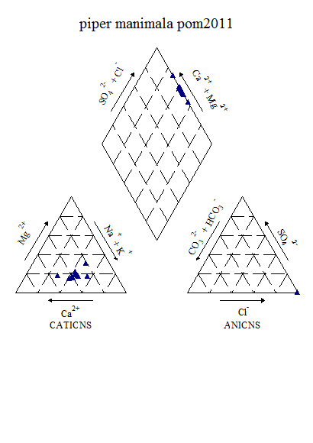

Figure6.10k Piper‘s Classification of Water (Post-monsoon, 2011)

From the results of piper diagram, during post-monsoon 2011, the water belongs to CaCl type and during pre-monsoon 2012 water belongs to CaHCO3 type.

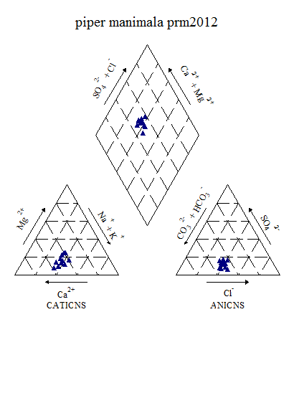

Figure6.10l : Piper ‘s Classification of Water (Pre-monsoon, 2012)

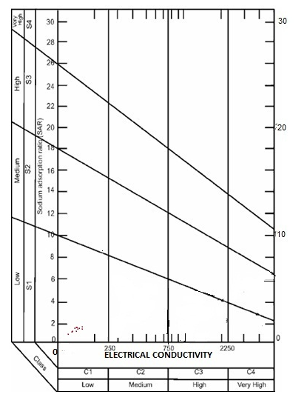

**Figure 6.10m: USSL Classification of** Manimala **(post-monsoon, 2011)**

From the USSL Diagram, during post-monsoon 2011 and pre-monsoon 2012, the water samples fall under C1S1 category and belong to Low sodium –Low salinity type.

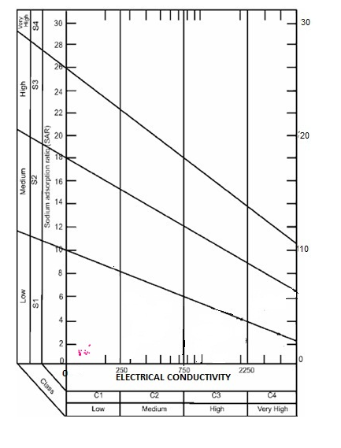

Figure 6.10n: USSL Classification of Manimala(pre-monsoon, 2012)

**6.11Pamba River Basin**

Pamba River which is popularly called as Dakshina Ganga is the third longest river in Kerala State (80 17'30" and 12047'40''N latitude and 740 24'47"E longitude), India with a length of 176 kms. It is formed by several streams having their origin in the Pullichi Malai, Naga Malai and Sundara Malai in the Peerumedu plateau of Western Ghats at an altitude of about 1650 M above M .S.L. This river spreads in Triveni, Vadasserikara and Aranmula region of Pathanamthitta district and enters Alappuzha district at Chengannur and flows through Pandanad, Veeyapuram and plunges into Vembanad Lake through several branches which in turn connected to the Arabian Sea. At its lower reaches, the rivers Achencovil and the Manimala join the Pamba. The catchment area of this river is 1987.17 Sq.Km. The basin extends over an area of 2235 km2 .The basin is bounded on the east by Western Ghats and on the west by Arabian Sea. Manimala basin forms the northern boundary of the basin while Achankovil basin forms southern boundary.

The famous Sabarimala temple dedicated to lord Ayyappa is located on the banks of the river Pamba. Sabarimala is one of the major pilgrimage centers of Kerala. The Sabarimala pilgrimage season is from December to February and is the largest annual pilgrimage.

One of the highest crowded temple during the season (December and January months), i.e. an estimated 45–50 million devotees visit every year as pilgrims from each and every corner of the country. Therefore the major cause of pollution in Pamba river is due to the free flow of sewage, domestic waste and faecal matters. Apart from this, in the downstream stretch of the river sea water also intrudes up to about 25-30km. According to the locals, this is also one of the reason for water quality deterioration in Pamba river.

Water samples were collected from selected locations during 2008 and 2009 to assess the surafce water quality of pamba river.

Figure 6.11a shows the average concentration of various paarmeters during the study period. The water quality analysis showed significant variations from stations to station. It is noted that the major cations like calcium and magnesium showed minor variationsthroughout the stretch of the river with sudden increase in the downstream part of the river. Among the anions, sulphate is found to be higher in one station which could be a local phenomenon and it declined towrds the downstream side. It is also important that the concentration of chloride and the presence of bicarbonates are highly significant in the downstream. The total colliforms are found to be in higher in many of locations and also the DO varied considerably from point to point. Figures 6.11b to 6.11j shows the variations of anion, cations and bactriological paarmeters along the river Pamba.

Figure 6.11a: Seasonal variation of water quality parameters in Pamba river

Figure6.11b:Spatial variation of major cations along the river Pamba (Upstream to downstream) during Premonsoon 2008

Figure 6.11c:Spatial variation of major anions along the river Pamba (Upstream to downstream) during Premonsoon 2008

Figure 6.11d: Spatial variation of bacteriological parameters along the river Pamba (Upstream to downstream) during Premonsoon 2008

Figure 6.11e: Spatial variation of major cations along the river Pamba (Upstream to downstream) during Postmonsoon 2008

Figure 6.11f: Spatial variation of major anions along the river Pamba (Upstream to downstream) during Postmonsoon 2008

Figure 6.11g: Spatial variation of bacteriological parameters along the river Pamba (Upstream to downstream) during Postmonsoon 2008

Figure 6.11h: Spatial variation of major cations along the river Pamba (Upstream to downstream) during Premonsoon 2009

Figure 6.11i: Spatial variation of major anions along the river Pamba (Upstream to downstream) during Premonsoon 2009

Figure 6.11j: Spatial variation of bacteriological parameters along the river Pamba (Upstream to downstream) during Premonsoon 2009

The water quality studies were continued during post-monsoon of 2011 and pre-monsoon.2012. The results of the study is summarized below (Table 11a &11b ).

Table 6.11a: Variation of Water Quality parameters in Pamba during post-

monsoon 2011

|  |  |  |  |  |  |
| --- | --- | --- | --- | --- | --- |
| **2011** | **UNIT** | **Min** | **Max** | **Mean** | **Std dev** |
| **Temp** | **°C** | 22.00 | 30.00 | 27.00 | 2.38 |
| **Ph** | **-** | 6.27 | 6.69 | 6.53 | 0.12 |
| **Turbidity** | **NTU** | 0.70 | 19.00 | 5.34 | 7.25 |
| **EC** | **Micro Seimens/cm** | 27.64 | 64.59 | 42.61 | 13.76 |
| **TDS** | **Mg/l** | 14.28 | 33.84 | 22.31 | 7.15 |
| **Alkalinity** | **Mg/l** | 10.00 | 18.00 | 14.44 | 2.60 |
| **T H** | **Mg/l** | 8.00 | 24.00 | 15.78 | 4.52 |
| **Calcium** | **Mg/l** | 4.00 | 8.00 | 5.56 | 1.33 |
| **Magnesium** | **Mg/l** | 0.49 | 4.37 | 2.48 | 1.10 |
| **Chloride** | **Mg/l** | 6.00 | 11.00 | 8.22 | 1.79 |
| **Sodium** | **Mg/l** | 1.77 | 5.68 | 3.31 | 1.18 |
| **Potassium** | **Mg/l** | 0.59 | 1.55 | 0.94 | 0.33 |
| **Sulphate** | **Mg/l** | 0.39 | 1.57 | 1.06 | 0.60 |
| **Fluoride** | **Mg/l** | 0.12 | 0.26 | 0.18 | 0.04 |
| **Nitrate** | **Mg/l** | 0.23 | 0.81 | 0.42 | 0.19 |
| **Iron** | **Mg/l** | 0.08 | 1.00 | 0.35 | 0.28 |
| **DO** | **Mg/l** | 7.20 | 9.10 | 8.06 | 0.58 |

**Table 6.11b: Variation of Water Quality parameters in Pamba during post-**

**monsoon 2011**

|  |  |  |  |  |  |
| --- | --- | --- | --- | --- | --- |
| **Parameters** | **UNIT** | **Min** | **Max** | **Mean** | **Std dev** |
| **Temp** | **°C** | 27.00 | 33.00 | 29.22 | 1.86 |
| **Ph** | **-** | 5.82 | 5.82 | 6.22 | 0.28 |
| **Turbidity** | **NTU** | 0.60 | 0.60 | 1.60 | 0.91 |
| **EC** | **Micro Seimens/cm** | 25.32 | 65.52 | 40.05 | 14.50 |
| **TDS** | **Mg/l** | 13.61 | 35.23 | 21.32 | 8.07 |
| **Alkalinity** | **Mg/l** | 8.00 | 20.00 | 13.33 | 4.24 |
| **Acidity** | **Mg/l** | 2.00 | 10.00 | 5.22 | 2.11 |
| **T H** | **Mg/l** | 8.00 | 22.00 | 13.11 | 4.48 |
| **Calcium** | **Mg/l** | 1.60 | 6.00 | 3.51 | 1.30 |
| **Magnesium** | **Mg/l** | 0.97 | 4.86 | 2.53 | 1.41 |
| **Bicarbonate** | **Mg/l** | 8.00 | 20.00 | 13.33 | 4.24 |
| **Chloride** | **Mg/l** | 5.00 | 9.00 | 7.22 | 1.20 |
| **Sodium** | **Mg/l** | 1.30 | 2.94 | 2.12 | 0.63 |
| **Potassium** | **Mg/l** | 0.56 | 1.39 | 0.96 | 0.25 |
| **Sulphate** | **Mg/l** | 1.13 | 5.77 | 3.64 | 1.53 |
| **Phosphate** | **Mg/l** | 0.02 | 0.04 | 0.02 | 0.01 |
| **Fluoride** | **Mg/l** | 0.05 | 1.59 | 0.56 | 0.56 |
| **Nitrate** | **Mg/l** | 0.23 | 0.82 | 0.46 | 0.22 |
| **Iron** | **Mg/l** | 0.05 | 0.22 | 0.14 | 0.06 |
| **DO** | **Mg/l** | 6.40 | 8.30 | 7.58 | 0.64 |
| **Bio COD** | **Mg/l** | 0.10 | 2.70 | 0.97 | 0.80 |
| **COD** | **Mg/l** | 2.00 | 8.00 | 4.00 | 2.39 |
| **Bacteriology** |  |  |  |  |  |
| **Total coliform** | **MPN/100ml** | 700.00 | 4800.00 | 2322.22 | 1482.21 |
| **E-Coli** | **MPN/100ml** | 100.00 | 200.00 | 125.00 | 50.00 |

Factor analyses were conducted for both post-monsoon 2011 and pre-monsoon 2012 to understand the loading of various ions. The Eigen values, fraction of variance and percentage of cumulative variance are given in table 6.11c and 6.11d.

Table 6.11c: Factor Analysis results of Pamba during post-monsoon (2011)

|  |  |  |  |  |  |
| --- | --- | --- | --- | --- | --- |
| Sl.No. | Parameter | Factor 1 | Factor 2 | Factor 3 | Factor 4 |
| 1 | Alkalinity | 0.603 | -0.073 | 0.258 | 0.704 |
| 2 | Fluoride | -0.063 | 0.668 | 0.195 | -0.672 |
| 4 | Total hardness | 0.739 | -0.015 | 0.009 | 0.620 |
| 5 | Chloride | 0.960 | 0.170 | -0.053 | -0.074 |
| 6 | EC | 0.871 | 0.122 | 0.240 | 0.394 |
| 7 | TDS | 0.860 | 0.115 | 0.252 | 0.414 |
| 8 | Iron | -0.217 | -0.151 | 0.050 | -0.868 |
| 9 | Potassium | 0.914 | -0.020 | 0.050 | 0.376 |
| 10 | Calcium | 0.172 | 0.259 | 0.945 | 0.024 |
| 11 | pH | -0.108 | 0.926 | 0.260 | -0.019 |
| 12 | Nitrate | 0.942 | 0.042 | -0.115 | 0.162 |
| 13 | Magnesium | 0.688 | -0.094 | -0.270 | 0.612 |
| 14 | Sulphate | 0.407 | 0.528 | ­-0.097 | 0.093 |
| 15 | Sodium | 0.230 | 0.626 | ­-0.635 | 0.201 |
| Eigen Value | | 7.546 | 2.409 | 1.609 | 1.113 |
| Fraction of variance, % | | 41.681 | 15.282 | 12.086 | 21.505 |
| Cumulative fraction of variance, % | | 41.681 | 56.963 | 69.049 | 81.554 |

**Table 6.11d: Factor Analysis results of Pamba during pre-monsoon (2012)**

|  |  |  |  |  |  |
| --- | --- | --- | --- | --- | --- |
| Sl.No. | Parameter | Factor 1 | Factor 2 | Factor 3 | Factor 4 |
| 1 | Alkalinity | 0.818 | 0.014 | -0.009 | 0.421 |
| 2 | Fluroide | -0.085 | -0.026 | 0.939 | 0.179 |
| 3 | Phosphate | 0.047 | 0.861 | 0.078 | 0.014 |
| 4 | Total hardness | 0.897 | 0.189 | 0.310 | -0.135 |
| 5 | Chloride | 0.753 | -0.389 | 0.003 | -0.064 |
| 6 | EC | 0.948 | 0.229 | 0.027 | 0.099 |
| 7 | TDS | 0.943 | 0.247 | 0.011 | 0.122 |
| 8 | Iron | 0.634 | 0.676 | 0.046 | 0.168 |
| 9 | Potassium | 0.791 | 0.510 | -0.134 | 0.124 |
| 10 | Calcium | 0.280 | -0.031 | 0.209 | 0.888 |
| 11 | pH | -0.175 | -0.354 | -0.767 | 0.019 |
| 12 | Nitrate | 0.019 | 0.924 | 0.151 | -0.105 |
| 13 | Magnesium | 0.737 | 0.238 | 0.106 | -0.583 |
| 14 | Sulphate | 0.285 | 0.891 | 0.092 | -0.098 |
| 15 | Sodium | 0.944 | 0.123 | -0.005 | 0.115 |
| Eigen Value | | 7.478 | 2.850 | 1.687 | 1.221 |
| Fraction of variance, % | | 43.262 | 24.040 | 11.190 | 9.751 |
| Cumulative fraction of variance, % | | 43.262 | 67.302 | 78.492 | 88.243 |

There are four factors have Eigen value more than 1 during post-monsoon 2011. Factor 1 shows 41.68% variance. This factor has positive loadings with alkalinity (0.60), total Hardness (0.74), chloride (0.96), EC (0.87) TDS (0.86), potassium (0.91), nitrate (0.94) and magnesium (0.69). Factor 2 shows 15.28% variance. This factor has positive loadings on fluoride (0.67), pH (0.93), sodium (0.63) and moderate loading on sulphate (0.63). Factor 3 shows 12.086% variance. This has positive loadings on calcium (0.94). Factor 4 shows 21.505% variance and has positive loadings on alkalinity (0.70) and Hardness (0.62).

During pre-monsoon 2012, four factors have Eigen value more than 1. Factor 1 shows 43.26% variance. This factor has positive loadings on alkalinity (0.82), Total Hardness (0.89), chloride (0.75), EC and TDS (0.94), iron (0.63), potassium (0.79), magnesium (0.74) and sodium (0.94). Factor 2 shows 24.04% variance. This factor has positive loadings and associated with phosphate (0.86), iron (0.67), nitrate (0.92), sulphate (0.89) and moderately with potassium (0.51). Factor 3 shows 11.19% variance. This has associated with fluoride (0.94). Factor 4 shows 9.751% variance and has associated with calcium (0.88).

The water quality indices estimated by using CCME and Bascaron methods are presented below (Table 6.11e)

**Table 6.11e: Overall CWQI and WQI Estimated values of Periyar basin for the selected station**

**(2008-2012)**

|  |  |  |  |  |  |  |
| --- | --- | --- | --- | --- | --- | --- |
| **Station** | **Methods** | **Pre -monsoon 2008** | **Post -monsoon 2008** | **Pre - monsoon 2009** | **Post -monsoon 2011** | **Pre -monsoon 2012** |
| Aranmula | WQI | 70.4918 | 58.19672 | 69.02 | - | - |
| CCME(WQI) | 86 | 84 | 61 | - | - |
| Athikkayam | WQI | - | - | - | 92.30 | 77.21 |
| CCME(WQI) | - | - | - | 84 | 91 |
| Edakkadathy | WQI | - | - | - | 88.36 | 76.89 |
| CCME(WQI) | - | - | - | 59 | 75 |
| Erapuzha | WQI | 64.7541 | 63.60656 | 66.07 | 62.30 | 88.20 |
| CCME(WQI) | 69 | 72 | 50 | 55 | 73 |
| Kozhenchery Town | WQI | 56.55738 | 63.11475 | 60.98 | 74.26 | 76.23 |
| CCME(WQI) | 62 | 86 | 62 | 72 | 74 |
| Kurudamannil | WQI | 47.70492 | 60.81967 | 69.84 | 78.03 | 70.33 |
| CCME(WQI) | 67 | 84 | 63 | 82 | 65 |
| Maramon | WQI | 62.45902 | 48.68852 | 69.18 | - | - |
| CCME(WQI) | 67 | 73 | 56 | - | - |
| Pamba at Neerettupuram | WQI |  | 50.16393 | 53.93 | 81.31 | 78.20 |
| CCME(WQI) | 86 | 83 | 54 | 72 | 82 |
| Ranni | WQI | - | - | - | 74.92 | 88.20 |
| CCME(WQI) | - | - | - | 60 | 84 |
| Thurappilly | WQI | - | - | - | 70.82 | 69.67 |
| CCME(WQI) | - | - | - | 59 | 69 |
| Vadasserikkara | WQI | - | - | - | 89.51 | 82.95 |
| CCME(WQI) | - | - | - | 83 | 84 |

Table 6.11f: CCME Score of Pamba (pre-monsoon, 2008-2012)

|  |  |  |  |  |  |  |  |
| --- | --- | --- | --- | --- | --- | --- | --- |
| **Data Summary** | **year** | **Overall** | **Drinking** | **Aquatic** | **Recreation** | **Irrigation** | **Livestock** |
| **CWQI** | **2008** | **83** | **100** | **72** | **100** | **100** | **100** |
|  | **2009** | **54** | **50** | **100** | **100** | **100** | **100** |
|  | **2012** | **72** | **71** | **47** | **100** | **81** | **85** |
| **F1 (Scope)** | **2008** | 20 | 0 | 33 | 0 | 0 | 0 |
|  | **2009** | 20 | 25 | 0 | 0 | 0 | 0 |
|  | **2012** | 40 | 43 | 75 | 0 | 33 | 25 |
| **F2 (Frequency)** | **2008** | 20 | 0 | 33 | 0 | 0 | 0 |
|  | **2009** | 20 | 25 | 0 | 0 | 0 | 0 |
|  | **2012** | 26 | 23 | 52 | 0 | 4 | 3 |
| **F3 (Amplitude)** | **2008** | 5 | 0 | 8 | 0 | 0 | 0 |
|  | **2009** | 75 | 79 | 0 | 0 | 0 | 0 |
|  | **2012** | 10 | 10 | 9 | 0 | 2 | 2 |

**Table6.11g: CCME Score of Pamba (post-monsoon, 2008,2011)**

|  |  |  |  |  |  |  |  |
| --- | --- | --- | --- | --- | --- | --- | --- |
| **Data Summary** | **year** | **Overall** | **Drinking** | **Aquatic** | **Recreation** | **Irrigation** | **Livestock** |
| **CWQI** | **2008** | **86** | **100** | **79** | **100** | **100** | **100** |
|  | **2011** | **65** | **61** | **49** | **100** | **100** | **100** |
| **F1 (Scope)** | **2008** | 17 | 0 | 25 | 0 | 0 | 0 |
|  | **2011** | 40 | 43 | 75 | 0 | 0 | 0 |
| **F2 (Frequency)** | **2008** | 17 | 0 | 25 | 0 | 0 | 0 |
|  | **2011** | 29 | 27 | 46 | 0 | 0 | 0 |
| **F3 (Amplitude)** | **2008** | 4 | 0 | 6 | 0 | 0 | 0 |
|  | **2011** | 35 | 44 | 14 | 0 | 0 | 0 |

Water quality analysis carried out during the study period (2008-2011)showed that there is no significant variation in the major anions and cations. However, bacteriological contamination was dominant particularly during the pilgrimage season. Though the present study does not provide exact number of coliform bacteria, data have been collected from a study carried out by Jalal et al., (2013). The biological characteristics of water and wastewater are of fundamental importance to human health, in controlling diseases caused by pathogenic organisms of human origin, and because of the role that they play in the decomposition of waste.Total coliform counts varies from few hundreds to several thousand in some of the locations during the pilgrimage season. This is a clear indication human interference and it needs a serious concern by the authorities to take appropriate measures during the pilgrimage season. Among the three seasons, monsoon season showed lowest TPC and TC density due to dilution and it is less polluted as it is the period before pilgrimage season. During the post monsoon season the water is much polluted as it is the peak period of pilgrimage season. TPC and TC count were so high making the water not suitable for drinking, domestic and other recreational purposes. During summer i.e., after pilgrimage season river water shows moderate pollution. The Site Triveni gives the high value of TPC and TC during all seasons because pilgrims use this site mainly for sanitation purposes due to lack of proper sanitary arrangements.

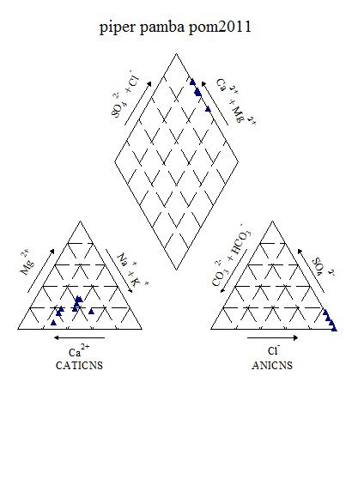

Figure6.11k : Piper ‘s Classification of Water (Post-monsoon, 2011)

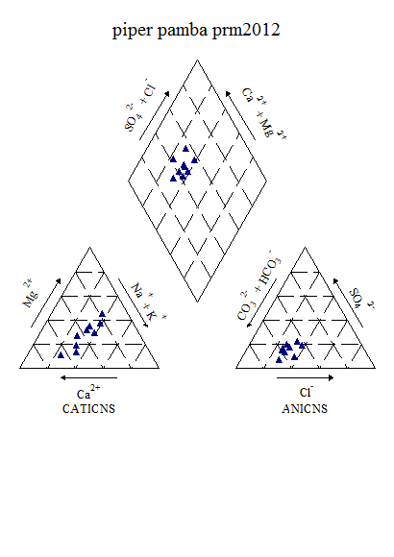

Figure6.11l : Piper ‘s Classification of Water (Pre-monsoon, 2012)

Piper’s diagram shows that, during post-monsoon 2011, the water samples belongs to CaCl type and during pre-monsoon 2012, belongs to CaHCO3 type.

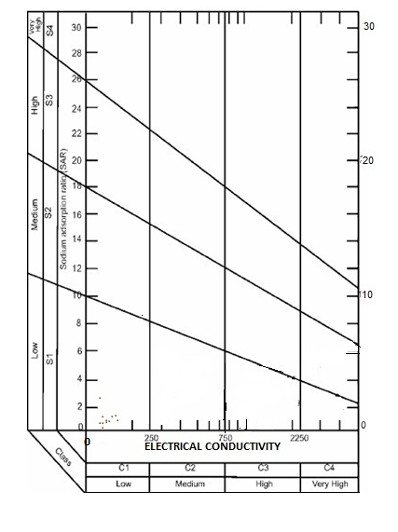

Figure 6.11m: USSL Classification of Periyar (post-monsoon, 2011)

The results of USSL classification indicate that the water sample fall under C1S1 category and belong to Low sodium-Low salinity water type during both the seasons.

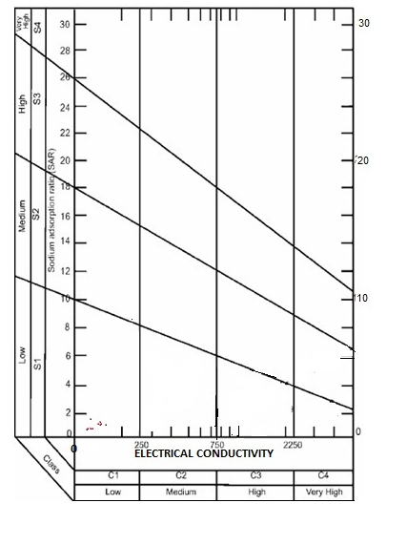

Figure 6.11n: USSL Classification of Periyar (pre-monsoon, 2012)

**6.12 Achankovil River Basin**

The river Achankovil rises south of Devarmalai in the Western Ghats in the Pathanamthitta district of Kerala at an elevation of 700 m. The Achankovil River after flowing for 128 km joins the Pamba River at Veeyapuram. The basin extends over an area of 1484 km2 and lies entirely in Kerala State. The basin is bounded on the north by Pamba basin and on the south by Kallada and Pallikkal basin. The Western Ghats form eastern boundary of the basin while the Arabian Sea forms the western boundary.

The physical and chemical analysis of water samples based on drinking water standards showed that pH values of majority of the samples are within the desired range. 80% of the samples exhibited turbidity values within the permissible limits. Alkalinity, calcium, magnesium, sulphates, chloride and Total Dissolved Solids are within the desirable limits for all test results. The anion chemistry indicated that carbonates andbicarbonates are the dominating anions followed by chloride. The sulphate ions were found only in the upstream part of the river. The calcium and magnesium distribution showed that magnesium is the most dominating one. Figure6.12a shows the average variations of water quality parameters during different seasons. Figures 6.12b to 6.12j show the variations of various anions and cations from upstream to downstream (both spatial and temporal).

Figure 6.12a: Seasonal variation of water quality parameters in Achankovil river

Figure 6.12b:Spatial variation of major cations along the river Achenkovil(Upstream to downstream) during Premonsoon 2008

Figure 6.12c:Spatial variation of major anions along the river Achenkovil

(Upstream to downstream) during Premonsoon 2008

Figure 6.12d:Spatial variation of bacteriological parameters along the river Achenkovil

(Upstream to downstream) during Premonsoon 2008

Figure 6.12e:Spatial variation of major cations along the river Achenkovil

(Upstream to downstream)during Postmonsoon 2008

Figure 6.12f:Spatial variation of major anions along the river Achenkovil

(Upstream to downstream) during Postmonsoon 2008

Figure 6.12g:Spatial variation of bacteriological parameters along the river Achenkovil

(Upstream to downstream) during Postmonsoon 2008

Figure 6.12h:Spatial variation of major cations along the river Achenkovil

(Upstream to downstream) during Premonsoon 2009

Figure 6.12i:Spatial variation of major anions along the river Achenkovil

(Upstream to downstream) during Premonsoon 2009

Figure 6.12j: Spatial variation of bacteriological parameters along the river Achenkovil

(Upstream to downstream) during Premonsoon 2009

Hotspots were identified during pre-monsoon of 2011, and water samples were collected from those locations during post-monsoon 2011 and pre-monsoon 2012. The results are shown table 6.12a.The analysis results shows that all the parameters are within the permissible limit except bacteriological contaminants.

Table 6.12a: Variation of Water Quality parameters in Achenkovil during post-

monsoon 2011

|  |  |  |  |  |  |  |  |
| --- | --- | --- | --- | --- | --- | --- | --- |
| **Parameters** | **UNIT** | **MIN** | | **MAX** | **Mean** | | **Std dev** |
| **Temp** | **°C** | 26.00 | | 30.50 | 28.72 | | 1.30 |
| **EC** | **Micro Seimens** | 49.73 | | 80.58 | 65.21 | | 10.01 |
| **Turbidity** | **NTU** | 1.30 | | 9.50 | 3.70 | | 2.82 |
| **DO** |  | 3.20 | | 8.50 | 6.47 | | 1.62 |
| **PH** |  | 5.89 | | 6.76 | 6.25 | | 0.37 |
| **Alkalinity** | **Mg/l** | 10.00 | | 30.00 | 19.33 | | 6.48 |
| **Calcium** | **Mg/l** | 4.00 | | 10.00 | 5.56 | | 1.94 |
| **Sodium** | **Mg/l** | 3.27 | | 6.31 | 4.79 | | 1.02 |
| **Magnesium** | **Mg/l** | 2.43 | | 4.86 | 3.56 | | 0.81 |
| **Potassium** | **Mg/l** | 0.83 | | 2.97 | 1.82 | | 0.76 |
| **Sulphate** | **Mg/l** | 2.41 | | 2.96 | 2.68 | | 0.39 |
| **Chloride** | **Mg/l** | 5.00 | | 13.00 | 10.11 | | 2.71 |
| **Fluoride** | **Mg/l** | 0.06 | | 0.22 | 0.15 | | 0.08 |
| **Nitrate** | **Mg/l** | 0.13 | | 0.58 | 0.38 | | 0.17 |
| **Iron** | **Mg/l** | 0.09 | | 1.75 | 0.59 | | 0.57 |
| **TDS** | **Mg/l** | 26.58 | | 42.74 | 34.64 | | 5.24 |
| **Acidity** | **Mg/l** | 5.00 | | 10.00 | 7.22 | | 2.64 |
| **TH** | **Mg/l** | 16.00 | | 26.00 | 20.22 | | 3.23 |
| **Bicarbonate** | **Mg/l** | 10.00 | | 30.00 | 19.33 | | 6.48 |
| **Phosphate** | **Mg/l** | 0.03 | | 0.11 | 0.04 | | 0.02 |
| **Bio COD** | **Mg/l** | 0.30 | | 1.70 | 0.88 | | 0.49 |
| **COD** | **Mg/l** | 2.00 | | 16.00 | 6.75 | | 5.23 |
| **Bacteriology** |  |  |  | | |  |  |
| **Total Coliform** | **MPN/100ml** | 500.00 | 4000.00 | | | 2371.43 | 1438.42 |
| **E-Coli** | **MPN/100ml** | 200.00 | 1300.00 | | | 740.00 | 421.90 |

Table6.12b: Variation of Water Quality parameters in Achenkovil during pre-

monsoon 2012

|  |  |  |  |  |  |  |  |
| --- | --- | --- | --- | --- | --- | --- | --- |
| **Parameters** | **UNIT** | **MIN** | | **MAX** | **Mean** | | **Std dev** |
| **Temp** | **°C** | 28.00 | | 32.50 | 30.39 | | 1.71 |
| **Ph** |  | 6.25 | | 7.20 | 6.55 | | 0.31 |
| **Turbidity** | **NTU** | 1.20 | | 12.90 | 5.91 | | 3.94 |
| **EC** | **Micro Seimens** | 43.90 | | 89.40 | 64.39 | | 16.13 |
| **TDS** | **Mg/l** | 23.44 | | 49.42 | 34.99 | | 8.50 |
| **Alkalinity** | **Mg/l** | 12.00 | | 30.00 | 18.00 | | 5.66 |
| **Acidity** | **Mg/l** | 4.00 | | 10.00 | 6.11 | | 2.37 |
| **T H** | **Mg/l** | 14.00 | | 32.00 | 17.56 | | 5.81 |
| **Calcium** | **Mg/l** | 2.00 | | 10.02 | 5.57 | | 2.41 |
| **Magnesium** | **Mg/l** | 1.94 | | 5.34 | 2.91 | | 1.03 |
| **Bicarbonate** | **Mg/l** | 12.00 | | 30.00 | 18.00 | | 5.66 |
| **Chloride** | **Mg/l** | 7.00 | | 12.00 | 9.78 | | 1.48 |
| **Sodium** | **Mg/l** | 2.18 | | 5.09 | 3.72 | | 1.19 |
| **Potassium** | **Mg/l** | 1.08 | | 1.74 | 1.28 | | 0.22 |
| **Sulphate** | **Mg/l** | 2.10 | | 4.67 | 3.10 | | 1.02 |
| **Phosphate** | **Mg/l** | 0.02 | | 0.03 | 0.02 | | 0.01 |
| **Fluoride** | **Mg/l** | 0.06 | | 0.75 | 0.24 | | 0.22 |
| **Nitrate** | **Mg/l** | 0.28 | | 0.62 | 0.51 | | 0.10 |
| **Iron** | **Mg/l** | 0.25 | | 1.37 | 0.59 | | 0.38 |
| **DO** | **Mg/l** | 3.30 | | 8.60 | 6.48 | | 1.58 |
| **Bio COD** | **Mg/l** | 0.10 | | 2.00 | 0.86 | | 0.58 |
| **COD** | **Mg/l** | 4.00 | | 18.00 | 8.80 | | 6.10 |
| **Bacteriology** |  |  |  | | |  |  |
| **Total Coliform** | **MPN/100ml** | 100.00 | 3600.00 | | | 1288.89 | 1417.25 |
| **E-Coli** | **MPN/100ml** | 100.00 | 200.00 | | | 133.33 | 57.74 |

Factor analyses were conducted for both post-monsoon 2011 and pre-monsoon 2012 to understand the loading of various ions. The eigen values, fraction of variance and percentage of cumulative variance are given in table 6.12c and 6.12d.

Table 6.12c: Factor Analysis results of Achenkovil during post-monsoon (2011)

|  |  |  |  |  |  |  |
| --- | --- | --- | --- | --- | --- | --- |
| Sl.No. | Parameter | Factor 1 | Factor 2 | Factor 3 | Factor 4 | Factor 5 |
| 1 | Alkalinity | 0.923 | -0.088 | 0.036 | 0.244 | 0.079 |
| 2 | Fluoride | 0.710 | -0.098 | 0.516 | -0.065 | 0.090 |
| 3 | Phosphate | 0.571 | 0.141 | 0.252 | 0.312 | 0.528 |
| 4 | Total hardness | 0.545 | 0.390 | -0.080 | 0.677 | 0.212 |
| 5 | Chloride | -0.087 | 0.890 | -0.180 | 0.174 | -0.304 |
| 6 | EC | 0.175 | 0.876 | 0.044 | 0.361 | 0.204 |
| 7 | TDS | 0.145 | 0.874 | 0.080 | 0.346 | 0.217 |
| 8 | Iron | -0.334 | 0.822 | -0.233 | -0.325 | 0.225 |
| 9 | Potassium | -0.386 | 0.742 | -0.432 | -0.154 | -0.144 |
| 10 | Calcium | 0.457 | 0.638 | -0.287 | -0.438 | 0.002 |
| 11 | pH | 0.027 | -0.500 | 0.003 | 0.015 | -0.749 |
| 12 | Nitrate | -0.470 | 0.446 | -0.660 | 0.032 | -0.355 |
| 13 | Magnesium | 0.265 | 0.004 | 0.091 | 0.916 | 0.208 |
| 14 | Sulphate | 0.308 | -0.234 | 0.295 | 0.299 | 0.813 |
| 15 | Sodium | 0.143 | 0.427 | 0.300 | 0.471 | 0.629 |
| Eigen Value | | 6.845 | 6.043 | 2.098 | 1.478 | 1.007 |
| Fraction of variance, % | | 20.567 | 29.617 | 14.464 | 13.847 | 13.461 |
| Cumulative fraction of variance, % | | 20.567 | 50.184 | 67.648 | 78.495 | 91.956 |

Table 6.12d: Factor Analysis results of Achenkovil during pre-monsoon (2012)

|  |  |  |  |  |  |
| --- | --- | --- | --- | --- | --- |
| Sl.No. | Parameter | Factor 1 | Factor 2 | Factor 3 | Factor 4 |
| 1 | Alkalinity | 0.886 | -0.381 | 0.044 | 0.180 |
| 2 | Fluoride | -0.205 | -0.145 | 0.211 | 0.854 |
| 3 | Phosphate | 0.353 | 0.331 | 0.205 | 0.716 |
| 4 | Total hardness | 0.960 | 0.133 | -0.003 | 0.195 |
| 5 | Chloride | 0.319 | 0.446 | 0.003 | 0.689 |
| 6 | EC | 0.560 | 0.059 | 0.646 | 0.338 |
| 7 | TDS | 0.606 | 0.097 | 0.620 | 0.373 |
| 8 | Iron | -0.278 | 0.858 | -0.226 | 0.084 |
| 9 | Potassium | 0.423 | 0.732 | -0.013 | 0.502 |
| 10 | Calcium | 0.686 | -0.213 | -0.307 | 0.475 |
| 11 | pH | -0.198 | -0.059 | 0.946 | 0.036 |
| 12 | Nitrate | 0.062 | 0.812 | 0.401 | 0.057 |
| 13 | Magnesium | 0.927 | 0.302 | 0.170 | -0.004 |
| 14 | Sulphate | 0.664 | 0.621 | -0.174 | 0.123 |
| 15 | Sodium | 0.488 | 0.234 | 0.014 | 0.791 |
| Eigen Value | | 6.955 | 2.656 | 2.146 | 1.548 |
| Fraction of variance, % | | 33.098 | 20.121 | 14.344 | 21.133 |
| Cumulative fraction of variance, % | | 33.098 | 53.219 | 67.563 | 88.696 |

There are five factors have Eigen value more than 1. Factor 1 shows 20.56% variance. This factor has positive loadings associated with alkalinity (0.92), fluoride (0.71) and moderately with phosphate (0.57) and Hardness (0.54). Factor 2 shows 29.617% variance. This has positive loadings associated with chloride (0.89), EC and TDS (0.87), iron (0.82), potassium (0.74) and calcium (0.64). Factor 3 shows 14.464% variance. This factor has moderately positive loadings associated with fluoride (0.52). Factor 4 shows 13.847 % variance and has positive loadings associated with Hardness (0.68) and magnesium (0.92).Factor 5 shows 13.461% variance. This factor has positive loadings associated with sulphate (0.81), sodium (0.63) and moderately with phosphate (0.53).

During pre-monsoon 2012, the four factors have Eigen value more than 1. Factor 1 shows 33.098% variance. This factor has positive loadings associated with alkalinity (0.88), total Hardness (0.96), calcium (0.68), magnesium (0.93), sulphate (0.66) and moderate with EC (0.56) and TDS (0.60). Factor 2 shows 20.121% variance and has positive loadings associated with iron (0.86), potassium (0.73), nitrate (0.81) and sulphate (0.62). Factor 3 shows 14.344% variance. This factor has associated with EC (0.64) TDS (0.62) and pH (0.95). Factor 4 shows 21.133% variance. This factor has positive loadings associated with fluoride (0.85), phosphate (0.72), chloride (0.69), sodium (0.79) and moderate with potassium (0.50).

The water quality indices estimated by using CCME and Bascaron methods are presented below (Table 7e)

Table 6.12e: Overall CWQI and WQI Estimated values of Achenkovil basin for the selected station (2008-2012)

|  |  |  |  |  |  |  |
| --- | --- | --- | --- | --- | --- | --- |
| **Station** | **Methods** | **Pre -monsoon 2008** | **Post -monsoon 2008** | **Pre - monsoon 2009** | **Post -monsoon 2011** | **Pre -monsoon 2012** |
| Achincovil | WQI | - | - | - | 75.40984 | 83.44262 |
| CCME(WQI) | - | - | - | 67 | 75 |
| Kaippattoor | WQI |  | 30 | 60.98361 | 67.37705 | 74.09836 |
| CCME(WQI) | 62 | 34 | 61 | 78 | 60 |
| Kallakadavu | WQI |  | 56.39344 | 62.62295 | 81.63934 | 82.95082 |
| CCME(WQI) | 72 | 50 | 55 | 75 | 73 |
| Kalleli | WQI |  | 58.19672 | 63.11475 | 71.96721 | 81.31148 |
| CCME(WQI) | 73 | 50 | 86 | 77 | 66 |
| Konni | WQI |  | 49.34426 | 58.19672 | 68.03279 | 81.14754 |
| CCME(WQI) | 62 | 50 | 37 | 57 | 57 |
| Kumbazha | WQI |  | 53.60656 | 62.13115 | - | - |
| CCME(WQI) | 56 | 79 | 70 | - | - |
| Nalukettukavala | WQI |  | 54.42623 | 54.09836 | 63.27869 | 75.08196721 |
| CCME(WQI) | 55 | 46 | 45 | 46 | 55 |
| Prayikkara | WQI | - | - | - | 62.13115 | 67.37705 |
| CCME(WQI) | - | - | - | 52 | 53 |
| Pendalam | WQI |  | 54.7541 | 61.14754 | - | - |
| CCME(WQI) | 68 | 58 | 51 | - | - |
| Thumpamon | WQI |  | 54.42623 | 57.54098 | 71.63934 | 84.42623 |
| CCME(WQI) | 56 | 58 | 38 | 67 | 74 |
| Venmoney | WQI | - | 49.67213 | 55.08197 | 73.77049 | 87.70492 |
| CCME(WQI) | 57 | 58 | 60 | 61 | 81 |

|  |  |  |  |  |  |  |  |  |  |  |  |  |  |  |  |
| --- | --- | --- | --- | --- | --- | --- | --- | --- | --- | --- | --- | --- | --- | --- | --- |
| **Table 6.12f: CCME Score of Achenkovil (pre-monsoon, 2008-2012)** | | | | | | | | | | | | | | | |
|  | | year | Overall | | Drinking | | Aquatic | | Recreation | | Irrigation | | Livestock | |
| CWQI | | 2008 | 66 | | 65 | | 51 | | 100 | | 100 | | 100 | |
|  | | 2009 | 47 | | 38 | | 29 | | 42 | | 71 | | 100 | |
|  | | 2012 | 62 | | 59 | | 43 | | 100 | | 100 | | 100 | |
| F1 (Scope) | | 2008 | 33 | | 33 | | 50 | | 0 | | 0 | | 0 | |
|  | | 2009 | 57 | | 75 | | 100 | | 100 | | 50 | | 0 | |
|  | | 2012 | 40 | | 43 | | 75 | | 0 | | 0 | | 0 | |
| F2 (Frequency) | | 2008 | 42 | | 42 | | 67 | | 0 | | 0 | | 0 | |
|  | | 2009 | 36 | | 31 | | 44 | | 11 | | 6 | | 0 | |
|  | | 2012 | 33 | | 32 | | 57 | | 0 | | 0 | | 0 | |
| F3 (Amplitude) | | 2008 | 25 | | 27 | | 19 | | 0 | | 0 | | 0 | |
|  | | 2009 | 61 | | 69 | | 56 | | 2 | | 4 | | 0 | |
|  | | 2012 | 40 | | 46 | | 29 | | 0 | | 0 | | 0 | |
| **Table 6.12g: CCME Score of Achenkovil (post-monsoon, 2008-2011)** | | | | | | | | | | | | | | | |
|  | year | | | Overall | | Drinking | | Aquatic | | Recreation | | Irrigation | | Livestock | |
| CWQI | 2008 | | | 53 | | 46 | | 37 | | 100 | | 100 | | 100 | |
|  | 2011 | | | 42 | | 36 | | 33 | | 17 | | 100 | | 100 | |
| F1 (Scope) | 2008 | | | 43 | | 50 | | 67 | | 0 | | 0 | | 0 | |
|  | 2011 | | | 44 | | 50 | | 75 | | 100 | | 0 | | 0 | |
| F2 (Frequency) | 2008 | | | 51 | | 56 | | 83 | | 0 | | 0 | | 0 | |
|  | 2011 | | | 44 | | 50 | | 80 | | 100 | | 0 | | 0 | |
| F3 (Amplitude) | 2008 | | | 47 | | 57 | | 20 | | 0 | | 0 | | 0 | |
|  | 2011 | | | 79 | | 86 | | 37 | | 28 | | 0 | | 0 | |

The water quality indices developed for Achenkovil river shows that there is a considerable variation in water quality both spatially and temporally. Therefore, it is quite essential to monitor the parameters regularly as there are large scale disturbances in the catchment as well as in the river due to pilgrims.

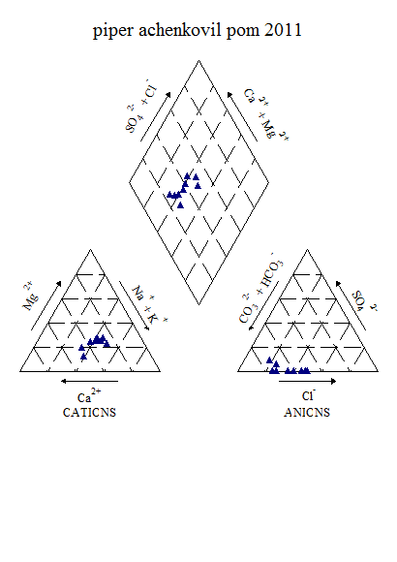

Figure 6.12k: Piper ‘s Classification of Water (Post-monsoon, 2011)

From the piper diagram, during post-monsoon 2011 the water samples belongs to CaHCO3 type and also the same trend is noticed during pre-monsoon 2012.

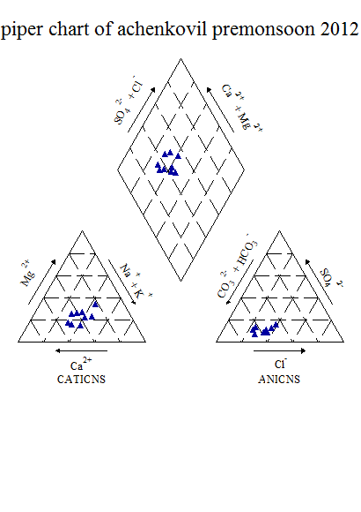

Figure 6.12l: Piper ‘s Classification of Water (Pre-monsoon, 2012)

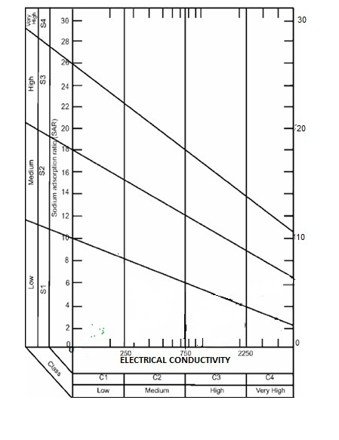

**Figure 6.12m: USSL Classification of Achenkovil (post-monsoon, 2011)**

The results of USSL classification clearly shows that during both the seasons the samples fall under C1S1 category and belongs to Low sodium-Low salinity type.

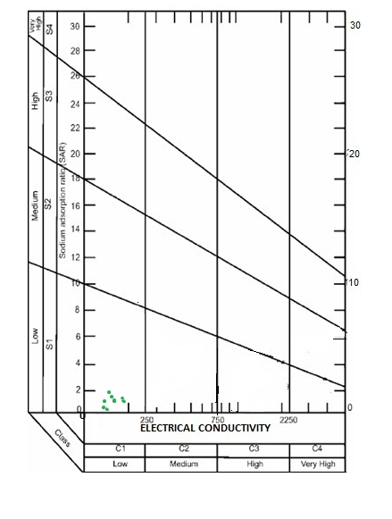

Figure 6.12n: USSL Classification of Achenkovil (pre-monsoon, 2012)

**6.13Kallada River Basin**

One of the important rivers in Kerala is Kallada River and is mainly used for irrigational purpose in the Kollam District and the project is termed as Kallada Irrigation Project (KIP). Kallada river is a west flowing river which originate from Kulathupuzha, Shenthuruni ranges of western ghats. The project area lies between 8o 49’N and 9o 17’N aat longitude 77o 16’E and 76o 24’ E. Kallada river basin is bounded by Achenkovil basin on the north and Ithikkara basin on the south. The tributes of Kallada river are Kalthuruthi river, Shenthuruni river and Kulathupuzha river. These river joints at Parappar where the reservoir is constructed. Kallada river passes through the following Taluks, Nedumangad, Pathanapuram, Kottarakkara, Kunnathur and Quilon and it ends at Ashtamudi lake. The length of Kallada river is about 130km. Kollam district is endowed with perennial supply of water. In order to augment the irrigation potential, several plans were evolved during 1953 to undertake river basin schemes. Kallada Irrigation Project, the biggest multipurpose project, undertaken by the State Government, is intended to utilise the water of Kallada river, mainly for irrigation purpose in Kollam, Pathanamthitta and Alappuzha districts. There is also a proposal to generate 50 M.W. of electricity from the dam at Thenmala. The Kallada project comprises of a masonry dam of 335 m. in length with a maximum height of 81 m. at Parappur in Thenmala across the river to form a reservoir, a pick up weir and sluices at Ottakkal. The 69 kms. right bank canal and the 57.75 kms. left bank canal take off from the pickup weir. It is estimated that the two canals together will serve an area of 68,000 hectares. The famous waterfall 'Palaruvi' is in this river. Kallada Irrigation Project in Parappara near Thenmala and Ottakkal Irrigation Project are situated in this river.

Water quality studies carried out during 2008 to 2012 for Kallada river water samples shows that the average concentration along the river is acceptable for both doemstic and irrigation purposes. Figures below indicate the variations from upstream to downstream which indicated that there are significant changes from station to station.

Figure 6.13a:Seasonal variation of water quality parameters in Kallada river

Figure6.13b:Spatial variation of major cations along the river Kallada

(Upstream to downstream)during Premonsoon 2008

Figure 6.13c:Spatial variation of major anions along the river Kallada

(Upstream to downstream)during Premonsoon 2008

Figure 6.13d:Spatial variation of bacteriological parameters along the river Kallada

(Upstream to downstream)during Premonsoon 2008

Figure 6.13e:Spatial variation of major cations along the river Kallada

(Upstream to downstream)during Postmonsoon 2008

Figure 6.13f:Spatial variation of major anions along the river kallada

(Upstream to downstream) Postmonsoon 2008

Figure 6.13g:Spatial variation of bacteriological parameters along the river Kallada

(Upstream to downstream)during Postmonsoon 2008

Figure 6.13h:Spatial variation of major cations along the river Kallada

(Upstream to downstream) during Premonsoon 2009

Figure 6.13i: Spatial variation of major anions along the river Kallada

(Upstream to downstream) during Premonsoon 2009

Figure 6.13j: Spatial variation of bacteriological parameters along the river Kallada

(Upstream to downstream) during Premonsoon 2009

**Table 6.13a: Variation of Water Quality parameters in Kallada during post-monsoon 2011**

|  |  |  |  |  |  |
| --- | --- | --- | --- | --- | --- |
| **Parameters** | **UNIT** | **MIN** | **MAX** | **Mean** | **Std dev** |
| **Temp** | **°C** | 26.00 | 29.00 | 27.50 | 1.27 |
| **Turbidity** | **NTU** | 2.00 | 10.00 | 3.91 | 2.56 |
| **DO** | **Mg/l** | 7.30 | 9.10 | 7.94 | 0.58 |
| **PH** |  | 5.90 | 6.65 | 6.24 | 0.22 |
| **TDS** | **Mg/l** | 18.99 | 2421.00 | 290.97 | 798.78 |
| **Alkalinity** | **Mg/l** | 12.00 | 24.00 | 15.11 | 3.89 |
| **TH** | **Mg/l** | 10.00 | 404.00 | 57.11 | 130.10 |
| **Calcium** | **Mg/l** | 4.00 | 28.00 | 7.11 | 7.88 |
| **Sodium** | **Mg/l** | 3.10 | 700.60 | 81.67 | 232.10 |
| **Magnesium** | **Mg/l** | 1.46 | 91.37 | 13.49 | 29.33 |
| **Potassium** | **Mg/l** | 1.00 | 25.93 | 4.25 | 8.15 |
| **Sulphate** | **Mg/l** | 2.12 | 92.43 | 33.59 | 51.00 |
| **Chloride** | **Mg/l** | 8.00 | 1349.60 | 158.29 | 446.74 |
| **Fluoride** | **Mg/l** | 0.14 | 0.37 | 0.19 | 0.08 |
| **EC** | **Mg/l** | 36.22 | 4596.00 | 552.45 | 1516.36 |
| **Phosphate** | **Mg/l** | 0.02 | 0.05 | 0.03 | 0.01 |
| **Nitrate** | **Mg/l** | 0.13 | 1.23 | 0.31 | 0.35 |
| **Iron** | **Mg/l** | 0.05 | 0.35 | 0.22 | 0.11 |

**Table 6.13b: Variation of Water Quality parameters in Kallada during pre-**

**monsoon 2011**

|  |  |  |  |  |  |  |  |
| --- | --- | --- | --- | --- | --- | --- | --- |
| **Parameters** | **UNIT** | **MIN** | | **MAX** | **Mean** | | **Std dev** |
| **Temp** | **°C** | 28.00 | | 32.00 | 30.44 | | 1.33 |
| **Ph** |  | 5.57 | | 6.47 | 6.16 | | 0.31 |
| **Turbidity** | **NTU** | 2.50 | | 9.60 | 5.34 | | 2.38 |
| **EC** | **Micro Seimens** | 42.53 | | 439.50 | 100.92 | | 128.34 |
| **TDS** | **Mg/l** | 22.46 | | 232.40 | 53.97 | | 67.77 |
| **Alkalinity** | **Mg/l** | 12.00 | | 110.00 | 25.33 | | 31.83 |
| **Acidity** | **Mg/l** | 2.00 | | 28.00 | 7.44 | | 8.06 |
| **T H** | **Mg/l** | 10.00 | | 180.00 | 32.22 | | 55.50 |
| **Calcium** | **Mg/l** | 2.00 | | 36.07 | 7.57 | | 10.82 |
| **Magnesium** | **Mg/l** | 1.46 | | 34.97 | 5.99 | | 10.88 |
| **Bicarbonate** | **Mg/l** | 12.00 | | 110.00 | 25.33 | | 31.83 |
| **Chloride** | **Mg/l** | 8.00 | | 65.00 | 16.78 | | 18.37 |
| **Sodium** | **Mg/l** | 2.51 | | 30.30 | 7.34 | | 8.87 |
| **Potassium** | **Mg/l** | 1.29 | | 20.60 | 3.99 | | 6.26 |
| **Sulphate** | **Mg/l** | 2.25 | | 33.95 | 6.23 | | 10.40 |
| **Phosphate** | **Mg/l** | 0.01 | | 0.03 | 0.02 | | 0.01 |
| **Fluoride** | **Mg/l** | 0.14 | | 0.18 | 0.17 | | 0.02 |
| **Nitrate** | **Mg/l** | 0.23 | | 1.90 | 0.63 | | 0.50 |
| **Iron** | **Mg/l** | 0.16 | | 0.69 | 0.32 | | 0.17 |
| **DO** | **Mg/l** | 2.40 | | 9.60 | 7.07 | | 1.97 |
| **Bio COD** | **Mg/l** | 0.10 | | 3.00 | 0.80 | | 0.85 |
| **COD** | **Mg/l** | 4.00 | | 50.00 | 20.50 | | 15.56 |
| **Bacteriology** |  |  |  | | |  |  |
| **Total Coliform** | **MPN/100ml** | 200.00 | 4200.00 | | | 1642.86 | 1438.58 |
| **E-Coli** | **MPN/100ml** | 200.00 | 700.00 | | | 325.00 | 250.00 |

One of the important observation is that the Kallada river water is acidic in nature most of the locations. Carbonate is absent and the alkalinity is due to the presence of bicarbonates only. All anions and cations observed lie within the permissible limits. Similar to other major rivers bacteriological contamination is quite dominant in few locations.

Factor analyses were conducted for both post-monsoon 2011 and pre-monsoon 2012 to understand the loading of various ions. The eigen values, fraction of variance and percentage of cumulative variance are given in table 6.13c and 6.13d.

**Table 6.13c: Factor Analysis results of Kallada during post-monsoon (2011)**

|  |  |  |  |  |
| --- | --- | --- | --- | --- |
| Sl.No. | Parameter | Factor 1 | Factor 2 | Factor 3 |
| 1 | Alkalinity | 0.916 | -0.155 | 0.123 |
| 2 | Fluoride | 0.771 | -0.054 | 0.587 |
| 3 | Phosphate | 0.226 | 0.908 | -0.249 |
| 4 | Total hardness | 0.970 | 0.217 | 0.097 |
| 5 | Chloride | 0.972 | 0.211 | 0.096 |
| 6 | EC | 0.972 | 0.210 | 0.093 |
| 7 | TDS | 0.972 | 0.210 | 0.093 |
| 8 | Iron | -0.372 | -0.635 | -0.612 |
| 9 | Potassium | 0.977 | 0.205 | 0.040 |
| 10 | Calcium | 0.983 | 0.145 | 0.084 |
| 11 | pH | 0.769 | -0.440 | 0.263 |
| 12 | Nitrate | 0.036 | 0.203 | -0.955 |
| 13 | Magnesium | 0.976 | 0.184 | 0.100 |
| 14 | Sulphate | 0.951 | 0.306 | 0.023 |
| 15 | Sodium | 0.972 | 0.210 | 0.093 |
| Eigen Value | | 11.318 | 1.923 | 1.221 |
| Fraction of variance, % | | 71.442 | 12.694 | 12.275 |
| Cumulative fraction of variance, % | | 71.442 | 84.136 | 96.411 |

**Table 6.13d: Factor Analysis results of Kallada during pre-monsoon (2012)**

|  |  |  |  |
| --- | --- | --- | --- |
| Sl.No. | Parameter | Factor 1 | Factor 2 |
| 1 | Alkalinity | 0.996 | 0.054 |
| 2 | Fluoride | -0.208 | -0.908 |
| 3 | Phosphate | -0.684 | 0.558 |
| 4 | Total hardness | 0.994 | 0.053 |
| 5 | Chloride | 0.989 | 0.115 |
| 6 | EC | 0.993 | 0.109 |
| 7 | TDS | 0.991 | 0.122 |
| 8 | Iron | -0.391 | -0.428 |
| 9 | Potassium | 0.995 | 0.089 |
| 10 | Calcium | 0.993 | 0.076 |
| 11 | pH | -0.749 | 0.569 |
| 12 | Nitrate | 0.967 | 0.156 |
| 13 | Magnesium | 0.992 | 0.047 |
| 14 | Sulphate | 0.994 | 0.019 |
| 15 | Sodium | 0.977 | 0.198 |
| Eigen Value | | 12.022 | 1.737 |
| Fraction of variance, % | | 79.932 | 11.791 |
| Cumulative fraction of variance, % | | 79.932 | 91.723 |

There are three factors have Eigen value more than 1 during post-monsoon 2011. Factor 1 shows 71.44% variance. This factor has positive loadings associated with alkalinity (0.92), fluoride (0.77), total Hardness, chloride, EC,TDS and potassium (0.97), calcium (0.98), pH(0.77), magnesium (0.98), sulphate (0.95) and sodium (0.97). Factor 2 shows 12.70% variance. This has positive loadings associated with phosphate (0.91).Factor 3 shows 12.27% variance. This factor has moderately positive loadings associated with fluoride (0.58).

During pre-monsoon 2012, there aretwo factors have Eigen value more than 1. Factor 1 shows 79.93% variance. This factor has positive loadings associated with alkalinity, total Hardness, chloride, EC, TDS, potassium calcium, magnesium and sulphate (0.99) and sodium and nitrate (0.97). Factor 2 shows 11.80% variance. This factor has moderate positive loadings on pH (0.57) and phosphate (0.56).

The water quality indices estimated by using CCME and Bascaron methods are presented below (Table 7e)

Table 6.13e: Overall CWQI and WQI Estimated values of Kallada basin for the selected station (2008-2012)

|  |  |  |  |  |  |  |
| --- | --- | --- | --- | --- | --- | --- |
| **Station** |  | **Pre -monsoon 2008** | **Post -monsoon 2008** | **Pre - monsoon 2009** | **Post -monsoon 2011** | **Pre -monsoon 2012** |
| Chittumala | WQI |  |  |  | 54.42623 | 55.90164 |
| CCME(WQI) |  |  |  | 45 | 60 |
| Edamon | WQI |  |  |  | 78.85246 | 75.90164 |
| CCME(WQI) |  |  |  | 72 | 65 |
| Elamannur | WQI |  |  |  | 70.32787 | 76.22951 |
| CCME(WQI) |  |  |  | 69 | 70 |
| Enath | WQI |  |  |  | 80.65574 | 71.80328 |
| CCME(WQI) | 56.72131 | 57.54098 |  | 71 |  |
| Kalayapuram Valiyathodu | WQI |  |  |  | 78.19672 | 76.22951 |
| CCME(WQI) |  |  |  | 61 |  |
| Kallada | WQI |  |  |  |  |  |
| CCME(WQI) | 42 | 52 | 53 |  |  |
| Mannady | WQI |  |  |  | 80.98361 | 73.77049 |
| CCME(WQI) | 56 | 54 | 58 | 62 |  |
| Nediyavila | WQI |  |  |  | 75.7377 | 82.95082 |
| CCME(WQI) |  |  |  | 71 |  |
| Orukunnu | WQI |  |  |  | 78.19672 | 71.63934 |
| CCME(WQI) |  |  |  | 75 |  |
| Punalur | WQI | 64.09836 | 59.18033 | 62.95082 | 67.54098 | 82.13115 |
| CCME(WQI) | 72 | 51 | 65 | 58 |  |

Table 6.13f: CCME Score of Kallada (pre-monsoon, 2008-2012)

|  |  |  |  |  |  |  |  |
| --- | --- | --- | --- | --- | --- | --- | --- |
| **Premonsoon** | | | | | | | |
| **Data Summary** | **year** | **Overall** | **Drinking** | **Aquatic** | **Recreation** | **Irrigation** | **Livestock** |
| **CWQI** | **2008** | **51** | **44** | **50** | **100** | **100** | **100** |
|  | **2009** | **57** | **56** | **76** | **100** | **100** | **100** |
|  | **2012** | **63** | **59** | **41** | **100** | **100** | **100** |
| **F1 (Scope)** | **2008** | 43 | 50 | 67 | 0 | 0 | 0 |
|  | **2009** | 33 | 25 | 33 | 0 | 0 | 0 |
|  | **2012** | 40 | 43 | 75 | 0 | 0 | 0 |
| **F2 (Frequency)** | **2008** | 40 | 42 | 56 | 0 | 0 | 0 |
|  | **2009** | 29 | 25 | 25 | 0 | 0 | 0 |
|  | **2012** | 35 | 37 | 67 | 0 | 0 | 0 |
| **F3 (Amplitude)** | **2008** | 63 | 73 | 10 | 0 | 0 | 0 |
|  | **2009** | 61 | 68 | 8 | 0 | 0 | 0 |
|  | **2012** | 36 | 42 | 20 | 0 | 0 | 0 |

Table 6.13g: CCME Score of Kallada (post-monsoon, 2008-2011)

|  |  |  |  |  |  |  |  |
| --- | --- | --- | --- | --- | --- | --- | --- |
|  | | | | | | | |
| **Data Summary** | **year** | **Overall** | **Drinking** | **Aquatic** | **Recreation** | **Irrigation** | **Livestock** |
| **CWQI** | **2008** | **51** | **48** | **47** | **100** | **100** | **100** |
|  | **2011** | **55** | **48** | **45** | **100** | **74** | **100** |
| **F1 (Scope)** | **2008** | 50 | 50 | 67 | 0 | 0 | 0 |
|  | **2011** | 60 | 71 | 75 | 0 | 33 | 0 |
| **F2 (Frequency)** | **2008** | 47 | 45 | 62 | 0 | 0 | 0 |
|  | **2011** | 38 | 40 | 59 | 0 | 4 | 0 |
| **F3 (Amplitude)** | **2008** | 49 | 59 | 8 | 0 | 0 | 0 |
|  | **2011** | 34 | 38 | 7 | 0 | 31 | 0 |

Water quality indices calculated by CCME method indicates degradation particularly in post-monsoon season. This could be due to the sewage and other waste waters entering the stream along with the overland flow.

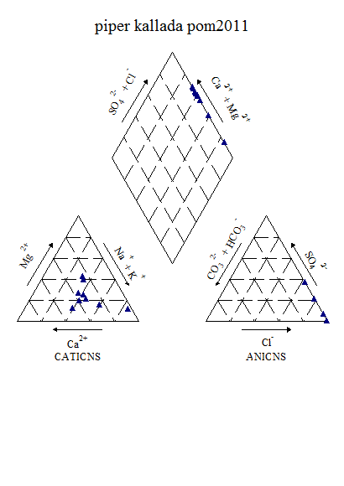

Figure6.13k : Piper ‘s Classification of Water (Post-monsoon, 2011)

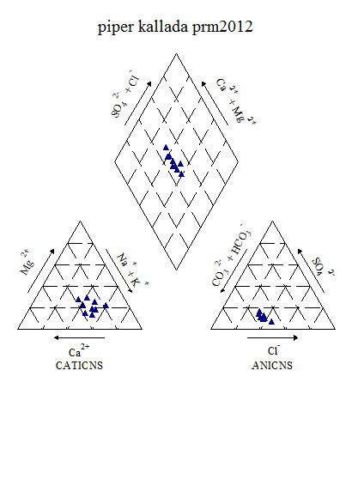

Figure6.13l:Piper‘s Classification of Water (Pre-monsoon, 2012)

From the piper’s diagram, the water during post-monsoon 2011 belongs to CaCl type where as during pre-monsoon 2012 it belongs to CaHCO3 type.

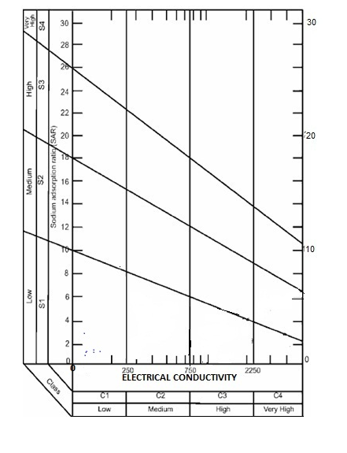

Figure 6.13m: USSL Classification of Kallada (post-monsoon, 2011)

The USSL classification shows that the water fall under C1S1 category and belongs to Low sodium-Low salinity water types during both the seasons.

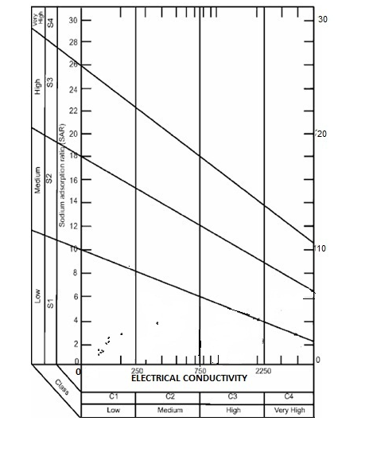

Figure 6.13n: USSL Classification of Kallada (pre-monsoon, 2012)

**6.14. Karamana River Basin**

This has its origin in the Chemunji Mottai-Agathiyakudam hills and reaches the Arabian sea near Pachallur. The tributary river are Kaviyar, Attayar, Veyyapadiyar and Thodyyar. There are two Dams are constructed in the river one at Peppara and another at Aruvikkara for the purpose of water supply to Trivandrum city and surrounding places. The capital city of Thiruvananthapuram is in the banks of this river.The Karamana River Basin (KRB) in Thiruvananthapuram District with an areal spread of 704km2 (Kerala Land Use Board 1995) spreading over Nedumangad, Thiruvanantghapuram and Neyyattinkara Taluks. The entire basin area geographically lies between N. Lat. 8o21'49" and 8o40'55"; E. Long. 76o49'46" and 77o14'35" (seeSOI topo sheet No. 58H/2, 58H/3, 58D/14, and 58D/15). The Karamana River has a length of 68 km. The annual water yield is estimated at 836 Mm3 and the annual utilizable water is estimated at 462 Mm3 (KSLUB, 1995). The available discharge data indicates that the maximum discharge occurs in Karamana River during the months of June and November. In terms of the basin area, among the west flowing rivers of Kerala, KB ranks 15th . The Agasthyamalai Hills (also called the Ashambu Hills), located at the extreme southern end of the Western Ghats mountain range and straddling both sides of the state border of Kollam and Thiruvananthapuram Districts of Kerala and Tirunelveli and Kanyakumari Districts in Tamil Nadu. The border between the two states is defined by a jagged high ridge, that runs from north to south connecting the peaks of the highest hills of the Sahyadri range . The eastern margin of KB coincides with the crest of the Western Ghats and parts of the eastern boundary of the Tambraparni River Basin of Tamil Nad .The mountain peak , named Chemmunji Mottai ( 1717 m above MSL) forms the source of Karamana River. The basin of the Vamanapuram River , ( area: 742.34km2) , is located north of KRB , while the basin of the Neyyar River (area: 497 km2) occupies its southern side. The eastern side of the KRB is flanked by the river basins of the Thambaparni River and its tributaries Papanasam River (163 km2) and the Manimuthar River (212 km2) of Tamil Nadu. The Lakshadweep Sea forms the western boundary of the KB basin. The Neyyar Wildlife Sanctuary (128 km2 and the Peppara Wildlife Sanctuary(53 km2) are located in KRB.

Killi Ar Kaviar, Attaiar, Todayar are the main tributaries of Karamana River. The river gets its name from Karamana, a suburb of Trivandrum city, through which it flows. Despite its short length, the Karamana river has the distinction of having two dams on it, one at Peppara the upper reach of the river, and the other one at Aruvikkara Dam, both meant for supply of water to the city of Thiruvananthapuram.

Water quality investigations were carried out for Karamana river during 2008 to 2012 (Figure 6.14a to 6.14j). Results of the analysis indicated that in Thiruvananthapuram and surrounding area, the surface water quality parameters show wide variations. Places like Ittikkara, Chittumala, Chavara and Tiruvallar temple area, etc. showed very high electrical conductivity values. It was maximum at Ittikkara followed by Chittumala, Thiruvallar temple and Chavara. In some of the locations turbidity was the major problem. A turbidity of 103 NTU was observed at Sooranad south, followed by Neyyar (95 NTU), Ayathikode (36 NTU), Tasvalayillakulam (31 NTU) and Ottashekharamangalam (25 NTU). pH of the waters show considerable variations in the region varying from highly alkaline (9.58) to acidic (5.2). Total hardness was high only at Chittumala (620 mg/l). At Chittumala chloride concentration was also markedly high (2740 mg/l). Thiruvallur (768 mg/l) and Ittikkara (486 mg/l) also showed high chloride content. One of the major observations made in this area is about the presence of Fluoride. Fluoride concentration was 17 mg/l at Puttkulam. Apart from this nitrate concentration up to 48.5 mg/l was recorded at Pandarakula. In addition, iron and coliform contamination was also observed in most of the locations.

Figure 6.14a:Seasonal variation of water quality parameters in Karamana river

(Except EC (microsiemen/cm) all are in mg/l)

Figure6.14b:Spatial variation of major cations along the river Karamana

(Upstream to downstream)during Premonsoon 2008

Figure6.14c:Spatial variation of major anions along the river Karamana

(Upstream to downstream)during Premonsoon 2008

Figure6.14d:Spatial variation of DO along the river Karamana

(Upstream to downstream)during Premonsoon 2008

Figure6.14e:Spatial variation of major cations along the river Karamana

(Upstream to downstream)during Postmonsoon 2008

Figure6.14f:Spatial variation of major anions along the river Karamana

(Upstream to downstream)during Postmonsoon 2008

Figure6.14g:Spatial variation of DO along the river Karamana (Upstream to downstream)during Postmonsoon 2008

Figure6.14h:Spatial variation of major cations along the river Karamana

(Upstream to downstream)during Premonsoon 2009

Figure6.14i:Spatial variation of major anions along the river Karamana

(Upstream to downstream) during Premonsoon 200

Figure 6.14j:Spatial variation of DO along the river Karamana

(Upstream to downstream) during Premonsoon 2009

Analysis of the water samples collected during post-monsoon 2011 and pre-monsoon shows that the quality of water Karamana is facing a greater threat as compared to other rivers in Kerala. Parameters such as EC, TDS, Chloride and sodium are much higher than the permissible limits. Apart from chemical parameters, bacteriological contamination was also a serious issue in the river water. The results of the analysis are shown below (Table 6.14a ).

**Table 6.14a: Variation of Water Quality parameters in Karamana during post-monsoon 2011**

|  |  |  |  |  |  |
| --- | --- | --- | --- | --- | --- |
| **Parameters** | **UNIT** | **MIN** | **MAX** | **Mean** | **Std dev** |
| **Temp** | **°C** | 21.10 | 27.10 | 25.24 | 1.95 |
| **PH** |  | 7.05 | 7.80 | 7.44 | 0.26 |
| **Turbidity** | **NTU** | 1.60 | 7.00 | 3.26 | 2.05 |
| **EC** | **Microsiemens/cm** | 45.55 | 3377.00 | 569.68 | 1238.62 |
| **TDS** | **Mg/l** | 24.31 | 1781.00 | 300.89 | 653.05 |
| **Alkalinity** | **Mg/l** | 14.00 | 56.00 | 26.86 | 15.09 |
| **TH** | **Mg/l** | 10.00 | 308.00 | 62.57 | 108.58 |
| **Calcium** | **Mg/l** | 4.00 | 30.00 | 10.57 | 8.92 |
| **Magnesium** | **Mg/l** | 1.46 | 67.55 | 12.64 | 24.26 |
| **Chloride** | **Mg/l** | 10.00 | 899.72 | 144.96 | 332.89 |
| **Sodium** | **Mg/l** | 4.10 | 515.60 | 81.69 | 191.38 |
| **Potassium** | **Mg/l** | 1.78 | 21.63 | 5.50 | 7.17 |
| **Sulphate** | **Mg/l** | 0.08 | 75.78 | 16.68 | 33.06 |
| **Phosphate** | **Mg/l** | 0.04 | 0.18 | 0.07 | 0.05 |
| **Fluoride** | **Mg/l** | 0.17 | 0.37 | 0.26 | 0.07 |
| **Nitrate** | **Mg/l** | 0.30 | 2.16 | 1.06 | 0.70 |
| **Iron** | **Mg/l** | 0.14 | 1.06 | 0.48 | 0.43 |
| **DO** | **Mg/l** | 2.60 | 8.10 | 6.36 | 1.79 |

**Table 6.14b: Variation of Water Quality parameters in Karamana during pre-**

**monsoon 2012**

|  |  |  |  |  |  |  |  |
| --- | --- | --- | --- | --- | --- | --- | --- |
| **Parameters** | **UNIT** | **MIN** | | **MAX** | **Mean** | | **Std dev** |
| **Temp** | **°C** | 29.00 | | 31.00 | 29.93 | | 0.84 |
| **Ph** |  | 5.89 | | 7.16 | 6.49 | | 0.45 |
| **Turbidity** | **NTU** | 4.40 | | 14.70 | 7.83 | | 3.61 |
| **EC** | **Microseimens/cm** | 57.22 | | 6824.00 | 1109.37 | | 2521.35 |
| **TDS** | **Mg/l** | 28.37 | | 3525.00 | 571.80 | | 1302.96 |
| **Alkalinity** | **Mg/l** | 12.00 | | 40.00 | 20.29 | | 11.63 |
| **Acidity** | **Mg/l** | 4.00 | | 24.00 | 8.00 | | 7.12 |
| **T H** | **Mg/l** | 12.00 | | 630.00 | 116.29 | | 227.00 |
| **Calcium** | **Mg/l** | 4.01 | | 60.12 | 21.19 | | 18.76 |
| **Magnesium** | **Mg/l** | 1.94 | | 138.49 | 23.11 | | 50.92 |
| **Bicarbonate** | **Mg/l** | 12.00 | | 40.00 | 20.29 | | 11.63 |
| **Chloride** | **Mg/l** | 9.00 | | 1911.91 | 309.76 | | 706.92 |
| **Sodium** | **Mg/l** | 3.56 | | 782.50 | 122.40 | | 291.20 |
| **Potassium** | **Mg/l** | 0.63 | | 41.00 | 8.75 | | 14.34 |
| **Sulphate** | **Mg/l** | 3.88 | | 88.14 | 17.12 | | 31.36 |
| **Phosphate** | **Mg/l** | 0.02 | | 0.13 | 0.04 | | 0.04 |
| **Fluoride** | **Mg/l** | 0.21 | | 0.21 | 0.21 | | - |
| **Nitrate** | **Mg/l** | 0.43 | | 1.08 | 0.76 | | 0.26 |
| **Iron** | **Mg/l** | 0.06 | | 0.39 | 0.23 | | 0.11 |
| **DO** | **Mg/l** | 1.30 | | 7.40 | 5.54 | | 2.30 |
| **Bio COD** | **Mg/l** | 1.30 | | 7.40 | 3.81 | | 2.47 |
| **COD** | **Mg/l** | 4.00 | | 40.00 | 12.29 | | 12.88 |
| **Bacteriology** |  |  |  | | |  |  |
| **Total Coliform** | **MPN/100ml** | 9000.00 | 160000.00 | | | 45666.67 | 58146.94 |
| **E-Coli** | **MPN/100ml** | 1400.00 | 160000.00 | | | 42316.67 | 60582.19 |

Factor analyses were conducted for both post-monsoon 2011 and pre-monsoon 2012 to understand the loading of various ions. The Eigen values, fraction of variance and percentage of cumulative variance are given in table 7c and 7d.

**Table 6.14c: Factor Analysis results of Karamana during post-monsoon (2011)**

|  |  |  |  |
| --- | --- | --- | --- |
| Sl.No. | Parameter | Factor 1 | Factor 2 |
| 1 | Alkalinity | 0.777 | 0.550 |
| 2 | Fluoride | 0.620 | 0.604 |
| 3 | Phosphate | 0.951 | 0.293 |
| 4 | Total hardness | 0.942 | 0.325 |
| 5 | Chloride | 0.950 | 0.287 |
| 6 | EC | 0.949 | 0.294 |
| 7 | TDS | 0.949 | 0.294 |
| 8 | Iron | 0.740 | -0.069 |
| 9 | Potassium | 0.936 | 0.348 |
| 10 | Calcium | 0.886 | 0.452 |
| 11 | pH | -0.470 | -0.695 |
|  |  |  |  |
| 12 | Nitrate | -0.017 | 0.971 |
| 13 | Magnesium | 0.945 | 0.313 |
| 14 | Sulphate | 0.952 | 0.286 |
| 15 | Sodium | 0.956 | 0.286 |
| Eigen Value | 12.384 | 1.366 |
| Fraction of variance, % | 70.778 | 20.890 |
| Cumulative fraction of variance, % | 70.778 | 91.668 |

Table 6.14d: Factor Analysis results of Karamana during pre-monsoon (2012)

|  |  |  |  |
| --- | --- | --- | --- |
| Sl.No. | Parameter | Factor 1 | Factor 2 |
| 1 | Alkalinity | 0.491 | 0.691 |
| 2 | Fluoride | 0.994 | 0.090 |
| 3 | Phosphate | 0.976 | 0.154 |
| 4 | Total hardness | 0.990 | 0.129 |
| 5 | Chloride | 0.993 | 0.099 |
| 6 | EC | 0.993 | 0.102 |
| 7 | TDS | 0.993 | 0.103 |
| 8 | Iron | -0.115 | -0.908 |
| 9 | Potassium | 0.981 | 0.161 |
| 10 | Calcium | 0.898 | 0.269 |
| 11 | pH | 0.104 | -0.880 |
| 12 | Nitrate | -0.608 | 0.255 |
| 13 | Magnesium | 0.992 | 0.116 |
| 14 | Sulphate | 0.993 | 0.093 |
| 15 | Sodium | 0.993 | 0.098 |
| Eigen Value | | 11.510 | 2.082 |
| Fraction of variance, % | | 74.935 | 15.681 |
| Cumulative fraction of variance, % | | 74.935 | 90.616 |

During post-monsoon 2011, there are two factors have Eigen value more than 1. Factor 1 shows 70.78% variance. This factor has positive loadings associated with alkalinity (0.77), fluoride (0.62), phosphate (0.95), total Hardness (0.94), chloride, EC and TDS (0.95), iron (0.74), potassium (0.94), calcium (0.88), magnesium (0.94),sulphate and sodium (0.95). Factor 2 shows 20.90% variance. This factor has high positive loadings on nitrate (0.97) and moderate loadings on alkalinity (0.55 and fluoride (0.60).

During pre-monsoon 2012, there are two factors have Eigen value more than 1. Factor 1 shows 74.94% variance. This factor has positive loadings associated with fluoride, total Hardness, chloride, EC and TDS (0.99), phosphate (0.97), potassium (0.98), calcium (0.89), magnesium, sulphate and sodium (0.99). Factor 2 shows 15.68% variance. This factor has positive loadings on alkalinity (0.69)The water quality indices estimated by using CCME and Bascaron methods are presented below (Table 6.14e

**table 6.14e: Overall CWQI and WQI Estimated values of** Karamana **basin for the selected station (2008-2012)**

|  |  |  |  |  |  |  |
| --- | --- | --- | --- | --- | --- | --- |
| **Station** |  | **Pre -monsoon 2008** | **Post -monsoon 2008** | **Pre - monsoon 2009** | **Post -monsoon 2011** | **Pre -monsoon 2012** |
| Aruvikkara | WQI | - | - | - | 70.81967 | 63.60656 |
| CCME(WQI) | - | - | - | 77 | 49 |
| Karakulam Killy | WQI | - | - | - | 75.57 | 57.05 |
| CCME(WQI) | - | - | - | 64 | 57 |
| Karamana Temple | WQI | 72.62295 | 73.44262 | 56.88525 | 77.86885 | 64.09836 |
| CCME(WQI) | 77 | 65 | 59 | 83 | 71 |
| Mangattukadavu | WQI | 79.67213 |  | 73.93443 | 71.31148 | 66.22951 |
| CCME(WQI) | 81 |  | 72 | 82 | 67 |
| Maruthankuzhy | WQI | 65.7377 | 69.01639 | 69.01639 | 74.7541 | 61.14754 |
| CCME(WQI) | 63 | 59 | 59 | 82 | 59 |
| Perumakara | WQI | - | 73.27869 | - | - | - |
| CCME(WQI) | - | 76 | - | - | - |
| Ponnamkulam | WQI | - | 66.55738 | - | - | - |
| CCME(WQI) | - | 83 | - | - | - |
| Thiruvallam | WQI | 71.96721 | - | 54.2623 | 48.68852 | 45.2459 |
| CCME(WQI) | 45 | - | 50 | 45 | 41 |
| Vilappilsala | WQI | - | - | - | 79.34426 | 70.98361 |
| CCME(WQI) | - | - | - | 79 | 75 |

**Table 6.14f: CCME Score of Karamana (pre-monsoon, 2008-2012)**

|  |  |  |  |  |  |  |  |
| --- | --- | --- | --- | --- | --- | --- | --- |
|  | | | | | | | |
| **Data Summary** | **year** | **Overall** | **Drinking** | **Aquatic** | **Recreation** | **Irrigation** | **Livestock** |
| **CWQI** | **2008** | **58** | **52** | **62** | **100** | **72** | **100** |
|  | **2009** | **54** | **51** | **64** | **100** | **64** | **100** |
|  | **2012** | **49** | **43** | **42** | **100** | **64** | **100** |
| **F1 (Scope)** | **2008** | 44 | 50 | 50 | 0 | 33 | 0 |
|  | **2009** | 44 | 50 | 50 | 0 | 33 | 0 |
|  | **2012** | 60 | 71 | 75 | 0 | 33 | 0 |
| **F2 (Frequency)** | **2008** | 31 | 38 | 38 | 0 | 8 | 0 |
|  | **2009** | 31 | 29 | 31 | 0 | 17 | 0 |
|  | **2012** | 34 | 35 | 59 | 0 | 7 | 0 |
| **F3 (Amplitude)** | **2008** | 48 | 54 | 19 | 0 | 33 | 0 |
|  | **2009** | 58 | 62 | 18 | 0 | 49 | 0 |
|  | **2012** | 55 | 57 | 33 | 0 | 52 | 0 |

**Table 6.14g: CCME Score of Muvattupuzha (post-monsoon, 2008-2011)**

|  |  |  |  |  |  |  |  |
| --- | --- | --- | --- | --- | --- | --- | --- |
| **Post-monsoon** | | | | | | | |
| **Data Summary** | **year** | **Overall** | **Drinking** | **Aquatic** | **Recreation** | **Irrigation** | **Livestock** |
| **CWQI** | **2008** | **66** | **62** | **67** | **100** | **100** | **100** |
|  | **2011** | **62** | **59** | **62** | **100** | **75** | **100** |
| **F1 (Scope)** | **2008** | 33 | 33 | 50 | 0 | 0 | 0 |
|  | **2011** | 50 | 57 | 50 | 0 | 33 | 0 |
| **F2 (Frequency)** | **2008** | 22 | 25 | 25 | 0 | 0 | 0 |
|  | **2011** | 27 | 24 | 33 | 0 | 5 | 0 |
| **F3 (Amplitude)** | **2008** | 42 | 51 | 14 | 0 | 0 | 0 |
|  | **2011** | 34 | 35 | 27 | 0 | 26 | 0 |

Water quality indices of the Karamana river indicate a decline in water quality both during the pre-monsoon and post-monsoon seasons. Spatial and seasonal variation are quite pronounced during the study period.

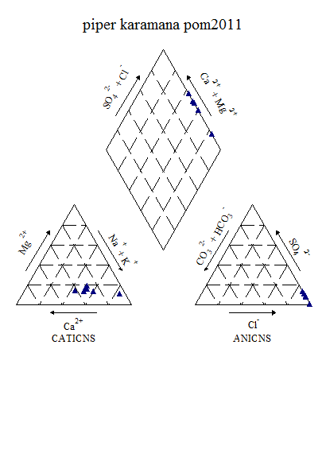

Figure 6.14k: Piper ‘s Classification of Water (Post-monsoon, 2011)

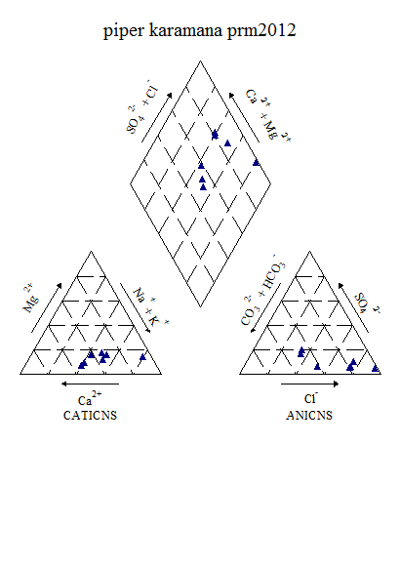

Figure6.14l : Piper ‘s Classification of Water (Pre-monsoon, 2012)

From the Piper’s diagram, it indicates that, the water belongs to CaCl type during post-monsoon 2011 and mixed CaMgCl followed by NaCl type during pre-monsoon 2011

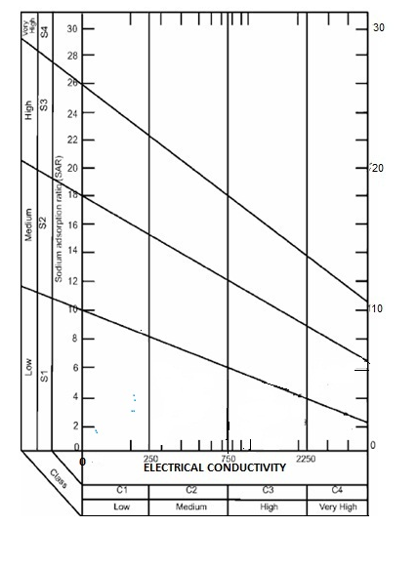

**Figure 6.14m: USSL Classification of Karamana (post-monsoon, 2011)**

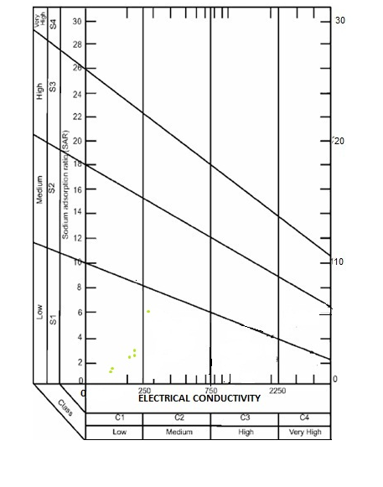

**Figure 14n: USSL Classification of Karamana (pre-monsoon, 2012)**

The USSL classification shows the water fall under C1S1 category and belongs to Low sodium-Low salinity water type during both the seasons.

**6.15 Vamanapuram River Basin**

The Vamanapuram river basin with a catchment area of 787 sq. km. is located mainly in Thiruvananthapuram district and a small part falls in Kollam district of Kerala state. Vamanapuram River Basin is bounded by latitudes of 8° 35’ 24’’ N and 8° 49’ 13’’ N and longitudes of 76°44’ 24’’ E and 77°12’ 45’’ E. The Vamanapuram River Basin is bounded by Nedumangad Taluk of Thiruvananthapuram district in the South, Kottarakkara Taluk of Kollam districts in the North, Tamil Nadu in the East and Arabian Sea in the West. The area forms part of the midland terrain of the state, characterized by lateritic uplands with undulating topography and intermittent valleys. The altitudes vary from 40m in the northwestern parts to about 300m in the eastern and south-eastern parts. The river Vamanapuram is a major river in South Kerala with its network of tributaries. The trunk stream originates from the foothills of the Ponmudi hills (1074 m above msl) and the tributaries from the surrounding hills like Kallar. The river then flows onwards through Vamanpuram town and two-branch stream join at Attaramoodu where the main stream is called Kilimanur River. From there the master stream flows onward and joins the Kadinamkulam backwater at the northern most extremity. It debouches into the Arabian Sea at Mudalapallipozhi near Perumathura, 25 km north of Thiruvananthapuram city. The two tributaries of this river are the Upper Chittar & Manjaprayar streams. The major portion of the Vamanapuram River flows through midland terrain and the remaining through highlands and lowlands areas.

Water samples were collected during post-monsoon of 2011 and pre-monsoon 2012. Chemical analysis were carried out and results are presented below (Table ). It is noticed that the quality of water is quite good and anions and cation concentration lie within the permissible limits. Bacteriological contamination is prominent in Vamanapuram basin.

Table 6.15a: Variation of Water Quality parameters in Vamanapuram during post-

monsoon 2011

|  |  |  |  |  |  |
| --- | --- | --- | --- | --- | --- |
| **Parameters** | **UNIT** | **Min** | **Max** | **Mean** | **Std dev** |
| **Temp** | **°C** | 20.00 | 30.00 | 26.17 | 2.72 |
| **Ph** | **-** | 5.53 | 7.79 | 7.06 | 0.72 |
| **Turbidity** | **NTU** | 0.40 | 12.00 | 5.21 | 3.75 |
| **EC** | **Microsiemen/cm** | 32.80 | 112.40 | 64.74 | 21.55 |
| **TDS** | **Mg/l** | 17.38 | 58.80 | 33.85 | 11.41 |
| **Alkalinity** | **Mg/l** | 14.00 | 24.00 | 18.17 | 3.46 |
| **T H** | **Mg/l** | 10.00 | 22.00 | 15.83 | 3.86 |
| **Calcium** | **Mg/l** | 4.00 | 8.02 | 5.67 | 1.44 |
| **Magnesium** | **Mg/l** | 0.97 | 4.37 | 2.59 | 1.00 |
| **Chloride** | **Mg/l** | 10.00 | 25.00 | 14.50 | 4.16 |
| **Sodium** | **Mg/l** | 3.13 | 12.45 | 6.58 | 2.52 |
| **Potassium** | **Mg/l** | 1.20 | 3.36 | 2.09 | 0.50 |
| **Fluoride** | **Mg/l** | 0.07 | 0.32 | 0.19 | 0.09 |
| **Nitrate** | **Mg/l** | 0.21 | 0.67 | 0.37 | 0.15 |
| **Iron** | **Mg/l** | 0.10 | 1.02 | 0.50 | 0.28 |
| **DO** | **Mg/l** | 4.90 | 9.10 | 7.79 | 1.23 |

**Table 6.15b: Variation of Water Quality parameters in Vamanapuram during pre-**

**monsoon 2012**

|  |  |  |  |  |  |
| --- | --- | --- | --- | --- | --- |
| **Parameters** | **UNIT** | **Min** | **Max** | **Mean** | **Std dev** |
| **Temp** | **°C** | 29.00 | 33.00 | 30.92 | 1.38 |
| **Ph** | **-** | 5.60 | 6.00 | 5.81 | 0.13 |
| **Turbidity** | **NTU** | 5.00 | 52.80 | 19.89 | 16.22 |
| **EC** | **Micro Seimens/cm** | 29.42 | 112.60 | 69.79 | 24.72 |
| **TDS** | **Mg/l** | 16.64 | 60.83 | 37.01 | 12.54 |
| **Alkalinity** | **Mg/l** | 12.00 | 22.00 | 16.00 | 2.95 |
| **Acidity** | **Mg/l** | 2.00 | 8.00 | 4.67 | 1.56 |
| **T H** | **Mg/l** | 8.00 | 18.00 | 14.00 | 3.07 |
| **Calcium** | **Mg/l** | 2.00 | 6.00 | 4.43 | 1.55 |
| **Magnesium** | **Mg/l** | 0.97 | 3.40 | 2.27 | 0.71 |
| **Bicarbonate** | **Mg/l** | 12.00 | 22.00 | 16.00 | 2.95 |
| **Chloride** | **Mg/l** | 7.00 | 27.00 | 11.42 | 5.30 |
| **Sodium** | **Mg/l** | 2.79 | 10.58 | 6.43 | 2.43 |
| **Potassium** | **Mg/l** | 1.26 | 3.85 | 2.32 | 0.67 |
| **Sulphate** | **Mg/l** | 2.40 | 8.32 | 4.71 | 2.19 |
| **Phosphate** | **Mg/l** | 0.02 | 0.04 | 0.03 | 0.01 |
| **Fluoride** | **Mg/l** | 0.16 | 1.34 | 0.78 | 0.54 |
| **Nitrate** | **Mg/l** | 0.31 | 1.04 | 0.60 | 0.24 |
| **Iron** | **Mg/l** | 0.23 | 2.29 | 0.74 | 0.56 |
| **DO** | **Mg/l** | 4.00 | 12.70 | 10.04 | 2.18 |
| **Bio COD** | **Mg/l** | 2.20 | 5.20 | 4.04 | 0.92 |
| **COD** | **Mg/l** | 8.00 | 52.00 | 17.50 | 12.39 |
| **Bacteriology** |  |  |  |  |  |
| **Total coliform** | **MPN/100ml** | 1600.00 | 16000.00 | 7114.29 | 5181.84 |
| **E-Coli** | **MPN/100ml** | 900.00 | 9000.00 | 4166.67 | 2960.57 |

Factor analyses were conducted for both post-monsoon 2011 and pre-monsoon 2012 to understand the loading of various ions. The eigen values, fraction of variance and percentage of cumulative variance are given in table 7c and 7d.

Table 6.15c: Factor Analysis results of Vamanapuram during post-monsoon (2011)

|  |  |  |  |  |  |
| --- | --- | --- | --- | --- | --- |
| Sl.No. | Parameter | Factor 1 | Factor 2 | Factor 3 | Factor 4 |
| 1 | Alkalinity | 0.290 | 0.122 | 0.146 | 0.878 |
| 2 | Fluoride | 0.248 | 0.273 | 0.831 | -0.233 |
| 3 | Total hardness | 0.299 | 0.900 | 0.232 | -0.094 |
| 4 | Chloride | 0.944 | -0.025 | -0.109 | 0.124 |
| 5 | EC | 0.806 | 0.513 | 0.243 | 0.070 |
| 6 | TDS | 0.806 | 0.505 | 0.251 | 0.061 |
| 7 | Iron | 0.027 | 0.506 | 0.021 | -0.520 |
| 8 | Potassium | 0.983 | 0.068 | 0.015 | 0.037 |
| 9 | Calcium | -0.017 | -0.088 | 0.787 | 0.496 |
| 10 | Ph | -0.058 | 0.457 | 0.094 | -0.857 |
| 11 | Nitrate | 0.689 | -0.279 | 0.444 | 0.002 |
| 12 | Magnesium | 0.063 | 0.898 | -0.096 | -0.175 |
| 13 | Sodium | 0.833 | 0.412 | 0.186 | 0.225 |
| Eigen Value | | 5.787 | 3.119 | 1.443 | 1.132 |
| Fraction of variance, % | | 35.166 | 22.688 | 13.601 | 16.859 |
| Cumulative fraction of variance, % | | 35.166 | 57.854 | 71.455 | 88.314 |

Table 6.15d: Factor Analysis results of Vamanapuram during pre-monsoon (2012)

|  |  |  |  |  |  |
| --- | --- | --- | --- | --- | --- |
| Sl.No. | Parameter | Factor 1 | Factor 2 | Factor 3 | Factor 4 |
| 1 | Alkalinity | 0.818 | 0.014 | -0.009 | 0.421 |
| 2 | Fluoride | -0.085 | -0.026 | 0.939 | 0.179 |
| 3 | Phosphate | 0.047 | 0.861 | 0.078 | 0.014 |
| 4 | Total hardness | 0.897 | 0.189 | 0.310 | -0.135 |
| 5 | Chloride | 0.753 | -0.389 | 0.003 | -0.064 |
| 6 | EC | 0.948 | 0.229 | 0.027 | 0.099 |
| 7 | TDS | 0.943 | 0.247 | 0.011 | 0.122 |
| 8 | Iron | 0.634 | 0.676 | 0.046 | 0.168 |
| 9 | Potassium | 0.791 | 0.510 | -0.134 | 0.124 |
| 10 | Calcium | 0.280 | -0.031 | 0.209 | 0.888 |
| 11 | Ph | -0.175 | -0.354 | -0.767 | 0.019 |
| 12 | Nitrate | 0.019 | 0.924 | 0.151 | -0.105 |
| 13 | Magnesium | 0.737 | 0.238 | 0.106 | -0.583 |
| 14 | Sulphate | 0.285 | 0.891 | 0.092 | ­-0.098 |
| 15 | Sodium | 0.944 | 0.123 | -0.005 | 0.115 |
| Eigen Value | | 7.478 | 2.850 | 1.687 | 1.221 |
| Fraction of variance, % | | 43.262 | 24.040 | 11.190 | 9.751 |
| Cumulative fraction of variance, % | | 43.262 | 67.302 | 78.492 | 88.243 |

There are four factors shows the Eigen value more than 1 during post-monsoon 2011. Factor 1 shows 35.16% variance. This factor has positive loadings associated with chloride (0.94), EC and TDS (0.80), potassium (0.98), nitrate (0.69) and sodium (0.83). Factor 2 shows 22.68% variance. This factor has positive loadings associated with Total Hardness and magnesium (0.90) and moderately with EC (0.51), TDS (0.50) and iron (0.50). Factor 3 shows 13.60% variance. This factor has positive loadings associated with fluoride (0.83) and calcium (0.78). Factor 4 shows 16.85% variance and has positive loadings associated with alkalinity (0.88).

There are four factors shows the Eigen value more than 1 during pre-monsoon 2012. Factor 1 shows 43.26% variance. This factor has positive loadings associated with alkalinity (0.82), total Hardness (0.89), chloride (0.75), EC and TDS (0.94), iron (0.63), potassium (0.80) sodium (0.94) and magnesium (0.74). Factor 2 shows 24.04% variance. This factor has positive loadings associated with phosphate (0.86), iron (0.67), nitrate (0.92), sulphate (0.89) and moderately with potassium (0.51). Factor 3 shows 11.19% variance. This factor has positive loadings associated with fluoride (0.94). Factor 4 shows 9.75% variance and has positive loadings associated with calcium (0.89).

The water quality indices estimated by using CCME and Bascaron methods are presented below (Table 15e)

Table 6.15e: Overall CWQI and WQI Estimated values of Periyar basin for the selected station (2008-2012)

|  |  |  |  |  |  |  |
| --- | --- | --- | --- | --- | --- | --- |
| **Station** |  | **Pre -monsoon 2008** | **Post -monsoon 2008** | **Pre - monsoon 2009** | **Post -monsoon 2011** | **Pre -monsoon 2012** |
| Aruvipuram | WQI | 79.5082 | - | 71.96721 | 66.06557 | 58.03279 |
| CCME(WQI) | 77 | - | 57 | 71 | 55 |
| Bharathannoor | WQI | - | - | - | 66.72131 | 58.85246 |
| CCME(WQI) | - | - | - | 79 | 51 |
| Chittar Valayenkil | WQI | 74.2623 | - | 71.14754 | 66.22951 | 62.29508 |
| CCME(WQI) | 66 | - | 66 | 91 | 74 |
| Kadavila | WQI | - | 72.13115 | - | - | - |
| CCME(WQI) | - | 64 | - | - | - |
| Kilimanoor | WQI | 75.2459 | - | 64.2623 | 65.90164 | 60.16393 |
| CCME(WQI) | 62 | - | 44 | 72 | 63 |
| Kollampuzha | WQI | - | - | - | 61.47541 | 59.18033 |
| CCME(WQI) | - | - | - | 56 | 42 |
| Maruthamon | WQI | - | - | - | 62.62295 | 58.03279 |
| CCME(WQI) | - | - | - | 63 | 59 |
| Metattumoozhi | WQI | - | - | - | 62.13115 | 69.34426 |
| CCME(WQI) | - | - | - | 58 | 68 |
| Nagaroor | WQI | - | - | - | 59.67213 | 59.5082 |
| CCME(WQI) | - | - | - | 57 | 42 |
| Neyyar | WQI | - | 74.91803 | - | - | - |
| CCME(WQI) | - | 66 | - | - | - |
| Palode | WQI | 72.78689 | - | 71.80328 | 64.42623 | 66.55738 |
| CCME(WQI) | 70 | - | 61 | 70 | 54 |
| Poovanpara | WQI | - | - | - | 64.91803 | 53.27869 |
| CCME(WQI) | - | - | - | 63 | 44 |
| Thycaud | WQI | - | - | - | 63.60656 | 53.44262 |
| CCME(WQI) | - | - | - | 60 | 45 |
| Vamanapuram | WQI | - | 77.54098 | - | 65.90164 | 64.59016 |
| CCME(WQI) | - | 60 | - | 71 | 60 |
| Venkula | WQI | - | 73.11475 | - | - | - |
| CCME(WQI) | - | 66 | - | - | - |

Table 6.15f: CCME Score of Vamanapuram (pre-monsoon, 2008-2012)

|  |  |  |  |  |  |  |  |
| --- | --- | --- | --- | --- | --- | --- | --- |
| **Pre-monsoon** | | | | | | | |
| **Data Summary** | **year** | **Overall** | **Drinking** | **Aquatic** | **Recreation** | **Irrigation** | **Livestock** |
| **CWQI** | **2008** | **66** | **61** | **66** | **100** | **100** | **100** |
|  | **2009** | **53** | **49** | **61** | **100** | **100** | **100** |
|  | **2012** | **47** | **43** | **29** | **100** | **80** | **85** |
| **F1 (Scope)** | **2008** | 33 | 33 | 50 | 0 | 0 | 0 |
|  | **2009** | 33 | 33 | 50 | 0 | 0 | 0 |
|  | **2012** | 50 | 43 | 100 | 0 | 33 | 25 |
| **F2 (Frequency)** | **2008** | 22 | 25 | 25 | 0 | 0 | 0 |
|  | **2009** | 28 | 25 | 38 | 0 | 0 | 0 |
|  | **2012** | 35 | 45 | 63 | 0 | 10 | 7 |
| **F3 (Amplitude)** | **2008** | 44 | 54 | 18 | 0 | 0 | 0 |
|  | **2009** | 70 | 77 | 26 | 0 | 0 | 0 |
|  | **2012** | 69 | 76 | 34 | 0 | 2 | 1 |

Table 6.15g: CCME Score of Vamanapuram (post-monsoon, 2008-2011)

|  |  |  |  |  |  |  |  |
| --- | --- | --- | --- | --- | --- | --- | --- |
|  | | | | | | | |
| **Data Summary** | **year** | **Overall** | **Drinking** | **Aquatic** | **Recreation** | **Irrigation** | **Livestock** |
| **CWQI** | **2008** | **63** | **54** | **80** | **100** | **100** | **100** |
|  | **2011** | **62** | **57** | **47** | **100** | **100** | **100** |
| **F1 (Scope)** | **2008** | 22 | 33 | 25 | 0 | 0 | 0 |
|  | **2011** | 44 | 50 | 75 | 0 | 0 | 0 |
| **F2 (Frequency)** | **2008** | 19 | 29 | 19 | 0 | 0 | 0 |
|  | **2011** | 31 | 31 | 48 | 0 | 0 | 0 |
| **F3 (Amplitude)** | **2008** | 56 | 66 | 15 | 0 | 0 | 0 |
|  | **2011** | 37 | 46 | 20 | 0 | 0 | 0 |

Water quality indices developed through CCME method shows that the water is not fit for drinking purposes in many of the locations. The major reason for such a result is the bacteriological contamination.

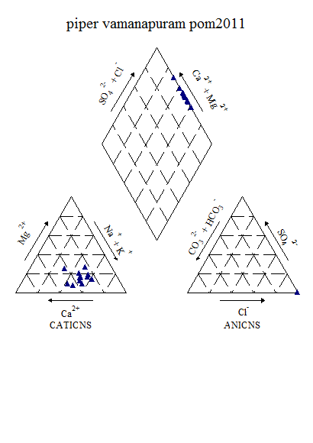

Figure 6.15a: Piper‘s Classification of Water (Post-monsoon, 2012)

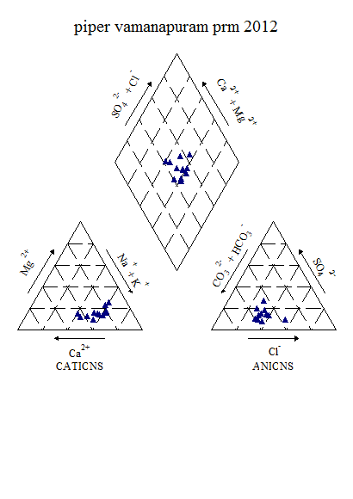

Figure 6.15b: Piper‘s Classification of Water (Pre-monsoon, 2012)

From the Piper’s diagram, it indicates that, the water belongs to CaCl type during post-monsoon 2011 and mixed CaNaHCO3 followed by NaCl type during pre-monsoon 2012.

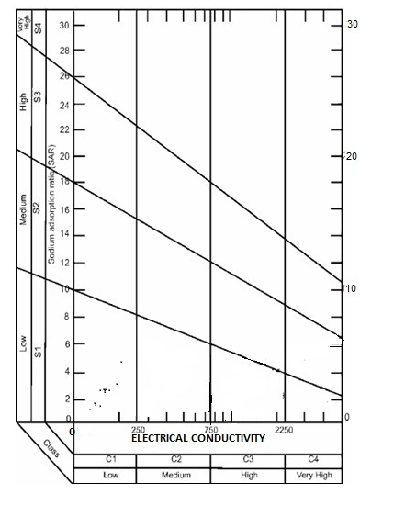

Figure 6.15c: USSL Classification of Vamanapuram (post-monsoon, 2011**)**

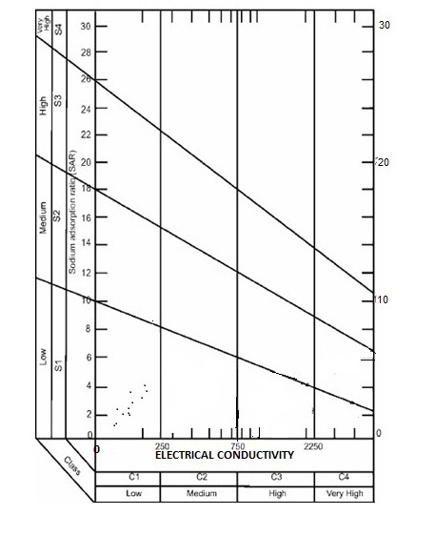

**Figure 6.15d: USSL Classification of Vamanapuram (pre-monsoon, 2012)**

The USSL classification shows the water fall under C1S1 category and belongs to Low sodium-Low salinity water type during both the seasons.

**Chapter 7**

**7.1 Regression Analysis of the Water Quality Data of Post-monsoon 2011**

Linear regression analysis is an important tool for the statistical analysis of water resources data. It is used to describe the covariation between some variable of interest and one or more other variables. Regression analysis is performed to estimate or predict values of one variable based on knowledge of another variable, for which more data are available. The linear regression equations are carried out among significantly correlated parameters. The regression analysis between pairs of EC-Alkalinity, EC-TH, EC-Na, EC-Cl, EC-SO4, Alkalinity-Na, Cl-Ca, Cl-Mg, Cl-Na, Cl-K, Cl-TH, SO4-Ca, SO4-Na and SO4-K are determined and shown in Table below. The different variable affecting water quality is calculated using the regression equation, by substituting values of independent variables/ parameters.

Scatter plots drawn between various parameters to develop a regression equation existing between individual ions during pre-monsoon season

Figure 7.7a:Scatter plot between EC and Sodium

Figure 7.7b:Scatter plot between EC and Chloride

Figure 7.7c:Scatter plot between EC and Sulphate

Figure 7.7d:Scatter plot between EC and Magnesium

Figure 7.7e:Scatter plot between EC and TDS

Figure 7.7f:Scatter plot between EC and TH

Figure 7.7g:Scatter plot between EC and TH

Figure 7.7h:Scatter plot between Calcium and TH

Figure 7.7i:Scatter plot between TH and Sulphate

7.2 Regression Analysis of the Water Quality Data of Pre-monsoon 2012

Figure 7.7j:Scatter plot between EC and Sodium

Figure 7.7k:Scatter plot between EC and Chloride

Figure 7.7l:Scatter plot between EC and Calcium

Figure 7.7m:Scatter plot between EC and Magnesium

Figure 7.7n:Scatter plot between EC and TDS

Figure 7.7o:Scatter plot between EC and TH

Figure 7.7p:Scatter plot between Na and Chloride

Figure 7.7q:Scatter plot between Sodium and Sulphate

Figure 7.7r:Scatter plot between Calcium and Sulphate

Figure 7.7s:Scatter plot between Calcium and Magnesium

Figure 7.7t:Scatter plot between EC and Sodium

Figure 7.7u:Scatter plot between TH and Sulphate

Table 7.3Regression equation for different surface water quality variables (Postmonsoon 2011)

|  |  |  |  |  |
| --- | --- | --- | --- | --- |
| SL.No. | Regression equation, y=a+bx |  | | R² value |
| x | y |
| 1. | y=0.178x-8.603 | EC | Sodium | R²=0.973 |
| 2. | y=0.294x-10.64 | EC | Chloride | R²=0.982 |
| 3. | y=0.010x+0.498 | EC | Sulphate | R²=0.520 |
| 4. | y=0.009x+6.637 | EC | Calcium | R²=0.524 |
| 5. | y=0.024x+2.921 | EC | Magnesium | R²=0.833 |
| 6. | y=0.529x+3.109 | EC | TDS | R²=0.999 |
| 7. | y=0.108x+20.36 | EC | TH | R²=0.816 |
| 8. | y=1.634x+3.940 | Sodium | Chloride | R²=0.989 |
| 9. | y=0.051x+1.235 | Sodium | Sulphate | R²=0.386 |
| 10. | y=0.410x-1.004 | Calcium | Sulphate | R²=0.137 |
| 11. | y=0.351x-0.096 | Magnesium | Sulphate | R²=0.379 |
| 12. | y=0.000x+0.026 | Sulphate | Phosphate | R²=0.022 |
| 13. | y=1.684x-6.906 | Calcium | Magnesium | R²=0.752 |
| 14. | y=7.890x-26.44 | Calcium | TH | R²=0.795 |
| 15. | y=4.532x+7.022 | Magnesium | TH | R²=0.989 |
| 16. | y=0.074x-0.534 | TH | Sulphate | R²=0.357 |
| 17. | y=0.053x+0.008 | Nitrate | Phosphate | R²=0.080 |
| 18. | y=36.96x+7.333 | Phosphate | Calcium | R²=0.056 |
| 19. | y=44.70x+5.953 | Phosphate | Magnesium | R²=0.022 |
| 20. | y=0.001x+0.024 | Potassium | Phosphate | R²=0.016 |

Table 7.4 Regression equation for different surface water quality variables (Premonsoon 2012)

|  |  |  |  |  |
| --- | --- | --- | --- | --- |
| SL.No. | Regression equation, y=a+bx |  | | R² value |
| x | y |
| 1. | y=0.111x-4.676 | EC | Sodium | R²=0.976 |
| 2. | y=0.269x-11.97 | EC | Chloride | R²=0.966 |
| 3. | y=0.016x+3.823 | EC | Sulphate | R²=0.617 |
| 4. | y=0.011x+6.619 | EC | Calcium | R²=0.438 |
| 5. | y=0.021x+2.334 | EC | Magnesium | R²=0.848 |
| 6. | y=0.523x+8.286 | EC | TDS | R²=0.994 |
| 7. | y=0.100x+18.11 | EC | TH | R²=0.84 |
| 8. | y=2.403x-0.576 | Sodium | Chloride | R²=0.983 |
| 9. | y=0.132x+4.653 | Sodium | Sulphate | R²=0.538 |
| 10. | y=0.799x-0.346 | Calcium | Sulphate | R²=0.483 |
| 11. | y=-0.021x+8.447 | Magnesium | Sulphate | R²=0.009 |
| 12. | y=0.000x+0.032 | Sulphate | Phosphate | R²=0.011 |
| 13. | y=1.050x-3.157 | Calcium | Magnesium | R²=0.668 |
| 14. | y=5.322x-10.77 | Calcium | TH | R²=0.749 |
| 15. | y=-0.225x+54.69 | Magnesium | TH | R²=0.034 |
| 16. | y=0.150x+1.250 | TH | Sulphate | R²=0.65 |
| 17. | y=-6E-05x+0.043 | Nitrate | Phosphate | R²=0.001 |
| 18. | y=28.81x+7.508 | Phosphate | Calcium | R²=0.066 |
| 19. | y=29.50x+4.761 | Phosphate | Magnesium | R²=0.042 |
| 20. | y=0.002x+0.030 | Potassium | Phosphate | R²=0.019 |

As a part of the study, Pamba river was selected as the representative river having various discharges as well as human interventions. With this, the river was monitored for DO and BOD on hourly and weekly bases to get an idea of the variation of DO – BOD with varying flow conditions. The experiments were also repeated season-wise. This data was used for QUAL2K model calibration and Validation.

Chapter 8

APPLICATION OF MATHEMATICAL MODELS

**Dissolved Oxygen Modeling**

Major water quality issues that effect on water quality of different water bodies in the country can be summarized as:

* Bacterial
* Oxygen depletion
* Eutrophication
* Increase in salinity and
* Toxicity

Dissolved oxygen fluctuation is an accessory indicator of the water quality status. This frequency permits dissolved oxygen to be utilized as a warning parameter, especially when industrial waste and sewage enters the river system. Dissolved oxygen in surface water normally depends on the atmosphere pressure and temperature that affect oxygen solubility.

Among a great number of water quality parameters dissolved oxygen concentration and oxygen saturation is known to be a critical factor for the survival of organisms in the ecosystem. At the same time, oxygen provides an indirect indicator for possible eutrophication. Dissolved oxygen concentration is directly affected by the atmosphere temperature and pressure conditions. (I. Mariolakos, 2006)

A prime consideration in stream assimilative capacity is dissolved oxygen. Positive dissolved oxygen content must be maintained to prevent putrefaction. However, if streams are to support fish, DO must be maintained not less than 4 to 5 mg/lt. or higher. Numbers of biogeochemical processes control the DO concentration in stream and rivers (i.e. reaeration, photosynthesis, respiration, nitrification, sediment oxygen demand). Although various models are developed, often-simpler approaches are used to estimate the DO concentration in streams affected by point sources of pollution.

**Sources and Sinks of DO:** In the water body itself, the sources of DO are:

1. Re-aeration from the atmosphere
2. Photosynthesis
3. DO addition from incoming tributaries or effluents

**Internal sinks of DO are:**

1. Oxidation of carbonaceous waste material
2. Oxidation of nitrogenous waste material
3. Oxygen demand of sediments in the water body
4. Use of oxygen for respiration by aquatic plants

With the above inputs, sources and sinks, the following general mass balance equation for in a segment volume V, can be written as:

V = re-aeration + (photosynthesis – respiration) – oxidation of CBOD, NBOD (form inputs) – sediment oxygen demand + oxygen inputs ± oxygen transport (into and out of segment)

This equation is applied to a specific water body where the transport and sources of sinks are unique to that particular aquatic system.

**8.2 QUAL-2K MODELLING FOR DO**

Mathematical model QUAL(2E) is used worldwide for the evaluation of surface water quality.(Dcolc,1995) QUAL(2E) is a popular computer model for evaluating a stream water quality (Abbasi et al 1999,Ghosh 1996,McA voy 2003,NEERI 1996,yang 2000)

QUAL2K (or Q2K) is a river and stream water quality model that is intended to represent a modernized version of the QUAL2E (or Q2E) model (Brown and Barnwell 1987). Q2K is similar to Q2E in the following respects:

*  One dimensional. The channel is well-mixed vertically and laterally.
*  Steady state hydraulics. Non-uniform, steady flow is simulated.
* Diurnal heat budget. The heat budget and temperature are simulated as a function of meteorology on a diurnal time scale.
*  Diurnal water-quality kinetics. All water quality variables are simulated on a diurnal time scale.
*  Heat and mass inputs. Point and non-point loads and abstractions are simulated.

The model allows for multiple waste discharges, withdrawals, tributary flows, and incremental inflow and outflow. It also has the capability to compute required dilution flows for flow augmentation to meet pre-specified dissolved oxygen level. The model can either be used as a steady state or as dynamic model. When operated as a steady-state model, it can be used to study the impact of waste loads (magnitude, quality and location) on in stream water quality and also can be used in conjunction with a filed

The QUAL2K framework includes the following new elements:

Software Environment and Interface. Q2K is implemented within the Microsoft Windows environment. It is programmed in the Windows macro language: Visual Basic for Applications (VBA). Excel is used as the graphical user interface.

Model segmentation. Q2E segments the system into river reaches comprised of equally spaced elements. In contrast, Q2K uses unequally-spaced reaches. In addition, multiple loadings and abstractions can be input to any reach.

Carbonaceous BOD speciation. Q2K uses two forms of carbonaceous BOD to represent organic carbon. These forms are a slowly oxidizing form (slow CBOD) and a rapidly oxidizing form (fast CBOD). In addition, non-living particulate organic matter (detritus) is simulated. This detrital material is composed of particulate carbon, nitrogen and phosphorus in a fixed stoichiometry.

Anoxia. Q2K accommodates anoxia by reducing oxidation reactions to zero at low oxygen levels. In addition, denitrification is modeled as a first-order reaction that becomes pronounced at low oxygen concentrations.

Sediment-water interactions. Sediment-water fluxes of dissolved oxygen and nutrients are simulated internally rather than being prescribed. That is, oxygen (SOD) and nutrient fluxes are simulated as a function of settling particulate organic matter, reactions within the sediments, and the concentrations of soluble forms in the overlying waters.

Bottom algae. The model explicitly simulates attached bottom algae.

Light extinction. Light extinction is calculated as a function of algae, detritus and inorganic solids.

pH. Both alkalinity and total inorganic carbon are simulated. The river’s pH is then simulated based on these two quantities.

Pathogens. A generic pathogen is simulated. Pathogen removal is determined as a function of temperature, light, and settling.

**8.3 Concepts in Formulation of Model**

The primary objective of any stream water quality model development is to produce a tool that has the capability for simulation the behavior of the hydrologic and water quality components of a stream. QUAL2K has also been developed to simulate prototype behavior by applying sets of mathematical equations as applicable for water quality simulations. There general phases ( Water resources Engineers, Inc,1967) have been considered for formulation of the model:

1. Conceptual representation
2. Functional representation
3. Computational representation

**Conceptual Representation**

Conceptual representation involves a graphic idealization of the prototype by description of the geometric properties that are to be modeled and identification of boundary conditions and interrelations between various parts of prototype. Fig. (2,4) shows a stream reach (n) that has been divided into a number of sub reaches or computational elements, each, of length <x. For each of these computational elements, the hydrologic balance in terms of flows into the upstream face of the element (Qi-1), external sources or withdrawals (Qxi), and the outflow (Qi), through the downstream face of the element has been written. In the similar fashion, a materials balance for any constituent C is written for the element. In the material balance, both transport (Q,C) and dispersion (Ax (D1/<x) x ( x ) as the movers of mass along the, stream axis has been considered. Mass can be added to or removed from the system via external sources and withdrawals (QxCx)i and added or removed via internal sources or sinks (Si) such as benthic courses and biological transformation. Each computational element is considered to be completely mixed.

ii) **Functional Representation**

The basic equation that has been solved in formulation of QUAL2K is the one-dimensional advection-dispersion mass transport equation, which has numerically been integrated over time and space for each water quality constituent. This equation includes the effects of advection, dispersion, dilution, constituent reactions and interactions, and sources and sinks For any constituent C, this equation can be represented as

= dx - +(Axdx)+ S ………… (1)

Where ,

M = mass (M)

X = distance (L)

T = time (T)

C = concentration (ML-3)

Ax = cross sectional area (L2)

Dl = dispersion co-efficient (L2 Tl)

U = mean velocity (LTl)

S = external source or sinks (MT-1)

Because, M=V. C and V=Ax dx Assuming flow in the stream is steady, i.e. Q/ = o, then

 =  - +  ………… (2)



The terms on the right hand side of the equation represent, respectively, dispersion, advection, constituent changes, external sources/sinks, and dilution. The dC/dt term refers only to constituent changes such as growth and decay, Ac/dt on the lef hand side is the local concentration gradient. The later term includes the effect of constituent changes as well as dispersion, advection, sources/sinks, and dilutions.

Under steady-state conditions, the local derivative becomes equal to zero; i.e.,

 = 0 …………. (3)

Changes that occur to individual constituents or particles independent of advection, dispersion and waste inputs are defined by the term;

 = 0 …………. (4)

These changes include the physical, chemical, and biological reactions and interactions that occur in the stream.

**a)Hydraulic Characteristics**

QUAL2K assumes that the stream hydraulic regime is steady state, i.e., therefore, the hydrologic balance for a computational element can be written as ,

 = (Qx)i …………. (5)

Where, (Qx)i is the sum of the external inflows and/or withdrawals to that element.

**Re-aeration Formulas**

The reaeration coefficient can be prescribed on the **Reach** worksheet. If reaeration is not prescribed, it can be computed using one of the following formulas:

O’Connor-Dobbins:



Owens-Gibbs:



Churchill:



where *U* = velocity [m/s] and *H* = depth [m].

Reaeration can also be internally calculated based on the following scheme patterned after a plot developed by Covar (1976)

If *H* < 0.61 m, use the Owens-Gibbs formula

If *H* > 0.61 m and *H* > 3.45*U*2.5, use the O’Connor-Dobbins formula

Otherwise, use the Churchill formula

This is referred to as option **Internal** on the **Rates** worksheet of Q2K.



**Figure 8.3a Reaeration rate (/d) versus depth and velocity (Covar 1976).**

**8.4 Discretization of River Reach**

The total length of the river considered for the study is about 40 km which extend from Kanur to Daddi. The entire stretch of river was discritized into reaches with computational element lengths of equal length. A schematic representation of the discretization is shown below (Fig 15)



Figure 8.4a : Schematic representation of Pamba river discretization

**Hydraulic data**

Flow measurements and river geometry were measured on various dates during January 2010, post monsoon season and pre-monsoon 2011. For an assumed value of roughness coefficient (0.025), the energy gradient slope was computed using the Manning’s equation from the field measured hydraulic data. River hydraulic parameters for velocity and depth were measured at seven different locations. The variation of depth of water varied from 0.5 m to 1.2 m across the river. The discharges from the point sources were calculated using the velocity and cross-sectional area. Similar method was adopted by (Ghosh et al. 1998).

**8.5 Deoxygenation Coefficient**

The deoxygenation rate coefficient has been obtained by the standard procedure of incubation of the sample over a period of time and the samples have been analyzed for different days at 20ºC. Plots between the DO consumption and incubation time give the laboratory rate constant at incubated temperature.

**8.6 Reaeration Rate Coefficient**

The oxygen transfer coefficient in natural water depends upon the various factors such as internal mixing and turbulence, temperature, wind mixing, sewage out falls and surface films. A fast moving, shallow stream will have a much higher re-aeration coefficient than a sluggish stream. There are number of methods available for the estimation, and most commonly used are (Churchill et al. 1962, O’ Connor et al. 1958, Owens et al. 1964, and Langbien et al. 1967) which are all in terms of depth and velocity. In the present study, the re-aeration coefficient was estimated by the method suggested (O’ Connor et al. 1958). Sediment oxygen demands were obtained by collecting samples from the vicinity of selected outfalls and upstream of the local drains. Samples were analyzed in the laboratory using standard methods to quantify the oxygen demand. QUAL2K being a steady state one-dimensional model, it has got its limitation of data acceptability. Keeping all these aspects in view, data collected from field observations and obtained from laboratory analysis have been made on representative form as acceptable to the model and, calibrated the model to match the observed values. Once the input file is prepared, the foremost task in model application is that of calibration and validation of the model. In this case, for DO – BOD modeling, the first task would be to match the observed and computed BOD rather than DO. This is because the concentration of DO is mainly governed by many factors e.g., conversion of NH3 – N to NO3 – N, re-aeration coefficient, river hydraulic parameters, algal concentration conservation and respiration etc. Once BOD is matched, the second task would be to match the DO concentration in each reach. Since the re-aeration coefficient varies with river hydraulic data and climatological data, efforts are to be made to calibrate those data rather than adjusting the measured values. Option of sensitivity analysis of each/ multiple parameters given in the model provides the appropriate tool to determine the response of the parameters on any desired location. The trail run, which represents the best matching between observed and computed values, is considered as the calibrated values of the model. During the calibration utmost care was taken to match the calibrated and observed values of river data. The calibrated curve with observed curve for O and BOD is shown below (Figure 8.6a).

Figure 8.6a : QUAL2K Model Calibration by using Pamba River DO-BOD data

The following rivers were also been monitored for DO and BOD during pre-monsoon and post-monsoon season of 2011. Modelling process will be repeated for the following rivers during the study period.

1. Chandragiri
2. Chaliyar
3. Bharathapuzha
4. Periyar
5. Pamba
6. Muvattupuzha
7. Meenachil
8. Achankovil
   1. Results of Biological, Bacteriological and Pesticide Analysis of Surface water (Sampling Locations in each distrct along with river basin name are mentioned)

ka(by DOBT) was estimated from the measured values of L,DO,k (Q=2.65 m³/s,U=0.71 m/s=61.34 km/d,and H=0.37

Table 8.1 Estimation of ka (by DOBT) from the measured values of L,DO, kr and kd in pre –

monsoon season

|  |  |  |  |  |  |  |  |  |
| --- | --- | --- | --- | --- | --- | --- | --- | --- |
| Dist.from u/s boundary,km | DO at u/s,mgL¯¹ | Temp ⁰C | Saturated  DO,mgL̄¹ | Initial deficit u/s DO,mgL̄¹ | Initial BOD Lo,mgL̄¹ | Kr  d̄¹ | Kd  d ̄¹ | Computed  Ka,d ̄¹ |
| 15.0 | 4.95 | 28.0 | 8.0 | 2.07 | 9.43 | 1.843 | 0.91 | 5.38 |
| 17.5 | 5.15 | 28.0 | 8.0 | 2.84 | 9.09 | 1.843 | 0.91 | 5.80 |
| 20.0 | 5.35 | 28.0 | 8.0 | 2.68 | 8.89 | 1.843 | 0.91 | 6.02 |
| 22.5 | 5.70 | 28.0 | 8.0 | 2.31 | 8.38 | 1.843 | 0.91 | 7.10 |
| 25.0 | 6.10 | 28.0 | 8.0 | 1.92 | 8.13 | 1.843 | 0.91 | 5.93 |
| 27.5 | 6.35 | 28.0 | 8.0 | 1.66 | 7.79 | 1.843 | 0.91 | 6.47 |

Table 8.2 Estimation of ka (by DOBT) from the measured values of L,DO,kr and kd in post –monsoon season

|  |  |  |  |  |  |  |  |  |
| --- | --- | --- | --- | --- | --- | --- | --- | --- |
| Dist.from u/s boundary,km | DO at u/s,mgL¯¹ | Temp ⁰C | Saturated  DO,mgL̄¹ | Initial deficit u/s DO,mgL̄¹ | Initial BOD Lo,mgL̄¹ | Kr  d̄¹ | Kd  d ̄¹ | Computed  Ka,d ̄¹ |
| 15.0 | 4.95 | 28.0 | 8.0 | 2.07 | 9.43 | 1.843 | 0.91 | 5.38 |
| 17.5 | 5.15 | 28.0 | 8.0 | 2.84 | 9.09 | 1.843 | 0.91 | 5.80 |
| 20.0 | 5.35 | 28.0 | 8.0 | 2.68 | 8.89 | 1.843 | 0.91 | 6.02 |
| 22.5 | 5.70 | 28.0 | 8.0 | 2.31 | 8.38 | 1.843 | 0.91 | 7.10 |
| 25.0 | 6.10 | 28.0 | 8.0 | 1.92 | 8.13 | 1.843 | 0.91 | 5.93 |
| 27.5 | 6.35 | 28.0 | 8.0 | 1.66 | 7.79 | 1.843 | 0.91 | 6.47 |

**Recommendations**

**Recommendations of the Regional Seminar on “Water Quality Assessment and Management of Kerala State”, at Thiruvananthapuram, from 5-6, February 2013.**

The Regional Seminar was inaugurated by the Hon’ble Minister for Water Resources, Govt. of Kerala, Sh. P.J. Joseph and Sh. R.D. Singh, Director NIH was the Chief Guest of the Function. During his Inaugural speech, the minister informed the gathering about the large scale deterioration of water quality in the State which needs to be addressed through the concerted efforts of different stake holders. He also stressed the need for de-centralisation of water quality monitoring and assessment and awareness creation. He informed that the chemistry laboratories of about 50 college in the State have been equipped with necessary facilities for water quality analysis. The Chief Guest of the function elaborated on importance of the water quality and its impact on the human health and on the environment in general. The other dignitaries present included Chief Engineer, Projects-II and Hydrology, and Director State Groundwater Department, Govt. of Kerala.

In the ensuing technical session 7 key-note papers were presented by the experts on different aspects of water quality and wet lands. About 50 technical papers dealing with various quality aspects of Surface Water, Groundwater and Lakes and Wetlands were presented. The technical sessions were attended by wide spectrum of delegates from various state and central government, Academic & research institutes and universities.

Based on the technical presentations and deliberations, the following major issues of Water Quality of Kerala State were emerged;

* Deterioration of water quality in the state is emerging as a matter of serious concern
* In general the water quality deterioration is reported to be mainly due to anthropogenic activities
* Large scale urbanization, indiscriminate disposal of solid and liquid waste, changes in land-use and agricultural practices contribute significantly to the water quality deterioration
* Bacteriological contamination mainly due to poor sanitation practices
* There is no proper coordination and sharing of information between various agencies engaged in water quality monitoring, assessment and management in the state

**Recommendations emerged from presentation and deliberation during this Regional Seminar**

1. There is an urgent need to make integrated efforts by different Government as well as Non-Governmental organizations in order to address issues related to large scale contamination of fresh water resources to provide the desired quality of water to various stake holders in Kerala.
2. A regular water quality monitoring program is required to be taken up by the State utilizing a better Water Quality, Sediment Quality and Soil Quality Monitoring Networks covering the entire State, for getting detailed account of water quality issues caused by different sources and to take up remedial measures.
3. Proper strategy has to be adopted for sampling rather than following the traditional criteria for sampling (Various Geo-environmental conditions such as Land use, Geology, Soil, Cropping pattern, types of fertilizers, type of aquifers etc to be considered while selecting the sampling location).
4. Water Quality Labs equipped with State-of-the-Art equipment for analyzing the various parameters are required to be established to support the analysis of the collected samples from the water quality monitoring program in an effective manner. Adequate and well trained technical staff is required for carrying out the analysis utilizing advanced equipments in the WQ laboratories.
5. Appropriate Scientific interventions and management practices are required to be evolved for proper disposal of solid and liquid waste as these lead to the contamination of the available fresh surface as well as ground water resources.
6. Over exploitation of groundwater may lead to severe groundwater pollution problem due to geogenic origin. Therefore there is a need to regulate the groundwater utilizations to avoid such problems. Suitable recharge measures should be taken up to augment the rainfall recharge to the groundwater for sustainable groundwater development.
7. Groundwater management plan should be developed utilizing the groundwater modeling tools and isotope analysis techniques, particularly in the coastal areas, considering the seawater- aquifer interaction in order to mitigate the salinity problems in the coastal aquifers.
8. Integrated water quality management programs need to be taken up in a holistic manner by the line departments of the state such as; water supply, irrigation, groundwater, health, environment, Panchayat Raj Institutions (PRI), etc. to tackle the water quality problems with particular emphasis on human health.
9. R & D efforts are needed by the Research and Academic institutions for the development of cost-effective and environmental friendly methodologies and technologies to mitigate as well as suggest proper remedial measures to the water quality problems resulting due to anthropogenic activities in the state.
10. Web based water quality information systems for different spatial and temporal scales with appropriate protocols should be developed for sharing the data and information among the various user agencies engaged in water quality analysis, assessment and management in the state.
11. The present regulatory measures should be reviewed. Suitable regulatory measures need to be evolved and effectively enforced in order to mitigate the problems of contamination of surface as well as groundwater resources resulting due to anthropogenic activities.
12. Mass awareness program should be organized by the various government and non-governmental organization for the stake holders on priority basis in order to manage the various water quality and related health problems.
13. The Purpose Driven Studies (PDS) taken-up by the Kerala state Irrigation and Groundwater Department in collaboration with National Institute of Hydrology Belgaum, under Hydrology Project Phase-II will be completed by June 2013. This study should be continued with extended objectives and scope to address the water quality problems of Kerala State in an Holistic Manner.

**REGIONAL SEMINAR ORGANISED BY NATIONAL INSTITUTE OF HYDROLOGY IN ASSOCIATION WITH KERALA STATE IRRIGATION DEPARTMENT AND KERALA STATE GROUNDWATER DEPARTMENT UNDER HP-II**

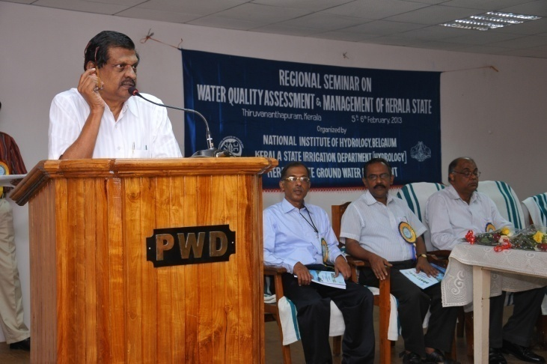

**Inaugural talk by Mr. Joseph Honorable Minister for Water Resources, Kerala**

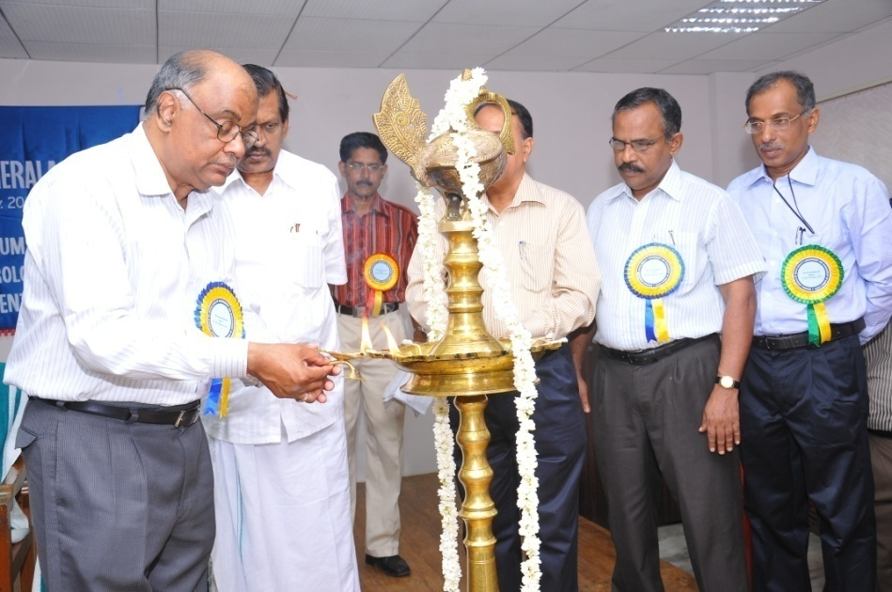

**Shri R. D. Singh, Director lighting the lamp on the occasion Regional Seminar on `Water Quality Assessment and Management of Kerala State’**

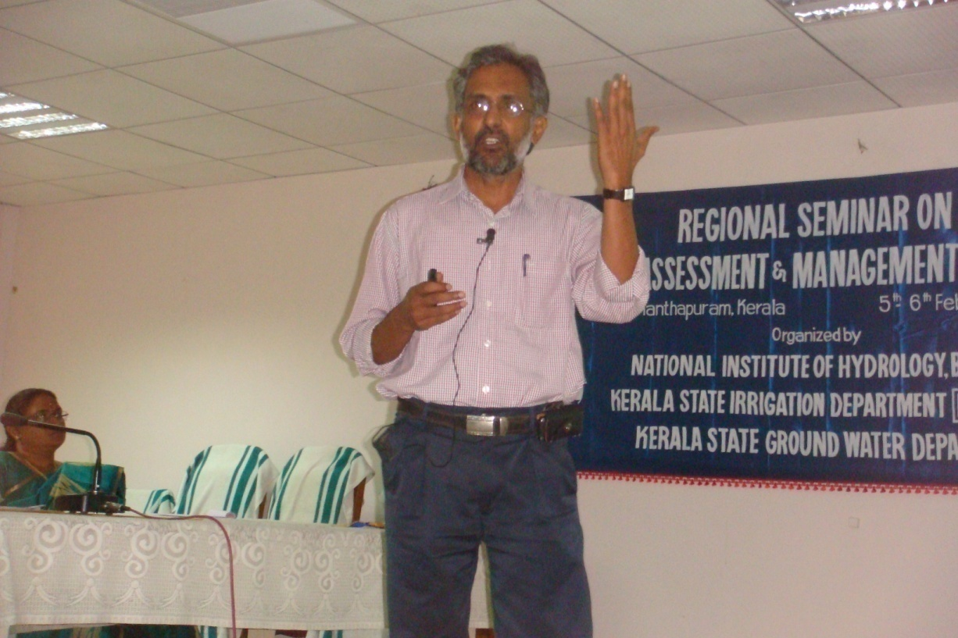

**Keynote Lecture by Dr. Nandakumar, Regional Director, CGWB, Thiruvananthapuram**

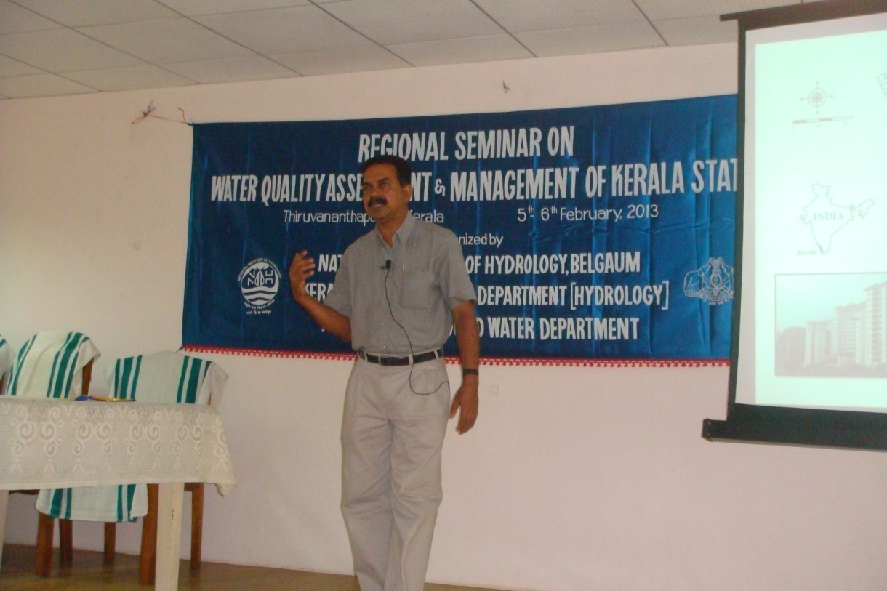

**Keynote Lecture by Dr. Padmalal, Scientist E2, CESS, Thiruvananthapuram**

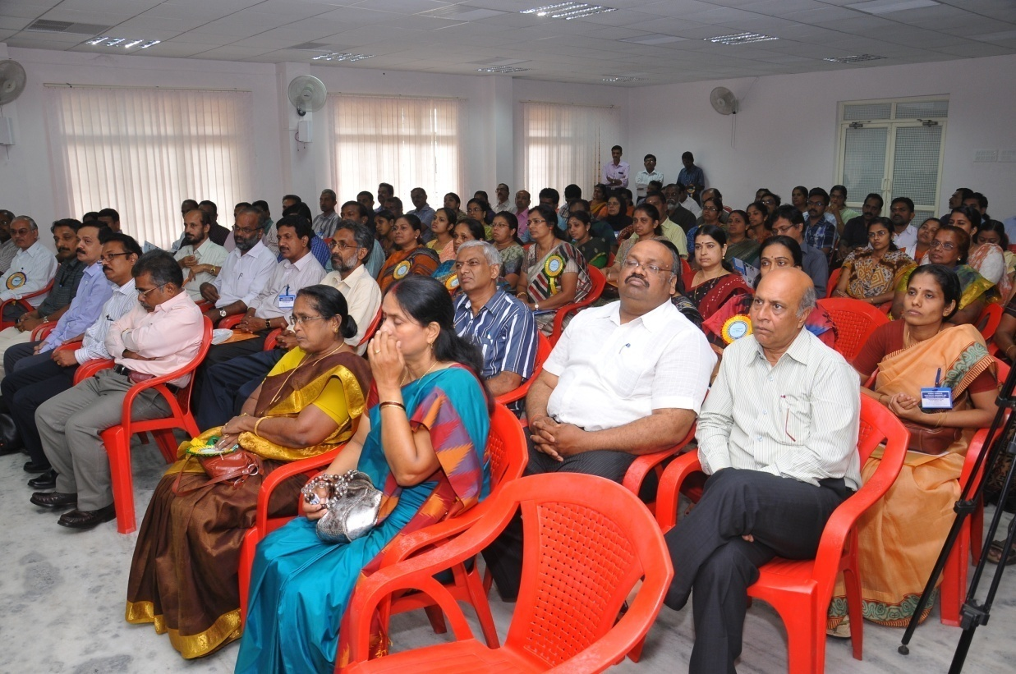

**Delegates of Regional Seminar**

**ANNEXURE -I**

Data pertaining pesticides and bacteriology are given in the annexures

**1.Kottayam**

|  |  |  |  |  |  |  |  |  |  |  |
| --- | --- | --- | --- | --- | --- | --- | --- | --- | --- | --- |
| **Sl No** | **Parameters** | **Unit** | **Poonjar** | **Erattupetta U/S of Meenachil** | **Erattupetta U/S of Poonjar** | **Erattupetta D/S** | **Pala D/S** | **Peroor Pumphouse** | **Kottayam D/S Illikckal** | **Kumarakom** |
|  |
|  |
| 1 | Temperature | o C | 30 | 28 | 28 | 30 | 28 | 31 | 33 | 34 |
| 2 | Dissolved Oxygen | Mg/l | 3.8 | 6.7 | 4.6 | 13.5 | 7.1 | 7.5 | 5 | 1.8 |
| 3 | Bio Chemical Oxygen Demand | Mg/l | Nil | 0.3 | Nil | 5.5 | 1.1 | 2.3 | 1.3 | Nil |
| 4 | Chemical Oxygen Demand | Mg/l | 10 | 12 | 10 | 12 | 10 | 10 | 12 | 8 |
|  | **Pesticides** |  |  |  |  |  |  |  |  |  |
| 5 | Lindane | Mic.g/l |  |  |  |  |  |  |  | 0.004/ |
| 6 | Aldrin | Microgram/l |  |  |  |  |  |  |  | 0.0007 |
| 7 | Die Aldrin | Microgram/l |  |  |  |  |  |  |  | ND |
| 8 | Endosulphan Alpha | Microgram/l |  |  |  |  |  |  |  | ND |
| 9 | Endosulphan Beta | Microgram/l |  |  |  |  |  |  |  | ND |
| 10 | DDD | Microgram/l |  |  |  |  |  |  |  | 0.0009 |
| 11 | DDE | Microgram/l |  |  |  |  |  |  |  | ND |
|  | **Bacteriology** |  |  |  |  |  |  |  |  |  |
| 12 | Total Coliform | MPN/100ml | >2400 | >2400 | >2400 | >2400 | >2400 | >2400 | >2400 | >2400 |
| 13 | E-Coli | MPN/100ml | Present | Present | Present | Present | Present | Present | Present | Present |

**2. Mundakkayam**

|  |  |  |  |  |  |  |  |  |  |  |
| --- | --- | --- | --- | --- | --- | --- | --- | --- | --- | --- |
| **Sl No** | **Parameters** | **Unit** | **Mundathanam** | **Erumeli Tap** | **Erumeli River** | **Mundakkayam D/S** | **Mundakkayam U/S** | **Enthayar** | **Kanjirappilly U/s** | **Kanjirappilly D/s** |
|
|
| 1 | Temperature | o C | 28 | 28 | 27 | 29 | 29 | 27 | 28 | 30 |
| 2 | Dissolved Oxygen | Mg/l | 9.5 | 8.4 | 6.4 | 8.1 | 8.4 | 7.8 | 6.4 | 7.5 |
| 3 | Bio Chemical Oxygen Demand | Mg/l | 0.9 | 1.2 | Nil | 0.6 | 1.3 | Nil | 1.5 | Nil |
| 4 | Chemical Oxygen Demand | Mg/l | 10 | 10 | 10 | 10 | 10 | 10 | 10 | 12 |
|  | **Trace Metals** |  |  |  |  |  |  |  |  |  |
| 5 | Arsenic | Mg/l |  |  | ND |  |  |  |  |  |
| 6 | Copper | Mg/l |  |  | 0.0078 |  |  |  |  |  |
| 7 | Mercury | Mg/l |  |  | ND |  |  |  |  |  |
| 8 | Lead | Mg/l |  |  | 0.0345 |  |  |  |  |  |
| 9 | Zinc | Mg/l |  |  | 0.009 |  |  |  |  |  |
| 10 | Nickel | Mg/l |  |  | ND |  |  |  |  |  |
| 11 | Cadmium | Mg/l |  |  | ND |  |  |  |  |  |
|  | **Pesticides** |  |  |  |  |  |  |  |  |  |
| 12 | Lindane | Microgram/l |  |  | 0.0028 |  |  |  |  |  |
| 13 | Aldrin | Microgram/l |  |  | 0.0008 |  |  |  |  |  |
| 14 | Die Aldrin | Microgram/l |  |  | ND |  |  |  |  |  |
| 15 | Endosulphan Alpha | Microgram/l |  |  | ND |  |  |  |  |  |
| 16 | Endosulphan Beta | Microgram/l |  |  | ND |  |  |  |  |  |
| 17 | DDD | Microgram/l |  |  | ND |  |  |  |  |  |
| 18 | DDE | Microgram/l |  |  | ND |  |  |  |  |  |
|  | **Bacteriology** |  |  |  |  |  |  |  |  |  |
| 20 | Total Coliform | MPN/100ml | 400 | ND | >2400 | >2400 | >2400 | >2400 | >2400 | >2400 |
| 21 | E-Coli | MPN/100ml | Present | Absent | Present | Present | Present | Present | Present | Present |

3.**Aluva**

|  |  |  |  |  |  |  |  |  |  |
| --- | --- | --- | --- | --- | --- | --- | --- | --- | --- |
| **Sl No** | **Parameters** | **Unit** | **Pathalam Lock** | **Edayar** | **Varapuzha Bridge** | **Manjummal kadavu** | **Aluva Market D/S** | **Manjaly** | **Vandiperiyar** |
|
|
| 1 | Temperature | o C | 31 | 31 | 31 | 31 | 31 | 31 | 29 |
| 2 | Dissolved Oxygen | Mg/l | 5.5 | 4.8 | 4.4 | 4.1 | 5.6 | 5.1 | 6.7 |
| 3 | Bio Chemical Oxygen Demand | Mg/l | 1.6 | 2.3 | 0.3 | 0.4 | 0.5 | 0.8 | 1.2 |
| 4 | Chemical Oxygen Demand | Mg/l | 12 | 14 | 14 | 14 | 12 | 12 | 20 |
|  | **Trace Metals** |  |  |  |  |  |  |  |  |
| 5 | .Arsenic | Mg/l | ND |  | ND | ND |  | ND | ND |
| 6 | Copper | Mg/l | ND |  | ND | ND |  | ND | 0.0079 |
| 7 | Mercury | Mg/l | ND |  | ND | ND |  | ND | ND |
| 8 | Lead | Mg/l | 0.0294 |  | 0.0366 | 0.0323 |  | 0.0254 | 0.0423 |
| 9 | Zinc | Mg/l | 0.005 |  | ND | 0.0207 |  | 0.025 | 0.001 |
| 10 | Nickel | Mg/l | 0.0083 |  | 0.003 | 0.0089 |  | 0.004 | 0.0044 |
| 11 | Cadmium | Mg/l | ND |  | 0.0017 | ND |  | ND | ND |
|  | **Pesticides** |  |  |  |  |  |  |  |  |
| 12 | Lindane | Microgram/l | ND |  | ND | ND |  | 0.0083 | 0.003 |
| 13 | Aldrin | Microgram/l | ND |  | ND | ND |  | 0.0017 | 0.0006 |
| 14 | Die Aldrin | Microgram/l | ND |  | ND | ND |  | ND | ND |
| 15 | Endosulphan Alpha | Microgram/l | ND |  | ND | ND |  | ND | ND |
| 16 | Endosulphan Beta | Microgram/l | ND |  | ND | ND |  | ND | ND |
| 17 | DDD | Microgram/l | ND |  | ND | ND |  | 0.0012 | 0.0009 |
| 18 | DDE | Microgram/l | ND |  | ND | ND |  | ND | ND |
|  | **Bacteriology** |  |  |  |  |  |  |  |  |
| 19 | Total Coliform | MPN/100ml | >2400 | >2400 | >2400 | >2400 | >2400 | >2400 | >2400 |
| 20 | E-Coli | MPN/100ml | Present | Present | Absent | Present | Present | Present | Present |

4.**Aluva 2**

|  |  |  |  |  |  |  |  |
| --- | --- | --- | --- | --- | --- | --- | --- |
| Sl No | Parameters | Unit | Chelamattom Temple | Kaladi Sringerimadom | Bhoothathankettu Dam | Bhoothathankettu Dam D/S | Neriyamangalam |
|
|
| 1 | Temperature | o C | 31 | 31 | 25.5 | 25.5 | 28.5 |
| 2 | Dissolved Oxygen | Mg/l | 6.9 | 7.1 | 5.5 | 7.3 | 7.4 |
| 3 | Bio Chemical Oxygen Demand | Mg/l | 1.2 | 0.5 | 0.5 | ND | 1.4 |
| 4 | Chemical Oxygen Demand | Mg/l | 14 | 16 | 14 | 14 | 14 |
|  | **Trace Metals** |  |  |  |  |  |  |
| 5 | .Arsenic | Mg/l |  |  |  |  |  |
| 6 | Copper | Mg/l |  |  |  |  |  |
| 7 | Mercury | Mg/l |  |  |  |  |  |
| 8 | Lead | Mg/l |  |  |  |  |  |
| 9 | Zinc | Mg/l |  |  |  |  |  |
| 10 | Nickel | Mg/l |  |  |  |  |  |
| 11 | Cadmium | Mg/l |  |  |  |  |  |
|  | **Pesticides** |  |  |  |  |  |  |
| 12 | Lindane | Microgram/l |  |  |  |  |  |
| 13 | Aldrin | Microgram/l |  |  |  |  |  |
| 14 | Die Aldrin | Microgram/l |  |  |  |  |  |
| 15 | Endosulphan Alpha | Microgram/l |  |  |  |  |  |
| 16 | Endosulphan Beta | Microgram/l |  |  |  |  |  |
| 17 | DDD | Microgram/l |  |  |  |  |  |
| 18 | DDE | Microgram/l |  |  |  |  |  |
|  | **Bacteriology** |  |  |  |  |  |  |
| 19 | Total Coliform | MPN/100ml | >2400 | >2400 | >2400 | 1900 | >2400 |
| 20 | E-Coli | MPN/100ml | Present | Absent | Absent | Absent | Present |

5.**Muvattupuzha**

|  |  |  |  |  |  |  |  |  |  |
| --- | --- | --- | --- | --- | --- | --- | --- | --- | --- |
| **Sl No** | **Parameters** | **Unit** | **Kothamangalam** | **Pareekkanni** | **Thommankuthu** | **Malankara Dam** | **Malankara Dam D/s** | **Thodupuzha Town** | **Nadukkara** |
|
|
| 1 | Temperature | o C | 27 | 28 | 26.5 | 29.5 | 27.5 | 29 | 30 |
| 2 | Dissolved Oxygen | Mg/l | 7 | 6.4 | 8.5 | 7.7 | 7.3 | 8 | 7.6 |
| 3 | Bio Chemical Oxygen Demand | Mg/l | 1.1 | Nil | 0.3 | 0.8 | 0.6 | 0.5 | 0.6 |
| 4 | Chemical Oxygen Demand | Mg/l | 14 | 14 | 10 | 10 | 12 | 10 | 12 |
|  | **Trace Metals** |  |  |  |  |  |  |  |  |
| 5 | Arsenic | Mg/l |  |  |  |  |  | ND | ND |
| 6 | Copper | Mg/l |  |  |  |  |  | ND | ND |
| 7 | Mercury | Mg/l |  |  |  |  |  | ND | ND |
| 8 | Lead | Mg/l |  |  |  |  |  | 0.028 | 0.0293 |
| 9 | Zinc | Mg/l |  |  |  |  |  | 0.0032 | 0.0049 |
| 10 | Nickel | Mg/l |  |  |  |  |  | 0.0039 | ND |
| 11 | Cadmium | Mg/l |  |  |  |  |  | ND | ND |
|  | **Pesticides** |  |  |  |  |  |  |  |  |
| 12 | Lindane | Microgram/l |  |  |  |  |  | ND | ND |
| 13 | Aldrin | Microgram/l |  |  |  |  |  | ND | ND |
| 14 | Die Aldrin | Microgram/l |  |  |  |  |  | ND | ND |
| 15 | Endosulphan Alpha | Microgram/l |  |  |  |  |  | ND | ND |
| 16 | Endosulphan Beta | Microgram/l |  |  |  |  |  | ND | ND |
| 17 | DDD | Microgram/l |  |  |  |  |  | ND | ND |
| 18 | DDE | Microgram/l |  |  |  |  |  | ND | ND |
|  | **Bacteriology** |  |  |  |  |  |  |  |  |
| 19 | Total Coliform | MPN/100ml | >2400 | >2400 | >2400 | >2400 | >2400 | >2400 | >2400 |
| 20 | E-Coli | MPN/100ml | Present | Present | Present | Present | Present | Present | Present |

6.**Muvattupuzha 2**

|  |  |  |  |  |  |  |  |  |
| --- | --- | --- | --- | --- | --- | --- | --- | --- |
| **Sl No** | **Parameters** | **Unit** | **Muvattupuzha** | **Piravom** | **Vaikom** | **Pambar** | **Kovilkkadavu** | **kalampoor** |
|
|
| 1 | Temperature | o C | 29 | 30 | 31 | 29 | 26.5 | 29 |
| 2 | Dissolved Oxygen | Mg/l | 7.2 | 6.4 | 6.2 | 7.6 | 7.3 | 6.6 |
| 3 | Bio Chemical Oxygen Demand | Mg/l | 0.4 | ND | 0.8 | 0.9 | 2.2 | 0.1 |
| 4 | Chemical Oxygen Demand | Mg/l | 12 | 12 | 10 | 10 | 10 | 12 |
|  | **Trace Metals** |  |  |  |  |  |  |  |
| 5 | Arsenic | Mg/l |  |  | ND |  |  |  |
| 6 | Copper | Mg/l |  |  | ND |  |  |  |
| 7 | Mercury | Mg/l |  |  | ND |  |  |  |
| 8 | Lead | Mg/l |  |  | 0.041 |  |  |  |
| 9 | Zinc | Mg/l |  |  | ND |  |  |  |
| 10 | Nickel | Mg/l |  |  | 0.0049 |  |  |  |
| 11 | Cadmium | Mg/l |  |  | ND |  |  |  |
|  | **Pesticides** |  |  |  |  |  |  |  |
| 12 | Lindane | Microgram/l |  |  | 0.003 |  |  |  |
| 13 | Aldrin | Microgram/l |  |  | 0.003 |  |  |  |
| 14 | Die Aldrin | Microgram/l |  |  | 0.0019 |  |  |  |
| 15 | Endosulphan Alpha | Microgram/l |  |  | ND |  |  |  |
| 16 | Endosulphan Beta | Microgram/l |  |  | 0.0079 |  |  |  |
| 17 | DDD | Microgram/l |  |  | 0.0023 |  |  |  |
| 18 | DDE | Microgram/l |  |  | 0.0004 |  |  |  |
|  | **Bacteriology** |  |  |  |  |  |  |  |
| 19. | Total Coliform | MPN/100ml | >2400 | >2400 | >2400 | >2400 | >2400 | >2400 |
| 20 | E-Coli | MPN/100ml | Present | Absent | Present | Present | Present | Present |

7.**Kozhikode**

|  |  |  |  |  |  |  |  |
| --- | --- | --- | --- | --- | --- | --- | --- |
| **Sl No** | **Parameters** | **Unit** | **Beypore** | **Kottakkadavu** | **Canoli Canal** | **Elathur** | **Kaniyamkode** |
| 1 | Temperature | o C | 28.6 | 30.2 | 31.8 | 32 | 32.5 |
| 2 | Dissolved Oxygen | Mg/l | ND | ND | ND | ND | ND |
| 3 | Bio Chemical Oxygen Demand | Mg/l | 24.46 | 27.47 | 23.45 | 25.46 | 27.47 |
| 4 | Chemical Oxygen Demand | Mg/l | 92.3 | 107.3 | 83.3 | 97.28 | 103.3 |
|  | **Trace Metals** |  |  |  |  |  |  |
| 5 | Arsenic | Mg/l | ND | ND | ND | ND | ND |
| 6 | Copper | Mg/l | 0.009 | 0.0056 | 0.017 | ND | 0.0109 |
| 7 | Mercury | Mg/l | ND | ND | ND | ND | ND |
| 8 | Lead | Mg/l | 0.0426 | 0.0504 | 0.065 | 0.0613 | 0.0591 |
| 9 | Zinc | Mg/l | 0.1449 | 0.0353 | 0.0735 | 0.0408 | ND |
| 10 | Nickel | Mg/l | ND | ND | ND | ND | 0.0045 |
| 11 | Cadmium | Mg/l | ND | ND | ND | ND | ND |
|  | **Pesticides** |  |  |  |  |  |  |
| 12 | Lindane | Micro Grams/L | ND | ND | 0.0088 | 0.0172 | 0.0055 |
| 13 | Aldrin | Micro Grams/L | ND | ND | ND | ND | 0.0017 |
| 14 | Die Aldrin | Micro Grams/L | ND | ND | ND | ND | ND |
| 15 | Endosulphan Alpha | Micro Grams/L | ND | ND | ND | ND | ND |
| 16 | Endosulphan Beta | Micro Grams/L | ND | ND | ND | ND | ND |
| 17 | 1,1-Dichlro-2,2-Bis (4-Chlorophenyl)-Ethane (DDD) | Micro Grams/L | ND | ND | ND | ND | 0.0012 |
| 18 | 1,1-Dichlro-2,2-Bis (4-Chlorophenyl)-Ethylene (DDE) | Micro Grams/L | ND | ND | ND | ND | ND |
|  | **Bacteriology** |  |  |  |  |  |  |
| 19 | Total Coliform | MPN/100ml | >2400 | >2400 | >2400 | >2400 | >2400 |
| 20 | E-Coli | MPN/100ml | Present | Present | Present | Present | Present |

1. **Malappuram**

|  |  |  |  |  |  |  |
| --- | --- | --- | --- | --- | --- | --- |
| **Sl No** | **Parameters** | **Unit** | **Koltickayam** | **Makkaruparamba** | **Perinthalmanna** | **Areacode** |
| 1 | Temperature | o C | 29.5 | 30.6 | 31 | 31.8 |
| 2 | Dissolved Oxygen | Mg/l | 4.48 | 3.59 | NA | NA |
| 3 | Bio Chemical Oxygen Demand | Mg/l | 3.64 | 3.12 | NA | NA |
| 4 | Chemical Oxygen Demand | Mg/l | 6.52 | 5.96 | NA | NA |
|  | **Trace Metals** |  |  |  |  |  |
| 5 | Arsenic | Mg/l | ND | ND | ND | ND |
| 6 | Copper | Mg/l | 0.0118 | 0.0128 | 0.0122 | 0.0105 |
| 7 | Mercury | Mg/l | ND | ND | ND | ND |
| 8 | Lead | Mg/l | 0.0574 | 0.0524 | 0.0542 | 0.0574 |
| 9 | Zinc | Mg/l | 0.0138 | 0.0184 | ND | 0.019 |
| 10 | Nickel | Mg/l | ND | 0.0107 | ND | 0.0031 |
| 11 | Cadmium | Mg/l | ND | ND | ND | ND |
|  | **Pesticides** |  |  |  |  |  |
| 12 | Lindane | Micro Grams | 0.0029 | 0.0139 | 0.0046 | 0.0066 |
| 13 | Aldrin | Micro Grams | ND | ND | ND | ND |
| 14 | Die Aldrin | Micro Grams | ND | ND | ND | ND |
| 15 | Endosulphan Alpha | Micro Grams | ND | ND | ND | ND |
| 16 | Endosulphan Beta | Micro Grams | ND | ND | ND | ND |
| 17 | 1,1-Dichlro-2,2-Bis (4-Chlorophenyl)-Ethane (DDD) | Micro Grams | ND | ND | ND | ND |
| 18 | 1,1-Dichlro-2,2-Bis (4-Chlorophenyl)-Ethylene (DDE) | Micro Grams | ND | ND | ND | ND |
|  | **Bacteriology** |  |  |  |  |  |
| 19 | Total Coliform | MPN/100ml | >2400 | >2400 | >2400 | >2400 |
| 20 | E-Coli | MPN/100ml | Present | Absent | Absent | Present |

1. **Wayanad**

|  |  |  |  |  |  |  |  |
| --- | --- | --- | --- | --- | --- | --- | --- |
| **Sl No** | **Parameters** | **Unit** | **Sultan Bathery** | **Muthanga** | **Thindummel** | **Vellamunda** | **Valada** |
| 1 | Temperature | o C | 28.3 | 29.8 | 30.5 | 30.8 | 31.2 |
| 2 | Dissolved Oxygen | Mg/l | 3.41 | 4.26 | 0.94 | NA | NA |
| 3 | Bio Chemical Oxygen Demand | Mg/l | 1.96 | 3.94 | 0.81 | NA | NA |
| 4 | Chemical Oxygen Demand | Mg/l | 4.3 | 6.56 | 1.56 | NA | NA |
|  | **Trace Metals** |  |  |  |  |  |  |
| 5 | Arsenic | Mg/l | ND | ND | ND | ND | ND |
| 6 | Copper | Mg/l | 0.0053 | 0.0095 | 0.0116 | 0.0056 | 0.0102 |
| 7 | Mercury | Mg/l | ND | ND | ND | ND | ND |
| 8 | Lead | Mg/l | 0.0622 | 0.0571 | 0.052 | 0.0603 | 0.0529 |
| 9 | Zinc | Mg/l | ND | 0.0238 | ND | 0.0079 | 0.019 |
| 10 | Nickel | Mg/l | 0.0043 | ND | 0.001 | 0.0056 | ND |
| 11 | Cadmium | Mg/l | ND | ND | ND | ND | ND |
|  | **Pesticides** |  |  |  |  |  |  |
| 12 | Lindane | Micro Grams/l | 0.0049 | 0.0038 | 0.0043 | 0.0123 | 0.0193 |
| 13 | Aldrin | Micro Grams/l | ND | 0.0013 | ND | ND | ND |
| 14 | Die Aldrin | Micro Grams/l | ND | ND | ND | ND | ND |
| 15 | Endosulphan Alpha | Micro Grams/l | ND | ND | ND | ND | ND |
| 16 | Endosulphan Beta | Micro Grams/l | ND | ND | ND | ND | ND |
| 17 | 1,1-Dichlro-2,2-Bis (4-Chlorophenyl)-Ethane (DDD) | Micro Grams/l | ND | ND | ND | ND | ND |
| 18 | 1,1-Dichlro-2,2-Bis (4-Chlorophenyl)-Ethylene (DDE) | Micro Grams/l | ND | ND | ND | ND | ND |
|  | **Bacteriology** |  |  |  |  |  |  |
| 19 | Total Coliform | MPN/100ml | 500 | >2400 | ND | >2400 | >2400 |
| 20 | E-Coli | MPN/100ml | Absent | Present | Absent | Present | Present |

**10 Thalassery &Payyannur**

|  |  |  |  |  |  |  |  |  |
| --- | --- | --- | --- | --- | --- | --- | --- | --- |
| **Sl No** | **Parameters** | **Unit** | **Aralamkadavu** | **Moolakadavu** | **Karimbam** | **Kuppam** | **Mathamangalam** | **Kariyamkode** |
| 1 | Temperature | o C | 28.6 | 29.1 | 33.1 | 32.4 | 32.3 | 32.6 |
| 2 | Dissolved Oxygen | Mg/l | 8.18 | 7.26 | 6.86 | 8.31 | 5.87 | 6.53 |
| 3 | Bio Chemical Oxygen Demand | Mg/l | 0.79 | 0.33 | 0.33 | 1.71 | 1.85 | 3.3 |
| 4 | Chemical Oxygen Demand | Mg/l | ND | 9 | 4 | 2 | 23 | 5 |
|  | **Trace Metals** |  |  |  |  |  |  |  |
| 5 | Arsenic | Mg/l |  |  |  |  |  |  |
| 6 | Copper | Mg/l |  |  |  |  |  |  |
| 7 | Mercury | Mg/l |  |  |  |  |  |  |
| 8 | Lead | Mg/l |  |  |  |  |  |  |
| 9 | Zinc | Mg/l |  |  |  |  |  |  |
| 10 | Nickel | Mg/l |  |  |  |  |  |  |
| 11 | Cadmium | Mg/l |  |  |  |  |  |  |
|  | **Pesticides** |  |  |  |  |  |  |  |
| 12 | Lindane | Micro Grams/L |  |  |  |  |  |  |
| 13 | Aldrin | Micro Grams/L |  |  |  |  |  |  |
| 14 | Die Aldrin | Micro Grams/L |  |  |  |  |  |  |
| 15 | Endosulphan Alpha | Micro Grams/L |  |  |  |  |  |  |
| 16 | Endosulphan Beta | Micro Grams/L |  |  |  |  |  |  |
| 17 | 1,1-Dichlro-2,2-Bis (4-Chlorophenyl)-Ethane (DDD) | Micro Grams/L |  |  |  |  |  |  |
| 18 | 1,1-Dichlro-2,2-Bis (4-Chlorophenyl)-Ethylene (DDE) | Micro Grams/L |  |  |  |  |  |  |
|  | **Bacteriology** |  |  |  |  |  |  |  |
| 19 | Total Coliform | MPN/100ml | >2400 | >2400 | >2400 | >2400 | >2400 | >2400 |
| 20 | E-Coli | MPN/100ml | Present | Absent | Absent | Present | Present | Absent |

11 **Kasargod**

|  |  |  |  |  |  |  |  |  |
| --- | --- | --- | --- | --- | --- | --- | --- | --- |
| **Sl No** | **Parameters** | **Unit** | **Manakkadavu** | **Karuvankayam** | **Uppala** | **Padiyathadukka** | **Thanniyadi** | **Mukkundil** |
| 1 | Temperature | o C | 31.5 | 33.9 | 32.8 | 29.5 | 33.4 | 32.5 |
| 2 | Dissolved Oxygen | Mg/l | 6.66 | 7.06 | 5.8 | 7.99 | 7.52 | 5.87 |
| 3 | Bio Chemical Oxygen Demand | Mg/l | 1.05 | 1.12 | 1.98 | 2.77 | 2.17 | 1.91 |
| 4 | Chemical Oxygen Demand | Mg/l | 7 | 9.5 | 4.6 | 29 | 8.5 | 87 |
|  | **Trace Metals** |  |  |  |  |  |  |  |
| 5 | Arsenic | Mg/l | ND |  | ND |  |  |  |
| 6 | Copper | Mg/l | 0.04 |  | ND |  |  |  |
| 7 | Mercury | Mg/l | ND |  | ND |  |  |  |
| 8 | Lead | Mg/l | 0.01 |  | ND |  |  |  |
| 9 | Zinc | Mg/l | ND |  | 0.008 |  |  |  |
| 10 | Nickel | Mg/l | ND |  | ND |  |  |  |
| 11 | Cadmium | Mg/l | ND |  | ND |  |  |  |
|  | **Pesticides** |  |  |  |  |  |  |  |
| 12 | Lindane | Micro Grams |  |  |  |  |  |  |
| 13 | Aldrin | Micro Grams |  |  |  |  |  |  |
| 14 | Die Aldrin | Micro Grams |  |  |  |  |  |  |
| 15 | Endosulphan Alpha | Micro Grams |  |  |  |  |  |  |
| 16 | Endosulphan Beta | Micro Grams |  |  |  |  |  |  |
| 17 | 1,1-Dichlro-2,2-Bis (4-Chlorophenyl)-Ethane (DDD) | Micro Grams |  |  |  |  |  |  |
| 18 | 1,1-Dichlro-2,2-Bis (4-Chlorophenyl)-Ethylene (DDE) | Micro Grams |  |  |  |  |  |  |
|  | **Bacteriology** |  |  |  |  |  |  |  |
| 19 | Total Coliform | MPN/100ml | >2400 | >2400 | Absent | >2400 | >2400 | 93 |
| 20 | E-Coli | MPN/100ml | Absent | Present | Absent | Present | Present | Absent |

**12 Thiruvananthapuram**

|  |  |  |  |  |  |  |  |  |  |  |
| --- | --- | --- | --- | --- | --- | --- | --- | --- | --- | --- |
| **Sl No** | **Parameters** | **Unit** | **Ithikara** | **Subramanya Temple Pond** | **Mangalathuvila Colony** | **Chittumala** | **Sasthamkotta** | **Chavara** | **Govt.HS Kollam** | **Poovanpara** |
|
| 1 | Temperature | o C | 29.1 | 28.5 | 28.9 | 30.3 | 30.3 | 25.8 | 27.6 | 30.5 |
| 2 | Dissolved Oxygen | Mg/l | 6.34 | 5.54 | 4.22 | 5.81 | 7.33 | 2.24 | 6.34 | 7.13 |
| 3 | Bio Chemical Oxygen Demand | Mg/l | NA | NA | NA | NA | NA | NA | NA | NA |
| 4 | Chemical Oxygen Demand | Mg/l | NA | NA | NA | NA | NA | NA | NA | NA |
|  | **Trace Metals** |  |  |  |  |  |  |  |  |  |
| 5 | Arsenic | Mg/l | ND | ND | ND | ND | ND | ND | ND | ND |
| 6 | Copper | Mg/l | 0.049 | 0.02 | 0.011 | 0.009 | 0.01 | 0.008 | 0.001 | 0.011 |
| 7 | Mercury | Mg/l | ND | ND | ND | ND | ND | ND | ND | ND |
| 8 | Lead | Mg/l | 0.005 | ND | ND | ND | 0.004 | 0.016 | ND | ND |
| 9 | Zinc | Mg/l | 0.018 | 0.002 | 0.006 | 0.007 | 0.002 | 0.015 | 0.006 | 0.015 |
| 10 | Nickel | Mg/l | ND | 0.006 | ND | 0.006 | 0.0109 | 0.0136 | 0.0078 | 0.0078 |
| 11 | Cadmium | Mg/l | 0.015 | 0.023 | 0.017 | 0.019 | 0.024 | 0.018 | 0.024 | 0.019 |
|  | **Pesticides** |  |  |  |  |  |  |  |  |  |
| 12 | Lindane | g/l | 0.003 | ND | 0.016 | ND | 0.0008 | 0.0047 | 0.683 | 0.004 |
| 13 | Aldrin | g/l | 0.013 | 0.169 | 0.156 | ND | 0.0005 | 0.0011 | 0.4018 | 0.02 |
| 14 | Die Aldrin | g/l | ND | ND | ND | ND | ND | ND | ND | ND |
| 15 | Endosulphan Alpha | g/l | ND | ND | 0.065 | ND | ND | ND | 0.11 | ND |
| 16 | Endosulphan Beta | g/l | ND | ND | ND | ND | ND | ND | ND | ND |
| 17 | 1,1-Dichlro-2,2-Bis (4-Chlorophenyl)-Ethane (DDD) | g/l | 0.001 | ND | ND | 0.0016 | ND | ND | ND | ND |
| 18 | 1,1-Dichlro-2,2-Bis (4-Chlorophenyl)-Ethylene (DDE) | g/l | ND | ND | ND | ND | ND | ND | ND | ND |
|  | **Bacteriology** |  |  |  |  |  |  |  |  |  |
| 19 | Total Coliform | MPN/100ml | >2400 | >2400 | 700 | >2400 | >2400 | >2400 | >2400 | >2400 |
| 20 | E-Coli | MPN/100ml | Absent | Present | Absent | Present | Absent | Absent | Absent | Present |

**13 Thiruvananthapuram 2**

|  |  |  |  |  |  |  |  |  |  |
| --- | --- | --- | --- | --- | --- | --- | --- | --- | --- |
| **Sl No** | **Parameters** | **Unit** | **Aruvipuram** | **Palode** | **Thycadu** | **Thiruvallam Temple** | **Sreevaraham** | **Karamana** | **Neyyar** |
|
|
| 1 | Temperature | o C | 28.6 | 27.5 | 27.9 | 29.2 | 30.8 | 29.7 | 28.6 |
| 2 | Dissolved Oxygen | Mg/l | 7.92 | 5.94 | 5.94 | 7.92 | 7.13 | 2.44 | 10.3 |
| 3 | Bio Chemical Oxygen Demand | Mg/l | NA | NA | NA | NA | NA | NA | NA |
| 4 | Chemical Oxygen Demand | Mg/l | NA | NA | NA | NA | NA | NA | NA |
|  | **Trace Metals** |  |  |  |  |  |  |  |  |
| 5 | Arsenic | Mg/l | ND | ND | ND | ND | ND | ND | ND |
| 6 | Copper | Mg/l | 0.014 | 0.018 | 0.02 | 0.014 | 0.009 | 0.006 | 0.011 |
| 7 | Mercury | Mg/l | ND | ND | ND | ND | ND | ND | ND |
| 8 | Lead | Mg/l | ND | ND | ND | ND | ND | ND | ND |
| 9 | Zinc | Mg/l | 0.004 | 0.003 | 0.009 | 0.009 | 0.011 | 0.282 | 0.01 |
| 10 | Nickel | Mg/l | 0.0072 | 0.0026 | 0.0129 | 0.0205 | 0.018 | 0.002 | 0.003 |
| 11 | Cadmium | Mg/l | 0.019 | 0.029 | 0.018 | 0.025 | 0.0169 | 0.017 | 0.019 |
|  | **Pesticides** |  |  |  |  |  |  |  |  |
| 12 | Lindane | g/l | ND | ND | 0.002 | 0.0014 | 0.167 | 0.004 | ND |
| 13 | Aldrin | g/l | ND | ND | ND | ND | ND | 0.0005 | 0.019 |
| 14 | Die Aldrin | g/l | ND | ND | ND | ND | ND | ND | ND |
| 15 | Endosulphan Alpha | g/l | ND | ND | ND | ND | ND | ND | ND |
| 16 | Endosulphan Beta | g/l | ND | ND | ND | ND | ND | ND | 0.0079 |
| 17 | 1,1-Dichlro-2,2-Bis (4-Chlorophenyl)-Ethane (DDD) | g/l | ND | 0.0012 | ND | 0.001 | ND | ND | 0.0009 |
| 18 | 1,1-Dichlro-2,2-Bis (4-Chlorophenyl)-Ethylene (DDE) | g/l | ND | ND | ND | ND | ND | ND | ND |
|  | **Bacteriology** |  |  |  |  |  |  |  |  |
| 19 | Total Coliform | MPN/100ml | >2400 | >2400 | >2400 | >2400 | >2400 | >2400 | >2400 |
| 20 | E-Coli | MPN/100ml | Present | Present | Present | Present | Present | Present | Present |

**14 Thrissur &Wadakkanchery**

|  |  |  |  |  |  |  |  |  |  |  |
| --- | --- | --- | --- | --- | --- | --- | --- | --- | --- | --- |
| Sl No | Parameters | Unit | **Pillathode** | **Kurumaly** | **Triprayar** | **Enamakkal** | **Puzhakkal** | **Pampady** | **Pattambi** | **Thrithala** |
| 1 | Temperature | o C | 30 | 32 | 33 | 33.5 | 30 | 33 | 34 | 34 |
| 2 | Dissolved Oxygen | Mg/l | 3.6 | 7.9 | 9.5 | 7.2 | 1.5 | 8.4 | 9.2 | 5.9 |
| 3 | Bio Chemical Oxygen Demand | Mg/l | 2.5 | 2.3 | 9 | 5.5 | 1.5 | 2.1 | 4.4 | 0.5 |
| 4 | Chemical Oxygen Demand | Mg/l | 6 | 18 | ND | ND | 6 | 8 | 10 | 12 |
|  | **Trace Metals** |  |  |  |  |  |  |  |  |  |
| 5 | Arsenic | Mg/l | ND | ND | ND | ND | ND | ND | ND | ND |
| 6 | Copper | Mg/l | 0.0065 | 0.008 | 0.0124 | 0.0079 | 0.0086 | 0.0136 | 0.0037 | 0.008 |
| 7 | Mercury | Mg/l | ND | ND | ND | ND | ND | ND | ND | ND |
| 8 | Lead | Mg/l | 0.001 | 0.0005 | 0.004 | ND | 0.0003 | ND | 0.0116 | ND |
| 9 | Zinc | Mg/l | 0.1689 | 0.1016 | 0.0174 | 0.8006 | 0.1013 | 0.0147 | 1 | 0.1013 |
| 10 | Nickel | Mg/l | 0.0197 | ND | ND | ND | 0.0475 | 0.0022 | ND | 0.0339 |
| 11 | Cadmium | Mg/l | 0.0059 | 0.012 | 0.0006 | 0.0014 | 0.0173 | 0.0009 | 0.0027 | 0.0068 |
|  | **Pesticides** |  |  |  |  |  |  |  |  |  |
| 12 | Lindane | Micro Gram/l | 0.0156 | 0.124 | 0.0155 | 0.0111 | 0.2231 | 0.0077 | 0.0216 | 0.0081 |
| 13 | Aldrin | Micro Gram/l | 0.0017 | 0.014 | 0.0014 | ND | 0.0012 | 0.0006 | ND | 0.0017 |
| 14 | Die Aldrin | Micro Gram/l | ND | ND | ND | ND | ND | ND | ND | ND |
| 15 | Endosulphan Alpha | Micro Gram/l | ND | ND | ND | ND | ND | ND | ND | ND |
| 16 | Endosulphan Beta | Micro Gram/l | ND | ND | ND | ND | ND | ND | ND | ND |
| 17 | 1,1-Dichlro-2,2-Bis (4-Chlorophenyl)-Ethane (DDD) | Micro Gram/l | 0.0019 | ND | ND | ND | ND | ND | ND | ND |
| 18 | 1,1-Dichlro-2,2-Bis (4-Chlorophenyl)-Ethylene (DDE) | Micro Gram/l | ND | ND | ND | ND | ND | ND | ND | ND |
|  | **Bacteriology** |  |  |  |  |  |  |  |  |  |
| 19 | Total Coliform | MPN/100ml | 2000 | 1700 | >2400 | >2400 | >2400 | >2400 | >2400 | >2400 |
| 20 | E-Coli | MPN/100ml | Absent | Absent | Present | Present | Absent | Present | Present | Absent |

**15 Palakkad**

|  |  |  |  |  |  |  |  |  |  |  |
| --- | --- | --- | --- | --- | --- | --- | --- | --- | --- | --- |
| **Sl No** | **Parameters** | **Unit** | **Kanjikode** | **Chullimada** | **Plazhy** | **Meenkara** | **Vithinassery** | **Kalpathy** | **Vandazhy** | **Chittoor** |
|
|
| 1 | Temperature | o C | 30 | 31 | 33 | 31 | 34 | 31 | 32 | 32 |
| 2 | Dissolved Oxygen | Mg/l | 3.5 | 4.7 | 7 | 7.1 | 6.5 | 4.1 | 5.4 | 7.7 |
| 3 | Bio Chemical Oxygen Demand | Mg/l | 0.2 | 1 | 5 | 6.1 | 6.5 | 2.8 | 2.2 | 1.7 |
| 4 | Chemical Oxygen Demand | Mg/l | 10 | 10 | 10 | 8 | ND | 12 | 10 | 12 |
|  | **Trace Metals** |  |  |  |  |  |  |  |  |  |
| 5 | Arsenic | Mg/l | ND | ND | ND | ND | ND | ND | ND | ND |
| 6 | Copper | Mg/l | 0.0096 | 0.0047 | 0.0063 | 0.0099 | 0.0086 | 0.0064 | ND | 0.0049 |
| 7 | Mercury | Mg/l | ND | ND | ND | ND | ND | ND | ND | ND |
| 8 | Lead | Mg/l | 0.0052 | ND | 0.0036 | 0.0006 | 0.0091 | 0.0065 | 0.0035 | 0.0059 |
| 9 | Zinc | Mg/l | 0.0925 | 0.0396 | 0.0214 | 0.0325 | 0.6936 | 0.0122 | 0.0109 | 0.0122 |
| 10 | Nickel | Mg/l | 0.0377 | 0.0067 | 0.0029 | 0.0072 | 0.0278 | 0.0012 | ND | ND |
| 11 | Cadmium | Mg/l | 0.0033 | ND | 0.0068 | 0.001 | 0.0045 | 0.0069 | 0.0003 | 0.0015 |
|  | **Pesticides** |  |  |  |  |  |  |  |  |  |
| 12 | Lindane | Micro Gram/l | 0.0136 | 0.0253 | 0.006 | 0.02 | 0.0052 | 0.0118 | 0.0059 | 0.0054 |
| 13 | Aldrin | Micro Gram/l | ND | ND | ND | ND | ND | 0.0018 | ND | ND |
| 14 | Die Aldrin | Micro Gram/l | ND | ND | ND | ND | ND | ND | ND | ND |
| 15 | Endosulphan Alpha | Micro Gram/l | ND | ND | ND | ND | ND | ND | ND | ND |
| 16 | Endosulphan Beta | Micro Gram/l | ND | ND | ND | ND | ND | ND | ND | ND |
| 17 | 1,1-Dichlro-2,2-Bis (4-Chlorophenyl)-Ethane (DDD) | Micro Gram/l | ND | ND | ND | ND | ND | ND | ND | ND |
| 18 | 1,1-Dichlro-2,2-Bis (4-Chlorophenyl)-Ethylene (DDE) | Micro Gram/l | ND | ND | ND | ND | ND | ND | ND | ND |
|  | **Bacteriology** |  |  |  |  |  |  |  |  |  |
| 19 | Total Coliform | MPN/100ml | >2400 | >2400 | >2400 | 1700 | >2400 | >2400 | >2400 | >2400 |
| 20 | E-Coli | MPN/100ml | Present | Present | Present | Absent | Present | Present | Present | Absent |

**16 Chengannur 1 & Adoor**

|  |  |  |  |  |  |  |  |  |  |  |
| --- | --- | --- | --- | --- | --- | --- | --- | --- | --- | --- |
| **Sl No** | **Parameters** | **Unit** | **Pandalam** | **Thumpamon** | **Kaipattoor** | **Kumpazha** | **Kalleli** | **Punalur** | **Kaduvathodu** | **Enathu** |
|
|
| 1 | Temperature | o C | 24 | 24 | 24 | 23 | 23 | 25 | 25 | 25 |
| 2 | Dissolved Oxygen | Mg/l | 7.6 | 7 | 6.7 | 7 | 8.1 | 6.4 | 7.4 | 8.4 |
| 3 | Bio Chemical Oxygen Demand | Mg/l | 1.8 | 0.6 | 0.9 | 0.7 | 0.8 | 1.1 | 1.1 | 1 |
| 4 | Chemical Oxygen Demand | Mg/l | 16 | 14 | 14 | 12 | 14 | 14 | 12 | 12 |
|  | **Trace Metals** |  |  |  |  |  |  |  |  |  |
| 5 | Arsenic | Mg/l | ND | ND | ND | ND | ND | ND | ND | ND |
| 6 | Copper | Mg/l | 0.0115 | 0.0827 | 0.0102 | 0.0138 | 0.0117 | 0.0131 | 0.0121 | 0.0095 |
| 7 | Mercury | Mg/l | ND | ND | ND | ND | ND | ND | ND | ND |
| 8 | Lead | Mg/l | 0.0431 | 0.0406 | ND | ND | ND | 0.0464 | 0.0462 | ND |
| 9 | Zinc | Mg/l | ND | 0.0067 | 0.0023 | 0.0256 | ND | ND | ND | 0.0178 |
| 10 | Nickel | Mg/l | 0.0035 | ND | ND | ND | 0.0036 | 0.0042 | 0.0035 | ND |
| 11 | Cadmium | Mg/l | ND | ND | 0.0007 | ND | ND | ND | ND | ND |
|  | **Pesticides** |  |  |  |  |  |  |  |  |  |
| 12 | Lindane | g/l | 0.0171 | 0.0541 | 0.0169 | 0.0266 | 0.0102 | ND | ND | ND |
| 13 | Aldrin | g/l | 0.0012 | 0.0012 | 0.0028 | 0.0029 | 0.0027 | ND | ND | ND |
| 14 | Die Aldrin | g/l | ND | ND | ND | ND | ND | ND | ND | ND |
| 15 | Endosulphan Alpha | g/l | ND | ND | ND | ND | ND | ND | ND | ND |
| 16 | Endosulphan Beta | g/l | ND | ND | ND | ND | ND | ND | ND | ND |
| 17 | DDD | g/l | ND | 0.0012 | 0.00019 | 0.0034 | ND | ND | ND | ND |
| 18 | DDE | g/l | ND | ND | ND | ND | ND | ND | ND | ND |
|  | **Bacteriology** |  |  |  |  |  |  |  |  |  |
| 19 | Total Coliform | MPN/100ml | >2400 | >2400 | >2400 | >2400 | >2400 | >2400 | >2400 | >2400 |
| 20 | E-Coli | MPN/100ml | Present | Absent | Absent | Present | Present | Present | Present | Absent |

**17 Chengannur 2 & Adoor 2**

|  |  |  |  |  |  |  |  |  |  |  |
| --- | --- | --- | --- | --- | --- | --- | --- | --- | --- | --- |
| **Sl No** | **Parameters** | **Unit** | **Adoor** | **Anayadi** | **Venmani** | **Thondra** | **Thengeli** | **Kathalimangalam** | **Neerettupuram** | **Pulikkezhu** |
|
|
| 1 | Temperature | o C | 26 | 26 | 30 | 29 | 29 | 28 | 29 | 28 |
| 2 | Dissolved Oxygen | Mg/l | 4 | 6.4 | 7.1 | 6.6 | 7.5 | 6.1 | 7.2 | 7.3 |
| 3 | Bio Chemical Oxygen Demand | Mg/l | 2.1 | 1.1 | 1.1 | 0.7 | 2.2 | 0.2 | 2.1 | 1.4 |
| 4 | Chemical Oxygen Demand | Mg/l | 14 | 12 | 12 | 10 | 14 | 14 | 12 | 12 |
|  | **Trace Metals** |  |  |  |  |  |  |  |  |  |
| 5 | Arsenic | Mg/l | ND | ND | ND | ND | ND | ND | ND | ND |
| 6 | Copper | Mg/l | 0.0094 | 0.0104 | 0.0137 | 0.0115 | 0.0827 | 0.0102 | 0.0138 | 0.0117 |
| 7 | Mercury | Mg/l | ND | ND | ND | ND | ND | ND | ND | ND |
| 8 | Lead | Mg/l | ND | ND | 0.0495 | 0.0431 | 0.0406 | ND | ND | ND |
| 9 | Zinc | Mg/l | 0.0044 | ND | ND | ND | 0.0067 | 0.0023 | 0.0256 | ND |
| 10 | Nickel | Mg/l | 0.0042 | 0.0006 | 0.0115 | 0.0035 | ND | ND | ND | 0.0036 |
| 11 | Cadmium | Mg/l | ND | ND | ND | ND | ND | 0.0007 | ND | ND |
|  | **Pesticides** |  |  |  |  |  |  |  |  |  |
| 12 | Lindane | microgram/l | 0.0031 | 0.0016 | 0.0022 | 0.0052 | 0.0104 | 0.0034 | ND | 0.0066 |
| 13 | Aldrin | microgram/l | 0.0012 | 0.0009 | ND | 0.0011 | 0.0005 | ND | ND | ND |
| 14 | Die Aldrin | microgram/l | ND | ND | ND | ND | ND | ND | ND | ND |
| 15 | Endosulphan Alpha | microgram/l | ND | ND | ND | ND | ND | ND | ND | ND |
| 16 | Endosulphan Beta | microgram/l | ND | ND | ND | ND | ND | ND | ND | ND |
| 17 | DDD | microgram/l | ND | ND | ND | ND | ND | ND | ND | ND |
| 18 | DDE | microgram/l | ND | ND | ND | ND | ND | ND | ND | ND |
|  | **Bacteriology** |  |  |  |  |  |  |  |  |  |
| 19 | Total Coliform | MPN/100ml | >2400 | >2400 | >2400 | >2400 | >2400 | >2400 | >2400 | >2400 |
| 20 | E-Coli | MPN/100ml | Present | Present | Present | Present | Absent | Absent | Present | Present |

**18 Chengannur 2 & Alapuzha**

|  |  |  |  |  |  |  |  |
| --- | --- | --- | --- | --- | --- | --- | --- |
| **Sl No** | **Parameters** | **Unit** | **Thottabhagom** | **Kozhanchery** | **Aranmula** | **Ambalappuzha Harijan Colony** | **Thookkukulam Pond** |
|
|
| 1 | Temperature | o C | 30 | 31 | 31 | 28 | 28 |
| 2 | Dissolved Oxygen | Mg/l | 8.3 | 7.4 | 8.5 | 2.2 | 8.4 |
| 3 | Bio Chemical Oxygen Demand | Mg/l | 2.3 | 1.7 | 2.2 | 1.2 | 8.4 |
| 4 | Chemical Oxygen Demand | Mg/l | 14 | 12 | 12 | 10 | 10 |
|  | **Trace Metals** |  |  |  |  |  |  |
| 5 | Arsenic | Mg/l | ND | ND | ND | ND | ND |
| 6 | Copper | Mg/l | 0.0131 | 0.0121 | 0.0095 | 0.0138 | 0.0058 |
| 7 | Mercury | Mg/l | ND | ND | ND | ND | ND |
| 8 | Lead | Mg/l | 0.0464 | 0.0462 | ND | 0.0418 | 0.0426 |
| 9 | Zinc | Mg/l | ND | ND | 0.0178 | 0.0123 | 0.0086 |
| 10 | Nickel | Mg/l | 0.0042 | 0.0035 | ND | 0.0147 | ND |
| 11 | Cadmium | Mg/l | ND | ND | ND | ND | ND |
|  | **Pesticides** |  |  |  |  |  |  |
| 12 | Lindane | microgram/l | 0.0031 | 0.0042 | 0.0061 | 0.005 | 0.0023 |
| 13 | Aldrin | microgram/l | ND | ND | ND | 0.0041 | ND |
| 14 | Die Aldrin | microgram/l | ND | ND | ND | ND | ND |
| 15 | Endosulphan Alpha | microgram/l | ND | ND | ND | ND | ND |
| 16 | Endosulphan Beta | microgram/l | ND | ND | ND | ND | ND |
| 17 | DDD | microgram/l | ND | ND | ND | ND | ND |
| 18 | DDE | microgram/l | ND | ND | ND | ND | ND |
|  | **Bacteriology** |  |  |  |  |  |  |
| 19 | Total Coliform | MPN/100ml | >2400 | >2400 | >2400 | ND | >2400 |
| 20 | E-Coli | MPN/100ml | Present | Present | Absent | Absent | Present |

**19 Chengannur 2 & Alapuzha 2**

|  |  |  |  |  |  |  |
| --- | --- | --- | --- | --- | --- | --- |
| **Sl No** | **Parameters** | **Unit** | **Vaikom Kayal** | **Pazhavangadi Tap Water** | **Aroor lake** | **Thanneermukkam** |
|
|
| 1 | Temperature | o C | 30 | 29 | 30 | 30 |
| 2 | Dissolved Oxygen | Mg/l | 9.4 | 6.9 | 7.7 | 2.6 |
| 3 | Bio Chemical Oxygen Demand | Mg/l | 5.3 | 6.9 | 4 | Nil |
| 4 | Chemical Oxygen Demand | Mg/l | 10 | 10 | 8 | 8 |
|  | **Trace Metals** |  |  |  |  |  |
| 5 | Arsenic | Mg/l | ND | ND | ND | ND |
| 6 | Copper | Mg/l | 0.0078 | 0.0121 | 0.0098 | 0.0061 |
| 7 | Mercury | Mg/l | ND | ND | ND | ND |
| 8 | Lead | Mg/l | 0.0464 | 0.0552 | 0.0564 | 0.0395 |
| 9 | Zinc | Mg/l | 0.0097 | 0.0136 | 0.0052 | 0.0075 |
| 10 | Nickel | Mg/l | 0.014 | 0.0025 | ND | 0.0095 |
| 11 | Cadmium | Mg/l | ND | ND | ND | ND |
|  | **Pesticides** |  |  |  |  |  |
| 12 | Lindane | microgram/l | 0.0036 | 0.004 | 0.005 | 0.0102 |
| 13 | Aldrin | microgram/l | ND | ND | ND | ND |
| 14 | Die Aldrin | microgram/l | ND | ND | ND | ND |
| 15 | Endosulphan Alpha | microgram/l | ND | ND | ND | ND |
| 16 | Endosulphan Beta | microgram/l | ND | ND | ND | ND |
| 17 | DDD | microgram/l | ND | ND | ND | ND |
| 18 | DDE | microgram/l | ND | ND | ND | ND |
|  | **Bacteriology** |  |  |  |  |  |
| 19 | Total Coliform | MPN/100ml | >2400 | >2400 | >2400 | >2400 |
| 20 | E-Coli | MPN/100ml | Present | Present | Present | Present |